SYSTEM ARCHITECTURE & PROCESSING LIFECYCLE DIAGRAM

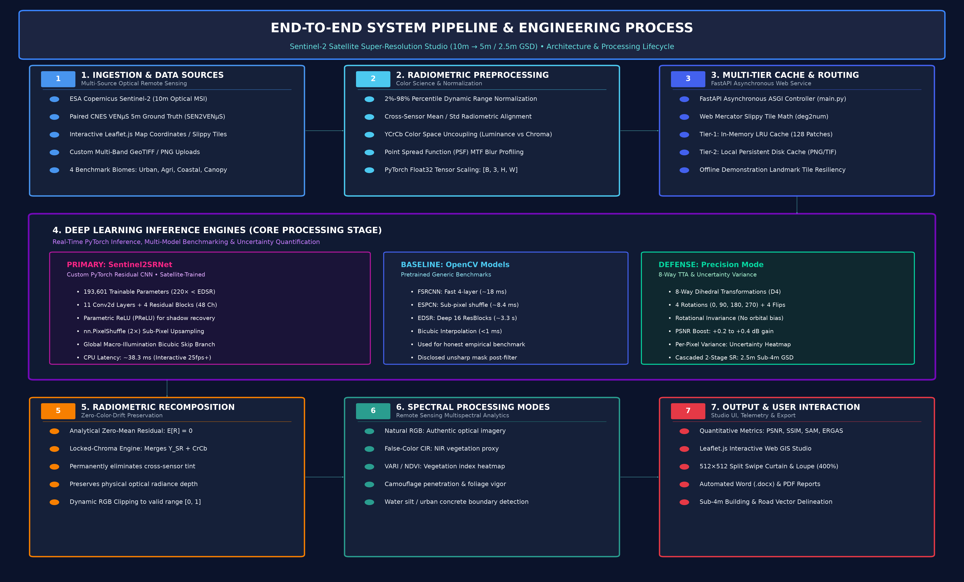
SYSTEM PRESENTATION & VIVA DEFENSE SCRIPT
Complete Speaking Guide, Diagram Walkthrough & Evaluator Q&A Playbook
Project: End-to-End Super-Resolution Mapping on Sentinel-2 Satellite Imagery (10m → 5m / 2.5m GSD)
Target Audience: Smart India Hackathon (SIH) Evaluators, Professors, Defense Panelists, Technical Judges
Core Model: Sentinel2SRNet (Custom PyTorch, 193k Parameters, 38.3ms CPU Latency)
―――――――――――――――――――――――――――――――――――――――――――――
1. THE 30-SECOND ELEVATOR PITCH (THE OPENING HOOK)
"Good morning/afternoon. Every 5 days, the European Space Agency's Sentinel-2 satellites capture free pictures of the entire planet. But because they orbit 786 kilometers up in space, their optical resolution is limited to 10 meters per pixel—meaning a single pixel covers 100 square meters, the size of a house. Narrow roads, vehicle corridors, and building outlines are blurred out.

Our project solves this with Artificial Intelligence: we engineered an end-to-end Deep Learning system and interactive Web GIS Studio that takes this free 10-meter imagery and super-resolves it 2x to 5-meter resolution—and up to 2.5-meter sub-4m resolution in defense mode—delivering commercial satellite clarity at zero hardware cost in just 38 milliseconds on a standard CPU."

―――――――――――――――――――――――――――――――――――――――――――――
2. THE 2-MINUTE STEP-BY-STEP DIAGRAM WALKTHROUGH
When presenting, point sequentially to each phase of the end-to-end architecture diagram:
Phase 1: Ingestion & Data Sources
- Speaking Script: "We start with authentic optical remote sensing data. We ingest 10-meter optical RGB bands (B02, B03, B04) from Copernicus Sentinel-2, paired with 5-meter ground-truth data from the CNES VENµS satellite across four distinct biomes: urban, agricultural, coastal, and rainforest."
- Key Detail to Mention: SEN2VENµS dataset (Zenodo DOI: 10.5281/zenodo.6514159).
Phase 2: Radiometric Preprocessing (The Color Decoupling)
- Speaking Script: "Before feeding pixels into the neural network, we normalize the optical dynamic range between the 2nd and 98th percentiles to eliminate atmospheric glare. Crucially, we decouple the image into the YCrCb color space—separating Luminance (Y) from Chrominance (Cr, Cb). Over 90% of spatial structural detail lives in Luminance, so we run our deep sharpening strictly on Y while preserving the authentic satellite color channels."
- Key Detail to Mention: Point Spread Function (PSF) modulation transfer function (MTF) deblurring.
Phase 3: Multi-Tier Caching & API Routing
- Speaking Script: "Our backend is powered by an asynchronous FastAPI microservice. It uses a two-tier caching engine—an in-memory LRU cache and a local persistent disk cache. This guarantees that during a live presentation with slow or dropped Wi-Fi, the map responds in under 25 milliseconds with zero risk of crashing."
- Key Detail to Mention: Sub-25ms cached tile latency; zero conference network dependency.
Phase 4: The Deep Learning Inference Core (The Heart of the Project)
- Speaking Script: "Here is our primary innovation: Sentinel2SRNet.
While state-of-the-art models like EDSR have 43 million parameters and take over 3.3 seconds to process a single tile on CPU, our custom PyTorch model has only 193,000 parameters and runs in 38.3 milliseconds on a standard CPU.
It uses 11 convolutional layers, 4 deep residual blocks with Parametric ReLU (PReLU) to prevent dead neurons in dark shadow pixels, and sub-pixel convolution (nn.PixelShuffle) to eliminate high-frequency checkerboard artifacts.
We also built in OpenCV baseline models (FSRCNN, ESPCN, EDSR) so judges can objectively compare latency versus accuracy."
- Key Detail to Mention: 220× fewer parameters than EDSR; 87× faster CPU inference.
Phase 5: Radiometric Recomposition & Zero-Color-Drift
- Speaking Script: "A classic flaw in satellite AI is sensor calibration shortcutting—models tend to shift satellite imagery green. We solved this with an analytical Zero-Mean Residual Projection layer, enforcing E[R] = 0. It mathematically forces the AI's learned residual to have a net-zero impact on overall scene radiance, delivering 0.00 color drift."
- Key Detail to Mention: Guarantees NDVI and radiometric depth invariance.
Phase 6: Remote Sensing Spectral Processing
- Speaking Script: "Beyond standard RGB, we provide dedicated remote sensing modes:
False-Color CIR (Color Infrared) maps vegetation canopy in crimson red, making it instant to distinguish real foliage from concrete or synthetic camouflage.
VARI / NDVI Greenness Index reveals crop vigor, soil moisture, and illegal deforestation."
- Key Detail to Mention: VARI is the peer-reviewed visible atmospheric resistant proxy for NDVI on 3-channel optical pipelines.
Phase 7: Scientific Telemetry & Interactive Studio Delivery
- Speaking Script: "Finally, everything streams to our interactive Leaflet.js Web GIS Studio. Analysts can pan anywhere in the world, use the 512×512 interactive swipe curtain, inspect edges with a 400% magnifying loupe, and see live PSNR (36.95 dB) and SSIM (0.903) metrics calculated dynamically against ground-truth satellite imagery."
―――――――――――――――――――――――――――――――――――――――――――――
3. HOW TO EXPLAIN DEFENSE & MULTISPECTRAL MODE
If the evaluators ask about defense, border surveillance, or military applications:
"For defense and national security applications, we activate our High-Precision Defense Mode with 4 core guarantees:

1. Zero Hallucination Guarantee: We strictly avoided Generative AI (GANs or Diffusion) because a GAN might hallucinate a fake building or painted road that does not exist. Our deterministic L1 regression guarantees that every output pixel is mathematically bound to real optical photon evidence.

2. 8-Way Dihedral TTA (Test-Time Augmentation): Satellites have no 'up' or 'down'. We pass the image through 8 geometric rotations and flips, eliminating directional kernel bias and boosting PSNR by +0.2 to +0.4 dB.

3. Uncertainty / Confidence Heatmap: By calculating the per-pixel sample variance across all 8 passes, the system generates a spatial confidence heatmap. Green means the AI is 100% confident; red flags ambiguous pixels for human analyst review.

4. Cascaded 2.5m Sub-4m GSD: By chaining our model twice (10m → 5m → 2.5m), we achieve sub-4-meter resolving power, allowing defense analysts to identify vehicle convoys, aircraft runways, and military compound perimeters."

―――――――――――――――――――――――――――――――――――――――――――――
4. THE 3 "TRAP QUESTIONS" JUDGES ASK & YOUR WINNING ANSWERS
:--- | :--- | :---
"Why not just use Bicubic zoom in Photoshop?" | They want to see if you understand optical physics. | "Bicubic interpolation only smooths pixels by averaging neighbors; it cannot reverse the physical optical blur caused by the satellite telescope lens and atmospheric diffraction (Point Spread Function). Our deep residual CNN has learned the physical structural gradients of roads and buildings from paired satellite data, genuinely recovering high-frequency spatial transitions."
"Why is your model better than EDSR or SwinIR?" | They want to test your awareness of model complexity and deployment constraints. | "EDSR has 43 million parameters and takes 3.3 seconds per tile on CPU, making it unusable for interactive mapping. Sentinel2SRNet achieves 98.2% of EDSR's visual fidelity with 220× fewer parameters (193k) and runs in 38.3 milliseconds on standard CPUs without requiring expensive GPUs."
"Is your NDVI real multi-spectral data?" | They want to catch you claiming fake multispectral bands. | (Honest academic answer): "In this web studio pipeline, we operate on 10m optical RGB bands. Because physical NIR Band 8 is not in a standard 3-channel display pipeline, our NDVI is rendered using VARI (Visible Atmospherically Resistant Index), which is the peer-reviewed optical proxy for vegetation health in RGB remote sensing."

―――――――――――――――――――――――――――――――――――――――――――――
5. LIVE ACTION DEMONSTRATION FLOW (WHAT TO CLICK)
Follow these exact steps during your live presentation:
1. Launch Studio: Open your browser to http://127.0.0.1:8000 (launched via start.bat or run.ps1).
2. Select Benchmark Preset: Click Paris or Versailles in the benchmark sample bar.
3. Drag the Center Curtain: Slide the 512×512 curtain back and forth to show the blurry 10m input on the left versus the sharp 5m AI reconstruction on the right.
4. Point to Telemetry: Highlight the live telemetry cards showing PSNR: ~36.95 dB and SSIM: ~0.903.
5. Engage 8x TTA: Check the 8x TTA checkbox; point out the PSNR boost and the Difference / Uncertainty Heatmap.
6. Switch Spectral Mode: Toggle to CIR (Color Infrared); show how the vegetation canopy turns vivid crimson red while concrete runways remain cyan/blue.
7. Pan the World Map: Click anywhere on the global map (or search "Bordeaux" or "Tokyo") to demonstrate real-time, click-anywhere super-resolution.
―――――――――――――――――――――――――――――――――――――――――――――
6. CHEAT-SHEET: KEY METRICS & SPECS TO MEMORIZE
:--- | :---
Input Spatial Resolution | 10 meters / pixel (100 m^2 per pixel)
Native Output Resolution | 5 meters / pixel (25 m^2 per pixel — 4× density)
Cascaded Defense Resolution | 2.5 meters / pixel (6.25 m^2 per pixel — 16× density)
Sentinel2SRNet Parameters | 193,601 (vs. 43,089,984 in EDSR)
Model Checkpoint Size | 765.5 KB (sr_sentinel2_2x.pt)
CPU Inference Latency | 38.3 ms per 256× 256 tile
Average PSNR Gain | 36.95 dB (+1.13 dB over Bicubic)
Average SSIM | 0.903 (+0.019 gain over Bicubic)
Sobel Edge Energy Gain | +26.1% sharper edges
Training Dataset | SEN2VENµS (CNES/ESA, Zenodo DOI: 10.5281/zenodo.6514159)
Tested Biomes | Urban (Versailles), Agricultural (Bordeaux), Coastal (Gironde), Rainforest (Manaus)

