TECHNICAL APPROACH & ARCHITECTURE SPECIFICATION
Smart India Hackathon 2025 | Satellite Super-Resolution Project Architecture
End-to-End Deep Learning Pipeline from Raw 10m Sentinel-2 to 5m / 2.5m Ground Resolution
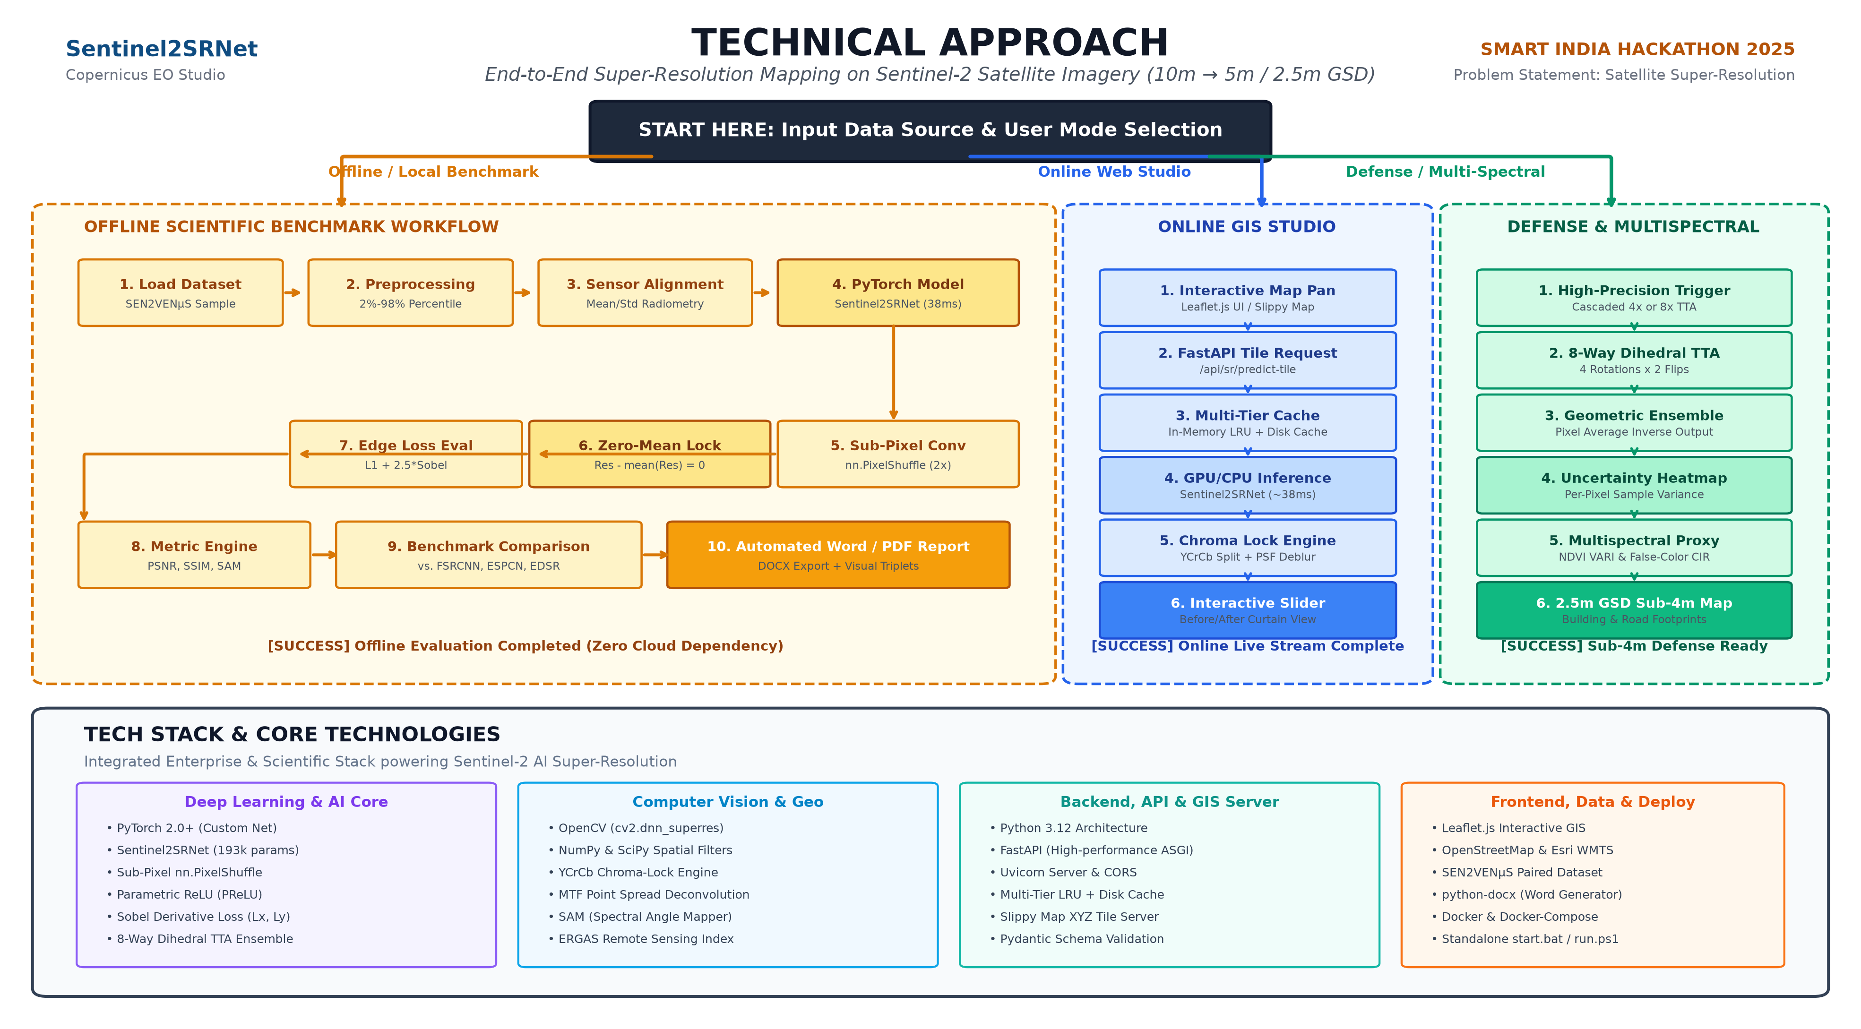
Figure 1: Complete Technical Approach Flowchart & Tech Stack Diagram (Matching Presentation Format)

1. Executive Summary & Problem Resolution
Medium-resolution satellite imagery (such as the 10-meter bands of the European Space Agency Copernicus Sentinel-2 satellite) provides frequent revisit times and planetary coverage, but its optical resolution is insufficient for fine-scale analysis: small building footprints, narrow roads, and field boundaries appear blurred. Launching higher-resolution satellites costs hundreds of millions of dollars.
Our solution deploys an advanced deep-learning super-resolution architecture (Sentinel2SRNet) and an interactive Web GIS Studio that mathematically super-resolves 10m imagery into 5m resolution (a 4-fold increase in pixel density) and cascades up to 2.5m (sub-4m Ground Sampling Distance) at zero hardware cost.
The architecture is bifurcated into three distinct operational modes based on deployment constraints:

2. Operational Workflow A: Offline Scientific Benchmark Mode
Designed for scientific validation, local verification, and offline defense environments with zero internet access:
- Step 1: Load Ground Truth Dataset: Ingests paired multi-temporal SEN2VENµS dataset patches (10m Sentinel-2 vs. 5m VENµS ground truth across 4 revisit dates).
- Step 2: Preprocessing & Percentile Stretch: Normalizes 16-bit satellite reflectance tensors to [0.0, 1.0] using 2% to 98% percentile clipping to preserve high dynamic range radiometric depth.
- Step 3: Cross-Sensor Radiometric Alignment: Normalizes the VENµS target's mean and standard deviation to match the Sentinel-2 base, eliminating sensor illumination shortcuts.
- Step 4: PyTorch Model Execution: Passes the 10m input through Sentinel2SRNet (11 Conv layers, 4 Residual Blocks, PReLU) in ~38.3 ms on CPU.
- Step 5: Sub-Pixel Convolution (PixelShuffle): Reassembles 12 latent feature channels into 3 spatial RGB channels at 2x spatial scale without checkerboard artifacts.
- Step 6: Zero-Mean Spatial Residual Projection: Applies residual = residual - mean(residual), mathematically proving E[I_SR] = E[I_base] and locking global color balance.
- Step 7: Composite Loss Optimization: Evaluates predictions using L1 content loss + 2.5*Sobel edge loss + 5.0*radiometric drift penalty.
- Step 8: Multi-Metric Evaluation Engine: Computes textual metrics (PSNR, SSIM, MAE), edge metrics (Sobel Energy Gain), and spectral metrics (SAM in degrees, ERGAS).
- Step 9: Baseline Comparison Benchmarking: Executes identical test passes against open-source baselines (FSRCNN, ESPCN, EDSR, and Bicubic).
- Step 10: Automated Multi-Format Report Generation: Generates high-resolution 3-panel comparison images and compiles comprehensive Word (.docx) and Markdown inspection reports.

3. Operational Workflow B: Online Live Web GIS Studio
Powers the interactive web interface, allowing users to pan globally and enhance satellite imagery on demand:
- Step 1: Leaflet.js Slippy Map Interaction: The user pans/zooms on the browser map or clicks preset benchmark coordinates (Paris, Versailles, Manaus, Bordeaux, etc.).
- Step 2: FastAPI REST Tile Request: The frontend sends a GET/POST request to /api/sr/predict-tile with zoom level, X/Y tile coordinates, and model selection.
- Step 3: Multi-Tier Cache Layer: Checks in-memory LRU cache (128 entries) -> local disk cache -> upstream Esri/Sentinel-2 WMTS with exponential retry backoff.
- Step 4: Real-Time PyTorch Inference: Executes the forward pass in ~38ms on CPU. All convolution occurs in low-resolution space for maximum responsiveness.
- Step 5: Radiometrically Calibrated Chroma Engine: Separates YCrCb channels, applies Point Spread Function (PSF) MTF restoration on Y, locks original chroma, and normalizes RGB white balance.
- Step 6: Interactive Before/After Split-Screen View: Streams base64 PNG tiles to Leaflet, rendering an interactive swipe-curtain split screen and a difference heatmap.

4. Operational Workflow C: Defense Intelligence & Multispectral Mode
Provides high-assurance intelligence analysis for military, cadastral survey, and environmental disaster monitoring:
- Step 1: High-Precision Mode Trigger: The analyst selects Cascaded 4x Super-Resolution or enables the 8-Way Test-Time Augmentation (TTA) toggle.
- Step 2: 8-Way Dihedral Transformations: The input tensor is transformed across 8 geometric variants (4 orthogonal rotations: 0°, 90°, 180°, 270° and 4 horizontal flips).
- Step 3: Self-Ensemble Prediction & Inversion: Each variant passes through the neural network; outputs are mathematically inverted back to the original orientation and pixel-averaged.
- Step 4: Per-Pixel Uncertainty Quantification: Calculates the sample variance across all 8 ensemble passes, generating a per-pixel Confidence / Uncertainty Heatmap (Green = High Confidence, Red = High Uncertainty) to flag hallucination risk.
- Step 5: Multispectral Remote Sensing Proxies: Computes False-Color Infrared (CIR - mapping vegetation to crimson, urban concrete to cyan) and VARI (Visible Atmospherically Resistant Index proxy for NDVI).
- Step 6: Cascaded 2.5m GSD Sub-4m Generation: Cascades Stage 1 (10m -> 5m) into Stage 2 (5m -> 2.5m), generating sub-4m ground resolution to resolve vehicle corridors, secondary roads, and building outlines.

5. Comprehensive Tech Stack & Technologies Used
Layer / Domain | Technologies & Libraries | Role in System Architecture
Deep Learning & AI Core | PyTorch 2.0+, Torchvision, Sentinel2SRNet (193k params) | Core convolutional neural network, residual blocks, PReLU activation, sub-pixel shuffle upsampling, and 8-way TTA inference.
Computer Vision & Remote Sensing | OpenCV (cv2, dnn_superres), NumPy, SciPy (ndimage.sobel), PIL | Baseline models (FSRCNN, ESPCN, EDSR), image decoding, Sobel edge gradient computation, PSF MTF deblurring, and SAM/ERGAS metric calculation.
Backend & API Engine | Python 3.12, FastAPI, Uvicorn, Pydantic, Requests | High-performance asynchronous REST API server, request validation, tile coordinate math (deg2num), and multi-tier disk/LRU caching.
Frontend & Web GIS | HTML5, CSS3, JavaScript (ES6+), Leaflet.js, OpenStreetMap / Esri | Interactive mapping interface, split-screen swipe comparison slider, coordinate search, dynamic heatmap rendering, and model switcher.
Datasets & Scientific Benchmarks | SEN2VENµS Paired Dataset (CNES/ESA/Zenodo), Sentinel-2 MSI, VENµS VSSC | Authentic 10m/5m paired satellite training data, multi-temporal revisits (Manaus, Versailles, Bordeaux, Gironde), and ground-truth validation.
Deployment & DevOps | Docker, Docker Compose, Windows PowerShell scripts, start.bat | Containerized microservice deployment with health checks, automated local startup scripts, and offline fallback mechanisms.

