Neural Network Practice 3

by: Olenburg Egor
id: 7261

learning rate = 0.01
2 Hidden nodes size by 100;

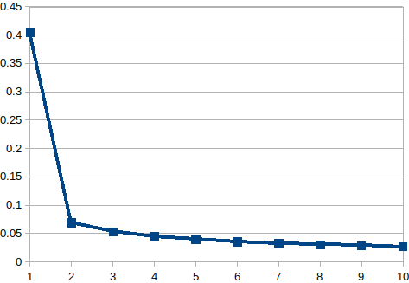

My training data amount is 60K and my testing amount is 10K
First my network shows how bad error is without training, then I train and it drops drasticly!
Number of epochs is 10,

learning rate = 0.1
2 Hidden nodes size by 50;

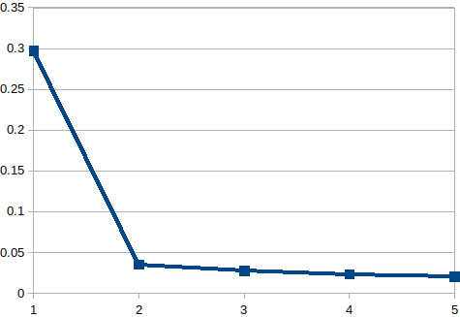

In this Network my Hidden layer size is 50, and my train epochs amount is 5
it takes too mush time with previous size amounts
my Learning rate is 0.1
My error does not change much in compare to the first graph! My error after training Is below 0.05;
with learning rate changed and lowerd size of hidden nodes network seems to be better!

earning rate = 0.5
2 Hidden nodes size by 50;

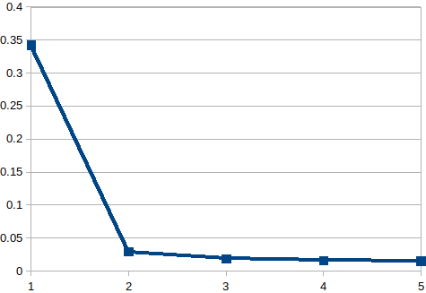

I used same pre-training method.
My learning rate is 0.5
my Network seems to be even better than the two previous graphs.

