For SecureChat, I would not use a generic “Next.js + Node + PostgreSQL” stack alone. Your hardest requirements are E2EE, real-time messaging, on-device AI, Android notification integration, low battery usage, threat intelligence, and a scalable backend.
My recommendation would be this:

🛡️ SecureChat — Recommended Tech Stack
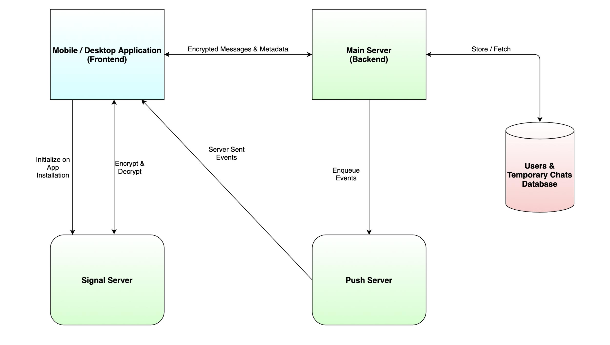
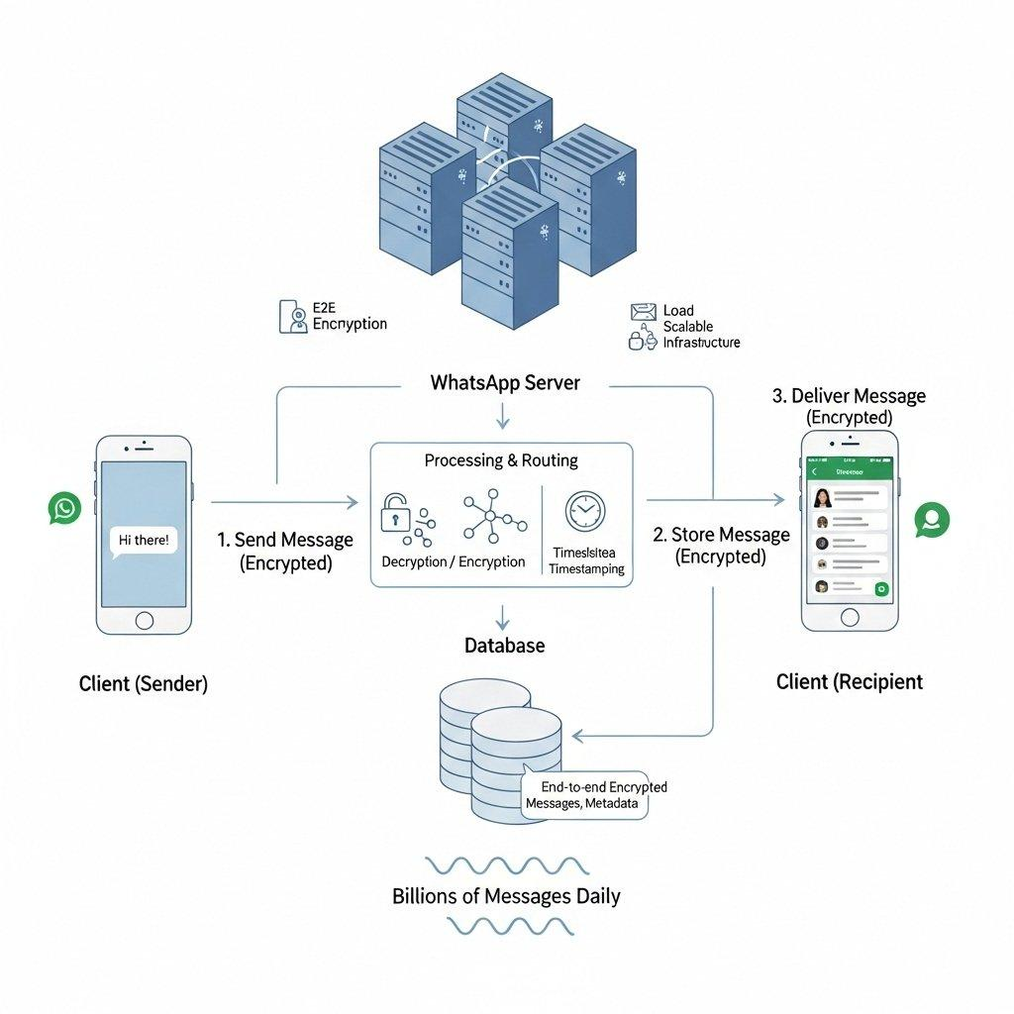
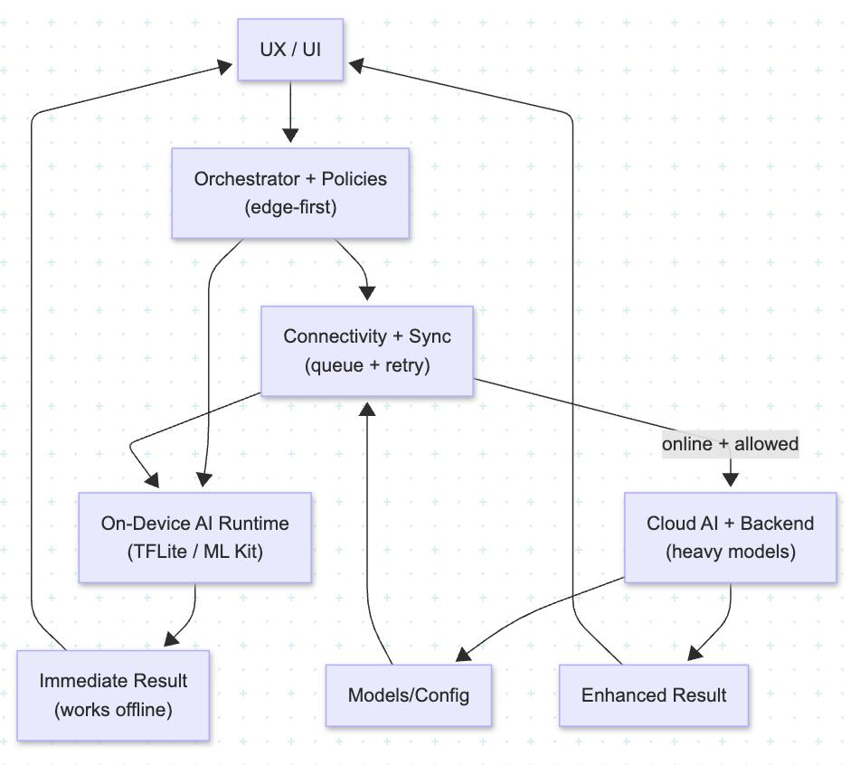
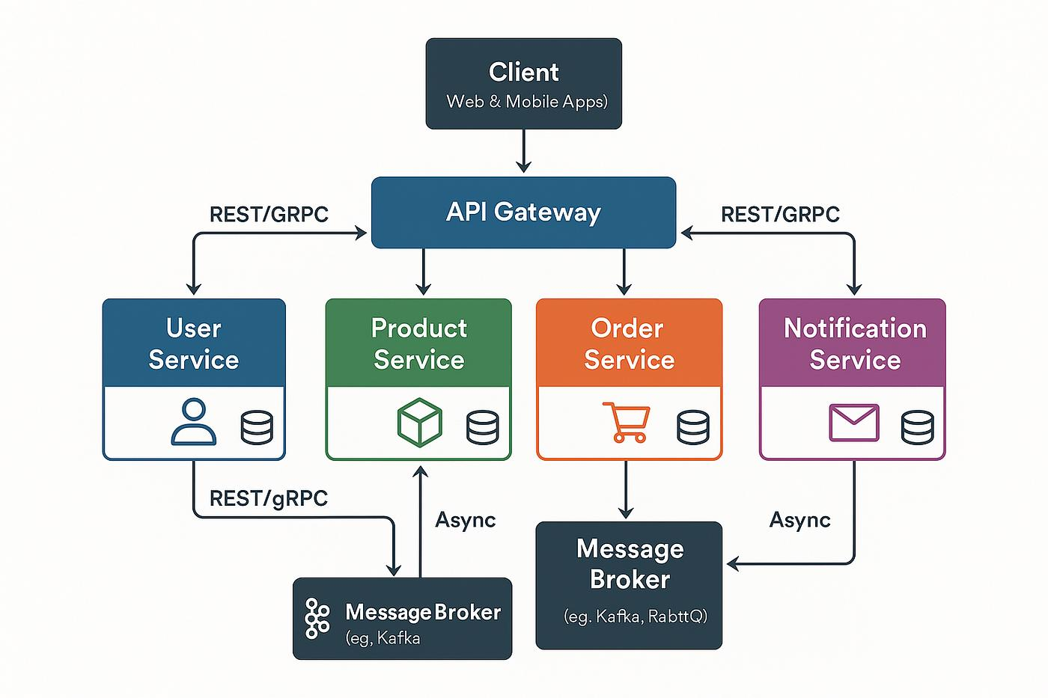
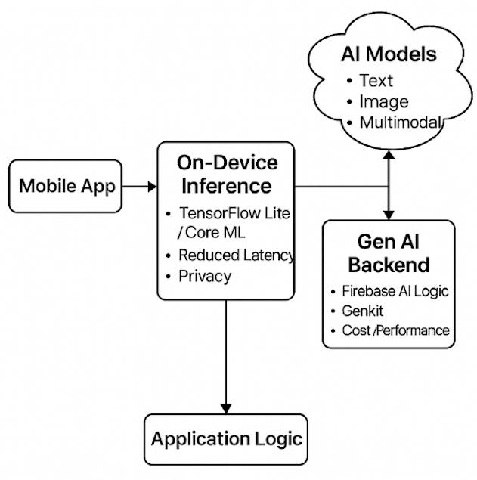
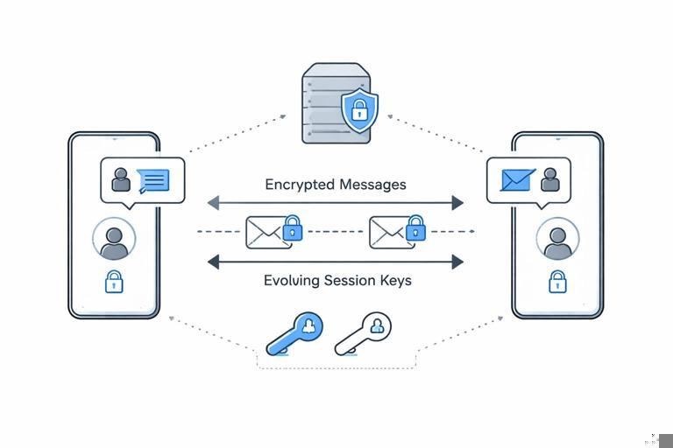

1. Overall Architecture
SECURECHAT
│
┌───────────────────┼──────────────────┐
│ │ │
MOBILE BACKEND AI
│ │ │
Android/iOS API Gateway AI Gateway
│ │ │
Local AI Services Models
│ │ │
E2EE Crypto PostgreSQL Threat Intel
│ │ │
SecureBridge Redis ML Pipeline
│ │
└───────────────────┼──────────────────┘
│
Infrastructure

2. Mobile App — Kotlin + Jetpack Compose

My strongest recommendation:
Android: Kotlin + Jetpack Compose
Rather than Flutter as the primary technology.
Why?
Your SecureBridge requirement makes Android a first-class security component, not merely a UI platform.
You need deep access to:
- Notification Listener Service
- Android Keystore
- WorkManager
- foreground/background processing
- encrypted local storage
- biometrics
- network security configuration
- app lifecycle
- battery optimization
- hardware-backed cryptography
- on-device ML
- push notifications
Kotlin gives you direct access to all of these.

Stack
Kotlin
Jetpack Compose
Android SDK
Coroutines
Flow
Hilt
Room
DataStore
WorkManager
Android Keystore
BiometricPrompt
FCM

3. Why I Wouldn't Make Flutter the Core
Flutter is excellent for normal applications.
But SecureChat isn't a normal application.
You have:
SecureBridge + local AI + cryptography + background services + notification interception + battery optimization.
Native Android gives you considerably more control.
You can still build iOS later using:
Swift + SwiftUI
rather than forcing identical implementation across platforms.

4. Backend — TypeScript + NestJS
I'd use:

TypeScript
with:

NestJS
for the main backend.
apps/
├── api/
│ └── NestJS
├── realtime/
│ └── WebSocket gateway
├── workers/
│ └── background jobs
└── threat-intelligence/
Why NestJS?
- Strong architecture
- Dependency injection
- Modules
- Guards
- Interceptors
- WebSockets
- validation
- testing
- scalable team development
And TypeScript keeps your backend development relatively consistent with the frontend/admin ecosystem.

5. Real-Time Messaging — WebSockets
Use:

WebSockets
for:
- messages
- typing indicators
- read receipts
- reactions
- presence
- message delivery
- security alerts
Architecture:
Client
│
WebSocket
│
Realtime Gateway
│
Message Service
│
Event Bus
Don't poll the backend for messages.

6. Database — PostgreSQL

PostgreSQL should be your primary database.
It is ideal for:
- users
- devices
- conversations
- groups
- message metadata
- security events
- permissions
- AI configuration
- threat records
Use:

Prisma
as your ORM if you want developer productivity and type safety.
Given your existing experience with Prisma + PostgreSQL, this also fits naturally.

7. Redis
Use:

Redis
for:
- caching
- rate limiting
- presence
- temporary sessions
- distributed locks
- WebSocket coordination
- job queues
- security intelligence caching
Example:
PostgreSQL
↓
Permanent data

Redis
↓
Temporary / fast data

8. Message Queue — Redis Streams initially
For MVP:

Redis Streams
or a queue library such as BullMQ.
For larger scale later:

Apache Kafka
or Redpanda.
I wouldn't start with Kafka.
Start:
NestJS
↓
Redis/BullMQ
↓
Workers
Move to Kafka/Redpanda only when actual scale justifies it.

9. AI — Hybrid On-Device + Server AI
This is probably the most important technical decision.
Don't build:
Every message
↓
Cloud GPT
↓
Analysis
That would undermine your privacy architecture.
Instead:
MESSAGE
│
▼
Local Analyzer
│
┌────────┴────────┐
│ │
Obviously safe Suspicious
│ │
▼ ▼
🟢 Green Deeper analysis
│
┌──────┴──────┐
│ │
Local AI Cloud AI*
* only where the privacy policy/user settings permit it.

10. On-Device AI
I'd evaluate:

ONNX Runtime Mobile

LiteRT
(Google's modern TensorFlow Lite direction)
and potentially:

ExecuTorch
depending on the models selected.
For Android, the objective is:
Small model
+
Quantization
+
Hardware acceleration
+
Low memory
+
Low battery

11. AI Model Architecture
Don't use one giant model.
Use a multi-model security pipeline.
MESSAGE
│
┌─────────┴─────────┐
│ │
Rules Classifier
│ │
└─────────┬─────────┘
↓
Risk Aggregator
│
┌─────────┴──────────┐
│ │
URL Engine Context AI
│ │
└─────────┬──────────┘
↓
Risk Engine
↓
Security Policy
↓
🟢 🟠 🔴
This is significantly more efficient than running an LLM for every message.

12. NLP / Security Models
You'll potentially need specialized models for:

Phishing
Binary/multiclass classifier.

Social Engineering
Text classification.

Sensitive Data
NER + deterministic pattern detection.

Scam Detection
Classification + contextual analysis.

Manipulation Signals
Behavioral/conversational pattern detection.

URL Security
Mostly deterministic/security intelligence rather than an LLM.

13. LLM
Use an LLM selectively.
For example:
Simple message
↓
No LLM

Suspicious message
↓
Small local model

Complex conversation
↓
Larger model
The LLM should be an analysis component, not the final authority.

14. Security Decision Engine
This should preferably be deterministic.
For example:
AI confidence: 87
URL reputation: 95
Credential request: +30
Urgency: +10
Known safe domain: -20
Then:
Risk Engine
↓
Policy Engine
↓
Final Security State
This prevents an LLM hallucination from deciding:
"This website is definitely safe."

15. URL Intelligence
I'd create a dedicated:

URL Security Service
It performs:
URL
↓
Normalization
↓
Domain extraction
↓
Homograph detection
↓
DNS analysis
↓
TLS/certificate information
↓
Redirect analysis
↓
Threat intelligence
↓
Reputation
↓
ML classification
Potential external intelligence sources can be integrated later.

16. Threat Intelligence Database
Maintain your own normalized threat-intelligence layer.
ThreatIndicator
├── indicator
├── type
├── source
├── confidence
├── firstSeen
├── lastSeen
├── expiration
└── reputation
Sources can include reputable feeds and APIs.
Don't make the AI responsible for maintaining threat intelligence.

17. SecureBridge — Native Android
This component should be 100% native Kotlin.
SecureBridge
│
├── NotificationListenerService
├── Notification Parser
├── WhatsApp Adapter
├── Notification Store
├── AI Analyzer
├── Security Event Manager
├── Alert Manager
└── Privacy Controller
This is one of the reasons I strongly prefer native Android for the primary mobile application.

18. Local Storage
Use:

Room + SQLCipher or Android's strongest supported encrypted-storage approach
for sensitive local application data.
But be careful:
Don't invent your own encryption layer.
Use established libraries/protocols.

19. Cryptography
This is an area where I would be extremely conservative.
Do not implement:
myCustomEncryption()
Use a professionally reviewed protocol/library.
Your design should include:
- authenticated encryption
- forward secrecy
- key rotation
- device keys
- identity keys
- secure session establishment
- key verification
- device revocation
For the actual messaging protocol, I'd investigate a Signal Protocol-based architecture rather than designing a new protocol.

20. Backend API
Use:

REST + WebSockets
REST:
/api/v1/auth
/api/v1/users
/api/v1/conversations
/api/v1/groups
/api/v1/security
/api/v1/devices
WebSockets:
/ws/messages
/ws/presence
/ws/security

21. API Security
Use:
- TLS
- short-lived access tokens
- refresh-token rotation
- device binding
- rate limiting
- request validation
- replay protection
- authorization guards
- audit logging
For highly sensitive operations, require additional device/user verification.

22. Authentication
I'd consider:

Passkeys/WebAuthn
for account authentication where practical.
For phone-centric onboarding, you can additionally support:
- phone verification
- device registration
- passkey
- biometric unlock
Avoid relying solely on SMS as the long-term security mechanism.

23. Push Notifications
Android:

Firebase Cloud Messaging
Use push notifications for:
- incoming messages
- critical security alerts
- device/session events
But don't put sensitive message contents into push payloads unnecessarily.
Prefer:
"New message"
rather than:
"Your OTP is 493821"

24. Object Storage
For media:

S3-compatible object storage
Examples:
- AWS S3
- Cloudflare R2
- MinIO
For your development environment:

MinIO
is excellent.
Production can move to:

S3/R2

25. Search
Initially:

PostgreSQL Full Text Search
Later:

OpenSearch
when you need large-scale search.
Don't introduce Elasticsearch/OpenSearch on day one.

26. Admin Panel
Use:

Next.js + React + TypeScript
for:
apps/admin
This is where Next.js is an excellent choice.
Admin dashboard:
- security events
- threat intelligence
- system health
- abuse reports
- model status
- analytics
- infrastructure monitoring
Again:
Admin dashboard ≠ access to private message contents.

27. Web/Desktop
For the web client:

Next.js + React + TypeScript
For desktop later:

Tauri
rather than Electron if the requirements fit.
This gives you:
Mobile
Kotlin

Web
Next.js

Desktop
Tauri

28. Monorepo
For your project, I'd use:

pnpm + Turborepo
Structure:
securechat/
│
├── apps/
│ ├── android/
│ ├── ios/
│ ├── web/
│ ├── admin/
│ ├── api/
│ ├── ai-service/
│ └── worker/
│
├── packages/
│ ├── database/
│ ├── validation/
│ ├── crypto/
│ ├── protocol/
│ ├── security/
│ ├── types/
│ └── ui/
│
├── infrastructure/
│ ├── docker/
│ ├── terraform/
│ └── kubernetes/
│
└── docs/

29. Important Change From Your Previous Esports Stack
Your previous architecture used a Next.js-centered application.
For SecureChat, I'd change that.

Don't make Next.js the core.
Instead:
SecureChat
│
┌─────────────┼─────────────┐
│ │ │
Android Backend AI
Kotlin NestJS Python/ONNX
│ │ │
└─────────────┼─────────────┘
│
PostgreSQL
Next.js becomes primarily:
Web Client
Admin
Dashboard

30. AI Service — Python
Although I recommend TypeScript for the primary backend, I'd use:

Python
for AI/ML services.
Stack:
Python
FastAPI
PyTorch
Transformers
ONNX
scikit-learn
Pydantic
Why?
The AI ecosystem is dramatically stronger in Python.

31. AI Service Architecture
apps/ai-service/

src/
├── api/
├── inference/
├── models/
│ ├── phishing/
│ ├── social_engineering/
│ ├── scam/
│ ├── dlp/
│ └── classification/
├── pipelines/
├── feature_engineering/
├── explainability/
└── evaluation/

32. Worker Architecture
Use workers for expensive operations:
Message
↓
Event
↓
Queue
↓
Worker
├── URL analysis
├── attachment analysis
├── threat intelligence
├── AI analysis
└── security event
This keeps the messaging API responsive.

33. Containerization
Use:

Docker
for every backend service.
Development:
Docker Compose
Production:
Kubernetes
But don't start with Kubernetes unless necessary.
Start with:
Docker
+
managed PostgreSQL
+
managed Redis
Then migrate when scale demands it.

34. Cloud Recommendation
For MVP, I'd prioritize simplicity.

Option A
AWS
or

Option B
Cloudflare + managed infrastructure
or

Option C
A VPS + Docker for early development/testing.
A good production architecture could eventually become:
Cloudflare
↓
Load Balancer
↓
API
↓
Workers
↓
PostgreSQL
Redis
Object Storage

35. Observability
Use:

OpenTelemetry
for telemetry.
Then:
- Prometheus
- Grafana
- Loki
- Sentry
Track:
API latency
Message delivery
AI inference latency
Battery impact
Crash rate
Security detections
False positives
False negatives
Queue latency
Database performance

36. CI/CD
GitHub Actions:
Push
↓
Lint
↓
Unit tests
↓
Security scan
↓
Build
↓
Integration tests
↓
Deploy staging
↓
E2E
↓
Production
Security tools:
- Semgrep
- CodeQL
- Trivy
- dependency scanning
- secret scanning

37. Infrastructure as Code
Use:

Terraform
Eventually:
infrastructure/
├── terraform/
│ ├── networking/
│ ├── database/
│ ├── redis/
│ ├── storage/
│ └── monitoring/

38. Secrets
Never:
.env committed to GitHub
Use:
- development .env
- GitHub Actions secrets
- production secret manager
- rotated credentials

39. Testing Stack

Android
- JUnit
- MockK
- Compose UI tests
- Android instrumentation tests

Backend
- Jest
- Supertest
- integration tests

AI
- pytest
- model evaluation datasets
- adversarial testing

E2E

Playwright
for web/admin.
For mobile, use Android instrumentation/Espresso/Compose testing and device-level automation as appropriate.

40. Security Testing
You need a dedicated security testing layer.
SAST
↓
DAST
↓
Dependency Scan
↓
API Security
↓
Mobile Security
↓
Cryptographic Review
↓
AI Red Teaming
↓
Penetration Testing

41. Recommended Final Stack
If I were building SecureChat today, my baseline would be:
Layer | Technology
Android | Kotlin + Jetpack Compose
iOS | Swift + SwiftUI
Web | Next.js + React
Admin | Next.js
Backend | NestJS + TypeScript
Realtime | WebSockets
Database | PostgreSQL
ORM | Prisma
Cache | Redis
Queue | BullMQ / Redis Streams
AI/ML | Python + PyTorch
On-device AI | ONNX Runtime / LiteRT
AI API | FastAPI
Crypto | Established Signal-compatible architecture/library
Local DB | Room + encrypted storage
WhatsApp bridge | Kotlin NotificationListenerService
Push | Firebase Cloud Messaging
Media | S3-compatible storage
Search | PostgreSQL → OpenSearch later
Monitoring | OpenTelemetry + Prometheus + Grafana
Errors | Sentry
Containers | Docker
IaC | Terraform
CI/CD | GitHub Actions
Security | CodeQL + Semgrep + Trivy
Web E2E | Playwright
Backend Tests | Jest
AI Tests | pytest
Package Manager | pnpm
Monorepo | Turborepo

42. One More Important Recommendation
I would not make "AI" the center of the security architecture.
Make this the center:
ZERO TRUST
│
┌──────────┼──────────┐
│ │ │
Crypto Policy Evidence
│ │ │
└──────────┼──────────┘
│
Security Engine
│
┌─────────┴─────────┐
│ │
AI Models Deterministic Rules
│ │
└─────────┬─────────┘
│
Risk Engine
│
🟢 🟠 🔴
AI should provide intelligence; the security policy engine should make the final decision.
That makes SecureChat much more defensible as a serious cybersecurity product.

My #1 stack recommendation
If you want me to lock the architecture today:
Kotlin + Jetpack Compose + NestJS/TypeScript + PostgreSQL/Prisma + Redis + Python/FastAPI + PyTorch + ONNX/LiteRT + WebSockets + Signal-compatible E2EE + Firebase + S3 + Docker + GitHub Actions + OpenTelemetry.
And because you've already been working with pnpm, Prisma, PostgreSQL, Next.js and monorepos, we can preserve those skills while changing the parts that don't fit SecureChat—particularly making native Kotlin the security-critical mobile layer.

