KO
Lives the Erisian illusion

KO is a comic hack 'n slash dungeon crawling adventure.

The main – and player-controlled – character is KO, the games namesake. KO is chaotic good.

Most of the game takes place in a dungeon with downward staircases. Upon entering a staircase a new level is generated. Each level contains monsters. When venturing deeper underground the monsters become harder to beat.

Combat will involve a lot of button bashing, simple combos, blocking and the quafing of potions. Slaying monsters will cause KO to gain experience. Also the monsters may drop items.
Gore will be optional.

The wreaking of havoc will be accompanied by a heavy metal soundtrack.

Inspiration:
Diablo & Dark Souls (Gameplay)
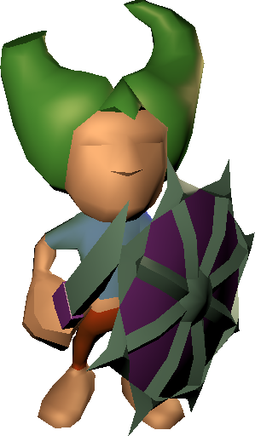
Angband (Random maps)
Zack & Wiki (Graphic style)
Discordianism (Lore)

