**Programming Assignment #3**

Files – Due Friday, October 24, 2014 at 2:30pm

Checklist – Due same day at the start of class

This assignment will exercise your skills in following and implementing a simple recursive algorithm. The task is to implement a solution to the popular puzzle game Sudoku. From Wikipedia: "The objective is to fill a 9×9 grid with digits so that each column, each row, and each of the nine 3×3 sub-grids that compose the grid (also called "boxes", "blocks", "regions", or "sub- squares") contains all of the digits from 1 to 9."

**A very easy Sudoku starting configuration**

An initial configuration of a Sudoku board. (9x9.txt)

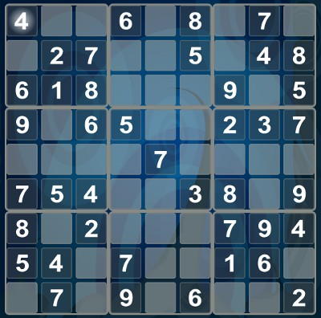

**Solution to the board on the left**

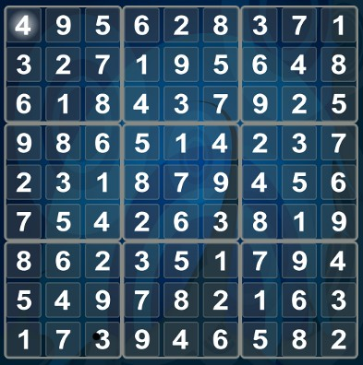

The complete solution required 533 "guesses"

and bactracked 40 times..

**Details**

Instead of simply hard-coding the algorithm to manipulate a 9x9 board, we are going to extend the algorithm so that it can handle boards of any size (e.g. 9x9, 16x16, 25x25, etc.). There are many ways to solve a Sudoku puzzle, but, as it turns out, a recursive solution is the simplest to implement. (It is not the most efficient, though.) Your solution to this exercise will involve a technique called *backtracking*. Backtracking is a popular technique that computers use to solve problems by systematically evaluating all possible combinations. This backtracking algorithm is also similar to how one would solve a maze. The interface to the algorithm is simply a single call to a method of the class *Sudoku* named *Solve:*

**bool** Sudoku::Solve();

The return is a boolean that indicates success (true) in finding the solution or failure (false) to find a solution. Within your code, the Solve method should call a private recursive function whose task it is to place the value in the specified position (row/column). Name this function *place_value* or something similar and call it to put the value in the first cell. After the function places the value at a particular position, it must check to see if there are more empty cells left and take appropriate action. There are four possible situations:

|  |  |
| --- | --- |
| **Situation** | **Action** |
| All cells have a value | The algorithm has successfully found the solution. Stop searching and return true. |
| Cells are still open | Call ***place_value***recursively to place a value in the next open cell. |
| Cells are still open and you can **NOT** place a value in the current cell. (The value is already the maximum.) | Remove the current value by "backtracking" to the previous cell that you placed a value, increment that value, and continue. |
| Cells are still open and you can **NOT** place any more values because you've exhausted all possibilities. | The algorithm was unsuccessful at finding the solution. Stop searching and return false. |

The algorithm continues until you successfully place a value to every cell on the board or you've tried all possible combinations and cannot place a value in all cells. A solution will have the number of "moves" or "guesses" that were required to find the solution.

More on the back →

**The Callback Function**

Providing a callback function to the constructor enables you to receive notifications at any point during the algorithm's execution. This allows you to separate the algorithm logic from other programming logic (e.g. debugging code or visualization code.) This separation of logic is crucial when developing software for any non-trivial project. The types and order of the messages are evident by looking at the sample output from the sample driver. One of your goals is to match the output exactly. (This will determine whether or not you followed the specifications correctly.) At various times during the algorithm's execution, you must call the function that was provided by the client. The callback function requires 7 parameters, but all of them may not be used during a callback. (This is similar to how the *lparam* and *wparam* of a Windows message may go unused.) The return value is only used by one particular type of callback.

**typedef bool** (*CALLBACK)(**const** Sudoku& sudoku, // the sudoku board itself

**const char** *board, // one-dimensional array of symbols

MessageType message, // type of message size_t move, // the move number

**unsigned** basesize, // 3, 4, 5, etc. (for 9x9, 16x16, 25x25, etc.)

**unsigned** index, // index of the current cell

**char** value // symbol (value) in current cell

);

Note: Be sure not to reset the board after the solution is found. The driver will call your Sudoku::GetBoard() after the solution is found and it expects the board to still be valid. Also, you are not implementing the callback function. It is implemented in the driver and you are to call it from your code.

|  |  |  |
| --- | --- | --- |
|  | **Parameter** | **Description** |
| 1 | **const** Soduko& soduko | A reference to the Sudoku board itself. |
| 2 | **const char** *board | A pointer to the 1-D representation of the state of the board. Internatlly, you can store the board in any format you like, it must be an array for the driver. |
| 3 | MessageType message | An integer (enum) representing the type of message. There are 6 message types defined in  *Sudoku.h*. See the driver for more details. |
| 4 | size_t move | The current move number. *move* is the total move count since the algorithm began. Every time you place a value on the board, it is considered a move. See the output from the driver for details. |
| 5 | **unsigned** basesize | 3, 4, 5, etc. (for 9x9, 16x16, 25x25, etc.) You cannot hard-code these sizes into your code and assume that you won't handle larger boards. |
| 6 | **unsigned** index | The index of the current cell. The index is based on the 1-D representation in the *board*  parameter. |
| 7 | **char** value | The symbol (value) in the current cell that is being placed or removed. |

You will find that callback functions such as this can be a very helpful aid when debugging your code. By providing a callback mechanism, you can inspect data from *outside* of the algorithm. Graphical drivers that I use often make extensive use of a callback function, which then kept the algorithm very simple. You will find additional information on the web page for this assignment.

**What to submit**

You must submit your header file and implementation file (Sudoku.h and Sudoku.cpp) and the compiled help file (index.chm)

in a .zip file to the CS280 submission page.

|  |  |
| --- | --- |
| **Source files** | **Description** |
| Sudoku.h | The header file for the Sudoku class. **No implementation is allowed in this file.** The public interface must be exactly as described above. |
| Sudoku.cpp | The implementation file. All implementation for the functions goes here. You must document the file (file header comment) and functions (function header comments) using Doxygen tags. Don't forget to include comments indicating why you are **#includ**ing certain header files. |

**Usual stuff**

Your code must compile (using the compilers specified in this course) to receive credit. The code must be formatted as per the documentation. Note that you must not submit any other files in the .zip file other than the 3 files specified. Details about what to submit and how are described in the syllabus.

**Make sure your name and other info is on all documents.**