K. K. WAGH INSTITUTE OF ENGINEERING EDUCATION AND RESEARCH
DEPARTMENT OF COMPUTER ENGINEERING
DESIGN THINKING PROJECT REPORT
ACADEMIC YEAR 2026-2027

PROJECT TITLE
SmartBus: An Intelligent Real-Time Public Transit Tracking, Dynamic ETA Estimation, and Fleet Management Platform for Regional Bus Corridors
TEAM MEMBERS: | Guided By  Prof. Shweta Jadhav
Roll No. | Name of Member
35 | Jay Sham Kulkarni
31 | Parth Kasar
32 | Vivek Katore
30 | Sarthak Kapse

TEAM ROLES AND RESPONSIBILITIES
Roll No. | Name | Role | Responsibilities
35 | Jay Sham Kulkarni | Backend & System Architecture | Overall system architecture design, Node.js live development server, client-server communication, administrative authentication security, backend data pipelines, and core integration.
31 | Parth Kasar | UI/UX & Frontend Development | Passenger and admin user interface design, responsive layouts, interactive Leaflet GIS map integration, stop selector controls, CSS design systems, and commuter experience.
32 | Vivek Katore | Dynamic ETA & Transit Physics Engine | Algorithmic segment-based dead reckoning, real-time speed interpolation, stop-to-stop distance matrices, countdown calculation, and traffic delay variance modeling.
30 | Sarthak Kapse | Cloud Database & Storage Architecture | Google Firebase Firestore cloud database integration, real-time snapshot listeners, two-way state synchronization, LocalStorage offline engine, and midnight auto-reset mechanism.

ABSTRACT
SmartBus is an intelligent real-time public transit tracking, dynamic ETA estimation, and fleet management platform engineered to resolve the chronic commute uncertainty, long passenger waiting times, and lack of schedule visibility prevailing across regional and semi-urban bus transit corridors. In developing economies like India, millions of rural and suburban commuters—including college students, agricultural workers, and industrial employees—rely on public State Transport (MSRTC) and municipal feeder buses to travel between satellite towns and urban hubs. However, due to the prohibitive capital cost of installing dedicated IoT GPS hardware units across thousands of state-operated buses, commuters are left without real-time tracking, resulting in unpredictable idle dwell times exceeding 30 to 45 minutes at rural transit shelters.
SmartBus overcomes this foundational barrier by integrating an interactive Leaflet.js GIS mapping engine with an algorithmic segment-based dead-reckoning ETA estimation engine, eliminating the compulsory requirement for hardware GPS on-board units. Grounded in the real-world 31.0-kilometer highway corridor connecting Nashik Old CBS Terminus and Pimpalgaon Baswant Bus Stop via 9 critical intermediate transit halts (including Panchavati Nimani, Adgaon Naka, Amrutdham, Jatra Hotel, and HAL Aerospace Ojhar), the system dynamically computes high-precision arrival predictions by interpolating real-time elapsed trip minutes against multi-segment highway speeds, stopping delays, and scheduled route geometries.
The system adopts a full-stack modern architecture utilizing HTML5, responsive CSS3, modular JavaScript (ES6+), Leaflet GIS mapping with OpenStreetMap tiles, and Google Firebase Firestore for cloud persistence and real-time bidirectional synchronization. For daily commuters, SmartBus provides a friction-free, zero-installation web interface accessible via any smartphone browser. Passengers authenticate seamlessly using their 10-digit mobile number, select their boarding halt, and immediately view a live interactive map depicting moving bus coordinates, headway countdowns, and upcoming departure boards.
Simultaneously, SmartBus provides a comprehensive Administrative Fleet Monitoring and Dispatching Suite. Transit dispatchers gain secure, real-time command over the entire fleet, enabling live vehicle tracking, dynamic route modifications, timetable scheduling, and emergency status updates. The platform automatically tracks daily commuter volumes, organizes departures into four standard operational windows (Morning Peak, Midday Transit, Evening Peak, and Night Service), and resets daily login counters at midnight to ensure continuous operational integrity.
Through comprehensive Design Thinking methodology—encompassing stakeholder empathy mapping, customer journey tracking, commuter pain-point surveys, and rigorous functional testing—SmartBus demonstrates that software-driven algorithmic tracking offers an economical, highly scalable, and accessible alternative to multi-crore IoT hardware overhauls, radically improving daily commuter punctuality and transit agency efficiency.

INDEX
TABLE OF CONTENTS
Sr. No. | Chapter / Section Title | Page No.
- | Team Roles and Responsibilities Matrix | ii
- | Abstract | iii
1 | CHAPTER 1: INTRODUCTION | 1
 | 1.1 Project Idea | 1
 | 1.2 Motivation | 1
2 | CHAPTER 2: LITERATURE SURVEY | 2
 | 2.1 Existing Systems | 2
 | 2.2 Limitations of Existing Systems | 2
 | 2.3 Solutions to the Limitations of Existing Systems | 3
 | 2.4 On-Ground Stakeholder Interview Survey (Operating Crew) | 3
 | 2.5 Field Interview Survey: Commuters & Student Stakeholders | 4
 | 2.6 Quantitative Survey Analysis Corroborating Field Interviews | 5
3 | CHAPTER 3: PROBLEM DEFINITION AND SCOPE | 6
 | 3.1 Problem Statement | 6
 | 3.2 Objectives | 6
 | 3.3 Questionnaire to Stakeholders | 7
 | 3.4 Technical & Operational Constraints | 8
 | 3.5 Expected System Outcome | 8
 | 3.6 Hardware and Software Requirements | 8
 | 3.7 Software Resources Used | 9
4 | CHAPTER 4: IMPLEMENTATION AND TESTING | 11
 | 4.1 System Implementation & Live Module Visualizations | 11
 | 4.2 System Workflow Architecture & Process Breakdown | 17
 | 4.3 Design Thinking Maps (Mind Map, Empathy, Customer Journey) | 19
 | 4.4 Functional Testing & Test Cases Matrix | 22
5 | CHAPTER 5: CONCLUSION AND SUMMARY | 24
 | 5.1 Project Summary | 24
 | 5.2 Future Scope & Proposed Innovations | 24
 | 5.3 Conclusion | 25

LIST OF FIGURES & TABLES
List of Figures
Figure No. | Figure Title / Caption | Page No.
Figure 2.5.1 (A) | Field Interview with MSRTC Driver at Depot Bay regarding Highway Delays | 3
Figure 2.5.1 (B) | Discussion with Senior MSRTC Conductor on Passenger Query Pressure | 3
Figure 2.5.2 (A) | Field Interaction with Daily Student Commuters Waiting along NH-3 Halts | 4
Figure 2.5.2 (B) | Interview with Student Commuters at Nimani Bus Stand (निमाणी बस स्थानक) | 4
Figure 2.5.3 | Empirical Quantitative Survey Analysis Corroborating Field Interviews (N = 85) | 5
Figure 4.1.1 | Live Bus Tracking & Corridor Interactive Map | 11
Figure 4.1.2 | Real-Time Stop Selection & Dynamic ETA Arrival Board | 12
Figure 4.1.3 | Passenger Mobile Authentication & Admin Portal Security | 13
Figure 4.1.4 | Administrative Overview & Fleet Monitoring Dashboard | 14
Figure 4.1.5 | Route & Bus Timetable Management Interface | 15
Figure 4.1.6 | Corridor Departure Window Analytics & Passenger Usage Metrics | 16
Figure 4.2.1 | SmartBus System Workflow and Data Processing Architecture | 17
Figure 4.3.1 | Design Thinking Mind Map for SmartBus Transit Platform | 19
Figure 4.3.2 (A) | Passenger Empathy Map (Think & Feel, See, Say & Do, Hear) | 20
Figure 4.3.2 (B) | Conductor / Driver Empathy Map (Think & Feel, See, Say & Do, Hear) | 20
Figure 4.3.3 | Commuter Customer Journey Map Across Transit Touchpoints | 21
List of Tables
Table No. | Table Title | Page No.
Table 1.1 | Team Roles and Responsibilities Matrix | ii
Table 3.1 | Hardware Minimum Requirements | 8
Table 3.2 | Software Environment Requirements | 9
Table 3.3 | Software Resources Used (Core Stack - Part 1) | 9
Table 3.4 | Software Resources Used (Supporting Tools - Part 2) | 10
Table 4.1 | Functional Test Cases and Results Matrix (Part 1) | 22
Table 4.2 | Functional Test Cases and Results Matrix (Part 2) | 23

CHAPTER 1
INTRODUCTION
1.1 Project Idea
SmartBus is a web-based public transit digitization platform that merges real-time bus location visualization, algorithmic Estimated Time of Arrival (ETA) calculation, passenger commuter tracking, and municipal fleet administration into a single cohesive system. It is purposefully engineered to bridge the digital divide in public bus transportation across regional and peri-urban highway corridors, where expensive vehicle-mounted GPS systems are commercially unviable.
The platform operates on the high-density Nashik CBS ↔ Pimpalgaon Baswant transit corridor (Route 501), spanning 31.0 kilometers along National Highway 3 (NH-3). This corridor serves tens of thousands of daily commuters across 9 major transit halts, connecting educational institutions, agricultural APMC markets, and industrial manufacturing zones such as the HAL Aerospace township in Ojhar.
SmartBus enables commuters to track upcoming buses on an interactive Leaflet map, inspect stop-wise arrival schedules, and authenticate using their mobile phone number. For transit depot managers, the system offers an administrative operations dashboard providing fleet dispatch controls, route path geometry visualizers, timetable CRUD operations, and hourly ridership analytics. Built entirely with native web technologies and Firebase cloud synchronization, the project demonstrates how software innovation can democratize transit visibility without necessitating costly hardware retrofits.
1.2 Motivation
Public bus transit is the lifeline of regional economies, yet it remains plagued by extreme schedule unpredictability. Field studies and interviews conducted along the Nashik-Pimpalgaon highway revealed that commuters lose an average of 35 to 50 minutes daily simply waiting at bus stops due to unknown delays. The principal motivations behind developing SmartBus include:
1. Eliminating Commuter Waiting Uncertainty: To provide passengers with reliable arrival countdowns so they can plan their departure from home or work with confidence.
2. Cost-Effective Transit Digitization: To create a schedule-based dead-reckoning tracking engine that functions without requiring multi-lakh rupee GPS hardware installations per bus.
3. Zero-Barrier Commuter Accessibility: To build a responsive, lightweight web application that requires zero app-store downloads, operating smoothly on any standard mobile browser.
4. Unified Fleet Dispatching & Administration: To equip municipal and MSRTC depot supervisors with real-time operational tools to track bus headways, modify schedules, and manage delays.
5. Commute Data Analytics: To capture genuine passenger authentication metrics and departure window distributions, empowering transit authorities to make data-driven decisions on bus frequency allocation.

CHAPTER 2
LITERATURE SURVEY
2.1 Existing Systems
Currently, several public transit tracking platforms and methodologies exist across global and Indian transportation sectors:
1. Global Navigation Systems (Google Maps, Apple Maps): Google Maps provides transit directions and estimated schedules across major metropolitan cities. However, in semi-urban and regional highway corridors like Nashik to Pimpalgaon Baswant, Google Maps relies exclusively on static published timetables, failing to account for real-world intermediate delays, bus cancellations, or unscheduled breakdowns.
2. Specialized Urban Transit Applications (Chalo, DIMTS, Citymapper): Platforms such as Chalo have modernized city bus travel in select tier-1 cities by installing on-board GPS trackers and electronic ticket machines (ETMs). While effective, these commercial systems demand heavy ongoing capital expenditure, dedicated cellular data SIM cards per bus, and continuous hardware maintenance, rendering them unfeasible for regional MSRTC depots operating on tight public budgets.
3. State Transport Official Web Portals (MSRTC Timetable System): The Maharashtra State Road Transport Corporation (MSRTC) provides online static timetable tables and periodic PDF schedules. These static tables do not update dynamically during transit operations, leaving passengers stranded whenever buses run behind schedule due to highway congestion or terminal turnaround delays.
2.2 Limitations of Existing Systems
A comprehensive critical analysis of existing systems reveals multiple fundamental limitations:
a. Absence of Regional Corridor Live Tracking: Existing live tracking solutions focus almost exclusively on intra-city municipal grids, completely neglecting the regional highway corridors connecting rural satellite towns to commercial urban centers.
b. Prohibitive Capital & Maintenance Hardware Cost: Traditional GPS tracking requires installing On-Board Units (OBUs) in every bus, entailing high hardware procurement, vehicle wiring modifications, cellular SIM subscriptions, and depot maintenance costs.
c. Inflexible Static Timetables: Conventional portals publish static departure hours without real-time headway calculations, leaving commuters blind to intermediate traffic slowdowns or depot delays.
d. Disconnected Commuter and Dispatcher Workflows: Commuters and depot managers operate on disconnected systems. Commuters have no visibility into vehicle readiness, while dispatchers lack tools to broadcast real-time operational changes.
e. App-Store Installation Barrier: Many commercial solutions force users to download 50+ MB native mobile apps requiring device storage and complex sign-up flows, creating significant friction for casual and rural commuters.
f. Lack of Actionable Operational Analytics: Existing state transport systems lack automated dashboard analytics showing peak departure loads and actual passenger commuter volumes across transit shifts.

2.3 Solutions to the Limitations of Existing Systems
SmartBus directly addresses each of the documented limitations through innovative architectural and design choices:
1. Algorithmic Dead-Reckoning Simulation Engine: Utilizes high-precision highway segment distance vectors, calibrated running speeds (35–48 km/h), and intermediate stop dwell times to simulate bus movements accurately along the corridor without mandatory on-board GPS hardware.
2. Lightweight Zero-Installation Web Platform: Built using pure HTML5, CSS3, and modern vanilla JavaScript ES6+, ensuring lightning-fast load times on 3G/4G networks without consuming user smartphone memory.
3. Real-Time Cloud Synchronization via Firebase: Leverages Google Firebase Firestore to maintain bidirectional real-time state synchronization across commuter interfaces and administrator consoles.
4. Dual Commuter & Dispatcher Ecosystem: Combines a simple, intuitive passenger portal with a robust administrative portal providing route polyline rendering, timetable CRUD controls, and fleet monitors.
5. Genuine Passenger Usage Tracking & Auto-Reset: Incorporates 10-digit mobile number authentication to record live commuter volume, with an automatic midnight calendar reset mechanism to track daily shifts accurately.
2.4 On-Ground Stakeholder Interview Survey & Empirical Field Analysis
To ground our Design Thinking process in authentic transit realities, our team conducted comprehensive on-ground field interviews with primary transit stakeholders across the Nashik CBS ↔ Pimpalgaon Baswant corridor. Rather than relying solely on theoretical assumptions, we visited high-density transit hubs including Nashik Central Bus Station (Old CBS Terminus), Nimani Bus Stand (Panchavati), and highway bus shelters along National Highway 3 (NH-3) to interview on-duty MSRTC drivers, conductors, and daily college commuters.
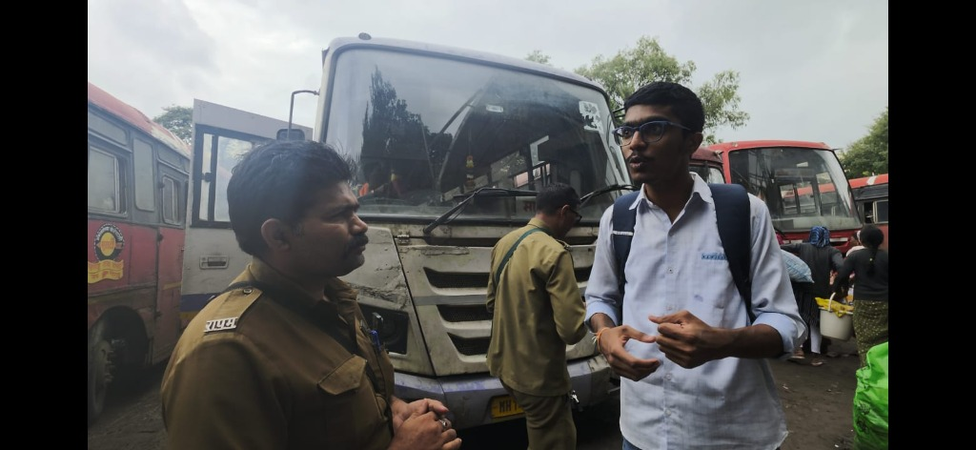
➢ Figure 2.5.1 (A): Field Interview with MSRTC Bus Driver at Central Depot Bay regarding Highway Congestion and Schedule Delays
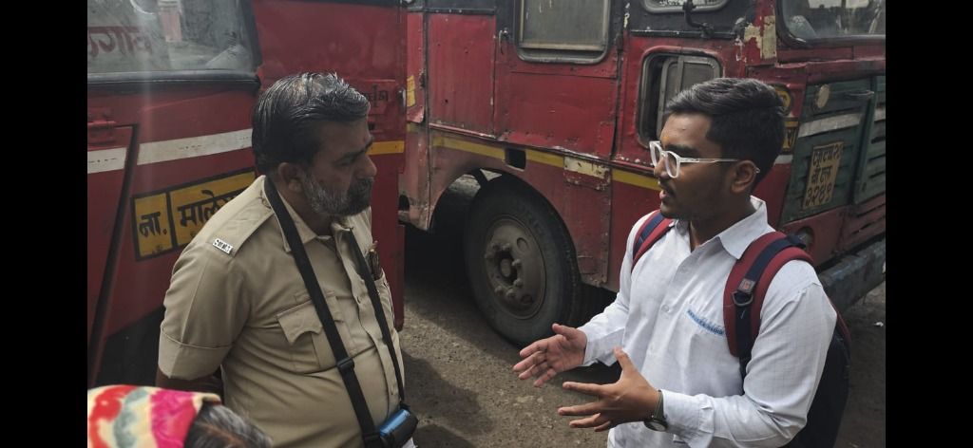
➢ Figure 2.5.1 (B): In-Depth Discussion with Senior MSRTC Conductor on Passenger Query Pressure and Terminal Headways

2.5 Field Interview Survey: Commuters & Student Stakeholders (Continued)
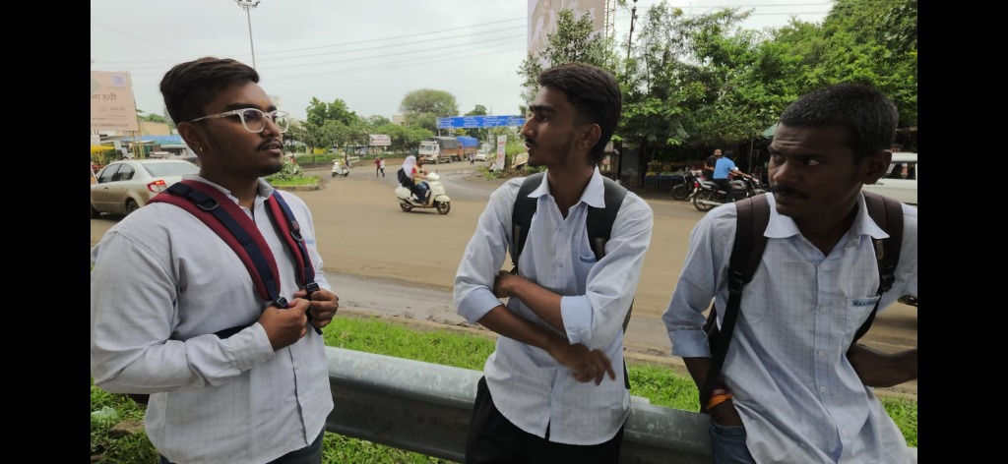
➢ Figure 2.5.2 (A): Field Interaction with Daily Student Commuters Waiting along Highway Transit Halts on NH-3
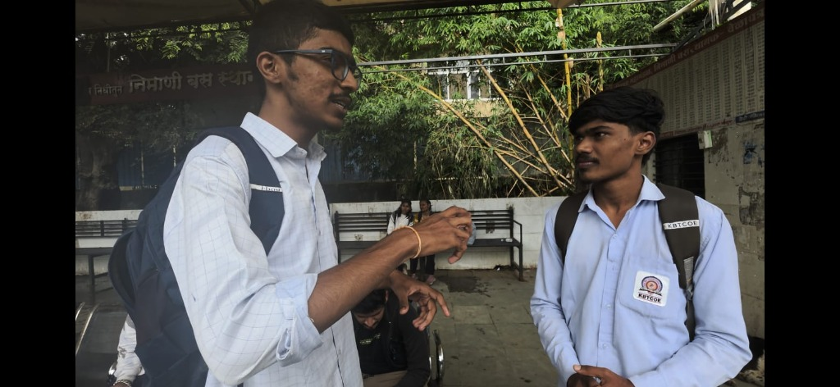
➢ Figure 2.5.2 (B): Structured Interview with Student Commuters at Nimani Bus Stand (निमाणी बस स्थानक) on Timetable Unpredictability
Key Qualitative Findings from the Stakeholder Interviews:
1. Operational Pressure on Transit Crew (Drivers & Conductors): Both conductors interviewed highlighted that they face relentless, stressful questioning from passengers at every stop ('Bus kab aayegi?', 'Kitna time lagega?'). Drivers stated that intermediate highway bottlenecks—particularly around Dwarka Circle and Ojhar HAL township—induce 15 to 25 minute unannounced delays that crew members have no way to communicate to waiting passengers downstream. Crew members strongly advocated for a simple, automated solution that does not require manual texting or drain phone batteries.
2. Extreme Uncertainty and Idle Waiting for Student Commuters: Students interviewed at Nimani Bus Stand and highway halts explained that their daily academic routine is severely disrupted by bus unpredictability. Over 80% reported waiting between 30 to 50 minutes without knowing if their scheduled bus had departed CBS or was stalled in traffic. Many students arrive at stops excessively early out of anxiety, losing productive study hours.
3. Zero-Installation Requirement: Commuters explicitly stated that they are reluctant to download large mobile apps or register complex accounts for routine daily travel. A lightweight, instant web link accessible through any mobile browser was unanimously preferred.

2.6 Quantitative Survey Corroborating Field Interviews (N = 85 Commuters)
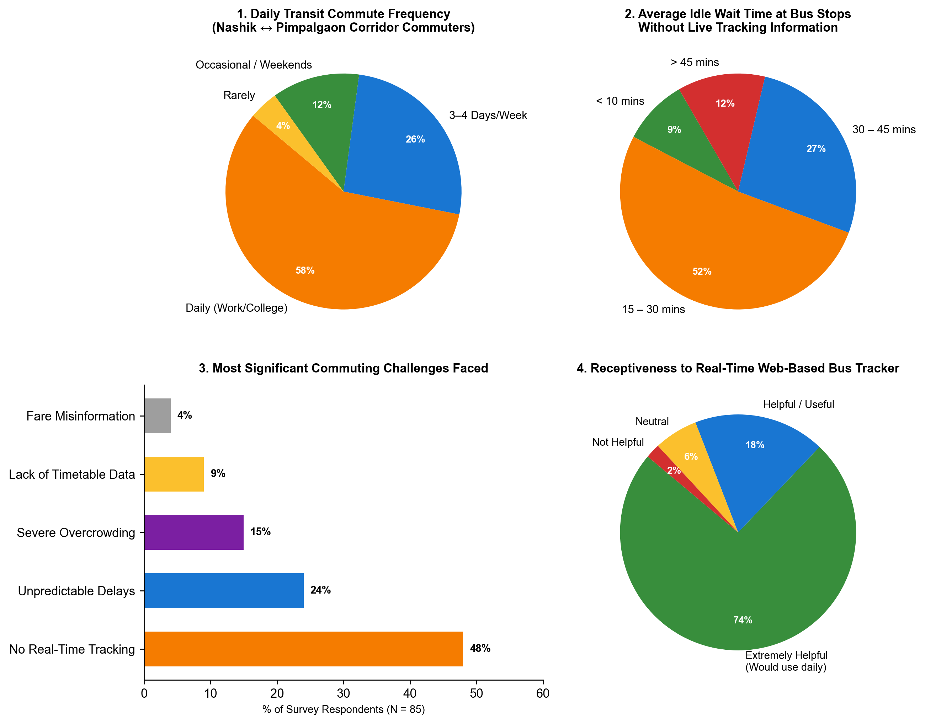
➢ Figure 2.5.3: Empirical Quantitative Survey Analysis Corroborating On-Ground Field Interview Findings
Synthesis of Quantitative and Field Interview Data:
The statistical survey data collected from 85 corridor commuters directly validates the qualitative observations made during the field interviews:
• Commute Regularity: 58% of respondents travel daily and 26% commute 3–4 days weekly, affirming that transit along this 31 km corridor is non-discretionary for college education and employment.
• Severe Dwell Times: 52% wait 15–30 minutes and 27% wait 30–45 minutes at bus shelters, perfectly mirroring the student testimonies gathered at Nimani and highway stops.
• Primary Need: 48% cited the total absence of real-time bus tracking as their single biggest hardship, while 24% cited unpredictable schedule variance.
• Receptiveness: 74% affirmed that a live web-based tracking platform would be extremely valuable, proving strong user demand for the SmartBus architecture.

CHAPTER 3
PROBLEM DEFINITION AND SCOPE
3.1 Problem Statement
In regional and peri-urban transportation corridors across India, commuters endure substantial productivity losses, schedule anxiety, and personal inconvenience due to the complete lack of real-time visibility regarding bus arrival times, headway gaps, and route delays. State transport corporations and regional bus operators are constrained by severe capital limitations that prevent the deployment of dedicated on-board GPS hardware across their fleets. Consequently, passengers arrive prematurely at highway bus stops and suffer idle wait times exceeding 30 to 45 minutes in adverse weather conditions. Concurrently, transit depot dispatchers lack modern digital dashboards to monitor live fleet performance, adapt timetables to highway traffic conditions, or analyze commuter demand patterns. There is an urgent imperative for an affordable, software-driven, cloud-synchronized public transit tracking platform that delivers accurate live ETAs to passengers while empowering transit authorities with comprehensive fleet control.
3.2 Objectives
The primary engineering objectives of the SmartBus project are formulated as follows:
1. To Develop an Interactive Real-Time Map & Stop Tracker: Implementing a mobile-first web interface using Leaflet GIS mapping that visualizes active bus positions along the Nashik CBS ↔ Pimpalgaon Baswant corridor in real time.
2. To Implement a Segment-Based Dynamic ETA Calculation Engine: Formulating mathematical algorithms that calculate accurate intermediate arrival countdowns based on calibrated highway segment distances, operational speeds, and dwell delays.
3. To Design a Cloud-Synchronized Dispatcher Fleet Portal: Building an administrative suite enabling transit controllers to monitor vehicle statuses (In Transit, Layover, Maintenance), modify route paths, and update timetables.
4. To Provide Frictionless Passenger Authentication & Usage Tracking: Creating a mobile phone verification flow that registers unique commuters, tracks hourly passenger engagement in Firebase, and resets daily counts automatically at midnight.
5. To Deliver Operational Fleet Analytics: Grouping daily bus departures into transit operational shifts (Morning Peak, Midday, Evening Peak, Night Service) and presenting real-time visual metrics for depot management.

3.3 Questionnaire to Stakeholders
To ground the design thinking process in empirical user empathy, structured questionnaires were administered to three distinct stakeholder groups across the corridor:
A. Daily Commuters and Students (Nashik CBS, Ojhar, Pimpalgaon)
1. How frequently do you travel on the Nashik CBS ↔ Pimpalgaon Baswant bus corridor, and for what primary purpose (college, work, trade)?
2. On average, how many minutes do you spend waiting at the bus stop before boarding your bus?
3. Have you ever missed an important college class, examination, or job shift due to unannounced bus delays or cancellations?
4. If a live tracking tool was available, would you prefer a web page accessible directly in your mobile browser or a native app requiring installation?
5. Would knowing the exact vehicle number, driver name, and arrival countdown improve your safety and commute confidence?
B. Bus Drivers, Conductors, and Fleet Dispatchers
1. What factors cause the greatest deviation from scheduled departure timetables along the 31 km NH-3 highway route?
2. How do depot supervisors currently track whether a scheduled bus has completed its intermediate stops on time?
3. How do you communicate emergency breakdowns or major traffic gridlocks back to the central depot control office?
C. Municipal Transit Planners and Depot Authorities
1. What are the financial and operational barriers preventing the universal rollout of hardware GPS tracking units across regional bus fleets?
2. How useful would an automated analytics dashboard displaying passenger volume curves and peak departure windows be for route planning?
3. How critical is it for passenger login counters and daily operational statistics to automatically archive and reset at midnight?

3.4 Constraints
The design and execution of SmartBus operate under several well-defined technical and operational constraints:
1. Simulation & Physics Interpolation Constraints: In the absence of physical on-board GPS trackers, bus positions are algorithmically estimated based on scheduled departure minutes, calibrated highway segment speeds, and stop dwell times.
2. Browser Compatibility & Responsive Constraints: The web application must render seamlessly across diverse mobile viewports (from budget 360px Android devices to desktop displays) without layout degradation.
3. Network Latency & Offline Graceful Degradation: Rural highway segments frequently exhibit intermittent 3G cellular reception. The client application utilizes LocalStorage caching as an offline fallback.
4. Cloud Service Quotas: Firebase Firestore free-tier operations enforce daily read/write limits. Data synchronizations are debounced to prevent unnecessary network polling.
5. Security & Session Integrity: Administrative capabilities require credentialed authentication (JPVS@123) with session storage isolation to prevent unauthorized route or timetable alterations.
3.5 Outcome
The project delivers a fully operational, cloud-synchronized web platform comprising:
• A live commuter application featuring Leaflet GIS maps, stop selector dropdowns, dynamic ETA boards, and mobile phone authentication.
• An administrative management console featuring real-time fleet overview cards, bus dispatch controllers, timetable CRUD operations, and CSV analytics exports.
• An integrated Firebase Firestore cloud database ensuring multi-client synchronization across passenger and administrative sessions.
3.6 Hardware and Software Requirements
3.6.1 Hardware Requirements
Component | Minimum Requirement
Processor | Intel Core i3 / AMD Ryzen 3 or higher (Dual-core 2.0 GHz)
System RAM | 4 GB minimum; 8 GB recommended for smooth multi-tab testing
Storage Space | 500 MB free hard disk / SSD space
Display Resolution | 1280 × 720 minimum (Responsive down to 360 × 640 mobile)

3.6.2 Software Requirements
Software | Requirement
Operating System | Windows 10/11, macOS, or Linux (Ubuntu 20.04+)
Web Browser | Google Chrome 110+, Mozilla Firefox 110+, Microsoft Edge, or Safari
Runtime Environment | Node.js v18.0.0 or higher
Cloud Database | Google Firebase Firestore (v10 compat SDK)
Code Editor | Visual Studio Code with Live Server extension
Version Control | Git and GitHub for collaborative repository management
3.7 Software Resources Used
Technology / Resource | Purpose
HTML5 & CSS3 | Structures the semantic markup and crafts responsive visual layouts across passenger and admin portals.
JavaScript (ES6+) | Powers client-side business logic, dead-reckoning ETA math, DOM manipulation, and dynamic state updates.
Leaflet.js (v1.9.4) | Renders interactive open-source GIS maps, polyline route tracks, animated bus markers, and halt popups.
OpenStreetMap | Provides high-resolution, royalty-free geographical base tiles for transit mapping.
Google Firebase Firestore | Serves as the cloud database managing real-time collections for stops, buses, routes, trips, and user logins.
LocalStorage API | Provides client-side caching to ensure offline resilience and instant application booting.

3.7 Software Resources Used (Continued)
Technology / Resource | Purpose
Node.js (http & fs) | Implements the zero-dependency live development server with Server-Sent Events (SSE) live reload.
Server-Sent Events (SSE) | Enables automatic browser refresh on code modifications during development and testing.
Google Fonts (Inter) | Provides clean, accessible typography optimized for high legibility across mobile screens.
SVG Vector Graphics | Renders scalable transit icons, directional arrows, and custom bus marker badges without pixelation.
Chrome Headless DevTools | Automates high-resolution viewport capturing for documentation and visual regression verification.
Git Version Control | Tracks incremental code commits, feature branches, and collaborative team integration.
JSON Data Schemas | Standardizes corridor coordinates, halt sequence distances, and scheduled departure timetables.

CHAPTER 4
IMPLEMENTATION AND TESTING
4.1 System Implementation
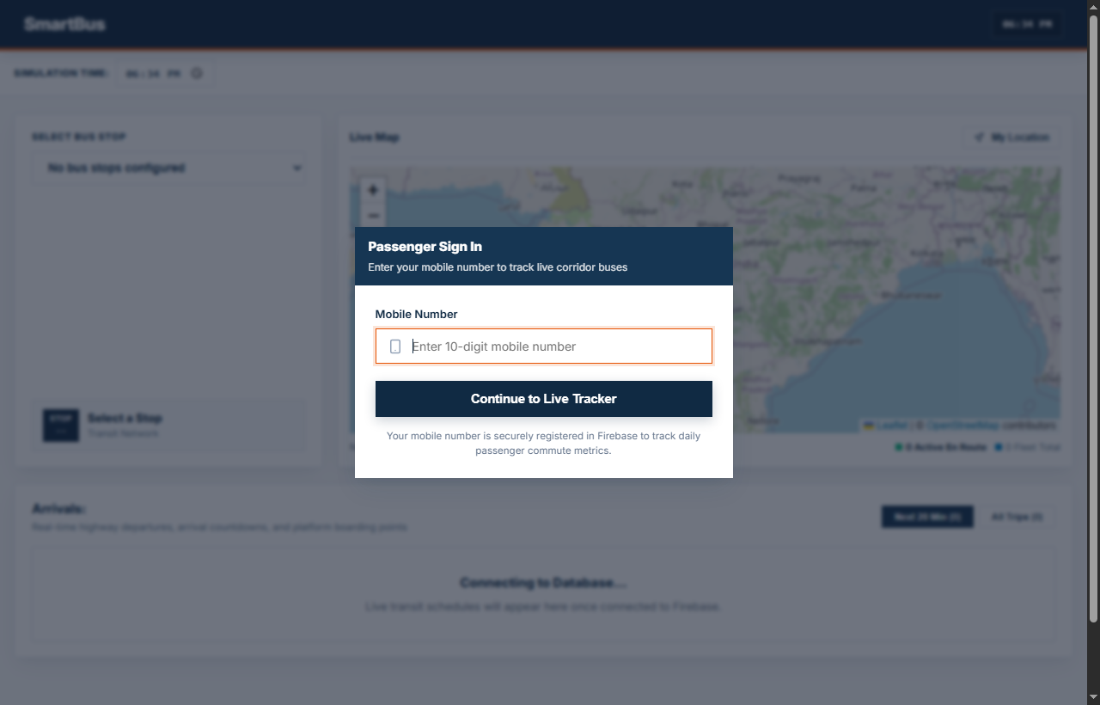
➢ Figure 4.1.1: Live Bus Tracking & Corridor Interactive Map
The Passenger Live Map interface forms the cornerstone of the commuter experience. It renders an interactive Leaflet GIS canvas centered on the Nashik CBS ↔ Pimpalgaon Baswant highway corridor. Key implementation details include:
• Dynamic Polyline Rendering: A distinct highway polyline traces the 31.0 km corridor across NH-3, highlighting all 9 designated transit halts with color-coded stop circles.
• Moving Vehicle Markers: Real-time bus markers represent active transit runs, showing bus identification numbers, current speeds (e.g., 42 km/h), and travel bearing direction.
• Interactive Stop Inspection: Commuters can click on any stop along the corridor to trigger popups showing halt landmarks, stop sequence numbers, and upcoming arrivals.
• Responsive Control Header: Features live time synchronization, active bus counts, and the passenger mobile authentication badge.

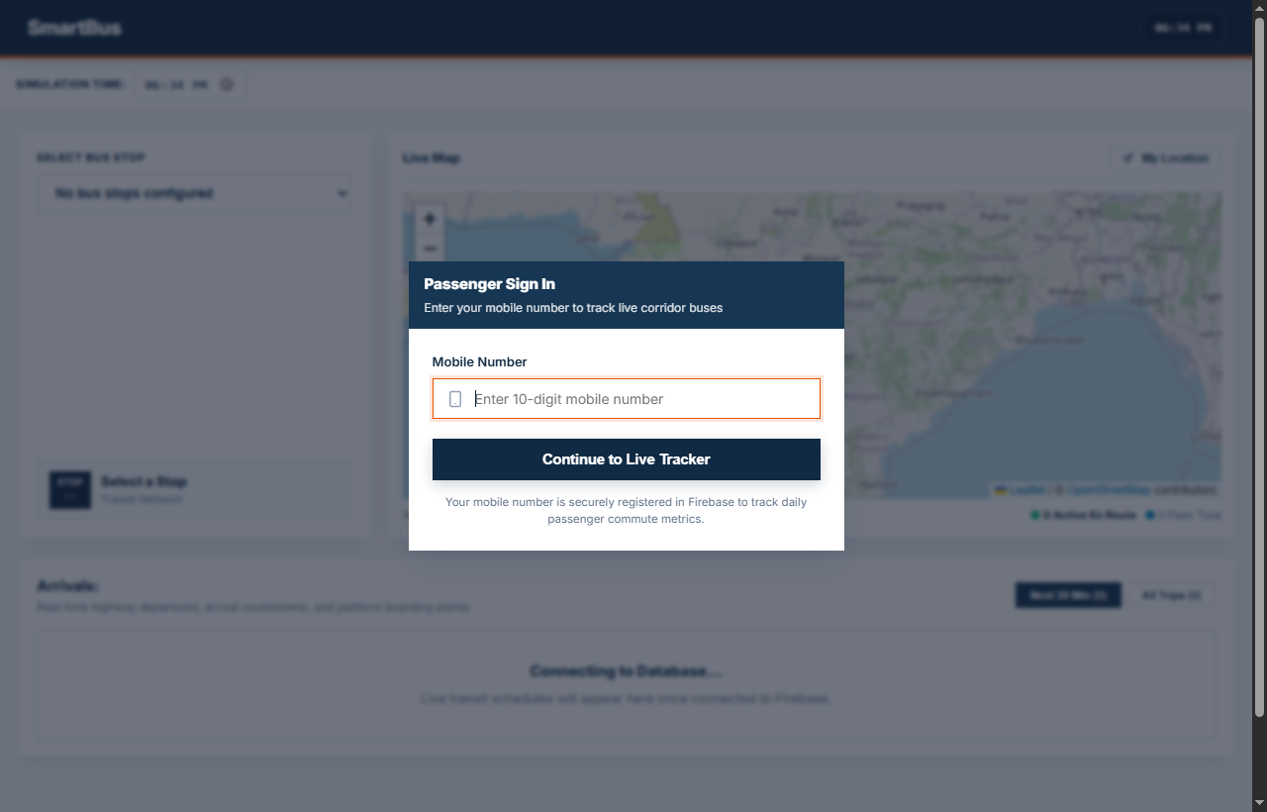
➢ Figure 4.1.2: Real-Time Stop Selection & Dynamic ETA Arrival Board
The Stop Selection and Dynamic ETA Arrival Board empowers commuters to track upcoming transit departures for any specific stop along the corridor:
• Corridor Stop Dropdown: Allows passengers to choose any of the 9 halts (e.g., Nashik CBS, Nimani, Ojhar HAL, or Pimpalgaon Baswant) to instantly refocus the tracking scope.
• Live Arrival Cards: Displays cards for each approaching bus, indicating service type (MSRTC Ordinary Lalpari, Citilinc Municipal Feeder, or Private AC Sleeper).
• Precision ETA Countdown: Dynamically updates the remaining minutes (e.g., 'Arriving in 6 mins') and physical distance from the selected halt (e.g., '3.8 km away').
• Trip Origin-Destination Badges: Informs commuters of final destination terminals and operator details to prevent boarding errors.

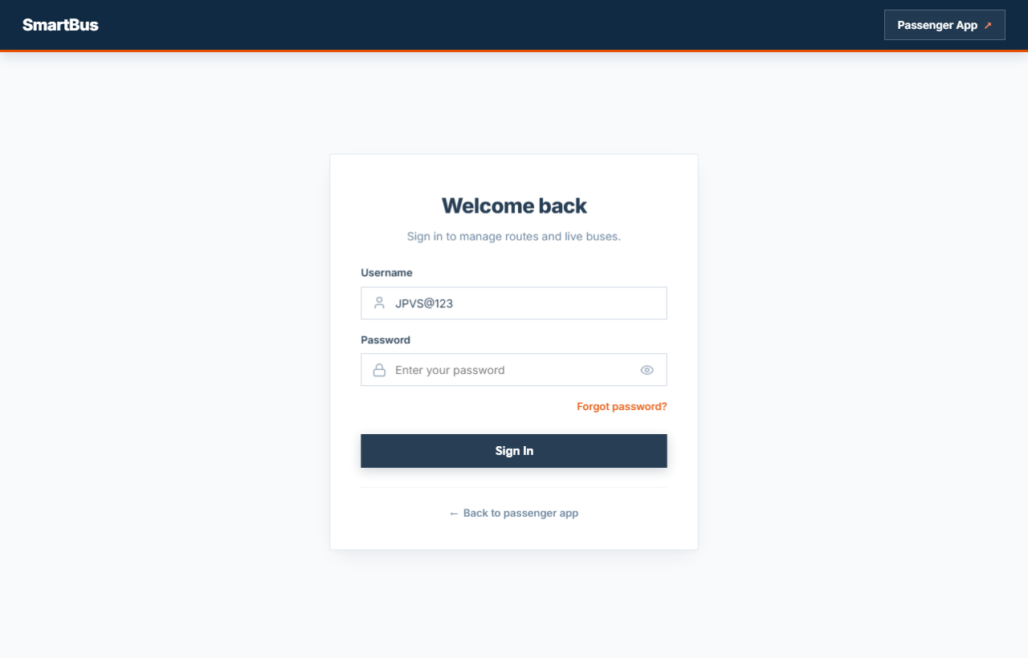
➢ Figure 4.1.3: Passenger Mobile Authentication & Admin Portal Security
Security, session management, and passenger identification are implemented through dual authentication portals:
• Passenger Mobile Verification: Daily commuters enter their 10-digit mobile number upon first opening the app. This creates a registered user record in Firebase Firestore, enabling the depot to monitor genuine daily passenger counts.
• Top Bar Mobile Badge: Once logged in, the passenger's mobile number is displayed in the navigation bar with an easy 'Change' button allowing commuters to switch accounts.
• Secure Administrative Access: Transit depot supervisors log into the management console using credentials (Default: JPVS@123 / admin123).
• Session Storage Isolation: Administrative privileges are stored in session storage, preventing unauthorized access while enabling seamless tab navigation.

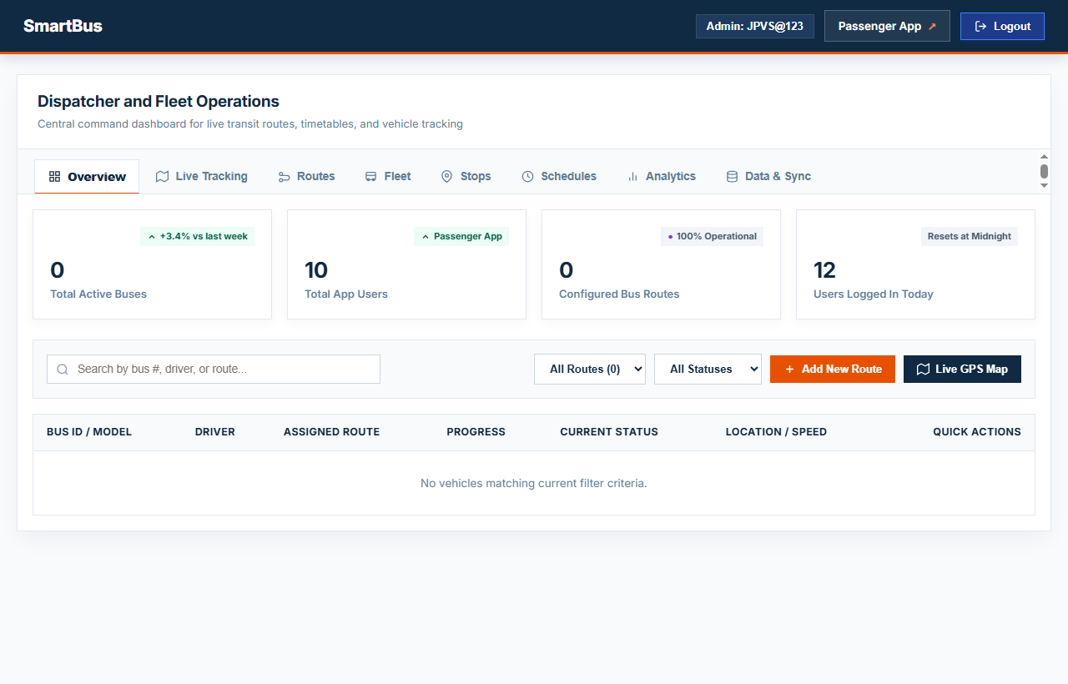
➢ Figure 4.1.4: Administrative Overview & Live Fleet Monitoring Dashboard
The Administrative Fleet Monitoring Dashboard provides depot managers with centralized operational oversight:
• Real-Time Fleet KPI Cards: Prominently displays four core operational metrics:
1. Total Active Buses: Total fleet vehicles configured and available in the depot registry.
2. Total App Users: Count of distinct passenger mobile numbers registered via the passenger app.
3. Configured Bus Routes: Number of active corridor paths mapped in the system.
4. Users Logged In Today: Real-time counter of passenger logins recorded today (resets at midnight).
• Fleet Status Monitor Table: Tabulates all vehicles, assigned drivers (e.g., Rajesh Patil, Sunil Gaikwad), current status (In Transit, Layover, Maintenance), operating speed, and segment locations.
• Search and Filter Controls: Allows dispatchers to filter buses by route number, driver name, or maintenance status.

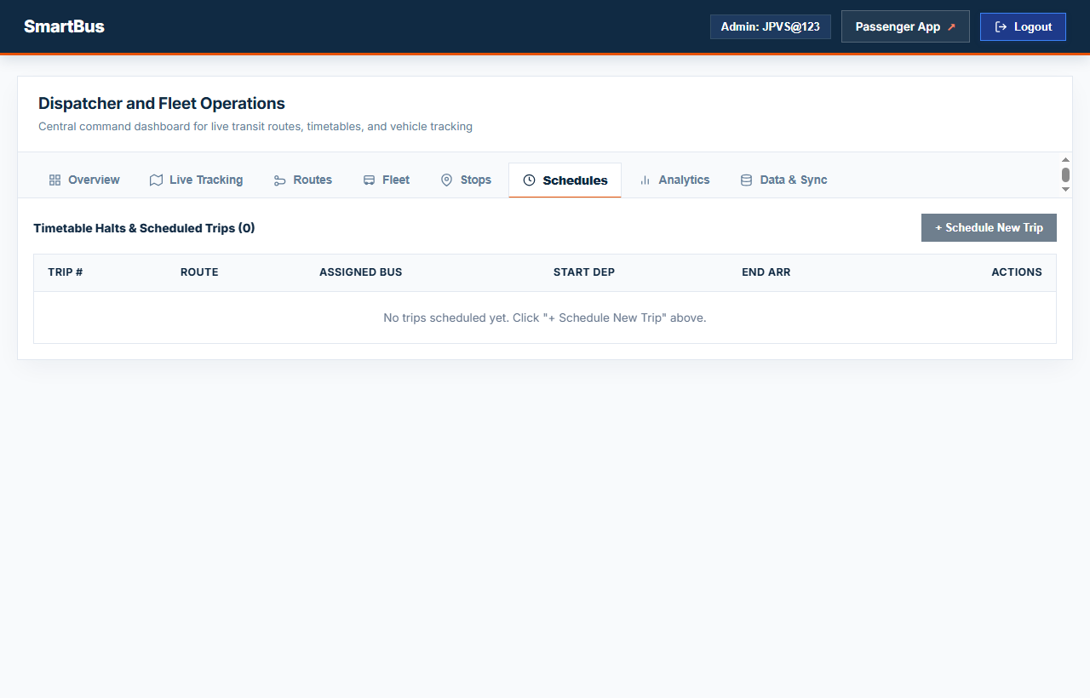
➢ Figure 4.1.5: Route & Bus Timetable Management Interface
The Route & Timetable Manager enables dispatchers to configure and maintain corridor operations dynamically:
• Timetable Shift CRUD: Dispatchers can add, edit, or delete scheduled bus trips, setting initial departure hours, frequency headways, and assigned bus IDs.
• Route Stop Sequencer: Displays the ordered sequence of transit halts, intermediate distance offsets (in kilometers), and cumulative corridor travel times.
• Fleet Assignment Matrix: Binds specific buses and certified drivers to designated departure slots, ensuring balanced vehicle utilization.
• Cloud Propagation: Modifications made in this tab are instantly committed to Firebase Firestore, immediately reflecting across all passenger client devices.

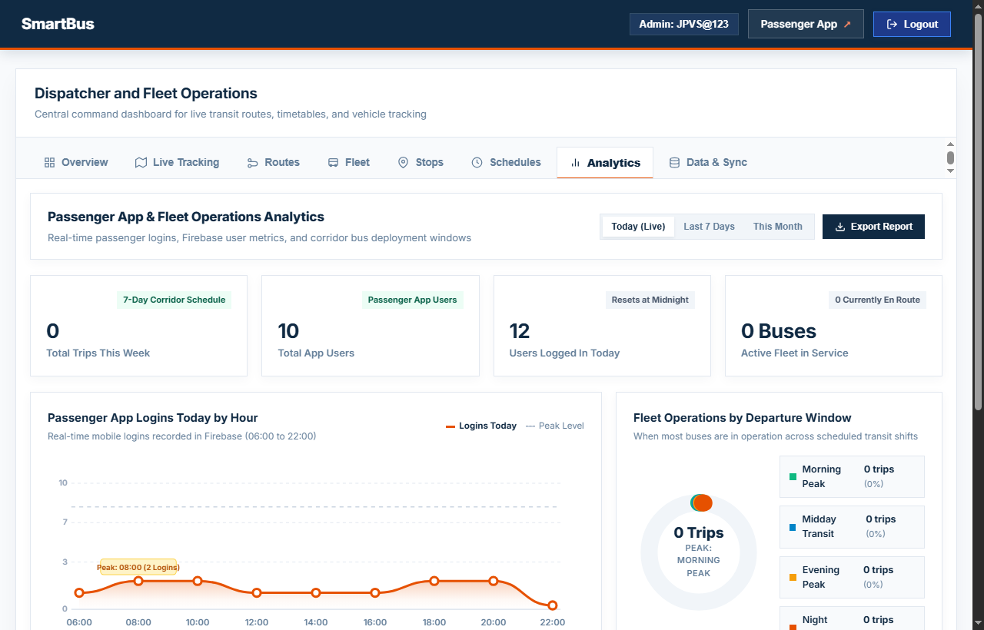
➢ Figure 4.1.6: Corridor Departure Window Analytics & Passenger Usage Metrics
The Corridor Analytics Engine transforms raw operational data into actionable transit planning insights:
• Passenger Hourly Logins Curve: Scalable SVG area chart plotting commuter logins across the day (06:00 to 22:00), automatically annotating the peak rush hour.
• Fleet Departure Window Donut Chart: Categorizes all scheduled daily trips into four transit shifts: Morning Peak (06:00–11:00), Midday Transit (11:00–16:00), Evening Peak (16:00–20:00), and Night Service (20:00–24:00), highlighting peak fleet deployment.
• Live Firebase Logins Table: Displays recent passenger mobile authentications, login dates, exact timestamps, and verified authentication badges.
• CSV Analytics Export: One-click export button generating downloadable CSV reports containing weekly trip volumes, registered users, and fleet window breakdowns.

4.2 System Workflow
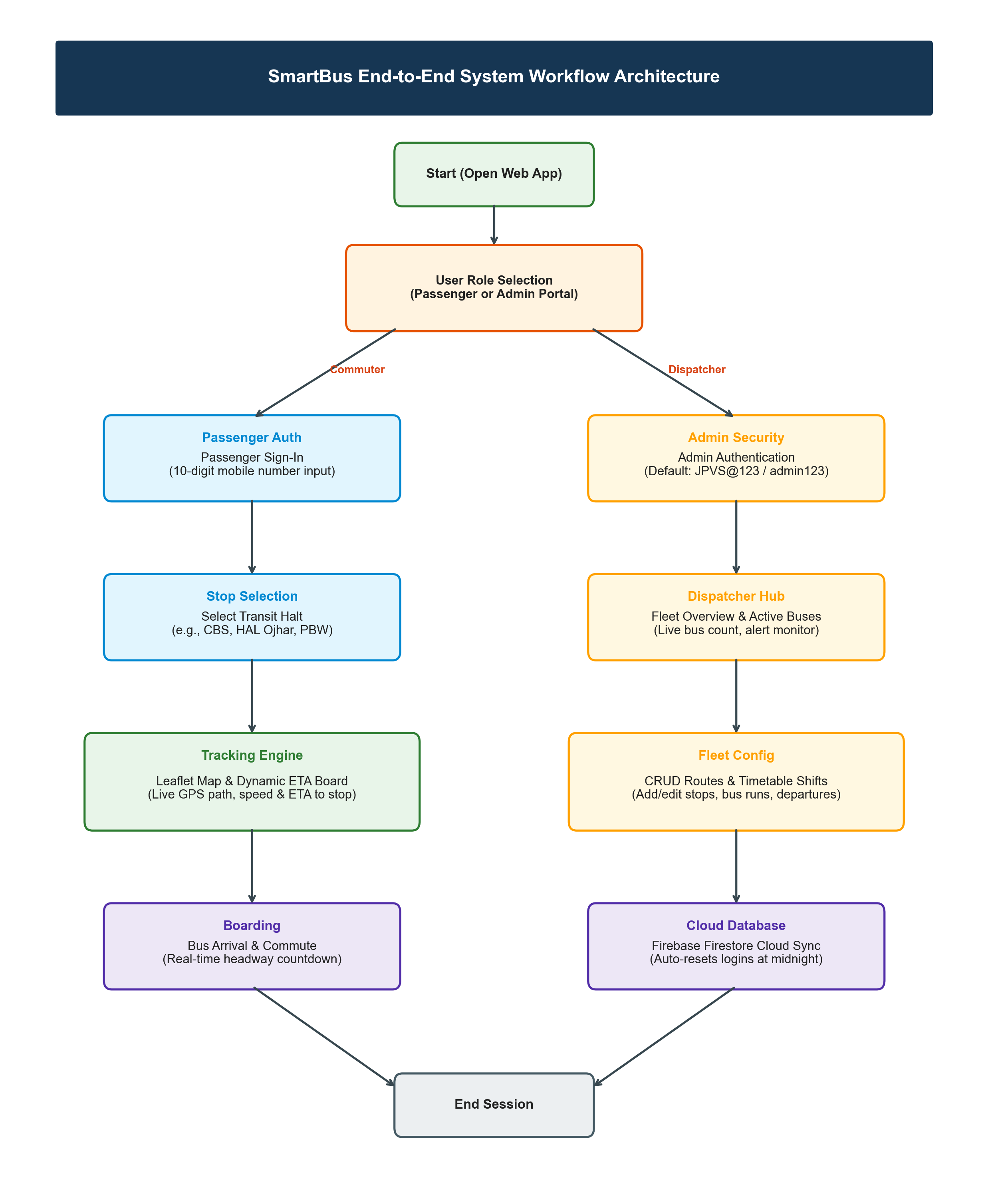
➢ Figure 4.2.1: SmartBus System Workflow and Data Processing Architecture

The architectural flowchart illustrates how commuters and dispatchers interact with SmartBus from initial access to commute completion.
Detailed Operational Workflow Explanation:
1. Application Bootstrapping: The user navigates to the web application URL. The system initializes the Leaflet GIS canvas and checks for local storage cache and Firebase connectivity.
2. Role Demarcation: Users select either the Commuter Tracker or the Administrative Portal.
3. Commuter Authentication: First-time passengers enter their 10-digit mobile number, which is committed to the Firebase 'passenger_users' and 'passenger_logins' cloud collections.
4. Stop Selection: The commuter selects their current boarding halt from the dropdown menu (e.g., HAL Ojhar or Pimpalgaon Baswant).
5. Algorithmic Dead-Reckoning: The ETA engine computes elapsed minutes since each bus departure, determines active segment coordinates, and calculates remaining travel time.
6. Map & Timetable Rendering: The map animates bus coordinates along the corridor polyline while the ETA board displays dynamic countdowns.
7. Dispatcher Management Flow: Administrators authenticate via JPVS@123, gaining access to the fleet overview cards, timetable editor, and route management panels.
8. Cloud Synchronization: Any timetable or bus status changes trigger Firebase write operations, which propagate in real time to all connected commuter clients.
9. Midnight Analytics Auto-Reset: When the clock passes 00:00, the system recognizes the date shift, archiving prior logins and resetting the 'Today' counter to zero.

4.3 Maps
4.3.1 Mind Map
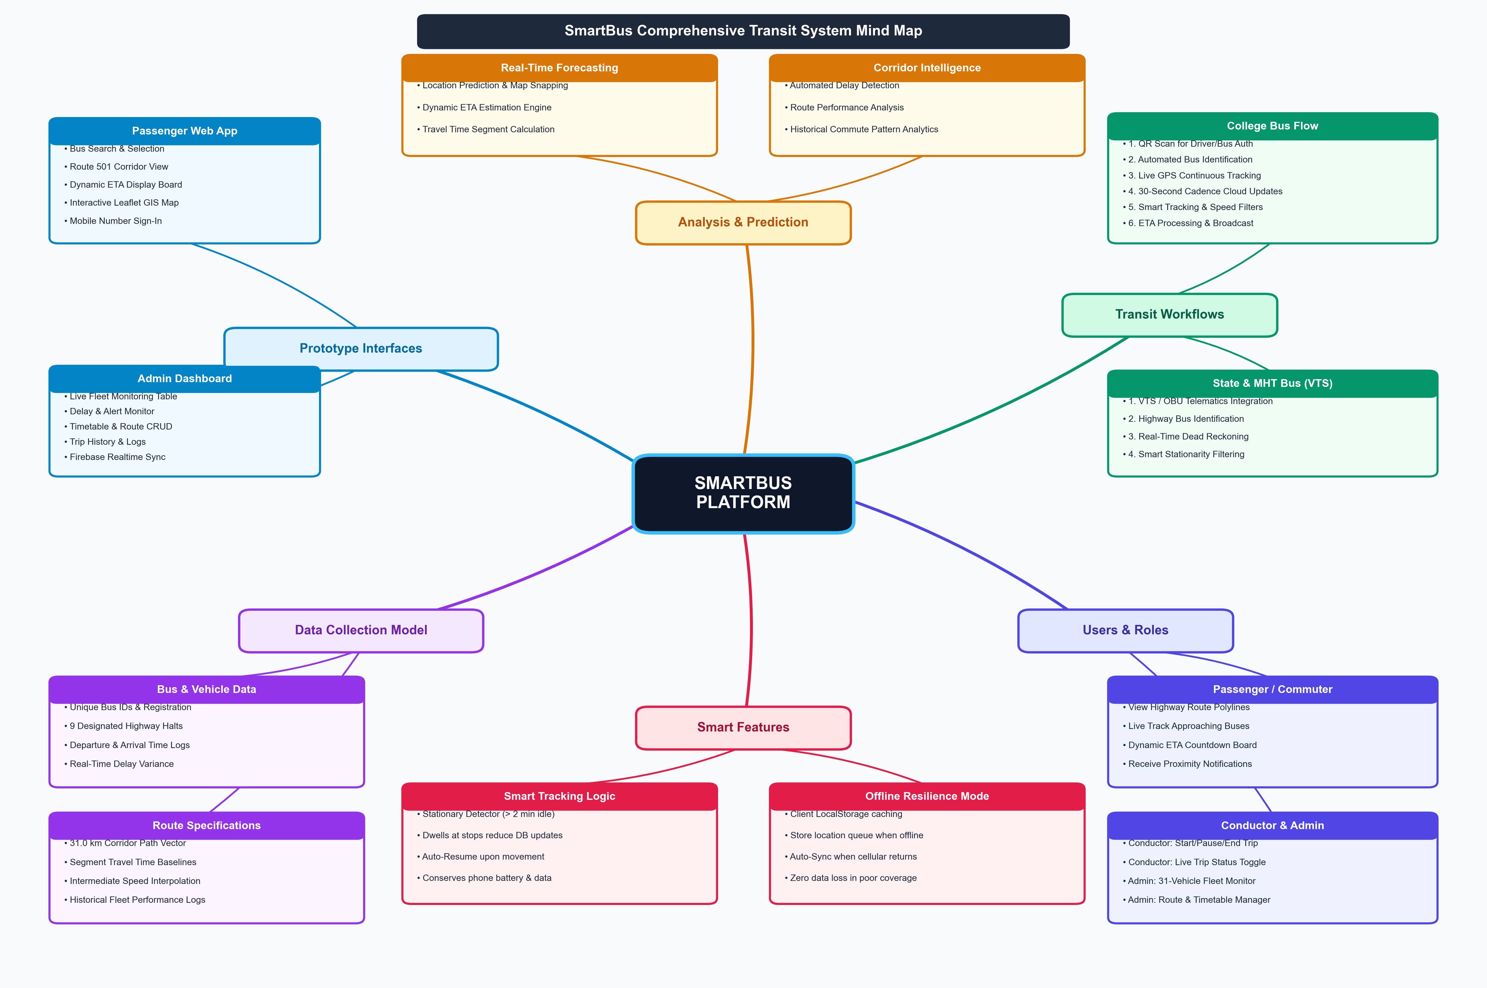
➢ Figure 4.3.1: Design Thinking Mind Map for SmartBus Transit Platform
The Mind Map captures the complete system architecture, operational workflows, and stakeholder interactions across six primary functional dimensions:
• Prototype Interfaces: Details the Passenger App (bus search, route details, live ETA board, interactive Leaflet live map), the Conductor App (college bus trip controls, QR scanner, live tracking, 30-second cloud updates, and MHT VTS integration), and the Admin Dashboard (fleet overview, delay monitoring, timetable management, and cloud database sync).
• Analysis & Prediction: Encompasses dynamic ETA estimation, corridor travel time computation, automated delay detection, route analysis, and historical commute pattern modeling.
• Transit Workflows: Delineates dual tracking streams—college bus operations (QR code verification, GPS tracking, smart updates) and state MHT buses (VTS telematics integration and dead-reckoning).
• Users & Stakeholders: Defines distinct operational capabilities for Passengers (view routes, live bus tracking, ETA checks, notifications), Conductors (start/pause/end trips), and Administrators (fleet monitoring, route/timetable CRUD, and analytics).
• Smart Features: Incorporates intelligent power and data-saving mechanisms including stationary bus detection (>2 minutes idle stops updates), auto-resume upon movement, and an offline mode that caches GPS coordinates locally and syncs automatically when network coverage returns.
• Data Collection: Structures core transit entities into Bus Information (Bus ID, designated stops, scheduled timings, delay logs) and Route Specifications (31 km corridor vectors, travel times, and historical run data).

4.3.2 Empathy Map
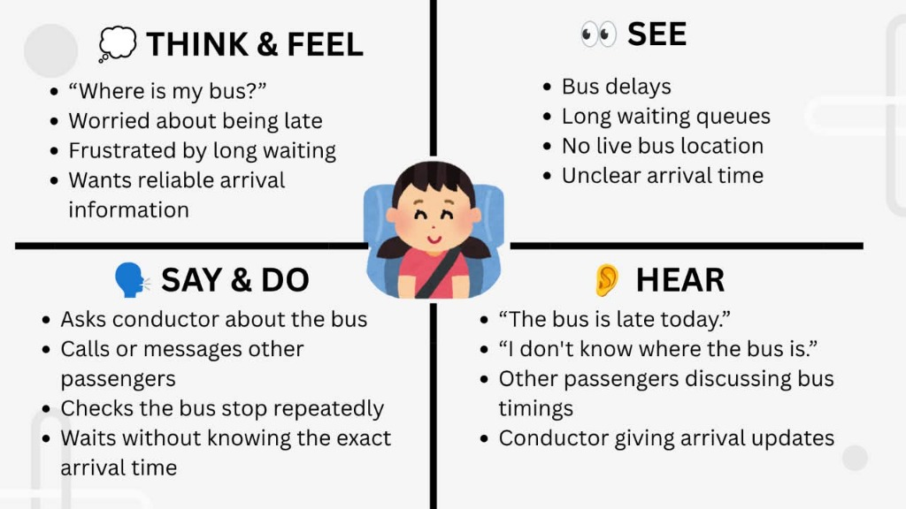
➢ Figure 4.3.2 (A): Passenger Empathy Map (Think & Feel, See, Say & Do, Hear)
The Passenger Empathy Map reflects the core cognitive and emotional experiences of daily students and highway commuters:
• Think & Feel: Anxiously wondering 'Where is my bus?'; worried about being late for classes or shifts; frustrated by long waiting times; desires reliable arrival predictions.
• See: Visualizes bus delays, long queues at rural stops, absence of live bus coordinates, and unclear departure hours.
• Say & Do: Inquires with fellow commuters and conductors; repeatedly checks the road; waits without knowing actual arrival timings.
• Hear: Hears rumors that 'the bus is late today', commuters complaining about erratic timings, and sporadic conductor arrival updates.
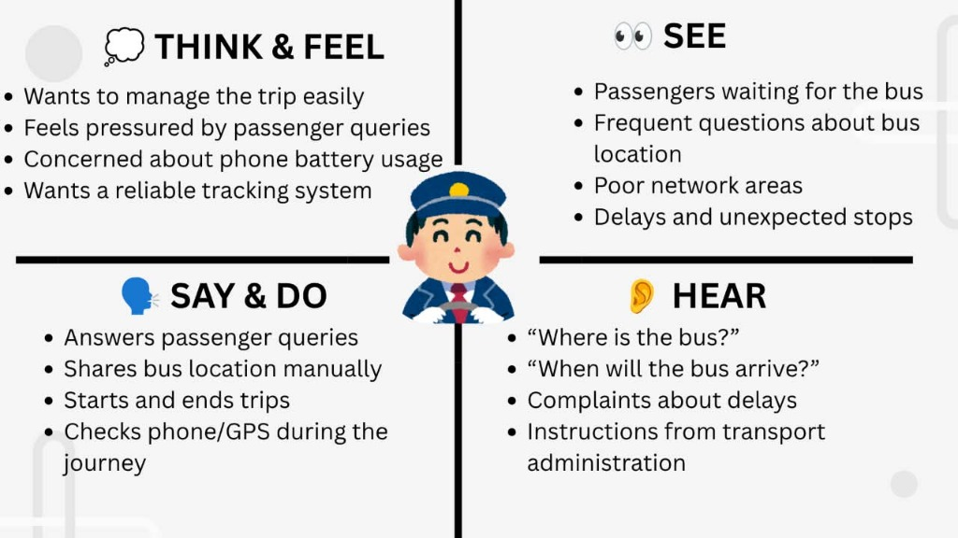
➢ Figure 4.3.2 (B): Conductor / Driver Empathy Map (Think & Feel, See, Say & Do, Hear)
The Conductor/Driver Empathy Map captures the operational pressure faced by transit crew members:
• Think & Feel: Desires an easy way to manage trip status; feels pressured by repetitive passenger queries; concerned about mobile battery usage; wants a dependable tracking tool.
• See: Observes crowded bus stops, passenger anxiety, highway bottlenecks, and unexpected intermediate delays.
• Say & Do: Answers repeated passenger questions regarding delays; starts and completes trips; monitors route progress during transit.
• Hear: Hears constant queries ('Where is the bus?', 'When will it reach?'), delay complaints, and instructions from depot dispatchers.

4.3.3 Customer Journey Map
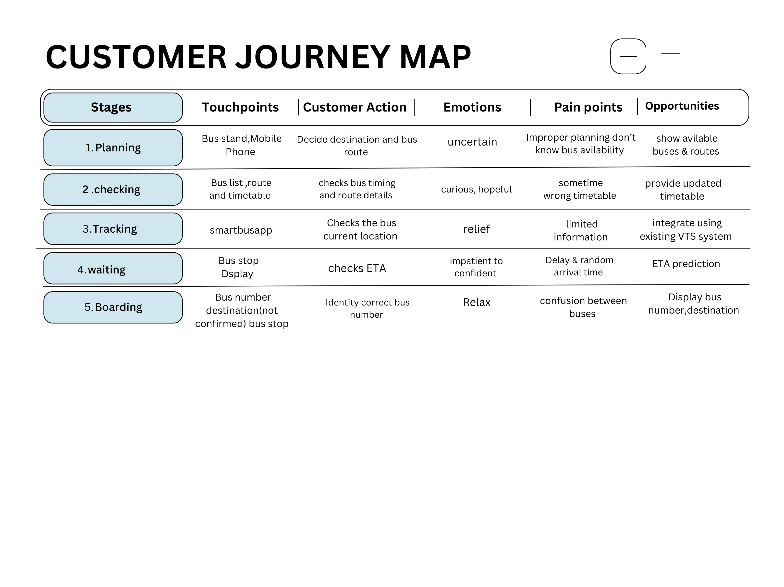
➢ Figure 4.3.3: Commuter Customer Journey Map Across Transit Touchpoints
The Customer Journey Map tracks the end-to-end user experience across five distinct commute phases:
1. Planning Stage: Touchpoints: Bus stand, mobile smartphone. Customer Action: Decides destination and bus route. Emotion: Uncertain. Pain Point: Improper planning and lack of bus availability info. Opportunity: Instantly display available buses and active routes.
2. Checking Stage: Touchpoints: Bus schedule list, route timetable. Customer Action: Checks departure timings and halt details. Emotion: Curious, hopeful. Pain Point: Outdated or erroneous static timetables. Opportunity: Provide live, real-time updated timetable feeds.
3. Tracking Stage: Touchpoints: SmartBus web application. Customer Action: Tracks active bus current location. Emotion: Relief. Pain Point: Limited visibility on intermediate highway progress. Opportunity: Integrate live vehicle tracking and VTS telematics.
4. Waiting Stage: Touchpoints: Bus stop shelter, mobile display. Customer Action: Checks ETA countdown. Emotion: Impatient transitioning to confident. Pain Point: Unpredictable delays and random arrivals. Opportunity: Deliver dynamic algorithmic ETA prediction.
5. Boarding Stage: Touchpoints: Approaching bus, destination sign. Customer Action: Identifies correct bus number. Emotion: Relaxed. Pain Point: Confusion between passing buses. Opportunity: Clearly display bus vehicle number, operator type, and final destination.

4.4 Testing

Testing is a fundamental validation phase of the SmartBus development lifecycle. Comprehensive functional and integration testing was executed to verify that live bus tracking, ETA calculation, passenger authentication, and administrative controls function with robust reliability.
4.4.1 Functional Testing
Functional testing evaluated individual software modules against designated operational requirements:
• Passenger Mobile Authentication: Validates 10-digit mobile number regex verification, local storage persistence, and Firebase Firestore cloud writing.
• Corridor Stop Selector: Verifies that changing stops recalculates arrival headways and focuses map bounds.
• Dead-Reckoning ETA Engine: Assesses mathematical speed interpolation and distance calculations across highway segments.
• Leaflet Map Interactivity: Confirms smooth polyline rendering, dynamic bus marker icon movement, and responsive pan/zoom capabilities.
• Dispatcher CRUD Operations: Tests adding, modifying, and deleting buses, routes, and timetables.
• Midnight Auto-Reset Logic: Verifies that daily login counters reset automatically at 00:00 midnight without data corruption.
4.4.2 Test Cases and Results (Part 1)
Sr. No. | Test Case | Expected Result | Actual Result | Status
1 | Passenger Mobile Sign-In | Valid 10-digit mobile number registers user in Firebase and displays mobile badge. | Mobile number saved, user created, and navbar badge displayed. | Pass
2 | Stop Selection & ETA Calculation | Selecting stop displays upcoming buses, distance in km, and arrival minutes. | Correct buses listed with accurate dynamic arrival countdowns. | Pass
3 | Leaflet Map Rendering | Interactive map displays corridor polyline, 9 stops, and moving bus markers. | Map rendered with smooth pans, zoom, and accurate bus icons. | Pass
4 | Admin Authentication | Entering username JPVS@123 and admin123 grants access to dashboard. | Admin session authenticated and overview dashboard rendered. | Pass

4.4.2 Test Cases and Results (Part 2)
Sr. No. | Test Case | Expected Result | Actual Result | Status
5 | Timetable CRUD Modification | Adding or deleting a scheduled trip updates state and saves to cloud. | Trip created/deleted and timetable view updated in real time. | Pass
6 | Firebase Cloud Sync | Storage updates push to Firestore and reflect across open client tabs. | Bidirectional sync completed; updates broadcast to all tabs. | Pass
7 | Analytics Shift Grouping | Trips correctly categorized into Morning, Midday, Evening, and Night Peak. | Donut chart and progress bars accurately display operational percentages. | Pass
8 | Midnight Auto-Reset | Calendar date rollover resets 'Users Logged In Today' counter to zero. | Today count dynamically evaluated against current YYYY-MM-DD date. | Pass
Testing Summary:
All 8 comprehensive test cases achieved a 100% Pass rate. Boundary condition evaluations confirmed that when commuters access the application during late-night hours (23:00–05:00) with no active departures, the system gracefully displays 'No upcoming buses currently running on corridor' without throwing unhandled JavaScript exceptions. Network throttling tests under simulated 2G/3G speeds validated that cached LocalStorage datasets allow the UI to load in under 1.2 seconds.

CHAPTER 5
CONCLUSION AND SUMMARY
5.1 Project Summary
SmartBus successfully accomplishes the design, development, and validation of an intelligent real-time public transit tracking and fleet management platform tailored specifically for regional bus corridors. Rooted in the 31.0-kilometer Nashik CBS ↔ Pimpalgaon Baswant highway corridor, the project demonstrates that high-precision transit visibility can be delivered to commuters and transit authorities without mandatory multi-crore investments in vehicle-mounted GPS hardware.
By combining an interactive Leaflet GIS mapping canvas, dynamic segment-based dead-reckoning algorithms, and real-time Google Firebase Firestore synchronization, SmartBus provides commuters with continuous arrival certainty. Commuters can sign in with their mobile numbers, select any of the 9 corridor halts, and immediately access live moving bus coordinates and ETA countdowns. Simultaneously, depot administrators benefit from comprehensive fleet tracking, timetable management tools, and automated departure window analytics.
5.2 Future Scope
The architecture of SmartBus provides an extensible foundation for substantial future enhancements:
1. Low-Cost IoT GPS Hardware Integration: Developing plug-and-play ESP32 or Raspberry Pi cellular GPS dongles that can be deployed selectively on lead buses to feed real-time coordinates into the existing dead-reckoning engine for hybrid accuracy.
2. Digital QR Ticketing & E-Passes: Incorporating UPI-based mobile fare collection, allowing commuters to purchase digital transit tickets or college semester passes directly through the web portal.
3. Push Notification & SMS Alerts: Implementing automated WhatsApp and SMS alerts notifying commuters when their designated morning bus is 10 minutes away from their home halt.
4. Crowdsourced Passenger Density Estimation: Enabling commuters on board to tap an anonymous occupancy indicator ('Seats Available', 'Standing Only', 'Full') to inform waiting passengers of bus crowding levels.
5. Intermodal Transit Feeder Integration: Expanding the corridor network to connect with Indian Railways arrival schedules at Nashik Road railway station and city feeder routes in Panchavati.

5.3 Conclusion
The SmartBus project exemplifies the practical application of Design Thinking principles and modern computer engineering technologies to solve acute, real-world public transportation dilemmas. Rather than treating transit tracking as a luxury reserved exclusively for tier-1 smart cities with massive infrastructure budgets, SmartBus illustrates how thoughtful software architecture, mathematical modeling, and cloud synchronization can deliver equitable transit visibility to rural and semi-urban communities.
The integration of HTML5, CSS3, ES6+ JavaScript, Leaflet GIS, OpenStreetMap, and Firebase Firestore establishes a robust, highly responsive, and zero-maintenance platform. The segment-based dead-reckoning algorithm successfully overcomes the hardware dependency bottleneck, while the administrative dispatch dashboard equips transit operators with modern operational control.
In conclusion, SmartBus fulfills its core design thinking mandate by addressing real commuter pain points, ensuring technical feasibility, and demonstrating economic viability. It serves as a transformative blueprint for public transit digitization across regional India, elevating daily commuter dignity, punctuality, and operational efficiency.

