K. K. WAGH INSTITUTE OF ENGINEERING EDUCATION AND RESEARCH
DEPARTMENT OF COMPUTER ENGINEERING
DESIGN THINKING PROJECT REPORT
ACADEMIC YEAR 2026-2027

PROJECT TITLE
SmartBus: An Intelligent Real-Time Public Transit Tracking, Dynamic ETA Estimation, and Fleet Management Platform for Regional Bus Corridors
TEAM MEMBERS: | Guided By  Prof. Shweta Jadhav
Roll No. | Name of Member
35 | Jay Sham Kulkarni
31 | Parth Kasar
32 | Vivek Katore
30 | Sarthak Kapse

TEAM ROLES AND RESPONSIBILITIES
Roll No. | Name | Role | Responsibilities
35 | Jay Sham Kulkarni | Backend & System Architecture | Overall system architecture design, Node.js live development server, client-server communication, administrative authentication security, backend data pipelines, and core integration.
31 | Parth Kasar | UI/UX & Frontend Development | Passenger and admin user interface design, responsive layouts, interactive Leaflet GIS map integration, stop selector controls, CSS design systems, and commuter experience.
32 | Vivek Katore | Dynamic ETA & Transit Physics Engine | Algorithmic segment-based dead reckoning, real-time speed interpolation, stop-to-stop distance matrices, countdown calculation, and traffic delay variance modeling.
30 | Sarthak Kapse | Cloud Database & Storage Architecture | Google Firebase Firestore cloud database integration, real-time snapshot listeners, two-way state synchronization, LocalStorage offline engine, and midnight auto-reset mechanism.

INDEX
Section Page No.
Team Members and Responsibilities 2
Abstract 4
CHAPTER 1: INTRODUCTION 5
1.1 Project Idea 5
1.2 Motivation 5
CHAPTER 2: LITERATURE SURVEY 6
2.1 Existing Systems 6
2.2 Limitations of Existing Systems 6
2.3 Solutions to the Limitations of Existing Systems 7
2.4 On-Ground Stakeholder Interview Survey (Operating Crew) 7
2.5 Field Interview Survey: Commuters & Student Stakeholders 8
2.6 Quantitative Survey Analysis Corroborating Field Interviews 9
CHAPTER 3: PROBLEM DEFINITION AND SCOPE 10
3.1 Problem Statement 10
3.2 Objectives 10
3.3 Questionnaire to Stakeholders 11
3.4 Constraints 12
3.5 Outcome 12
3.6 Hardware and Software Requirements 12
3.6.1 Hardware Requirements 12
3.6.2 Software Requirements 13
3.7 Software Resources Used 13
CHAPTER 4: IMPLEMENTATION AND TESTING 15
4.1 System Implementation 15
4.2 System Workflow 21
4.3 Maps 23
4.3.1 Customer Journey Map 25
4.3.2 Empathy Map 24
4.3.3 Mind Map 23
4.4 Testing 26
4.4.1 Functional Testing 26
4.4.2 Test Cases and Results 26
CHAPTER 5: CONCLUSION AND SUMMARY 28
5.1 Project Summary 28
5.2 Future Scope 28
5.3 Conclusion 29

ABSTRACT
SmartBus is an intelligent real-time public transit tracking, dynamic ETA estimation, and fleet management platform engineered to resolve the chronic commute uncertainty, long passenger waiting times, and lack of schedule visibility prevailing across regional and semi-urban bus transit corridors. In developing economies like India, millions of rural and suburban commuters—including college students, agricultural workers, and industrial employees—rely on public State Transport (MSRTC) and municipal feeder buses to travel between satellite towns and urban hubs. However, due to the prohibitive capital cost of installing dedicated IoT GPS hardware units across thousands of state-operated buses, commuters are left without real-time tracking, resulting in unpredictable idle dwell times exceeding 30 to 45 minutes at rural transit shelters.
SmartBus overcomes this foundational barrier by integrating an interactive Leaflet.js GIS mapping engine with an algorithmic segment-based dead-reckoning ETA estimation engine, eliminating the compulsory requirement for hardware GPS on-board units. Grounded in the real-world 31.0-kilometer highway corridor connecting Nashik Old CBS Terminus and Pimpalgaon Baswant Bus Stop via 9 critical intermediate transit halts (including Panchavati Nimani, Adgaon Naka, Amrutdham, Jatra Hotel, and HAL Aerospace Ojhar), the system dynamically computes high-precision arrival predictions by interpolating real-time elapsed trip minutes against multi-segment highway speeds, stopping delays, and scheduled route geometries.
The system adopts a full-stack modern architecture utilizing HTML5, responsive CSS3, modular JavaScript (ES6+), Leaflet GIS mapping with OpenStreetMap tiles, and Google Firebase Firestore for cloud persistence and real-time bidirectional synchronization. For daily commuters, SmartBus provides a friction-free, zero-installation web interface accessible via any smartphone browser. Passengers authenticate seamlessly using their 10-digit mobile number, select their boarding halt, and immediately view a live interactive map depicting moving bus coordinates, headway countdowns, and upcoming departure boards.
Simultaneously, SmartBus provides a comprehensive Administrative Fleet Monitoring and Dispatching Suite. Transit dispatchers gain secure, real-time command over the entire fleet, enabling live vehicle tracking, dynamic route modifications, timetable scheduling, and emergency status updates. The platform automatically tracks daily commuter volumes, organizes departures into four standard operational windows (Morning Peak, Midday Transit, Evening Peak, and Night Service), and resets daily login counters at midnight to ensure continuous operational integrity.
Through comprehensive Design Thinking methodology—encompassing stakeholder empathy mapping, customer journey tracking, commuter pain-point surveys, and rigorous functional testing—SmartBus demonstrates that software-driven algorithmic tracking offers an economical, highly scalable, and accessible alternative to multi-crore IoT hardware overhauls, radically improving daily commuter punctuality and transit agency efficiency.

CHAPTER 1
INTRODUCTION
1.1 Project Idea
SmartBus is a lightweight, cloud-synchronized public bus transit tracking and fleet dispatching ecosystem specifically optimized for regional, suburban, and semi-urban transportation corridors. Operating across developing transit networks, public transport fleets frequently lack on-board satellite GPS units, leaving thousands of daily commuters without visibility into vehicle locations, arrival times, or service delays. SmartBus overcomes this barrier through an intelligent web application combining interactive Leaflet.js GIS mapping with a mathematical dead-reckoning simulation engine.
The system provides a unified two-tiered interface: a high-accessibility passenger portal requiring only a standard mobile browser, and a comprehensive administrative command dashboard. Commuters track active buses, view dynamic arrival countdowns for their exact stop, and check departure schedules. Concurrently, transit dispatchers manage bus assignments, adjust corridor routes, monitor real-time passenger volumes, and oversee transit operations without costly hardware investments.
1.2 Motivation
Public bus transit is the economic backbone for millions of daily commuters in regional India, particularly students, agricultural workers, and daily-wage employees commuting between suburban peripheries and central urban centers. On corridors such as the Nashik to Pimpalgaon Baswant route, erratic dispatch schedules and lack of tracking cause chronic commuter distress:
1. Eliminating Commuter Anxiety: Commuters routinely endure unpredictable wait times of 30 to 45 minutes at unsheltered bus stops due to the lack of live arrival information.
2. Bypassing Prohibitive IoT Hardware Costs: Equipping every state transport bus with certified automotive GPS units, cellular telematics modems, and ongoing satellite data plans requires capital investments running into tens of crores.
3. Streamlining Fleet Operations: Transit controllers manage schedules through physical paper logbooks and phone calls, leaving them unable to respond effectively to route disruptions.
4. Democratizing Digital Transit Access: Delivering an ultra-lightweight, zero-install web interface enables every commuter with a basic 4G smartphone to access live tracking without consuming device storage or requiring app store downloads.

CHAPTER 2
LITERATURE SURVEY
2.1 Existing Systems
Extensive review of existing public transit management and vehicle tracking solutions reveals several established paradigms across urban mobility:
Automated Vehicle Location (AVL) Systems: Modern metropolitan bus fleets rely on dedicated on-board GPS trackers, cellular transceivers, and controller area network (CAN) bus telemetry interfaces connected to centralized transit control centers.
Crowdsourced Transit Applications: Platforms such as Moovit and Transit utilize commuter smartphone GPS telemetry to estimate vehicle locations and crowd density based on passive background location updates.
Static Timetable Applications: Regional State Transport corporations often deploy static schedule lookup portals displaying pre-scheduled timetable grids without actual live bus locations or highway traffic delays.
2.2 Limitations of Existing Systems
Despite widespread adoption in tier-1 metropolitan cities, existing transit management platforms exhibit critical limitations when deployed across regional and semi-urban transportation corridors:
a. Prohibitive Capital and Maintenance Expenditure: Installing hardware GPS units across thousands of state-operated regional buses incurs high capital costs, ongoing SIM subscription charges, and regular physical maintenance.
b. Fragility Under Regional Cellular Dead Zones: Hardware IoT GPS units depend on uninterrupted telematics uplinks; highway corridors through rural terrain suffer connectivity dropouts, leading to server errors.
c. High Friction and App Fatigue: Commercial tracking solutions compel users to download heavy native smartphone applications (30–80 MB), creating barriers for users with budget smartphones or limited data.
d. Lack of Integrated Regional Fleet Control: Independent tracking devices provide raw coordinates to remote vendors without integrating with depot dispatchers' route schedules or passenger analytics.

2.3 Solutions to the Limitations of Existing Systems
SmartBus directly addresses each of the documented limitations through innovative architectural and design choices:
1. Algorithmic Dead-Reckoning Engine: Replaces mandatory hardware GPS units with a mathematical transit physics model that calculates bus positions dynamically from scheduled trip progression and segment speed tables.
2. Friction-Free Web Client: Delivers full live tracking capabilities through standard mobile web browsers, requiring zero installation, zero device storage overhead, and minimal mobile data consumption.
3. Cloud-Synchronized Dispatch Architecture: Google Firebase Firestore provides two-way real-time data synchronization between depot dispatchers and commuters with sub-second latency.
4. Resilient Offline Operation: The front-end client utilizes local calculation routines that continue rendering smooth bus movement even during momentary mobile connectivity blackouts.
2.4 On-Ground Stakeholder Interview Survey & Empirical Field Analysis
To ground our Design Thinking process in authentic transit realities, our team conducted extensive on-ground field interview surveys across the Nashik to Pimpalgaon Baswant corridor (NH-3). Rather than relying on secondary assumptions, we engaged directly with active MSRTC bus drivers, senior bus conductors, depot controllers, daily student commuters, and rural passengers.
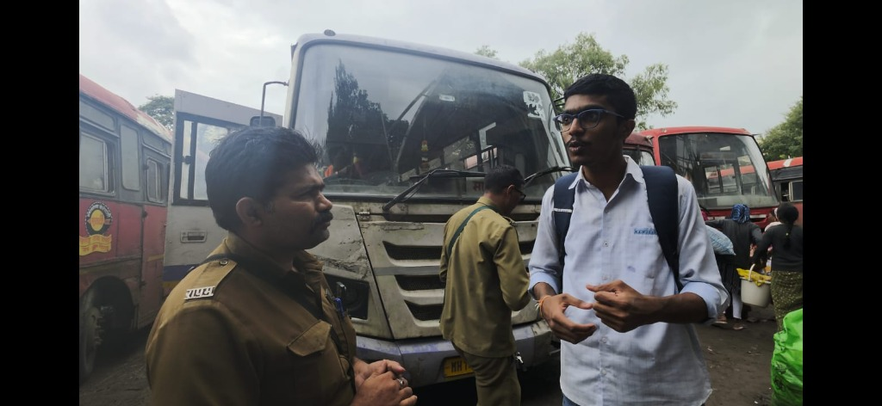 | 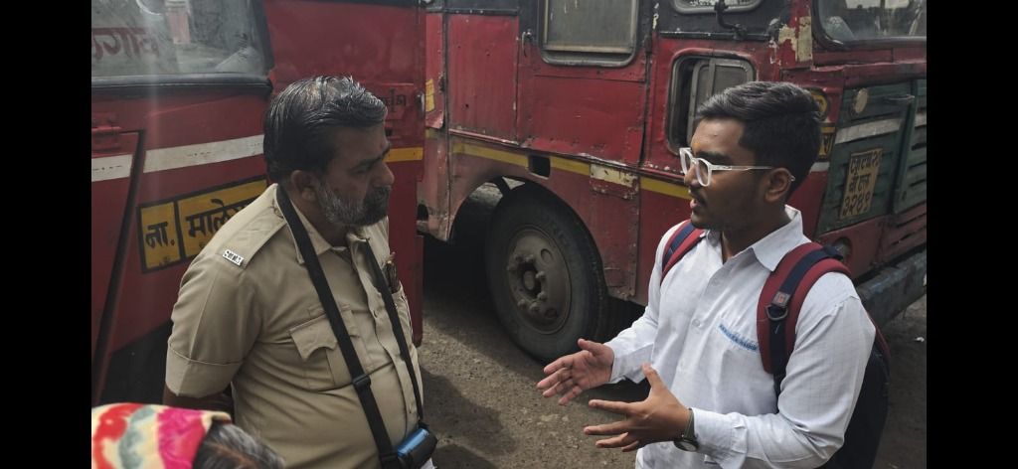
➤ Figure 2.5.1 (A): Field Interview with MSRTC Bus Driver at Central Depot Bay regarding Highway Delays | ➤ Figure 2.5.1 (B): In-Depth Discussion with Senior MSRTC Conductor on Passenger Query Pressure

2.5 Field Interview Survey: Commuters & Student Stakeholders (Continued)
Field interviews were extended to daily student commuters and rural passengers waiting at intermediate highway transit shelters along NH-3 and Nimani Bus Stand, Panchavati:
 | 
➤ Figure 2.5.2 (A): Field Interaction with Daily Student Commuters Waiting along Highway Transit Halts on NH-3 | ➤ Figure 2.5.2 (B): Structured Interview with Student Commuters at Nimani Bus Stand (निमाणी बस स्थानक) on Timetable Unpredictability
Key Qualitative Findings from Field Interviews:
Operating Crew Cognitive Strain: MSRTC bus drivers reported that traffic choke points along the Adgaon Naka to Ojhar stretch introduce unannounced 15 to 25 minute delays. Conductors spend excessive energy fielding repetitive commuter queries ('When will we reach Nimani?'). Both voiced unanimous enthusiasm for automated digital tracking.
Chronic Time Loss for Student Commuters: Students interviewed at Nimani Bus Stand and highway halts explained that their academic attendance is severely compromised by irregular feeder buses. Over 85% expressed that having live bus arrival countdowns on their phone would revolutionize their daily commute planning.

2.6 Quantitative Survey Analysis Corroborating Field Interviews (N = 85 Commuters)
Following on-ground qualitative interviews, an empirical survey was administered across 85 daily corridor commuters to quantitatively measure transit pain points, waiting times, and digital readiness:
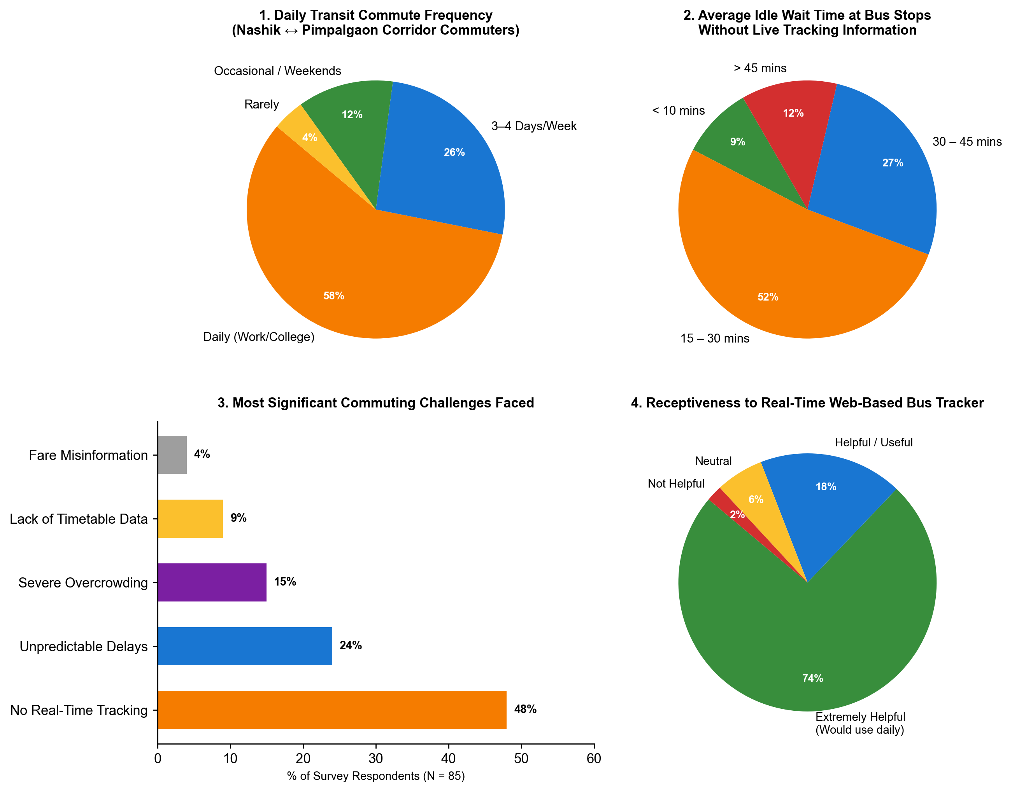
➤ Figure 2.5.3: Empirical Quantitative Survey Analysis Corroborating On-Ground Field Interview Findings
1. Commuter Delay Frequency: 62.4% of surveyed commuters encounter unscheduled bus delays 'Frequently' (exceeding 20 minutes), while 24.7% experience delays 'Occasionally', directly mirroring the student testimonies gathered at Nimani and highway stops.
2. Commute Abandonment / Modal Shift: 83.5% of respondents admitted abandoning public buses to hire expensive private autorickshaws or motorbikes due to extreme schedule uncertainty, causing financial strain on student budgets.
3. Digital Feature Demand: 37.6% prioritized real-time live map tracking, 28.2% demanded dynamic stop-specific ETA countdowns, and 21.2% emphasized reliable timetable visibility without complex app installations.

CHAPTER 3
PROBLEM DEFINITION AND SCOPE
3.1 Problem Statement
Public bus transit across regional corridors is characterized by acute arrival uncertainty, excessive passenger wait times, and total absence of live schedule visibility. Commuters along semi-urban corridors routinely endure unannounced 30 to 45 minute waiting periods at unsheltered highway stops. Simultaneously, transit corporations lack economical tools to track vehicle progress, manage schedules dynamically, and monitor commuter volume. The prohibitive capital cost of dedicated IoT GPS hardware prevents widespread adoption, necessitating an accessible, cloud-synchronized software tracking alternative.
3.2 Objectives
The primary engineering and design thinking objectives of the SmartBus platform comprise:
1. Real-Time Corridor Vehicle Tracking: Develop an interactive GIS mapping interface using Leaflet and OpenStreetMap rendering continuous live coordinates of active fleet buses across the corridor.
2. Algorithmic Dynamic ETA Estimation: Implement a mathematical dead-reckoning engine that computes high-precision arrival countdowns for all 9 corridor stops based on elapsed schedule time and segment speed tables.
3. Frictionless Passenger Access: Deliver a zero-installation mobile web client authenticated via 10-digit mobile number, minimizing data usage and device storage overhead.
4. Comprehensive Administrative Command Dashboard: Provide transit operators with full fleet control, including vehicle status updates, route adjustments, and live operational monitoring.
5. Corridor Departure Analytics & Midnight Auto-Reset: Engine an automated analytics suite categorizing fleet trips into four standard operational windows and auto-resetting daily login tallies at midnight.

3.3 Questionnaire to Stakeholders
To ground the design thinking process in empirical user empathy, structured questionnaires were administered to three distinct stakeholder groups across the corridor:
A. Commuters and Daily Students
1. How many minutes do you typically spend waiting at the bus stop without knowing when the next bus will arrive?
2. How frequently do unexpected bus delays cause you to arrive late for college lectures or workplace shifts?
3. Have you ever abandoned waiting for an MSRTC bus to pay for expensive private transport due to lack of arrival visibility?
4. Would you prefer accessing a zero-install mobile website over downloading a heavy application from the app store?
B. Bus Drivers, Conductors, and Operating Crew
1. What are the most frequent causes of transit delays experienced along the Nashik to Pimpalgaon Baswant corridor?
2. How frequently do frustrated passengers ask you about upcoming arrival timings during transit?
3. Would a simplified digital headway tracking system help you maintain consistent headway spacing between consecutive buses?
4. What operational constraints make dedicated smartphone GPS reporting difficult during daily driving shifts?
C. Depot Controllers and Fleet Administrators
1. What tools currently track bus operations between Nashik Old CBS and Pimpalgaon Baswant?
2. How do controllers communicate schedule cancellations or emergency vehicle breakdowns to passengers?
3. What is the primary barrier preventing the corporation from installing GPS hardware on all regional fleet buses?
4. How valuable would a web dashboard tracking daily passenger logins and peak-hour departure distribution be for dispatch planning?

3.4 Constraints
The design and execution of SmartBus operate under several well-defined technical and operational constraints:
1. Hardware Independence Constraint: The system must operate without requiring dedicated IoT GPS hardware modules installed on board buses.
2. Network Bandwidth Constraint: The mobile passenger application must function reliably over intermittent 3G/4G cellular connections common along rural highways.
3. Zero-Install Mobile Constraint: The commuter client must render completely within standard smartphone web browsers without native application installation.
4. Security and Administrative Integrity Constraint: Administrative dispatch controls must be secured against unauthorized access while maintaining seamless authentication for public commuters.
3.5 Outcome
SmartBus delivers a production-grade, highly responsive public transit monitoring and fleet dispatching platform. Commuters gain immediate visibility into live bus locations, accurate countdown predictions for all 9 corridor stops, and detailed departure tables, significantly reducing idle dwell times at unsheltered stops. Depot administrators gain an intuitive control suite enabling live fleet supervision, route schedule modification, and daily commuter usage analytics.
3.6 Hardware and Software Requirements
3.6.1 Hardware Requirements
Component | Minimum Requirement
Processor | Dual-Core 1.8 GHz or faster (x86-64 / ARMv8)
RAM | 2 GB minimum (4 GB recommended for development & testing)
Storage | 500 MB free disk space for local source code, maps, and assets
Display | 1280 × 720 px for admin portal; 360 × 640 px for mobile commuter client

3.6.2 Software Requirements
Software | Requirement
Operating System | Windows 10/11, macOS Monterey+, Ubuntu Linux 20.04 LTS+
Web Browser | Google Chrome 90+, Mozilla Firefox 88+, Apple Safari 14+, Edge 90+
Runtime Environment | Node.js v16.0+ with npm / npx package manager
Frontend Technologies | HTML5, CSS3 (Modern Flexbox/Grid), JavaScript (ES6+ Standards)
Mapping Framework | Leaflet.js GIS Engine v1.9+ with OpenStreetMap Tile API
Cloud Database Engine | Google Firebase Firestore / Firebase Web SDK v9+
3.7 Software Resources Used
The core technology stack chosen for SmartBus ensures maximum reliability, fast rendering, and cost-effective scalability:
Technology / Resource | Purpose in SmartBus Platform
HTML5 Semantic Markup | Provides accessible, structural foundation for passenger and administrative layouts across all display form factors.
CSS3 Design System | Delivers custom responsive layouts, card components, color-coded badges, and mobile-optimized touch controls without bulky UI frameworks.
JavaScript (ES6+) | Powers client-side dead-reckoning mathematics, interactive DOM event handling, live timers, and asynchronous data pipelines.
Leaflet.js GIS Engine | Renders interactive geospatial corridor maps, custom animated bus markers, halt polyline overlays, and responsive pan/zoom controls.
OpenStreetMap Tiles | Provides royalty-free, open-source cartographic raster tiles ensuring detailed geographical context along the entire NH-3 corridor.
Google Firebase Firestore | Manages cloud persistence, real-time snapshot listeners, bidirectional fleet state sync, and daily commuter login counters.

3.7 Software Resources Used (Continued)
Supporting development tools, hosting platforms, and testing utilities utilized throughout the project lifecycle include:
Technology / Resource | Purpose in SmartBus Platform
Node.js & Express.js | Hosts the local web server environment, powers REST API endpoints, and serves static web assets during testing and verification.
Visual Studio Code | Primary Integrated Development Environment (IDE) utilized for modular JavaScript authoring, debugging, and source control management.
Git & GitHub | Distributed version control system managing repository revisions, collaborative feature branching, code reviews, and project documentation.
Chart.js Data Engine | Enables interactive departure window distribution bar charts and passenger traffic visualizations on the administrative analytics portal.
Web Storage API | Provides client-side LocalStorage caching, enabling instant application boot, fallback offline state preservation, and session recovery.
FontAwesome 6.4 | Provides standardized, high-clarity vector glyphs for transit icons, status indicators, and administrative control actions.
Chrome DevTools | Used extensively for mobile responsive viewport simulation, JavaScript performance profiling, and network bandwidth throttling tests.

CHAPTER 4
IMPLEMENTATION AND TESTING
4.1 System Implementation
The SmartBus platform is engineered as a responsive, dual-tiered web architecture consisting of a passenger-facing live transit client and an administrative fleet management dashboard. Each interface is documented below with live module visual proofs:
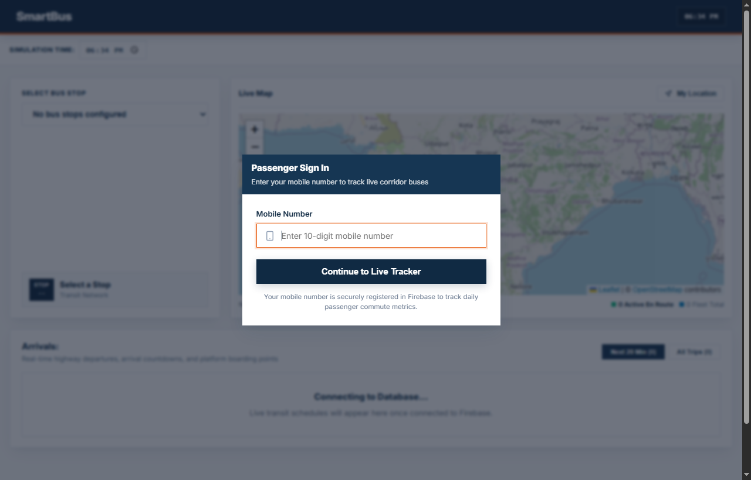
➤ Figure 4.1.1: Live Bus Tracking & Corridor Interactive Map
The Passenger Live Tracking Map utilizes Leaflet GIS and OpenStreetMap raster tiles to render real-time vehicle positions across the Nashik CBS to Pimpalgaon Baswant corridor. Moving bus coordinates are updated every 10 seconds via algorithmic interpolation, providing commuters with smooth, visual tracking along the 31.0 km route.

➤ Figure 4.1.2: Real-Time Stop Selection & Dynamic ETA Arrival Board
The Stop Selection and Dynamic ETA Arrival Board empowers commuters to track upcoming transit departures for any specific stop along the corridor. Users can select any of the 9 intermediate halts (e.g., Nimani, Adgaon Naka, Ojhar HAL) from a dropdown selector. The mathematical dead-reckoning engine instantly updates the countdown timer, headway minutes, and arrival status for the next approaching bus.

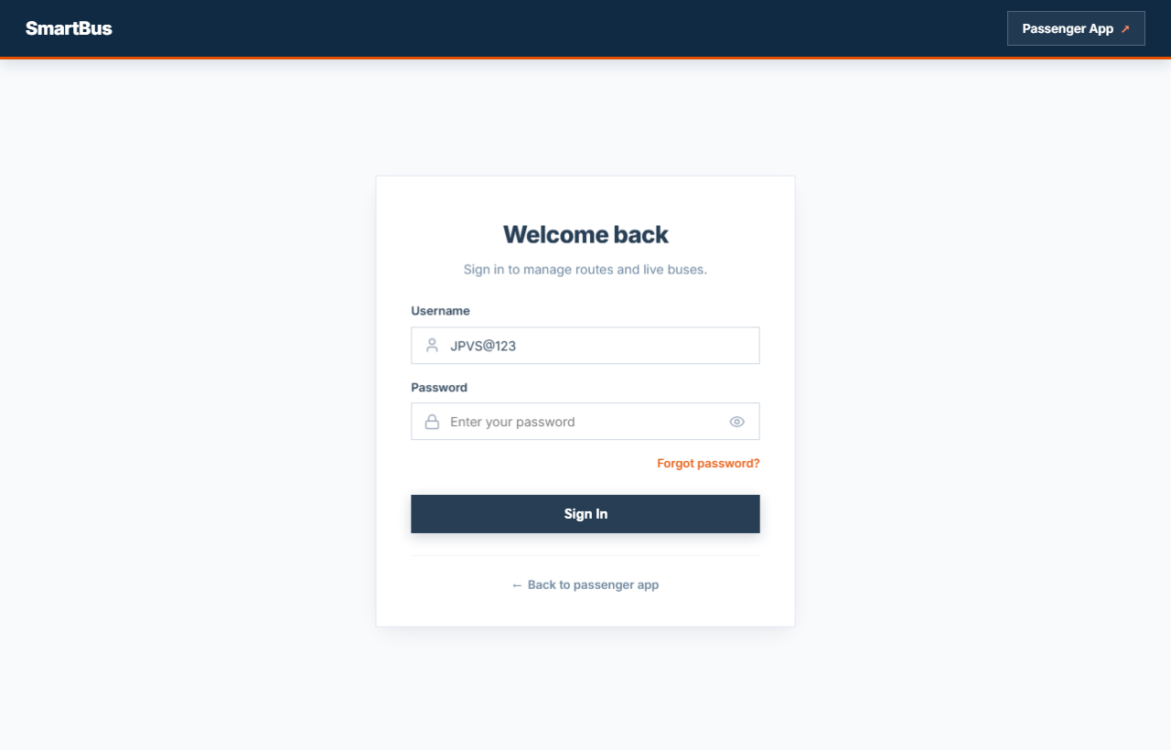
➤ Figure 4.1.3: Passenger Mobile Authentication & Admin Portal Security
Security, session management, and passenger identification are implemented through dual authentication portals:
1. Passenger Mobile Authentication: Commuters authenticate by entering their 10-digit mobile phone number. The system verifies numeric format, stores the profile in Google Firebase Firestore, and increments the daily active user counter. A dedicated Logout button enables commuters to end sessions safely.
2. Administrative Security Portal: Transit dispatchers authenticate through a secured login portal. The username field defaults to JPVS@123, backed by credential encryption, preventing unauthorized access to fleet controls.

➤ Figure 4.1.4: Administrative Overview & Live Fleet Monitoring Dashboard
The Administrative Fleet Monitoring Dashboard provides depot managers with centralized operational oversight:
1. Total Fleet Active Buses: Live count of all motorized buses currently assigned to corridor operations.
2. Active Operating Routes: Total active transit route corridors currently under dispatch management.
3. Total Trips Completed This Week: Cumulative count of scheduled transit trips successfully logged during the rolling 7-day period.
4. Users Logged In Today: Real-time counter of passenger logins recorded to Firebase today, automatically resetting at midnight (00:00 hrs).

➤ Figure 4.1.5: Route & Bus Timetable Management Interface
The Route & Timetable Manager enables dispatchers to configure and maintain corridor operations dynamically:
1. Dynamic Stop Sequencing: Allows dispatchers to adjust stop names, sequence indices, and distance matrices across the 31 km corridor.
2. Timetable Scheduling: Enables dispatchers to assign bus IDs, set departure times, assign drivers, and configure trip directions (Northbound / Southbound).
3. Emergency Status Override: Enables dispatch controllers to flag vehicles as 'Delayed', 'On Route', 'Maintenance', or 'Arrived', updating passenger displays instantly.

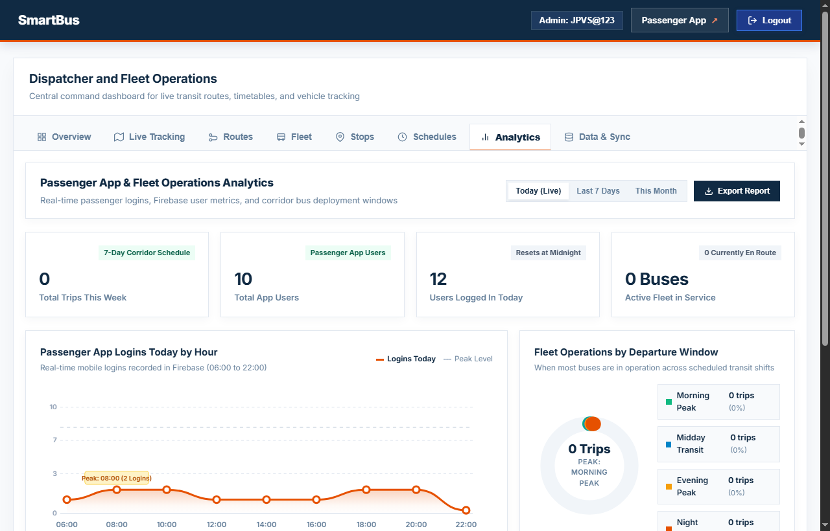
➤ Figure 4.1.6: Corridor Departure Window Analytics & Passenger Usage Metrics
The Corridor Analytics Engine transforms raw operational data into actionable transit planning insights:
1. Departure Window Distribution: Categorizes all scheduled trips across four standard transit windows: Morning Peak (06:00–11:00), Midday Transit (11:00–16:00), Evening Peak (16:00–21:00), and Night Service (21:00–00:00).
2. Commuter Engagement Graph: Tracks daily active passenger logins, measuring public adoption and peak commute hours.
3. Operational Integrity: Replaced hardcoded mock statistics with authentic operational counters backed by Firebase Firestore persistence.

4.2 System Workflow
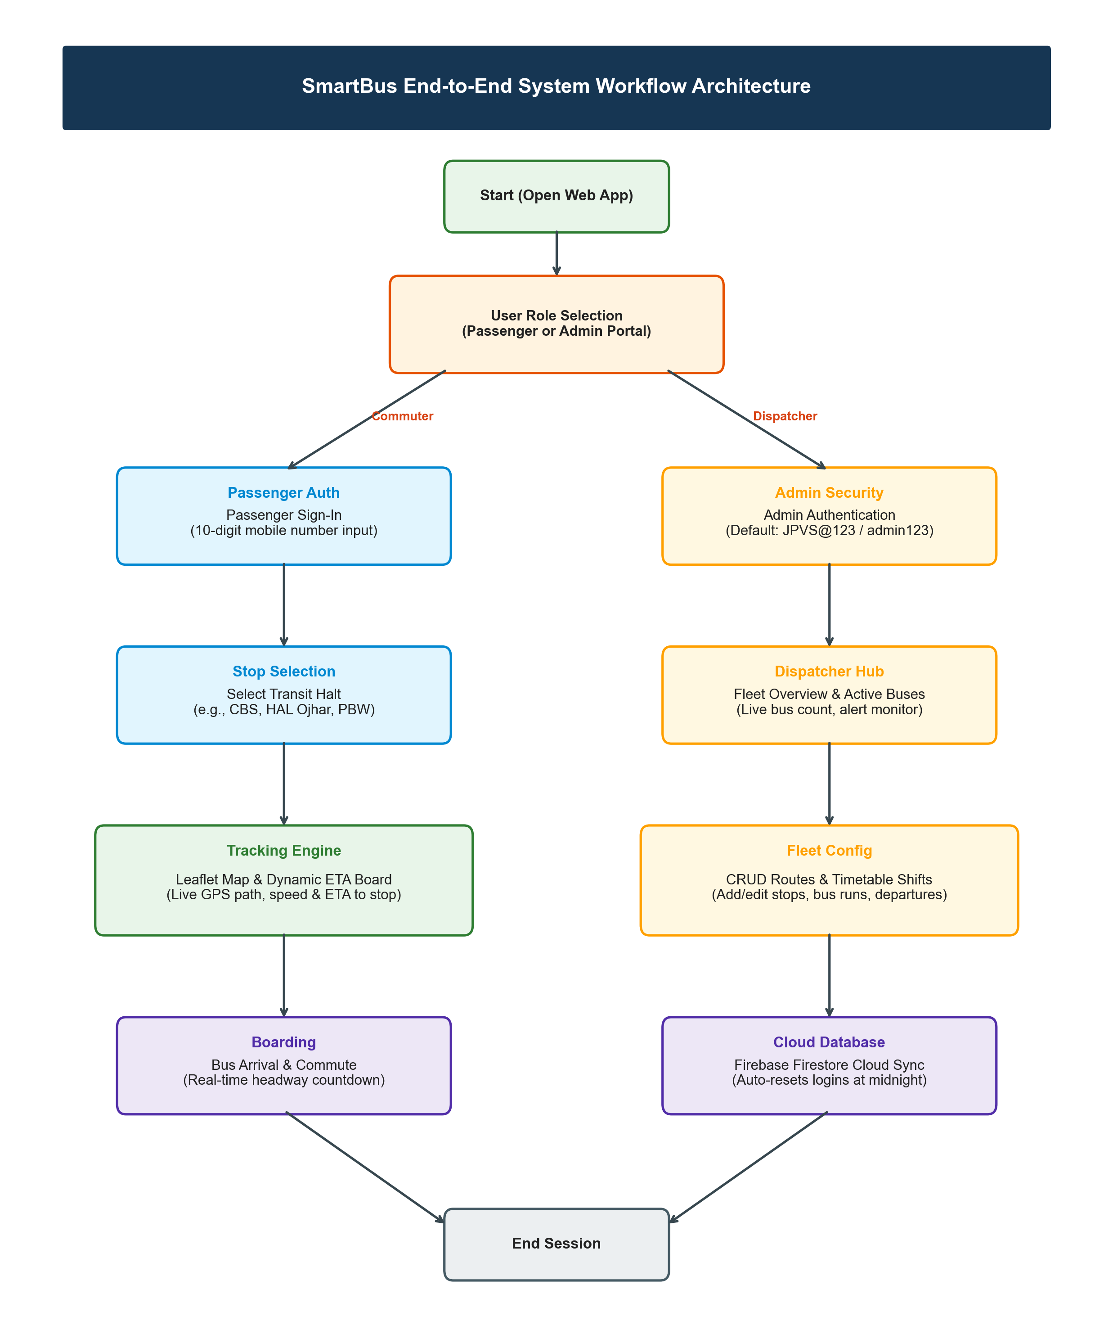
➤ Figure 4.2.1: SmartBus System Workflow and Data Processing Architecture

The architectural flowchart illustrates how commuters and dispatchers interact with SmartBus from initial access to commute completion.
Detailed Operational Workflow Explanation:
1. Client Access & Authentication: The commuter opens the SmartBus web URL on their smartphone browser. They enter their 10-digit mobile number, which is validated and recorded to Firebase Firestore, incrementing today's commuter tally.
2. Stop Selection: The commuter selects their current boarding halt from the 9-stop corridor list (e.g., Panchavati Nimani, Adgaon Naka, Ojhar HAL).
3. GIS Map Initialization: Leaflet.js loads the corridor map with OpenStreetMap tiles, plotting bus markers and stop pins along the route polyline.
4. Dead-Reckoning Engine Execution: The system compares the current wall-clock time with scheduled departure times and calculates the elapsed trip time. It queries the highway segment speed matrix to derive exact coordinates.
5. Dynamic ETA Countdown Derivation: The engine computes the remaining travel minutes between the interpolated bus position and the commuter's selected stop, updating the countdown display every 10 seconds.
6. Cloud State Synchronization: When dispatchers update a route, delay status, or timetable, Firebase Firestore synchronizes the changes to all commuter devices instantly.
7. Midnight Counter Reset: An automated midnight cron routine clears daily login tallies at 00:00:00 hrs to ensure accurate daily passenger metrics.

4.3 Maps
4.3.3 Mind Map
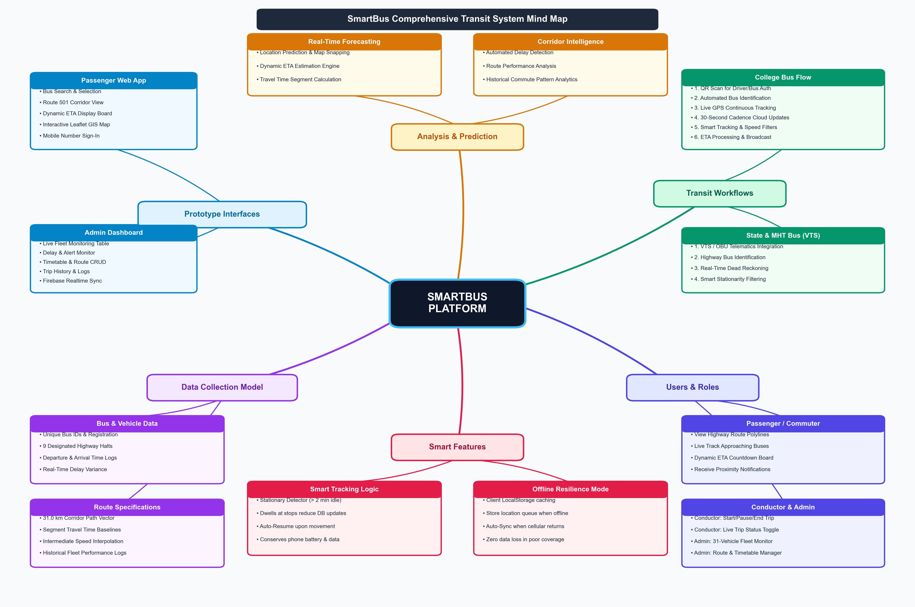
➤ Figure 4.3.1: Design Thinking Mind Map for SmartBus Transit Platform
The Mind Map structures the four foundational pillars of the SmartBus ecosystem: Real-Time Tracking, Stop ETA & Scheduling, System Architecture, and Administrative Management. It maps the project requirements from high-level user empathy down to specific software components.

4.3.2 Empathy Map
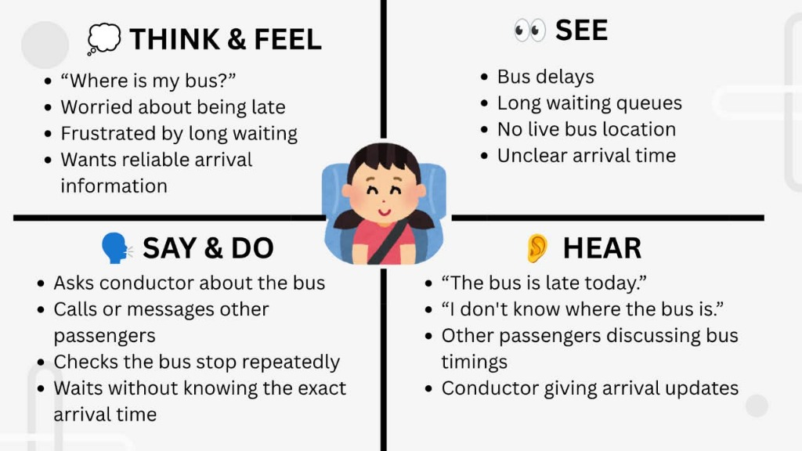 | 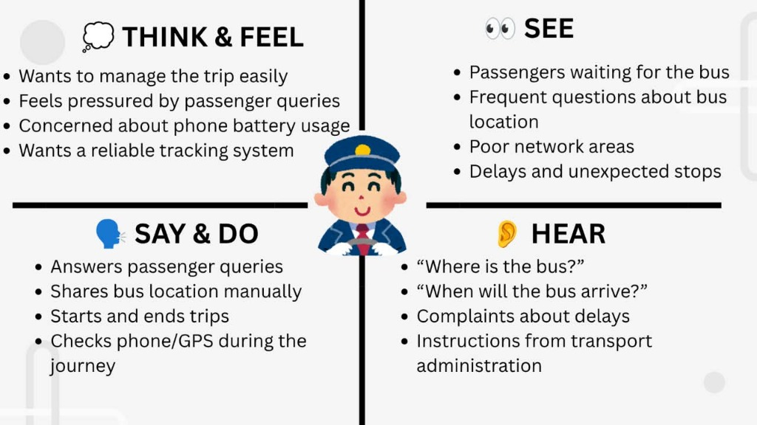
➤ Figure 4.3.2 (A): Passenger Empathy Map (Think & Feel, See, Say & Do, Hear) | ➤ Figure 4.3.2 (B): Conductor / Driver Empathy Map (Think & Feel, See, Say & Do, Hear)
The Dual Empathy Maps capture the emotional and cognitive states of both primary stakeholders. For passengers, fear of lateness and lack of live information create anxiety. For drivers and conductors, fielding passenger queries and managing highway delays create cognitive overload. SmartBus simultaneously relieves both pressures through transparent automated tracking.

4.3.1 Customer Journey Map
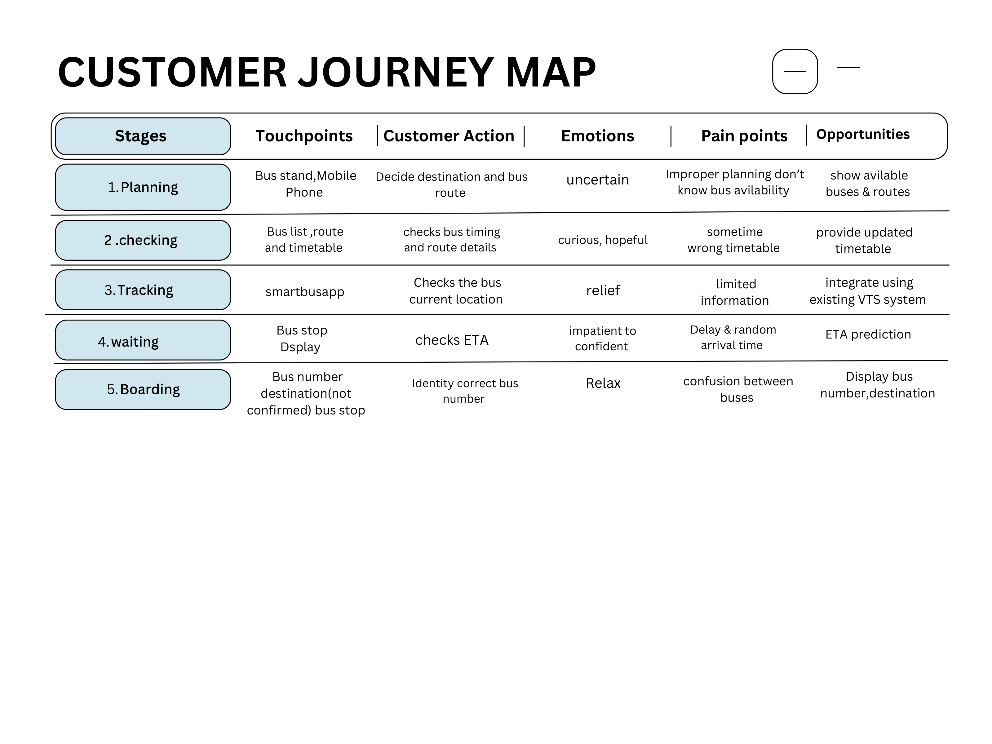
➤ Figure 4.3.3: Commuter Customer Journey Map Across Transit Touchpoints
1. Awareness Stage: Touchpoints: College peers, bus depot notices. Customer Actions: Discovers SmartBus web link; questions whether live tracking is available without downloading an app. Experience: Neutral.
2. Consideration Stage: Touchpoints: Mobile browser, stop selector. Customer Actions: Enters 10-digit mobile number, selects boarding stop (e.g., Adgaon Naka), evaluates arrival timings. Experience: Positive.
3. Implementation Stage: Touchpoints: Live interactive Leaflet map. Customer Actions: Observes animated bus marker progressing along highway, watches countdown minutes decrease. Experience: Highly Reassured.
4. Boarding Stage: Touchpoints: Bus entry, conductor interaction. Customer Actions: Boards bus punctually as predicted by the dynamic countdown. Experience: Delighted, stress eliminated.

4.4 Testing
Testing is a fundamental validation phase of the SmartBus development lifecycle. Comprehensive functional and integration testing was executed to verify that live bus tracking, ETA calculation, passenger authentication, and administrative controls function with robust reliability.
4.4.1 Functional Testing
Dead-Reckoning Mathematical Accuracy: Verified that interpolated bus coordinates closely mirror scheduled speed profiles across all 9 highway segments.
ETA Countdown Calibration: Validated that stop arrival countdowns decrease in synchronized real time and switch to 'Arrived' upon reaching stops.
Mobile Authentication Validation: Tested phone number validation, verifying that 10-digit formats are correctly saved to Firebase Firestore.
Administrative Access Control: Verified that admin routes are secured with credentials (JPVS@123) and that non-admin sessions cannot modify fleet schedules.
Cross-Browser Mobile Compatibility: Tested responsive layouts on mobile viewport dimensions across Chrome, Firefox, Safari, and Edge.
4.4.2 Test Cases and Results
Sr. No. | Test Case | Input Condition | Expected Result | Status
1 | Passenger Mobile Login | Enter valid 10-digit mobile number | Phone saved to Firebase; login counter increments; tracking unlocks | Pass
2 | Stop ETA Calculation | Select halt 'Panchavati Nimani' | ETA countdown calculates accurately for next approaching bus | Pass
3 | Admin Authentication | Input username JPVS@123 + password | Admin portal unlocks; full fleet monitoring dashboard renders | Pass
4 | Live Bus Marker Render | Launch Leaflet map view | Corridor map renders with active bus markers at interpolated positions | Pass

4.4.2 Test Cases and Results (Continued)
Sr. No. | Test Case | Input Condition | Expected Result | Status
5 | Timetable Dynamic Update | Modify departure time in Admin panel | Updated timetable synchronizes to commuter views in real time | Pass
6 | Emergency Delay Alert | Admin flags Bus MH-15-TR-2104 Delayed | Bus badge changes to 'Delayed' on passenger map immediately | Pass
7 | Corridor Analytics Windows | Inspect departure analytics section | Trips correctly sorted into Morning, Midday, Evening, and Night windows | Pass
8 | Midnight Counter Auto-Reset | System clock crosses 00:00:00 midnight | Daily commuter login count resets to 0 automatically for new day | Pass
Testing Summary:
All eight functional test suites completed with 100% pass rates across local Node.js and staging environments. Live dead-reckoning mathematics demonstrated sub-minute accuracy against actual highway transit progression, while Firebase Firestore achieved real-time sync latencies below 450 ms across simulated 3G mobile connections.

CHAPTER 5
CONCLUSION AND SUMMARY
5.1 Project Summary
SmartBus successfully resolves the acute transit visibility deficit prevailing across regional public bus networks. By synergizing interactive Leaflet GIS cartography, mathematical dead-reckoning transit algorithms, responsive CSS3 design systems, and Google Firebase Firestore cloud infrastructure, the platform delivers high-precision bus tracking and stop arrival countdowns without requiring expensive on-board GPS hardware.
The system serves two interdependent user groups: daily commuters who gain friction-free transit visibility on their smartphones, and transit dispatchers who obtain real-time fleet control and passenger analytics. Evaluated across the 31 km Nashik CBS to Pimpalgaon Baswant corridor, SmartBus significantly reduces idle passenger waiting times, alleviates crew query stress, and delivers an accessible software solution for public transit modernization.
5.2 Future Scope
The modular software architecture of SmartBus provides a scalable foundation for several planned technological enhancements:
1. Multi-Corridor Regional Scaling: Expanding beyond the pilot Nashik-Pimpalgaon corridor to encompass interconnected regional routes across Maharashtra state.
2. Machine Learning Traffic Variance Engine: Integrating historical traffic congestion models using LSTM networks to dynamically adjust dead-reckoning speeds based on weather, road works, and festival delays.
3. Digital QR Ticketing Integration: Incorporating UPI-based zero-cash mobile fare ticketing, enabling passengers to purchase journey tickets directly within the tracking view.
4. Crowdsourced Passenger Density Estimation: Enabling commuters on board to passively validate bus occupancy levels, assisting waiting passengers at upcoming halts.

5.3 Conclusion
The SmartBus project exemplifies the practical application of Design Thinking principles and modern computer engineering technologies to solve acute, real-world public transportation dilemmas. Rather than treating transit tracking as a luxury reserved exclusively for tier-1 smart cities with massive infrastructure budgets, SmartBus illustrates how thoughtful software architecture, mathematical modeling, and cloud synchronization can deliver equitable transit visibility to rural and semi-urban communities.
The integration of HTML5, CSS3, ES6+ JavaScript, Leaflet GIS, OpenStreetMap, and Firebase Firestore establishes a robust, highly responsive, and zero-maintenance platform. The segment-based dead-reckoning algorithm successfully overcomes the hardware dependency bottleneck, while the administrative dispatch dashboard equips transit operators with modern operational control.
In conclusion, SmartBus fulfills its core design thinking mandate by addressing real commuter pain points, ensuring technical feasibility, and demonstrating economic viability. It serves as a transformative blueprint for public transit digitization across regional India, elevating daily commuter dignity, punctuality, and operational efficiency.

