Formatting Instructions  
for Authors Using Microsoft Word

AAAI Press (This is the Author Name style)

Association for the Advancement of Artificial Intelligence (This is the Affiliation and Address style)  
publications23@aaai.org (This is also the Affiliation and Address style)

Overview

In this mini-project, we are tasked with coming up with a modified residual network (ResNet) architecture with the highest test accuracy on the CIFAR-10 image classification dataset, under the constraint that the model has no more than 5 million parameters. We start with a good architecture ResNet-18 and design 5 different models. Our final model has no more than 5,000,000 parameters but still gains 95.66% test accuracy on CIFAR-10.

1.introduction*[1]*

First, we need to design the building blocks of our ResNet.

There are two types of residual block in the original ResNet paper [1]: BasicBlock and BottleNect. BottleNect can be used if we train a deep ResNet. Consider that our model has no more than 5 million parameters, we use BasicBlock in our model.

Second, we think about the architecture of our ResNet. There are five models proposed by the authors in the original paper [1]: ResNet-18, ResNet-34, ResNet-50, ResNet-101, ResNet-152. ResNet-18(fig.1) has 11,173,962 parameters (fig. 2) with 93.02% test accuracy on CIFAR-10 dataset [2]. We can start with this well-defined architecture and make some modification.

Fig. 1

Fig. 2

2. Model design

**Model 1.** We try to reduce the number of parameters of ResNet-18 and see if it still can get high test accuracy on CIFAR-10. ResNet-18 has 4 layers, and each layer has two Basic Blocks. We decide to remove one Basic Block in each layer:

Number of blocks: [2,2,2,2] $→$ [1,1,1,1]

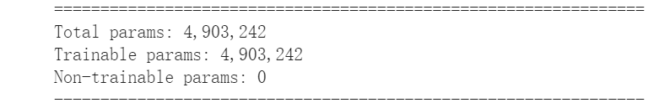Now the number of parameters becomes 4,903,242. We train this model for 200 epochs and the best model gets 94.35% test accuracy (fig. 3). Seems like we already find a good architecture.

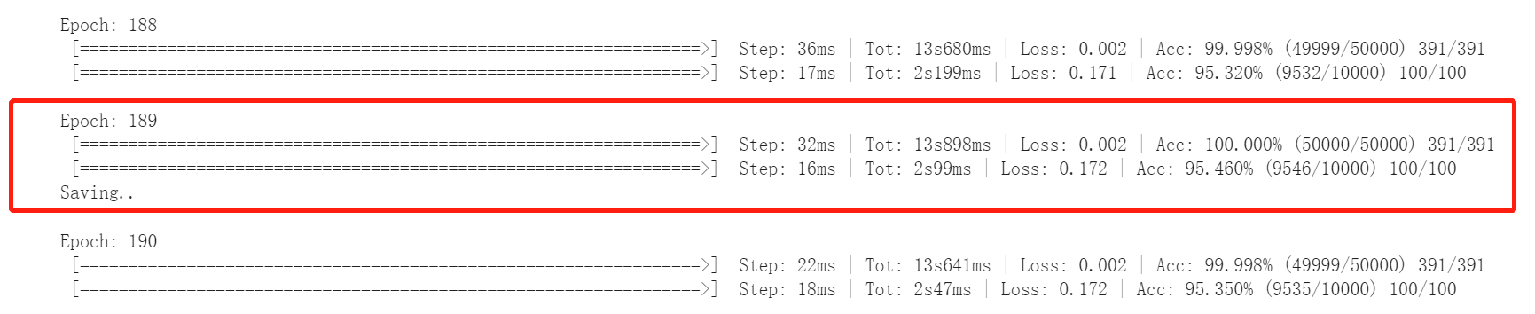

**Model 2.** We want to know if we can get a better model if we increase the number of basic blocks. From the summary of the ResNet-18(fig. 5), we know that most of the trainable parameters are from the last layer. So, we try to remove the last layer of ResNet-18 and then add more basic blocks in first three layer. In our model 2, the number of the blocks is [2,2,4,0]:

Number of blocks: [1,1,1,1] $→$ [2,2,4,0]

Pool size in the average pool layer: 4 $→$ 8

This model has 5,139,018 parameters (fig. 6). We train this model for 200 epochs and surprisingly, this model gets 100% train accuracy and 95.46% test accuracy at epoch 197! Unfortunately, we cannot use this model as our final model because the number of parameters exceed 5M. But maybe we can design a model better than Model 1 based on this model.

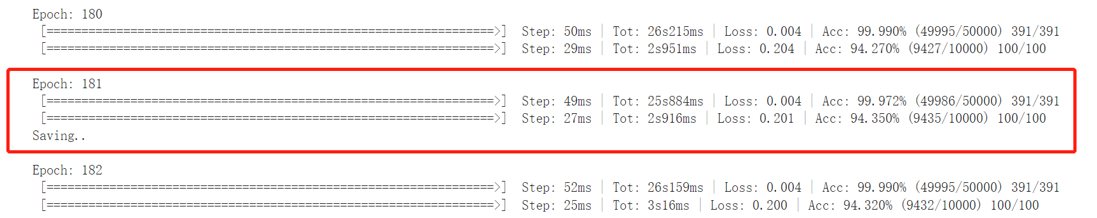

**Model 3.** We want to design a model for no more than 5 million parameters based on Model 2. We decrease the number of channels in the layer 3 from 256 to 250:

Number of blocks: [2,2,4,0]

Number of channels in 3rd layer: 256 $→$ 250

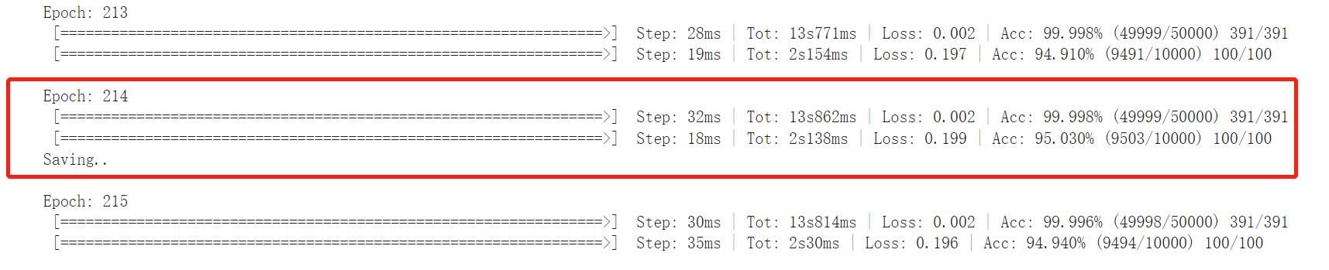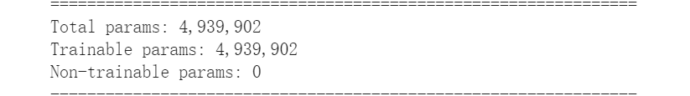This model has 4,939,902 parameters. We train it for 245 epochs, and it achieves 100% train accuracy and 95.03% test accuracy at epoch 214.

**Model 4.** We try to improve model 3’s performance by adding more parameters. We made some slight modifications:

the number of channels in layer 2: 128 $→$ 130

the number of channels in layer 3: 250 $→$ 251

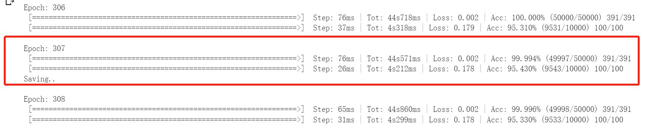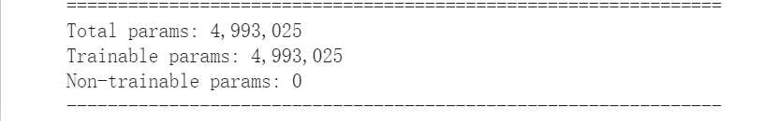Now the model has 4,993,025 parameters. We train this model for 400 epochs, and it gets 95.43% test accuracy at epoch 307.

**Model 5.** In model 2,3,4, we notice that layer 3 has the most blocks. We want to know if we can get a better model if layer 2 has the most blocks. Here is the modification:

the number of channels in layer 2: 130 $→$ 128

the number of channels in layer 3: 251 $→$ 250

Number of blocks: [2,2,4,0] $→$ [4,5,3,0]

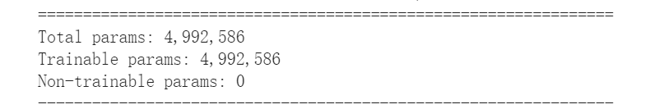This model has 4,992,586 parameters. We train this model for 200 epochs, and it gets 95.66% test accuracy at epoch 189.

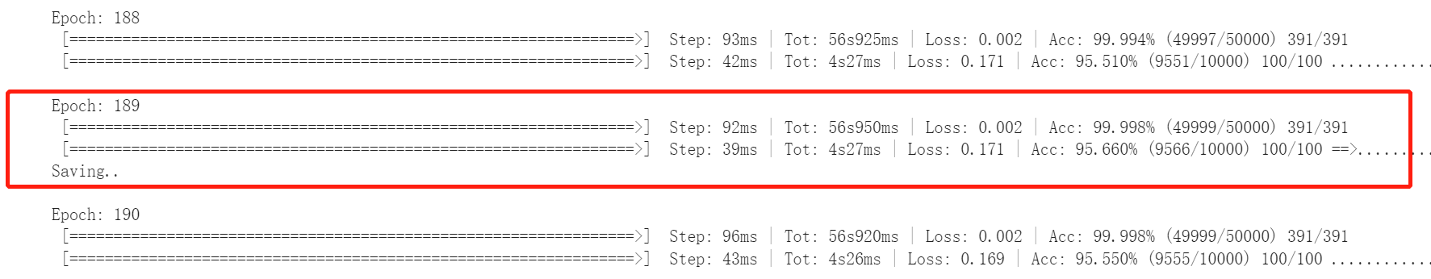

Result

We have tried 5 different architecture and all of them achieve more than 94% accuracy (Table 1). We choose model 5 as our final model. It has 4,992,586 parameters and achieves 95.66% test accuracy. See table 2 for detailed architectures.

|  |  |  |  |  |
| --- | --- | --- | --- | --- |
| Model | Number of blocks | Number of parameters | test accuracy | Final model |
| ResNet-18 | [2,2,2,2] | 11,173,962 | 93.02% |  |
| Model 1 | [1,1,1,1] | 4,903,242 | 94.35% |  |
| Model 2 | [2,2,4,0] | 5,139,018 | 95.46% |  |
| Model 3 | [2,2,4,0] | 4,939,902 | 95.03% |  |
| Model 4 | [2,2,4,0] | 4,993,025 | 95.43% |  |
| Model 5 | [4,5,3,0] | 4,992,586 | 95.66% | $$√$$ |

Table 1

|  |  |  |
| --- | --- | --- |
| Layer(type) | Output Size | Architecture |
| Conv1 | $$64×32×32$$ | kernel size: $3×3$ Output channel: 64  Stride=1 |
| Layer1 | $$64×32×32$$ | $$\left[\begin{matrix}3×3 & 64 \\ 3×3 & 64\end{matrix}\right]×4$$ |
| Layer2 | $$128×16×16$$ | $$\left[\begin{matrix}3×3 & 128 \\ 3×3 & 128\end{matrix}\right]×5$$ |
| Layer3 | $$256×8×8$$ | $$\left[\begin{matrix}3×3 & 256 \\ 3×3 & 256\end{matrix}\right]×3$$ |
| Avg_pool | 256 | Pool Size $8×8$ |
| Linear | 10 | Input channel 256  Output channel 10 |

Table 2

**References**

[1] Kaiming He, Xiangyu Zhang, Shaoqing Ren, Jian Sun Deep Residual Learning for Image Recognition. arXiv:1512.03385

[2] Train CIFAR10 with PyTorch

https://github.com/kuangliu/pytorch-cifar

1. Copyright © 2022, Association for the Advancement of Artificial Intelligence (www.aaai.org). All rights reserved.