BCSE497J - Project-I

ARIA — AUTONOMOUS REASONING & INTERACTION AGENT
A Cognitive, Multi-Agent Vision-Language-Action System for Adaptive Manipulation on a Low-Cost 5-DoF Robotic Arm

23BCT0005
GARV ARORA

Under the Supervision of
Prof. Yuvaraj N

B.Tech.
in
Computer Science and Engineering

School of Computer Science and Engineering



September 2026

ABSTRACT
ARIA (Autonomous Reasoning & Interaction Agent) is a locally-run, multi-agent manipulation system built around an affordable 5-degree-of-freedom (5-DoF) robotic arm. It is designed to understand spoken or typed natural-language instructions, decompose them into goals, subgoals, and actions, and then pick up, move, and manipulate objects roughly the way a person would: adjusting for uncertainty, checking in with the user when it is not sure, and steadily improving its own skills over time.
The arm uses SG90 servos for its lighter joints and MG995 servos for load-bearing joints, with vision supplied by an ESP32-CAM or Logitech C270 webcam and an MPU6050 IMU on the end effector. Perception is deliberately hybrid rather than purely learned: YOLO handles fast per-frame object detection, while monocular depth estimation (Depth-Anything or MiDaS) is combined with camera-and-table-height calibration geometry to recover a reliable Z-coordinate, removing the need for a dedicated RGB-D depth sensor. Grasp candidates generated by GraspNet or AnyGrasp are filtered by an Affordance Agent that selects grasps based on how an object is actually used rather than the nearest reachable surface.
A locally-run LLM-based Planning Agent (built on Llama 3.1 8B, served through Ollama) orchestrates roughly fifteen cooperating specialist agents through function-calling, with every action carrying a confidence score so that the system pauses for user approval whenever confidence drops below a defined threshold. A World Model Agent maintains a running semantic map of known objects and their lifecycle state, while Health Monitoring, Learning, and Evaluation agents continuously track system performance and drive self-supervised skill improvement. As of this review, simulation-based validation of the perception baseline, Z-coordinate recovery, and inverse-kinematics benchmarking has been completed, with full agent integration and end-to-end pick-place-stack-sort demonstrations scheduled ahead.
Keywords - Multi-Agent Systems, Vision-Language-Action Models, Robotic Manipulation, Monocular Depth Estimation, Affordance-Aware Grasping, Inverse Kinematics, Low-Cost Robotics.

TABLE OF CONTENTS
Sl.No | Contents | Page No.
 | Abstract | i
1. | INTRODUCTION | 5
 | 1.1 Background | 5
 | 1.2 Motivation | 5
 | 1.3 Scope of the Project | 5
2. | PROJECT DESCRIPTION AND GOALS | 6
 | 2.1 Literature Review | 6
 | 2.2 Research Gap | 7
 | 2.3 Objectives | 7
 | 2.4 Problem Statement | 7
 | 2.5 Project Plan (Gantt Chart) | 8
3. | TECHNICAL SPECIFICATION | 9
 | 3.1 Requirements | 9
 | 3.1.1 Functional | 9
 | 3.1.2 Non-Functional | 9
 | 3.2 Feasibility Study | 9
 | 3.2.1 Technical Feasibility | 9
 | 3.2.2 Economic Feasibility | 10
 | 3.2.3 Social Feasibility | 10
 | 3.3 System Specification | 10
 | 3.3.1 Hardware Specification | 10
 | 3.3.2 Software Specification | 10
4. | DESIGN APPROACH AND DETAILS | 12
 | 4.1 System Architecture | 12
 | 4.2 Detailed Design Diagrams | 13
 | 4.2.1 Data Flow Diagram | 13
 | 4.2.2 Use Case Diagram | 13
 | 4.2.3 Class Diagram | 14
 | 4.2.4 Sequence Diagram | 15
 | 4.3 Where the Novelty Lies | 17
 | 4.4 Implementation Status and Results | 17
5. | REFERENCES | 19
 | 5.1 Journal Articles | 19
 | 5.2 Conference Papers | 20
 | 5.3 Books | 22
 | 5.4 Websites | 22

1. INTRODUCTION

1.1 Background
Industrial robotic manipulators remain expensive and typically depend on dedicated RGB-D or LiDAR sensors to recover depth, putting flexible manipulation research and small-scale automation out of reach for students, small labs, and low-budget facilities. At the same time, recent advances in monocular depth estimation, open-vocabulary grasp generation, and local large-language-model (LLM) planning have made it possible to reconstruct much of that capability in software rather than in expensive hardware.
ARIA is built to test how far this substitution can go: a 5-DoF arm built from SG90 and MG995 hobby servos, a single webcam or ESP32-CAM, and an IMU, combined with a cognitive multi-agent software stack that handles perception, planning, grasp selection, motion execution, safety, and self-improvement. The project is being developed and validated primarily in simulation before any hardware deployment, allowing each subsystem to be benchmarked and tuned safely.

1.2 Motivation
Most published manipulation stacks assume a dedicated depth sensor and a research-grade arm, and multi-agent robotics research rarely attempts an agent hierarchy at the scale ARIA proposes on a single consumer GPU. This gap motivates ARIA: a system that shows a sub-$200 hobby-servo arm can exhibit research-grade manipulation behaviour when perception, planning, grasp selection, and safety are carefully wired together, while remaining transparent enough to debug through explicit chain-of-thought logging.
The project is also motivated by the practical value of confidence-gated, explainable autonomy: rather than a black-box policy that fails silently, ARIA is designed to recognise its own uncertainty and ask for help, which matters both for safety in shared workspaces and for trust in human-robot collaboration.

1.3 Scope of the Project
The scope of this phase of the project covers modelling and simulating the 5-DoF arm and its workspace, validating a YOLO-based perception baseline, recovering Z-coordinates from monocular depth and calibration geometry without a depth sensor, benchmarking inverse-kinematics solvers and integrating MoveIt2 for trajectory execution, and beginning integration of the LLM-based Planning Agent with confidence-gated decision-making and a semantic World Model.
Full end-to-end demonstration of pick, place, stack, and sort tasks driven by natural-language commands, together with Learning Agent skill improvement and Evaluation Agent failure classification across a fixed set of simulated test scenes, is planned as the project progresses toward the Final Review. Physical hardware deployment and real-world validation are considered future scope beyond this project phase.

2. PROJECT DESCRIPTION AND GOALS

2.1 Literature Review
Paper | Objective | Methodology | Pros / Cons | Findings
π0.5 (Physical Intelligence, 2025) | Open-world VLA generalization | Flow-based VLA policy trained on broad robot data | + Strong generalization  – Heavy compute | Baseline for evaluating ARIA's VLA skill layer
SMART-LLM (IROS 2024) | Multi-robot task planning via LLMs | LLM decomposes commands into a task graph | + Clear subgoal structure  – No affordance grounding | Basis for ARIA's Planning Agent hierarchy
Depth Anything V2 (2024) | Monocular depth estimation | Large-scale synthetic + real depth pretraining | + Sensor-free depth  – Scale ambiguity | Selected for Z-recovery, benchmarked vs MiDaS
AffordGrasp (IROS 2025) | Task-oriented open-vocab grasping | In-context affordance reasoning over grasp candidates | + Use-case aware  – Needs clean segmentation | Directly informs ARIA's Affordance Agent
SAM 2 (Meta AI, 2024) | Instance segmentation in images/video | Promptable segmentation transformer | + Pixel-accurate masks  – Real-time cost | Used for grasp-region accuracy over boxes
GraspNet / AnyGrasp | Grasp pose generation from RGB-D / point-cloud input | Learned grasp-quality scoring over candidate poses | + Strong candidate coverage  – Reachability-only ranking | Baseline generator for ARIA's grasp candidates, re-ranked by affordance
CuRobo (ICRA 2023) | Parallelized collision-free motion generation | GPU-accelerated trajectory optimization | + Fast collision-free planning  – Not tuned for hobby-servo cabling | Reference point for ARIA's cable-aware motion planner
FoundationPose (CVPR 2024) | Unified 6D pose estimation and tracking | Render-and-compare pose refinement for novel objects | + Strong 6D pose accuracy  – Compute-heavy, needs reference models | Scoped as a future addition to ARIA's X/Y/Z pipeline
OpenVLA (2024) | Open-source vision-language-action model | Generalist transformer policy over image + instruction input | + Open, reproducible  – Decisions not easily auditable | Benchmarked as an alternate VLA skill-layer option
SayCan (2022) | Grounding language in robotic affordances | LLM scores action feasibility against a fixed skill library | + Grounds language in affordances  – Assumes existing robot infrastructure, no safety loop | Informs ARIA's language-to-affordance grounding approach
Note: the review above is limited to ten representative papers most directly relevant to ARIA's design; the full literature survey draws on a broader set of sources across VLA models, multi-agent planning, monocular depth, affordance reasoning, and motion planning.

2.2 Research Gap
- Most published manipulation stacks assume a dedicated RGB-D or LiDAR sensor; few recover a reliable Z-coordinate from a plain $10–30 webcam using monocular depth combined with calibration geometry alone.
- Multi-agent robotics research rarely attempts an agent hierarchy at ARIA's scale — around fifteen cooperating agents — running together on a single consumer GPU paired with sub-$200 hobby-servo hardware.
- Affordance-aware grasp selection and confidence-gated human approval are typically studied in isolation; ARIA couples the two into one live decision loop.
- Explainable, chain-of-thought decision logging alongside cable-aware, self-calibrating motion planning is uncommon at this price point, limiting transparency in low-cost manipulation research.

2.3 Objectives
- Model and simulate a 5-DoF SG90/MG995 arm with a validated YOLO-based perception baseline.
- Recover reliable Z-coordinates via monocular depth and calibration geometry, without any dedicated depth sensor.
- Build an Affordance Agent that filters GraspNet/AnyGrasp candidates by real-world use-case rather than nearest reachable surface.
- Benchmark inverse-kinematics solvers and integrate MoveIt2 for collision-free trajectory execution.
- Deploy a local LLM Planning Agent that orchestrates specialist agents through function-calling.
- Implement confidence-gated decision-making, a semantic World Model, and self-supervised skill improvement.
Identified SDGs: SDG 9 (Industry, Innovation & Infrastructure), SDG 4 (Quality Education). Target Outcome: Conference / Scopus Publication.

2.4 Problem Statement
Affordable manipulator arms lack the sensing, reasoning, and safety infrastructure needed to perform reliable, language-driven pick-and-place manipulation: they typically have no depth sensor, no grasp strategy beyond geometric reachability, no mechanism to recognise their own uncertainty, and no structured way to explain or improve their own behaviour over time. ARIA addresses this by combining monocular depth recovery, affordance-aware grasp selection, a multi-agent LLM-based planning pipeline, and confidence-gated safety checks into a single, explainable manipulation stack built entirely around sub-$200 hobby-servo hardware.

2.5 Project Plan
The project follows a week-by-week simulation-based timeline from late July through the third week of September 2026, moving from perception validation through to full end-to-end integration. The Gantt chart below summarizes the eight planned work packages and their durations.
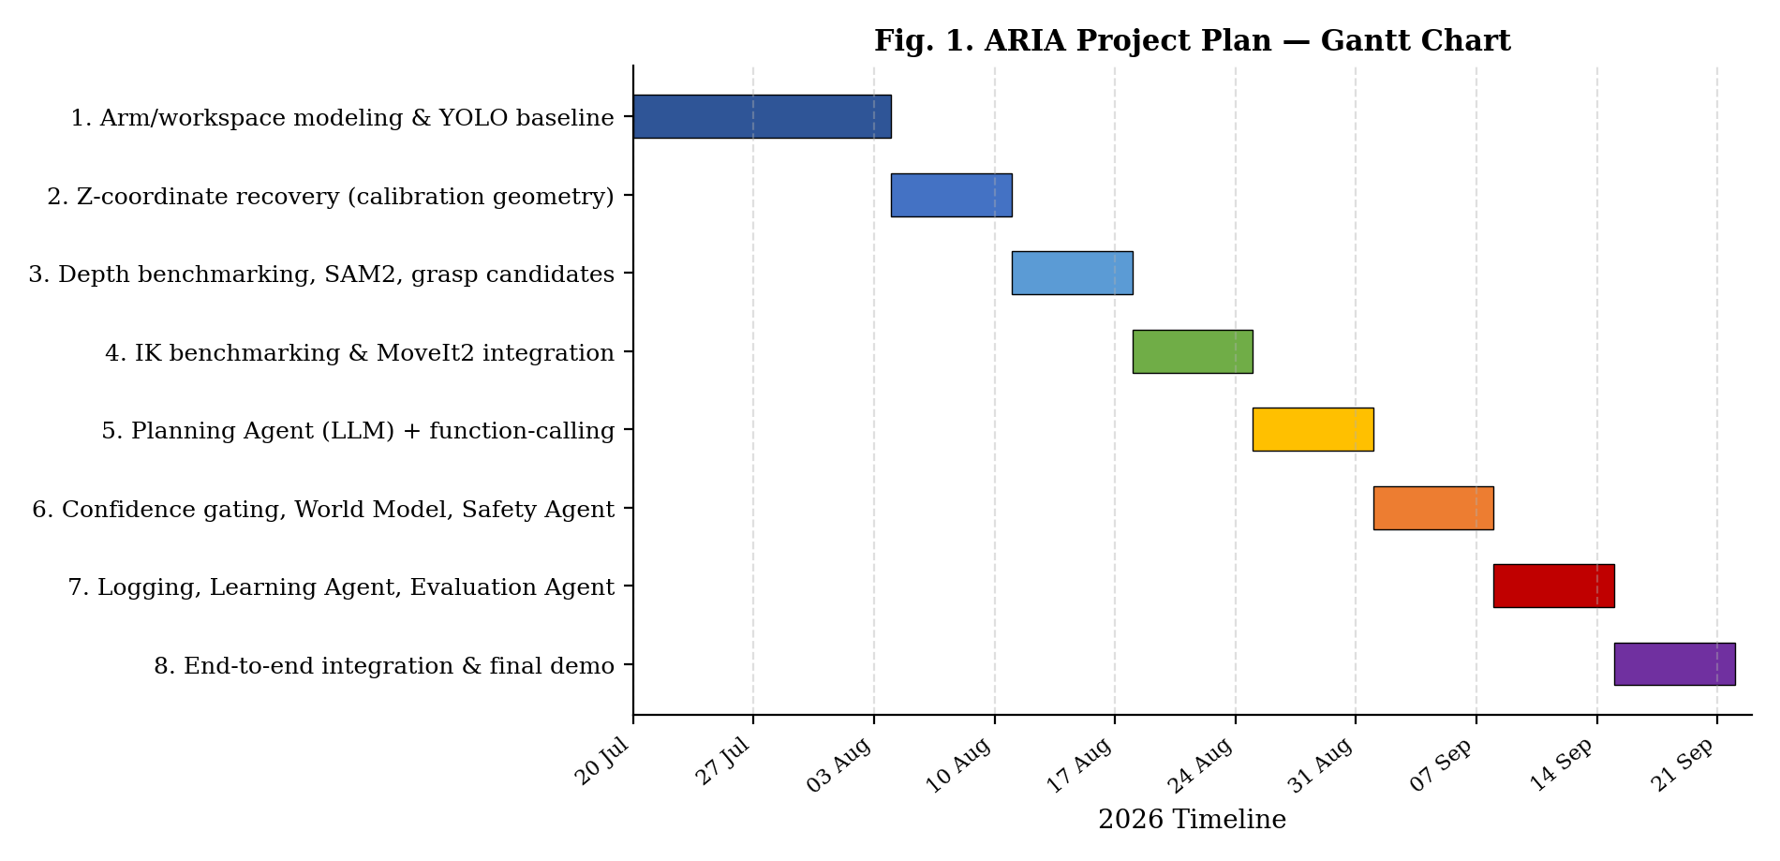
Figure 1. ARIA Project Plan — Gantt Chart (July–September 2026)
- WP1 (20 Jul – 3 Aug): 5-DoF arm and workspace modeled in simulation; YOLO detection baseline validated; camera/IMU brought online.
- WP2 (4–10 Aug): Z-coordinate recovery via calibration geometry validated against simulator ground truth; edge cases tested.
- WP3 (11–17 Aug): Depth-Anything vs. MiDaS benchmarked; SAM2 integrated; first GraspNet/AnyGrasp candidates ranked by the Affordance Agent.
- WP4 (18–24 Aug): IK solvers benchmarked and integrated with MoveIt2; first successful simulated pick-and-lift trajectory demonstrated.
- WP5 (25–31 Aug): Planning Agent (Llama 3.1 8B via Ollama) integrated with function-calling; affordance-based grasp selection demonstrated end-to-end.
- WP6 (1–7 Sep): Confidence-gated approval implemented; World Model Agent and Safety Agent validated against test scenarios.
- WP7 (8–14 Sep): Performance metrics logged; Learning Agent's first improvement pass; Evaluation Agent failure classification; pick/place/stack/sort tasks completed.
- WP8 (15–21 Sep): Full pipeline integrated end-to-end; chain-of-thought logging finalized; final demonstration recorded for submission.

3. TECHNICAL SPECIFICATION

3.1 Requirements
3.1.1 Functional
- The system shall accept spoken or typed natural-language commands and decompose them into goals, subgoals, and actions.
- The system shall detect, segment, and localize objects in the workspace using only a monocular camera feed.
- The system shall recover a real-world Z-coordinate without any dedicated depth sensor.
- The system shall generate and rank grasp candidates by how an object is actually used, not merely the nearest reachable surface.
- The system shall plan and execute collision-free, cable-aware trajectories to pick, place, stack, and sort objects.
- The system shall compute a confidence score per action and pause for user approval when confidence falls below a defined threshold.
- The system shall maintain a semantic World Model of known objects, including position, attributes, and lifecycle state.
- The system shall log performance metrics and classify failures to support continuous, self-supervised skill improvement.
3.1.2 Non-Functional
- Performance: Perception and planning should run at interactive rates on a single consumer GPU (RTX 5060 class).
- Reliability: The system should degrade gracefully — searching the workspace and retrying — rather than halting on a single failure.
- Safety: Motion planning must account for collision and cable-entanglement risk before any trajectory executes.
- Explainability: Every decision must be accompanied by a plain-language chain-of-thought log.
- Modularity: Perception, planning, and control layers should be loosely coupled enough to retarget to a different arm with modest rework.
- Extensibility: The skill library and agent set should support incremental addition of new skills (e.g., slide, roll, in-hand manipulation) without a full system rebuild.

3.2 Feasibility Study
3.2.1 Technical Feasibility
- All core components — YOLO, SAM2, Depth-Anything/MiDaS, GraspNet/AnyGrasp, MoveIt2, and Llama 3.1 8B via Ollama — are open, well-documented, and already used across robotics and vision research.
- The available compute (Intel i7-13700HX, RTX 5060) is sufficient to run perception, VLA inference, and LLM planning locally, though careful scheduling and quantization will be needed to keep all models within real-time budgets.
- ROS2 and MoveIt2 provide a mature middleware and motion-planning backbone for integrating the arm, sensors, and control agent.
3.2.2 Economic Feasibility
- Using SG90/MG995 servos and a $10–30 webcam in place of an industrial arm and RGB-D camera brings hardware cost down by an order of magnitude or more, keeping the project affordable for a single-student build.
- Running all AI models locally (via Ollama and open-source checkpoints) avoids recurring API or cloud-inference costs.
3.2.3 Social Feasibility
- Natural-language command input and confidence-gated approval make the system approachable for users without robotics programming expertise.
- Explicit chain-of-thought logging supports teaching use cases, letting students and reviewers follow the system's reasoning directly.

3.3 System Specification
3.3.1 Hardware Specification
Component | Specification
Mechanical frame | 5-DoF robotic arm frame
Actuation – fine joints | SG90 micro servos
Actuation – load-bearing joints | MG995 servos
Vision sensor | ESP32-CAM or Logitech C270
Orientation sensor | MPU6050 IMU (end effector)
Firmware / link | ESP32 Interface (bridges ROS2 to servo hardware)
Compute | Lenovo LOQ · Intel i7-13700HX · RTX 5060
Calibration hardware | AprilTag fiducials
3.3.2 Software Specification
Component | Specification
Middleware | ROS2
Motion framework | MoveIt2
LLM runtime | Ollama (Llama 3.1 8B)
Perception models | YOLO (v8/v9), SAM2, Depth-Anything, MiDaS
Grasp generation | GraspNet, AnyGrasp
VLA policies (benchmarked) | LeRobot, OpenVLA, Pi0, GR00T N1
IK solvers (benchmarked) | ikpy, roboticstoolbox-python, trac-ik, KDL, analytical, Neural IK
Programming languages | Python, ROS2 (Python/C++ nodes)

4. DESIGN APPROACH AND DETAILS

4.1 System Architecture
Figure 2 traces a single command from the moment it is spoken through to the arm actually moving, and then back through the monitoring and learning loop that feeds improvements back into planning. User input passes through a Dialogue Agent and a Planning Agent to a Task Manager, which dispatches work to six Perception/Cognition/Manipulation agent groups: Perception (Vision, Depth, Tracking), World Model, Skill, Reachability, Affordance, and Tracking agents. Their outputs feed a Motion Planning Pipeline (IK Agent, Motion Planner, Safety Agent, Trajectory generation), which is executed by the Control Agent through the ESP32 interface onto the physical 5-DoF arm.
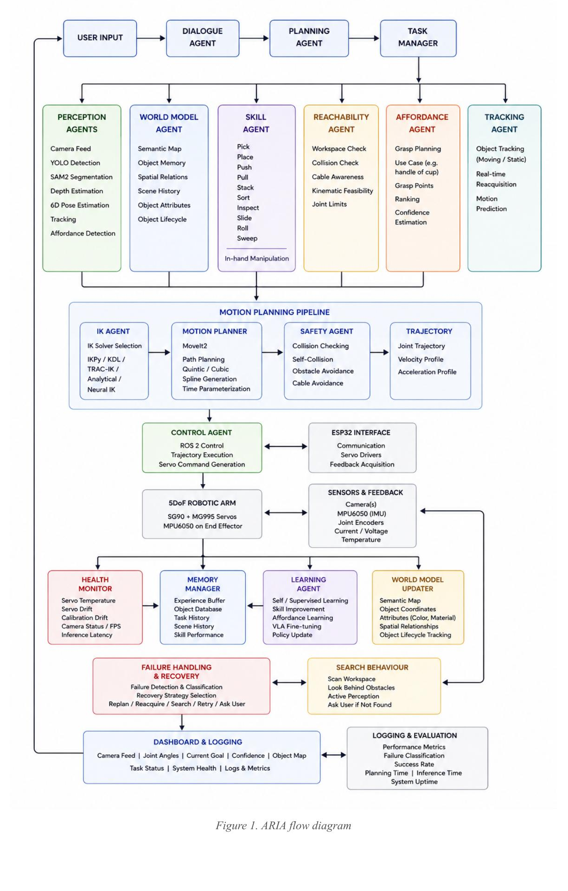
Figure 2. ARIA system architecture and execution flow
Sensor feedback flows back through the Health Monitor, Memory Manager, Learning Agent, and World Model Updater, which in turn feed the Failure Handling & Recovery and Search Behaviour modules and a Dashboard & Logging layer, closing the loop back to the Planning Agent so that future decisions are informed by past performance.

4.2 Detailed Design Diagrams
The following diagrams present ARIA's design from four complementary viewpoints — the flow of data through the system, the interactions available to its users, the static structure of its core agents, and the runtime message sequence for a single command.
4.2.1 Data Flow Diagram
Figure 3 traces information through ARIA as a Level-1 Data Flow Diagram. A user command enters the Dialogue/Planning process, which forwards a goal to Perception; detected objects pass to the Affordance/Grasp-Planning process, which returns a grasp pose to Motion Planning. Motion Planning generates a trajectory for the Control Agent, which sends servo commands and returns status back to the Safety/Health/Learning process. Two persistent data stores — the World Model (semantic map) and the Experience Log (skill/failure database) — are read from and written to throughout execution, closing the loop back to planning.
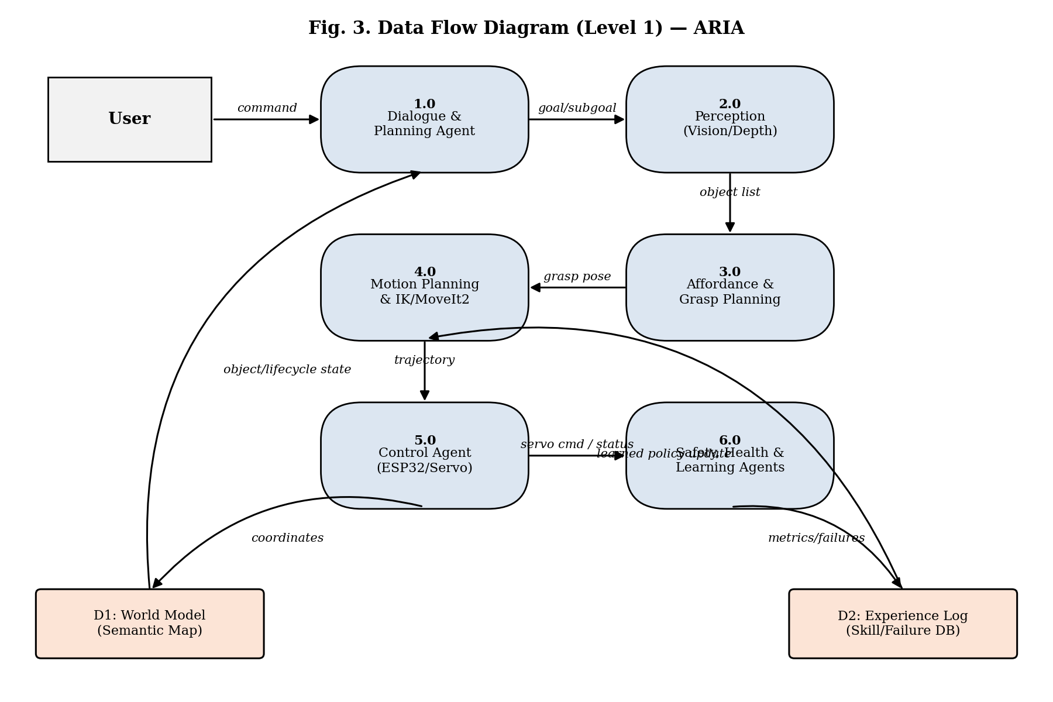
Figure 3. Data Flow Diagram (Level 1) — ARIA
4.2.2 Use Case Diagram
Figure 4 shows the two actors who interact with ARIA — the End User, who issues natural-language commands and approves low-confidence actions, and the Guide/Reviewer, who monitors the dashboard and reviews recovery behaviour — against the system's principal use cases: issuing commands, perceiving and localizing objects, planning affordance-aware grasps, executing pick/place/stack/sort actions, tracking moving objects, monitoring health, and recovering from failure.
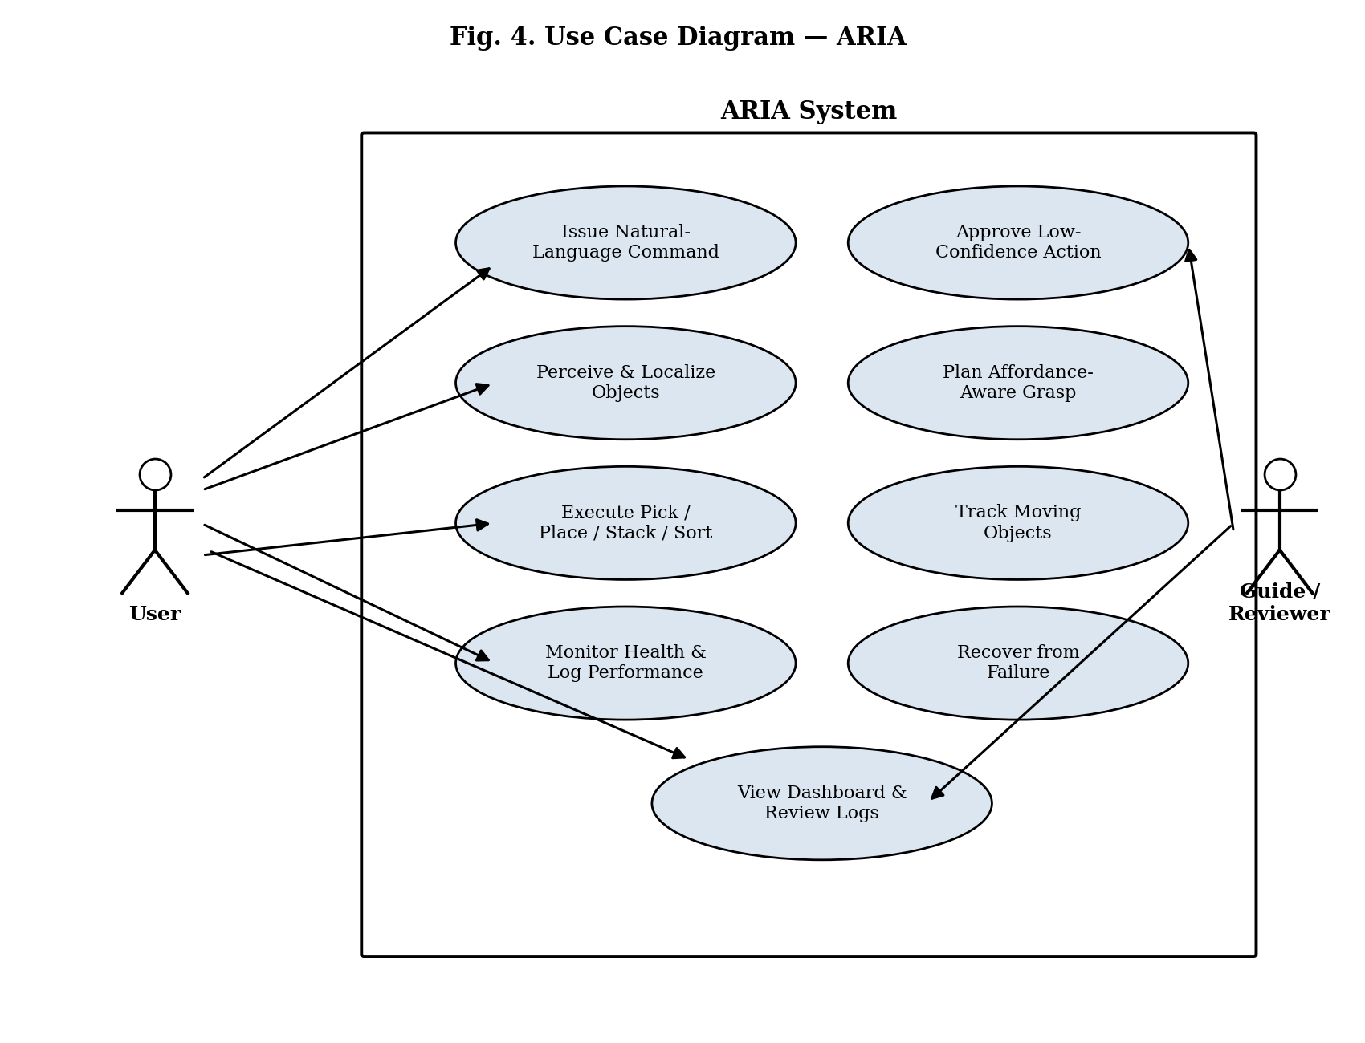
Figure 4. Use Case Diagram — ARIA
4.2.3 Class Diagram
Figure 5 shows the static structure of ARIA's core agent classes. A PlanningAgent decomposes commands and dispatches work to VisionAgent, DepthAgent, AffordanceAgent, and SafetyAgent. VisionAgent and DepthAgent feed a WorldModelAgent and a MotionPlanner respectively; AffordanceAgent feeds a ControlAgent through the MotionPlanner. A LearningAgent consumes logged data to update the MotionPlanner's policies over time, illustrating the self-improvement loop described in Section 4.3.
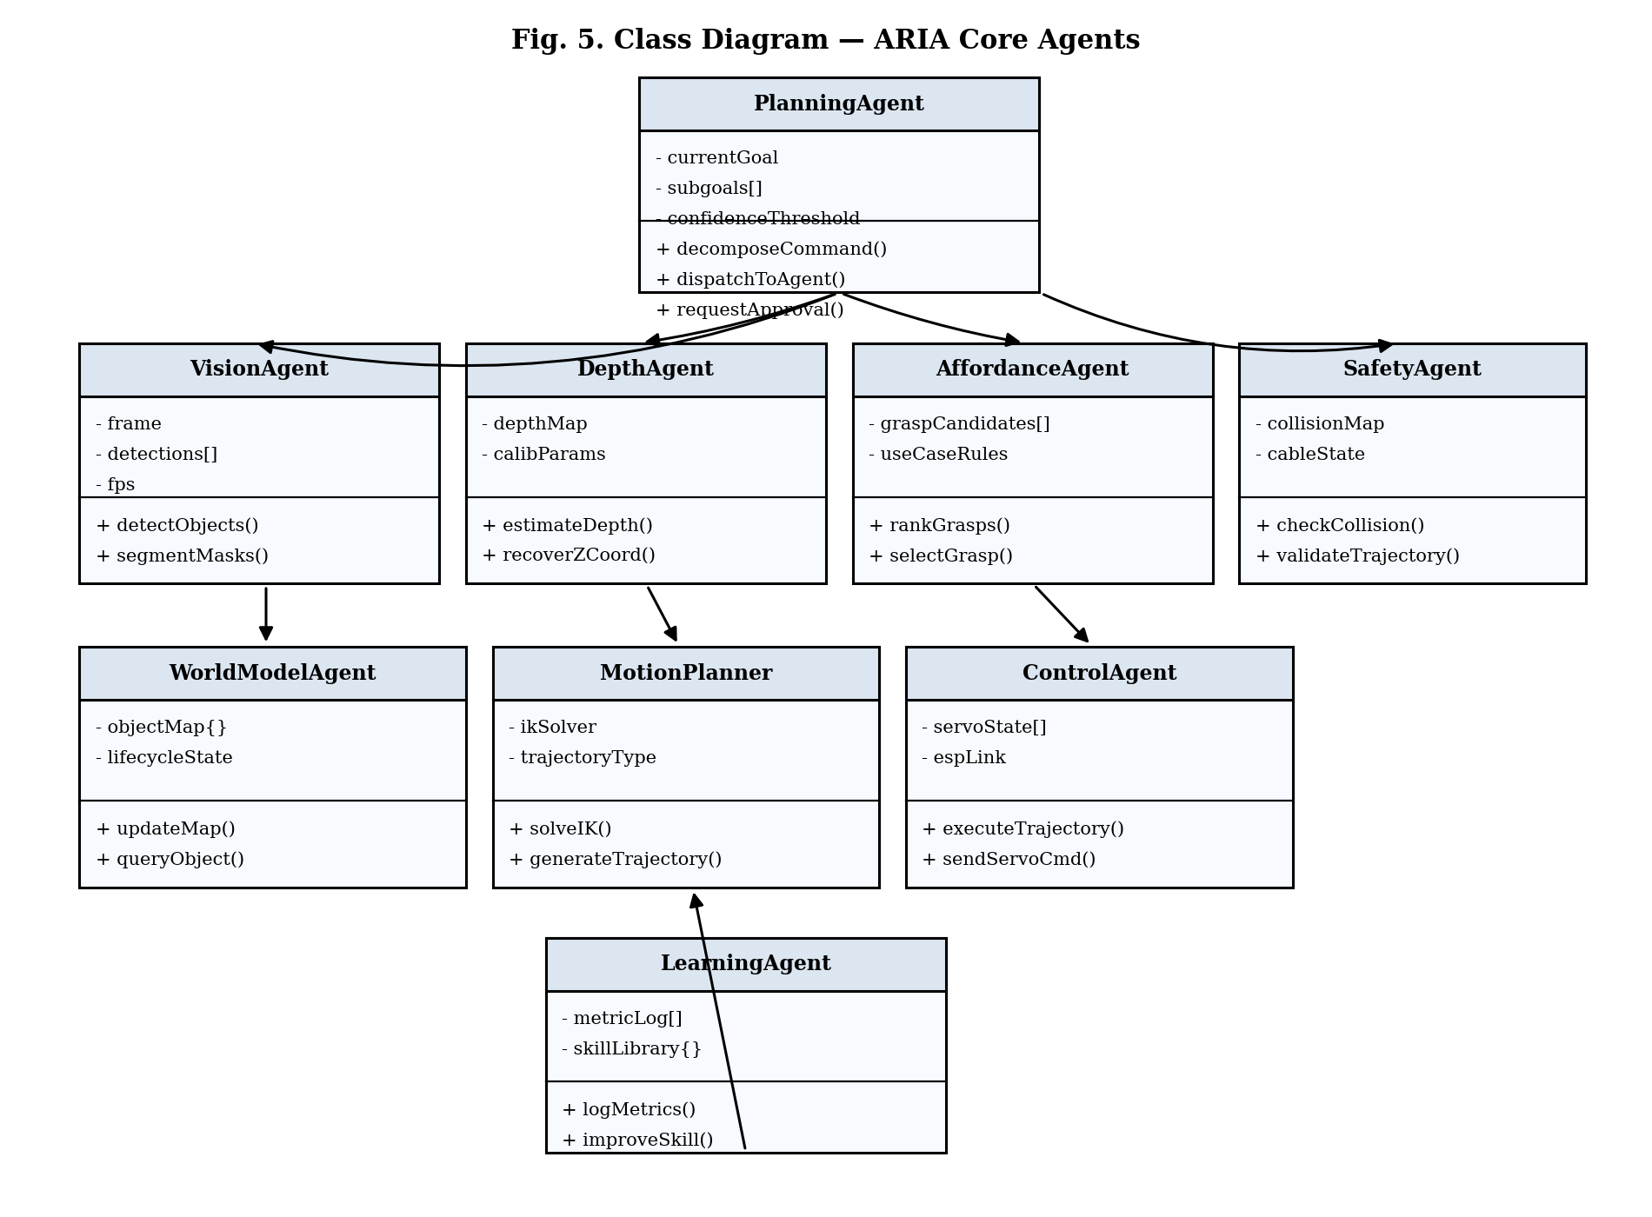
Figure 5. Class Diagram — ARIA Core Agents
4.2.4 Sequence Diagram
Figure 6 illustrates the runtime message sequence for a single command. The User's instruction is parsed by the Dialogue Agent and handed to the Planning Agent, which queries Perception/Affordance for a ranked grasp; Perception, in turn, queries the World Model for object pose and attributes. If the returned confidence meets the threshold, the Planning Agent dispatches execution directly to Motion & Control; otherwise it routes back through the Dialogue Agent to request the User's approval before proceeding. Execution results update the World Model's object lifecycle state and are relayed back to the User as a final confirmation.
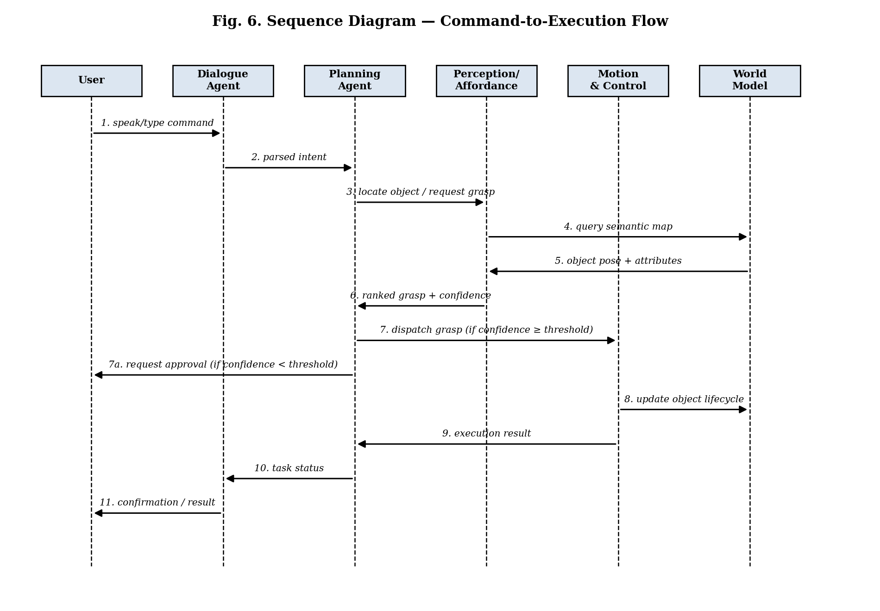
Figure 6. Sequence Diagram — Command-to-Execution Flow

4.3 Where the Novelty Lies
Individually, YOLO, depth estimation, GraspNet, MoveIt2, and open VLA policies are established building blocks in robotics research. ARIA's contribution is in how these pieces are wired together so that a $150–200 hobby-servo arm can behave like something closer to a research-grade platform, while remaining legible enough to debug:
- Agent-hierarchy scale. Around fifteen cooperating agents (vision, depth, tracking, affordance, planning, skill, control, safety, memory, world model, learning, evaluation, dialogue, attention, reachability) run together on a single consumer GPU.
- Hybrid perception. Classical camera-and-table-height calibration geometry combines with learned monocular depth to recover a trustworthy Z-coordinate, with no native depth sensing required.
- Affordance-and-confidence loop. Grasps are chosen based on how an object is actually used, and the system only pauses to ask the user when its own confidence estimate says it should.
- Self-supervised operational logging. IK error, pick success rate, recovery rate, and localisation drift feed directly into a Learning Agent that improves the skill library over time.
- Explainability. An explicit chain-of-thought log runs for every task, alongside cable-aware, self-calibrating motion planning on hobby servos.

4.4 Implementation Status and Results
Project is under active development — the results below reflect simulation validation completed to date, and not final end-to-end performance.
Completed So Far
- 5-DoF arm and workspace modeled in simulation; YOLO detection baseline validated against spawned test objects.
- Z-coordinate recovery via camera–table calibration geometry validated against simulator ground-truth poses.
- Depth-Anything and MiDaS benchmarked under varied simulated lighting for the perception pipeline.
- IK solvers (ikpy, roboticstoolbox, trac-ik, KDL, analytical) benchmarked on the arm's geometry.
Planned Metrics
- Pick success rate vs. baseline over repeated trials.
- IK / localization error — accuracy of solved joint targets.
- Planning & inference latency — end-to-end command-to-action time.
- Failure-category breakdown — missed object, slip, IK, collision, perception.
The next milestone is an end-to-end pick/place/stack/sort demonstration across a fixed set of simulated test scenes, with results classified by the Evaluation Agent, moving toward the Final Review.

5. REFERENCES
The following bibliography lists the peer-reviewed journal articles and conference papers consulted across ARIA's research domains, including teleoperation and imitation learning, 3D vision and spatial representation, kinematics and motion planning, robotics middleware and calibration, object pose estimation and tracking, vision-language-action foundation models, LLM-based task planning, robotic grasping, and predictive maintenance.

5.1 Journal Articles
Harish Ravichandar, Athanasios S. Polydoros, Sonia Chernova, Aude Billard, “Recent Advances in Robot Learning from Demonstration,” Annual Review of Control, Robotics, and Autonomous Systems, 2020.
Samuel Looper, Javier Rodriguez-Puigvert, Roland Siegwart, Cesar Cadena, Lukas Schmid, “3D VSG: Long-term Semantic Scene Change Prediction through 3D Variable Scene Graphs,” IEEE Robotics and Automation Letters (RA-L) / arXiv:2209.07896, 2023.
Rawan A. AlRashid Agha, Zhwan Hani Mahdi, Muhammed N. Sefer, Ibrahim Hamarash, “A ROS-Gazebo Interface for the Katana Robotic Arm Manipulation,” UKH Journal of Science and Engineering, 2021.
Rajkumar Muthusamy, Juan S. Toquica, et al., “A Multi-Robot Collaborative Manipulation Framework with Real-Time Distributed Optimization,” Frontiers in Robotics and AI (DOI: 10.3389/frobt.2025.1585544), 2025.
Louw Jakobus Murray, Verster Jaco, Dickens John, “Assessing Depth Anything V2 Monocular Depth Estimation as a LiDAR Alternative in Robotics,” MATEC Web of Conferences (RAPDASA-RobMech-PRASA-AMI 2025), 2025.
Umesh Kumar Sahu, Mebin K. S., Abhinav K., Muhammed Muzammil P., Ankur Jaiswal, Umesh Kumar Yadav, Santanu Kumar Dash, “Autonomous Object Tracking with Vision-Based Control Using a 2-DOF Robotic Arm,” Scientific Reports (Nature) (DOI: 10.1038/s41598-025-97930-3), 2025.
Mechanical Diagnostics Research Consortium, “Prognostics and Health Management of Rotating Machinery: A Review and Future Prospects,” Journal of Prognostics & System Health Management, 2023.
Steven Macenski, Tully Foote, Brian Gerkey, Chris Lalancette, William Woodall, “Robot Operating System 2: Design, Architecture, and Uses In The Wild,” Science Robotics (DOI: 10.1126/scirobotics.abm6074), 2022.
Vision and Autonomous Systems Group, “Speed-FairMOT: Multi-Class Multi-Object Tracking for Real-Time Robotic Applications,” IEEE Transactions on Automation Science and Engineering, 2023.
Manipulation and Soft Robotics Group, “Stress-Minimizing Grasping for Deformable and Fragile Objects,” IEEE Robotics and Automation Letters (RA-L), 2023.
Embodied AI Survey Group, “Vision-Language-Action Models in Robotic Manipulation: A Comprehensive Review,” Robotics and Autonomous Systems Review, 2024.
Kavitha, Vijayanand, “Deep Learning Approaches for Robotic Arm Trajectory Prediction and Kinematics,” International Journal of Intelligent Systems and Applications in Engineering (IJISAE), 2024.
Annual Reviews Control Editorial Consortium, “Autonomous Robotic Manipulation: Fundamental Algorithms and Future Directions,” Annual Review of Control, Robotics, and Autonomous Systems, 2024.
Toni Cvitanic, Shreyes Melkote, Stephen Balakirsky, “Improved State Estimation of a Robot End-Effector Using Laser Tracker and Inertial Sensor Fusion,” CIRP Journal of Manufacturing Science and Technology, 2022.
Nesrine Wagaa, Hichem Kallel, Nedra Mellouli, “Analytical and Deep Learning Approaches for Solving the Inverse Kinematic Problem of High-DOF Robotic Arms,” Engineering Applications of Artificial Intelligence, 2023.
Guoai Ren, Xiaoqin Liu, Feng Song, “Remaining Useful Life Prediction of Industrial Robot RV Reducer with Multiple Deep Networks and Multicore Support Vector Data Description,” Journal of Mechanical Engineering / PHM, 2024.
Shunxiang Pang, Fan Guo, Bin Zhang, Hai Huang, Xiaoyang Pan, Weiwei Shang, “High-Stiffness Path Planning for 7-DOF Cable-Driven Manipulators in Single and Dual-Arm Configurations,” IEEE Transactions on Robotics / Mechatronics, 2025.
Shaolong Ling, et al., “Prognostics and Health Management of the Robotic Servo-Motor under Variable Operating Conditions,” Mathematics (MDPI) (DOI: 10.3390/math11020398), 2023.
Mobile AR Robotics Group, “Using Mobile AR for Rapid Feasibility Analysis for Deployment of Robotic Arms,” IEEE Robotics and Automation Letters (RA-L), 2025.
Active Vision-Action Group, “Observe Then Act: Asynchronous Active Vision-Action Model for Robotic Manipulation,” IEEE Robotics and Automation Letters (RA-L), 2025.
Shaolong Ling, et al., “Prognostics and Health Management of the Robotic Servo-Motor under Variable Operating Conditions,” Mathematics (MDPI), 2023.
Jiaqi Jiang, et al., “Robotic Perception of Transparent Objects: A Review,” IEEE Transactions on Artificial Intelligence (DOI: 10.1109/TAI.2023.3268800), 2023.
MDPI Sensors Robotics Authors, “Adaptive Grasp Pose Optimization for Robotic Arms Using Low-Cost RGB-D Sensors,” Sensors (MDPI) (DOI: 10.3390/s25030909), 2025.
Diogo Vieira, Miguel Martins, et al., “Application of Cloud Simulation Techniques for Robotic Software Validation,” Sensors (MDPI) (DOI: 10.3390/s25051693), 2025.
Sensor Fusion Research Team, “Time and Frequency Domain Analysis of IMU-Based Orientation Estimation Algorithms with Comparison to Robotic Manipulators,” Sensors (MDPI) (DOI: 10.3390/s25165161), 2025.
Yicheng Zhu, et al., “Deformable and Fragile Object Manipulation: A Review and Prospects,” Sensors (MDPI) (DOI: 10.3390/s25175430), 2025.
Hongjie Fang, Hao-Shu Fang, Sheng Xu, Cewu Lu (Shanghai Jiao Tong University), “TransCG: A Large-Scale Real-World Dataset for Transparent Object Grasping and Depth Estimation,” IEEE Robotics and Automation Letters (RA-L) / arXiv:2202.08471, 2022.
Tao Chen, Megha Tippur, Siyang Qin, Edward Adelson, Pulkit Agrawal (MIT), “Visual Dexterity: In-Hand Reorientation of Novel and Complex Object Shapes,” Science Robotics / arXiv:2211.11744, 2023.
Journal of Robotics and Mechatronics Authors, “Wide-Range and Real-Time 3D Tracking of a Moving Object by Dynamic Vision Sensor,” Journal of Robotics and Mechatronics (DOI: 10.20965/jrm.2025.p0399), 2025.

5.2 Conference Papers
Bernhard Kerbl, Georgios Kopanas, Thomas Leimkühler, George Drettakis, “3D Gaussian Splatting for Real-Time Radiance Field Rendering,” ACM Transactions on Graphics (SIGGRAPH 2023) / arXiv:2308.04079, 2023.
IEEE ROMAN Research Team, “LLM-Based Ambiguity Detection in Natural Language Instructions for Collaborative Surgical Robots,” IEEE International Conference on Robot and Human Interactive Communication (ROMAN), 2025.
Octo Model Team (Dibya Ghosh, Homer Walke, Karl Pertsch, Kevin Black, Oier Mees, et al.), “Octo: An Open-Source Generalist Robot Policy,” Robotics: Science and Systems (RSS 2024) / arXiv:2405.12213, 2024.
Adam Fishman, Murtaza Dalal, Michael Posa, et al., “Avoid Everything: Real-Time Dynamic Obstacle Avoidance for Robot Manipulators,” Robotics: Science and Systems (RSS 2025), 2025.
Edwin Olson, “AprilTag: A Robust and Flexible Visual Fiducial System,” IEEE International Conference on Robotics and Automation (ICRA) (DOI: 10.1109/ICRA.2011.5979561), 2011.
John Wang, Edwin Olson, “AprilTag 2: Efficient and Robust Fiducial Detection,” IEEE/RSJ International Conference on Intelligent Robots and Systems (IROS) (DOI: 10.1109/IROS.2016.7759617), 2016.
Fethiye Irmak Doğan, Ilaria Torre, Iolanda Leite, “Asking Follow-Up Clarifications to Resolve Ambiguities in Human-Robot Conversation,” ACM/IEEE International Conference on Human-Robot Interaction (HRI), 2022.
Ali Jlidi, Rabab Benotsmane, László Kovács, Attila Trohák, “A Novel Graph Neural Network Approach for Inverse Kinematics in Robotic Arms,” IEEE International Conference on Cognitive Infocommunications (ICCC), 2025.
Attila Aradi, Attila Varga, “Predictive Maintenance for Servo Motors Using Kafka Streams and Machine Learning Based on Acoustic Microphones,” Springer Lecture Notes / Industry 4.0, 2025.
Mujin Kim, Sejun Park, Heoung-Jae Chun, Jongsoo Lee, “Physics-Aided RUL Prediction of Pick-and-Place Robotic Arms Using Dynamic Simulation and GMM-Based Health Indicator,” PHM Society European Conference, 2026.
Shreeyak Sajjan, Matthew Moore, Mike Pan, Ganesh Nagaraja, Johnny Lee, Andy Zeng, Shuran Song, “ClearGrasp: 3D Shape Estimation and Grasping of Transparent Objects,” IEEE International Conference on Robotics and Automation (ICRA 2020), 2020.
Balakumar Sundaralingam, Siva Kumar S. S. Sastry, et al. (NVIDIA), “cuRobo: Parallelized GPU-Accelerated Robot Motion Generation and Collision Checking,” IEEE International Conference on Robotics and Automation (ICRA 2024), 2024.
Bowen Wen, Wei Yang, Jan Kautz, Stan Birchfield (NVIDIA Research), “FoundationPose: Unified 6D Pose Estimation and Tracking of Novel Objects,” CVPR 2024 / arXiv:2312.08344, 2024.
Van Nguyen Nguyen, Thibault Groueix, Vincent Lepetit, “GigaPose: Fast and Robust Novel Object Pose Estimation via CAD Models,” CVPR 2024 / arXiv:2311.14155, 2024.
Hao-Shu Fang, Chenxi Wang, Minghao Gou, Cewu Lu, “GraspNet-1Billion: A Large-Scale Benchmark for General Object Grasping,” CVPR 2020 / arXiv:1912.13470, 2020.
Jiefeng Li, Chao Xu, Zhicun Chen, Siyuan Bian, Cewu Lu, “HybrIK: A Hybrid Analytical-Neural Inverse Kinematics Solution for 3D Mesh Recovery and Robotics,” CVPR 2021 / arXiv:2011.14672, 2021.
Robot Learning Consortium, “Learning 3D Grasp Synthesis from Demonstration: ICML Final,” International Conference on Machine Learning (ICML 2011), 2011.
Andy Zhou, Kai Yan, Michal Shlapentokh-Rothman, Haohan Wang, Yu-Xiong Wang, “Language Agent Tree Search Unifies Reasoning, Acting, and Planning in Language Models (LATS),” ICLR 2024 / arXiv:2310.04406, 2024.
Yann Labbé, Lucas Manuelli, Arsalan Mousavian, Stephen Tyree, Stan Birchfield, et al., “MegaPose: 6D Pose Estimation of Novel Objects via Render & Compare,” CoRL 2022 / arXiv:2212.06870, 2022.
Ajay Mandlekar, Soroush Nasiriany, Bowen Wen, Iretiayo Akinola, Yashraj Narang, Linxi Fan, Yuke Zhu, Dieter Fox, “MimicGen: A Data Generation System for Scalable Robot Learning using Human Demonstrations,” CoRL 2023 / arXiv:2310.17596 (NVIDIA), 2023.
Jason Wei, Xuezhi Wang, Dale Schuurmans, Maarten Bosma, Fei Xia, Ed Chi, Quoc V. Le, Denny Zhou (Google Brain), “Chain-of-Thought Prompting Elicits Reasoning in Large Language Models,” NeurIPS 2022 / arXiv:2201.11903, 2022.
Shibo Hao, Yi Gu, Haodi Ma, Joshua Jiahua Hong, Zhen Wang, Daisy Zhe Wang, Zhiting Hu, “Reasoning with Language Model is Planning with World Model (RAP),” EMNLP 2023 / arXiv:2305.14992, 2023.
Jiehong Lin, Lihua Liu, Dekun Lu, Kui Jia, “SAM-6D: Segment Anything Model Meets Zero-Shot 6D Object Pose Estimation,” CVPR 2024 / arXiv:2311.15707, 2024.
Shunyu Yao, Dian Yu, Jeffrey Zhao, Izhak Shafran, Thomas L. Griffiths, Yuan Cao, Karthik Narasimhan (Princeton & Google DeepMind), “Tree of Thoughts: Deliberate Problem Solving with Large Language Models,” NeurIPS 2023 / arXiv:2305.10601, 2023.

5.3 Books
B. Siciliano, L. Sciavicco, L. Villani, and G. Oriolo, Robotics: Modelling, Planning and Control. London, U.K.: Springer, 2009.
J. J. Craig, Introduction to Robotics: Mechanics and Control, 4th ed. Boston, MA: Pearson, 2018.
P. Corke, Robotics, Vision and Control: Fundamental Algorithms in MATLAB, 3rd ed. Cham, Switzerland: Springer, 2023.
S. M. LaValle, Planning Algorithms. Cambridge, U.K.: Cambridge University Press, 2006.
S. Russell and P. Norvig, Artificial Intelligence: A Modern Approach, 4th ed. Boston, MA: Pearson, 2020.

5.4 Websites
Open Robotics, “ROS 2 Documentation,” https://docs.ros.org, accessed 2026.
PickNik Robotics, “MoveIt 2 Documentation,” https://moveit.picknik.ai, accessed 2026.
Ollama Inc., “Ollama — Get up and running with large language models locally,” https://ollama.com, accessed 2026.
Ultralytics, “YOLOv8/v9 Documentation,” https://docs.ultralytics.com, accessed 2026.
Hugging Face, “LeRobot: State-of-the-Art Machine Learning for Real-World Robotics,” https://github.com/huggingface/lerobot, accessed 2026.
NVIDIA, “cuRobo: CUDA Accelerated Robot Library,” https://curobo.org, accessed 2026.
Meta AI (FAIR), “Segment Anything Model 2 (SAM 2),” https://ai.meta.com/sam2/, accessed 2026.
E. Olson, “AprilTag Visual Fiducial System,” https://april.eecs.umich.edu/software/apriltag, accessed 2026.
Physical Intelligence, “π-series Vision-Language-Action Models,” https://www.physicalintelligence.company, accessed 2026.
NVIDIA, “Isaac GR00T Foundation Model for Humanoid Robots,” https://developer.nvidia.com/isaac/gr00t, accessed 2026.
L. Yang et al., “Depth Anything V2 Project Page,” https://depth-anything-v2.github.io, accessed 2026.
Shanghai Jiao Tong University, “GraspNet: A Large-Scale Benchmark for General Object Grasping,” http://graspnet.net, accessed 2026.

