UNIT 1(Advanced java programming)
AWT
- When Java 1.0 was introduced, it contained a class library, called the Abstract Window Toolkit (AWT), for basic GUI programming.
- AWT is platform-dependent in terms of GUI rendering,but platform-independent in terms of code execution.(compile and bytecode runs)
- How AWT works?
  - AWT uses something called the peer-based architecture.
  - Each AWT component (like Button, TextField, Checkbox) has a peer object, which is a native object provided by the operating system.
  - The AWT component in Java acts like a wrapper, delegating the actual drawing and behavior to the peer.
Example:
1. The JVM creates a Java object for TextField.
2. Behind the scenes, the AWT Toolkit asks the operating system to create a native text box (the peer).
- On Windows → a Win32 textbox is created.
- On Linux → a GTK/X11 textbox is created.
- On macOS → a Cocoa textbox is created.
So in short:
AWT → delegates to native peers → platform-dependent look & behavior.

What is Peer-Based Architecture?
- In AWT, every GUI component (like Button, TextField, Checkbox) has a peer object.
- A peer is a bridge between the Java AWT component and the native GUI component of the operating system.

Button b = new Button("Click Me"); // create an object of type Button
- Behind the scenes, AWT uses the class Toolkit to ask the OS to create a native button.
- The Toolkit returns a peer object that acts as a wrapper around the native button.
- When you click the button, the event is actually handled by the native button (peer), and then passed back to your Java program.
  - On Windows → WButtonPeer.
  - On Linux (X11) → XButtonPeer.
  - On macOS → CButtonPeer.
Java AWT Component (Button)
↓
Peer Object (ButtonPeer)
↓
Native OS Component (Windows/Linux/Mac button)

What is Toolkit in AWT?
- Toolkit is an abstract class in the java.awt package.
- It acts as the interface between Java’s AWT components and the native operating system.
- Every JVM has a platform-specific implementation of Toolkit.
So, when you write AWT code, you’re not directly calling the OS — you’re calling Toolkit, which knows how to talk to the OS.
Role of Toolkit
- Creates Peers
  - When you make an AWT component (Button, TextField, Frame), the Toolkit creates the peer object for that component.
  - Example:
  - Button b = new Button("Click");
  - Toolkit internally creates a ButtonPeer that maps to the native button.
- Handles Graphics
  - Provides methods to get screen resolution, fonts, images, etc.
  - Example: Toolkit.getDefaultToolkit().getScreenSize();
- Bridges to Native Windowing System
  - Translates Java method calls into OS-specific system calls.
  - Ensures the component shows up on screen and responds to user input.

Communication Flow

Your Java Code
↓
AWT Component (e.g., Button)
↓
Toolkit (abstract API, JVM picks OS-specific implementation)
↓
Peer (e.g., ButtonPeer → WButtonPeer / XButtonPeer)
↓
Native OS GUI (Windows/Linux/macOS GUI library)
Example
import java.awt.*;
public class ToolkitExample {
public static void main(String[] args) {
Toolkit tk = Toolkit.getDefaultToolkit();
Dimension screenSize = tk.getScreenSize();
System.out.println("Screen width: " + screenSize.width);
System.out.println("Screen height: " + screenSize.height);
}
}
Toolkit.getDefaultToolkit() → loads the platform-specific toolkit.
On Windows, it uses sun.awt.windows.WToolkit.
On Linux, it uses sun.awt.X11.XToolkit.
These classes are part of the JDK and know how to make OS calls.
Key Point
- Toolkit = Mediator between Java AWT and the native OS GUI subsystem.
- You write one Java program, and Toolkit ensures it runs on different platforms, though with platform-specific look & feel.

Swing: Peerless (Lightweight)

- Swing removes most of the dependency on native peers.
- Swing components (like JButton, JTextField) are written in pure Java.
- They are drawn on the screen using Java 2D API instead of asking the OS to render them.
- Only the top-level containers (JFrame, JDialog, JWindow, JApplet) still rely on AWT peers to get a “window” from the OS.
    - Inside that window, everything else is drawn by Java itself.

Swing hierarchy
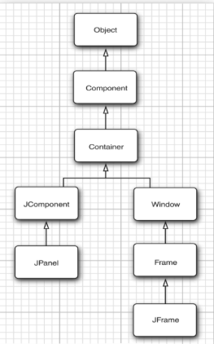
- Component (java.awt.Component)
- Base class for all GUI elements.
- Anything you see on the screen (button, label, text field, panel, window) is a Component as everything extends component.
- Provides common features:
- Size, position → setBounds(), setSize(), setLocation()
- Appearance → setBackground(), setForeground(), setFont()
- Painting → paint(Graphics g) (how it is drawn) .// awt feature
Think: “If it’s visible, it’s a Component.”

- Container (java.awt.Container)
- A specialized Component that can hold other components.
- Adds methods for managing children:
  - add(Component c)
  - remove(Component c)
  - setLayout(LayoutManager mgr)
- Uses Layout Managers to arrange children (FlowLayout, BorderLayout, GridLayout).
Think: “A box that can hold other Components.”

- JComponent (javax.swing.JComponent)
- Base class for all Swing lightweight components (JButton, JLabel, JTextField, etc.).
- Extends Container.
- Adds Swing features:
- Double buffering (smooth graphics, less flicker)
- Tooltips
- Custom painting → paintComponent(Graphics g)
Think: “The heart of all Swing components.”
Abstract class → cannot be instantiated directly.

- JPanel (javax.swing.JPanel)
- A lightweight container (extends JComponent).
- Used for grouping components.
- By default → FlowLayout, but can change using setLayout().
- Often used for organizing UI and custom drawing.
Think: “A flexible drawing board or container inside a window.”

- Window (java.awt.Window)
- A top-level container (extends Container).
- Appears as a separate window on the screen.
- Has no title bar, border, or menu by itself.
- Parent of Frame and Dialog.
Think: “A blank window on the desktop.”
- Frame (java.awt.Frame)
- A Window with a title bar, border, and buttons (minimize, maximize, close).
- Part of AWT.
- Can have a menu bar via setMenuBar(MenuBar m).
Think: “An actual application window (old AWT style).”

- JFrame (javax.swing.JFrame)
- Swing’s main top-level window (extends Frame).
- Has everything Frame provides, plus Swing features.
- Provides a content pane:
  - Components are added to the content pane (frame.add(...)).
- Common methods:
- setDefaultCloseOperation(JFrame.EXIT_ON_CLOSE)
- setSize(width, height)
- setVisible(true)
Think: “The main window of a Swing application.”

What is JFrame?
In Java Swing, a JFrame is a top-level container, meaning it is a standalone window with its own title bar, borders, and decorations managed by the operating system's windowing system. Top-level containers like JFrame, JDialog, and JWindow are not designed to be added as children to other containers, including other JFrame instances.

- JFrame is a class in Swing (javax.swing.JFrame) used to create a top-level window for desktop GUI applications.
- It represents the main window where you place all your UI components like buttons, labels, panels, etc.
- JFrame inherits from Frame (which comes from AWT).
- Because it extends Container, it can hold other components.
- It is a top-level container (doesn’t need to be added to another container).

It’s basically the “window” with title bar, minimize/maximize/close buttons.

Key Features of JFrame

- Title bar → you can set it with setTitle("My App").
- Close/minimize/maximize buttons.
- Resizable (can be enabled/disabled with setResizable(true/false)).
- Has a default content area where you add components.
(Technically, you add components to content pane getContentPane() rather than directly to the frame, still it happens indirectly)

Important Methods
- setTitle(String title) → set window title.
- setSize(int width, int height) → set dimensions.
- setBounds(x, y, w, h) → set position and size at once.
- setVisible(true) → make the frame visible.
- setDefaultCloseOperation(int operation) → what happens when you click “X”:
  - EXIT_ON_CLOSE → terminates program.
  - DISPOSE_ON_CLOSE → closes only that window.
  - HIDE_ON_CLOSE → hides the frame.
  - DO_NOTHING_ON_CLOSE → nothing happens.
- getContentPane() → returns the main container where components go.
- add(Component c) → add a component (e.g. JButton, JPanel).

By default decorations is enabled:

To undecorate we do:
frame.setUndecorated(true);
no decorations (no title bar, no borders), the actual area of content pane.

can one JFrame add another JFrame ? Answer = NO
JFrame f1 = new JFrame("first");
JFrame f2 = new JFrame("second");
f1.add(f2); // ❌ Not allowed

import javax.swing.*;

public class JFrameExample {
public static void main(String[] args) {
// Create JFrame
JFrame frame = new JFrame("My First JFrame");

// Set size
frame.setSize(400, 300);

// Close operation
frame.setDefaultCloseOperation(JFrame.EXIT_ON_CLOSE);

// Add a button
JButton button = new JButton("Click Me");
frame.add(button); // adds to content pane (indirectly it is actually added to //contentPane , frame.getContentPane().add(btn); // correct way

// Make visible
frame.setVisible(true);
}
}

Internal Structure of JFrame

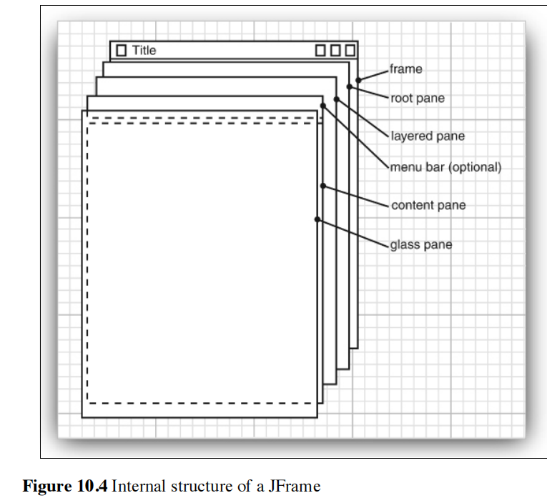

All are the parts of JRootPane:

Glass pane
Layered pane
Content pane
Menu bar

JRootPane
It is the invisible container that organizes the glass pane, layered pane, content pane, menu bar, and popups in every JFrame, JDialog, or JWindow.
Layer | Role | Access Method
Glass Pane | Transparent layer on top — used for effects, blocking input, drawing overlays. Eg: show loading/waiting | frame.getGlassPane()
Layered Pane | Manages depth (Z-order) — holds content pane, and pop-ups. | frame.getLayeredPane()
Content Pane | The area where your app’s components (like buttons, panels, labels) go. (Actual UI) | frame.getContentPane()
Menu Bar | Optional — for JMenuBar. | frame.getJMenuBar()

Hierarchy
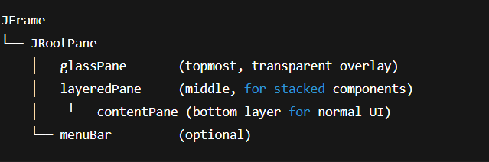

Glass pane:
The Glass Pane is a transparent top layer in JRootPane used to block input and show overlays like loading screens, add empty mouse listeners to block clicks.

JLayeredPane
It is a special container in Swing that lets you stack components on top of each other.(the components are sent to depths according to layer, the more , the more on top).

Content pane:
The Content Pane is the main container inside a JFrame where you add your JPanels and other components.
frame.getContentPane() returns the main JPanel inside the frame.

Displaying Information in a component:
You could draw the message string directly onto a frame, but that is not
considered good programming practice. since frames are designed
to be containers for components, instead of drawing the string directly, we add the strings through other components,
eg: JLabel label = new JLabel("Enter your name:");
let’s see how to paint something on the component:
Create custom component by:
import javax.swing.*;
import java.awt.*;

public class MyComponent extends JComponent {

@Override
public void paintComponent(Graphics g) {
super.paintComponent(g);
g.setColor(Color.BLUE);
g.drawString("Hello World", 1, 20);
// g.setColor(Color.RED);
// g.setFont(new Font("Times New Roman", Font.BOLD, 40));
// g.drawString("Second World", 100, 300);
}
}

import javax.swing.*;
public class RunnerClass {
public static void main(String[] args) {
JFrame frame = new JFrame();
frame.setDefaultCloseOperation(JFrame.EXIT_ON_CLOSE);
frame.setSize(800, 600);
MyComponent myComponent = new MyComponent();
frame.add(myComponent);
frame.setVisible(true);
}
}
Painting flow in swing:
- Swing calls paintComponent(Graphics g) of a component.
- This uses Java 2D API to draw shapes, text, and images.
- The drawing is the same on all platforms → consistent look & feel.

Button b = new Button("Click Me"); // Uses OS button when AWT
JButton b = new JButton("Click Me"); // Drawn by Java 2D for Swing
How it works:
JButton btn = new JButton("Click Me"); // when you do this

Your Code (JButton)
↓
JComponent
↓
Java 2D (painting system)

Responsibilities of JComponent
Here’s what JComponent provides to all Swing components:
1. Painting & Rendering
- Defines paintComponent(Graphics g) → where the component draws itself.
- Instead of delegating to a peer (like AWT), Swing uses Java 2D to draw text, shapes, and images directly.
Example:
@Override
protected void paintComponent(Graphics g) {
super.paintComponent(g);
g.drawString("Hello Swing!", 20, 20);
}
So when we do
@Override
protected void paintComponent(Graphics g) {
super.paintComponent(g); // Clear background
g.setColor(Color.RED);
g.fillOval(20, 20, 100, 100);
}

What Swing Does Automatically

// This runs in the background (you don't write it)
public void paint(Graphics g) {
paintComponent(g); // ← Your code runs
paintBorder(g); // ← Border
paintChildren(g); // ← All child components
}

Double buffering and flickering (how the components are being painted)
Normally, when a component is drawn on the screen, each small drawing operation (like drawing a rectangle, text, or image) is sent directly to the screen one by one.
This can cause flickering, because the user can see the intermediate steps of drawing.
Double buffering solves this by:
- Drawing everything first on an off-screen image (a hidden buffer).
- Copying the fully drawn image to the screen in one step(at once).

