**TITLE: ROBO-EXPLORER**

**Name of Authors:**

Rodrigo Bonzerr S. Lopez 2021

**Intro scene:**

**Narrator**: Screen is panning around the destroyed city of Terrofadia.

**Narrator**: The world is in ruins… year 2044, resources are low, and humanity is looking for a way to salvage the remaining resources for survival. Mutated monsters roam around the city and other parts of the world. An after effect of human experiments that intoxicated the environment.

**Narrator**: Robo Explorer is a humanoid that was created by Dr. Ambervad. As a last resort to a dying civilization. This humanoid was once a human being that was one of the casualties of the “GREAT WAR”.

Dr. Ambervad was able to salvage the brain of the man who once saved him during the chaotic war that happened five years ago.

**Scene:**

Starts with a dark screen and slowly shows a blinking eye of the newly booted humanoid.

Humanoid looks around the laboratory and starts to walk moving towards the unfamiliar face of Dr. Ambervard.

**\*\*\*\*\*\*\*\*\*\*\*\*\*\*\*\*\*\*\*\*\*\*\*\*\*\*\*\*\*\*\*\*\*\*\*\*\*\*\*\*\*\*\*\*\*\*\*\*\*\*\*\*\*\*\*\*\*\*\*\*\*\*\*\*\*\*\*\*\*\*\*\*\*\*\*\*\*\***

**Robo-Explorer:** Where am I? What happened to me?

**Dr.Ambervard:** Hello, Robo-Explorer. I am Dr. Ambervard, you saved me from one of the monsters that got into this laboratory 5 years ago during the “GREAT WAR”.

**Robo-Explorer:** I can’t remember…

**Dr. Ambervard:** You are a hero Robo-Explorer, that is what you need to know. You saved a lot of lives not only mine way back then. You can try to access parts of your memory through a device that I’ve created, however, that device is stored in a laboratory that we had to evacuate due to the monsters flooding it. It’s located in a safe storage, and I highly doubt that the monsters can find it, but the greatest challenge to get that device are the obstacles to getting into that laboratory. It will not be easy to pass through the monsters to get to that laboratory which is located out of the safe zone of Terrofadia city.

**Narrator:**

As Dr. Ambervard was explaining to Robo-explorer their current condition, a sound of distress was triggered, and someone was calling out the name of Dr. Ambervard.

**\*\*\*\*\*\*\*\*\*\*\*\*\*\*\*\*\*\*\*\*\*\*\*\*\*\*\*\*\*\*\*\*\*\*\*\*\*\*\*\*\*\*\*\*\*\*\*\*\*\*\*\*\*\*\*\*\*\*\*\*\*\*\*\*\*\*\*\*\***

**TERROFADIA TUNNEL**

There are other survivors in the City of Terrofadia that depend on Dr. Ambervad’s leadership. A small number of remaining residents in the city after it was destroyed by the aftermath of the “GREAT WAR”.

Dr. Ambervad was one of the people who decided to take in some of the survivors into his laboratory that was secured from the aftermath of the war. He continued searching for survivors and helped them by inviting them into his lair to provide some roof and supplies to them.

Dr. Ambervad organized the people in groups when exploring at first but due to the aftermath of the “GREAT WAR”, more and more monsters are appearing within the city. Monsters that mutated from the bio genetic elements that were released during the war. This puts the lives of the people at stake every time they try to explore the city for supplies and other survivors.

Dr. Ambervad was alerted by one of the citizens of TERROFADIA, a mother was looking for her child that got lost in the **TERROFADIA TUNNELS** when the kid accidentally fell from one of the open holes in the destroyed city while playing with other kids.

********************************************************

**Joana:** Dr. Ambervard, I need your help. Luis fell on one of the open holes in 25th street. He was with some other kids and didn’t notice that the ground in that area was about to collapse. Some of the other kids said that he was just about to get their ball then suddenly the ground collapsed.

**Dr. Ambervard:** I thought we told the kids not to go beyond 25th street. Some of the areas there are a bit fragile and are close to the outer zone. We need to find him quickly, Joana, it's not safe for that kid to be in the Terrofadia tunnels.

**Manny:** Dr. Ambervard, should we call for a search party?

**Narrator:** Said Manny, one of the young resident patrol guys that went with Joana to the laboratory of Dr. Ambervard.

**Dr. Ambervard:** Those tunnels are infested with mutated monsters. It will be difficult for us to go there and search for the boy. I’ve been conducting some reconnaissance under those tunnels using some of my little robots and those robots usually get attacked by monsters inside of the tunnel. It will be a high risk for ordinary people to go down there.

**Joana:** I know that Dr. Ambervard, I hope we can find a way to look for Luis in the tunnels. Please help me find him.

**Narrator:** When Robo-Explorer heard that a young boy was lost in the Terrofadia tunnels. His mechanical brain suddenly sparked, and he volunteered to Dr. Ambervard to try and look for the young boy.

**Robo-Explorer:** Dr. Ambervard, let me try to go and help the young boy. I believe I can try to go and find him.

**Dr. Ambervard:** I’m not sure about that, we still haven’t perfected your armor defense and I haven’t yet installed a set of weapon mechanisms for you to be able to fight monsters. It will be a great risk.

**Robo-Explorer:** I think I am obligated to help that young boy even if the design of my suit is not yet finished. I still have a bit of memory of my previous life, and I have this flashback of a baby with a woman inside of a house. I just cannot stand idle and not try to look for that young boy who is lost in those tunnels that you’ve said are dangerous. I am already a half human and half machine. We don’t need to put other people’s lives at stake to go down and search the tunnels.

**Dr. Ambervard:** Ok Robo-Explorer, let me just prepare some adjustments to your suit so that you can also go and try to protect yourself as you try to explore the Terrofadia tunnels.

**Character List:**

**Dr. Ambervard –** A government hired researcher conducting research in biomechanics. He is an expert in robotics, machine ai, mechanical engineering and has invented numerous devices that were used by soldiers and other branches of the government for their operations.

**BIOMECHANICS DEFINITION:** Wikipedia

>Biomechanics is the study of the structure, function and motion of the mechanical aspects of biological systems, at any level from whole organisms to organs, cells and cell organelles, using the methods of mechanics. Biomechanics is a branch of biophysics.

**Robo-Explorer –** A former martial arts instructor, Robo-explorer was

**Luis** – The young boy that was lost in the Terrofadia tunnels. He is the son of Joana, a single mom that survived an attack on the 30th street near their apartment.

**Joana**- Joana is a former teacher in the nearby school on 30th street. She and her son hid in the basement of their apartment when the attack of the monsters in Terrofadia started. While some of the other tenants who resided in their residence went out to escape, she decided that the best course of action was to stay hidden until things settled down.

**Manny -** Manny is a young teenager that Dr. Ambervard found a few months ago who was staying in one of the local supply markets in Terrofadia. He was a student in a local community college when he got trapped in Terrofadia due to the war. He was an electrical engineering first year student when the great war happened.

**NOTES TO SELF AND THE TEAM:**

* HISTORY OF THE GREAT WAR?
* How did Robo-Explorer met Dr. Ambervard?
* HISTORY OF DR. AMBERVARD?
* “Hybrid-Gen” genetically modified super soldiers.
* HISTORY OF MONSTERS?
* Monster Description?
* TOXIC GAS IN TUNNEL
* TOXIC MONSTER
* ART FOR SKULLS

**PHOTOGRAPHY SHOOTS FOR ART REFERENCE and INSPIRATION FOR THE DESTRUCTED WORLD**

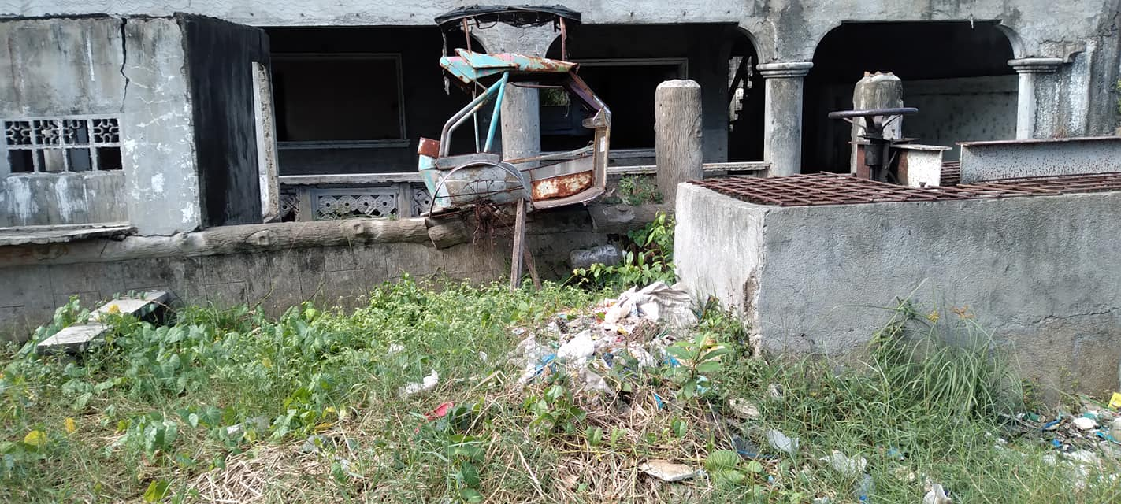

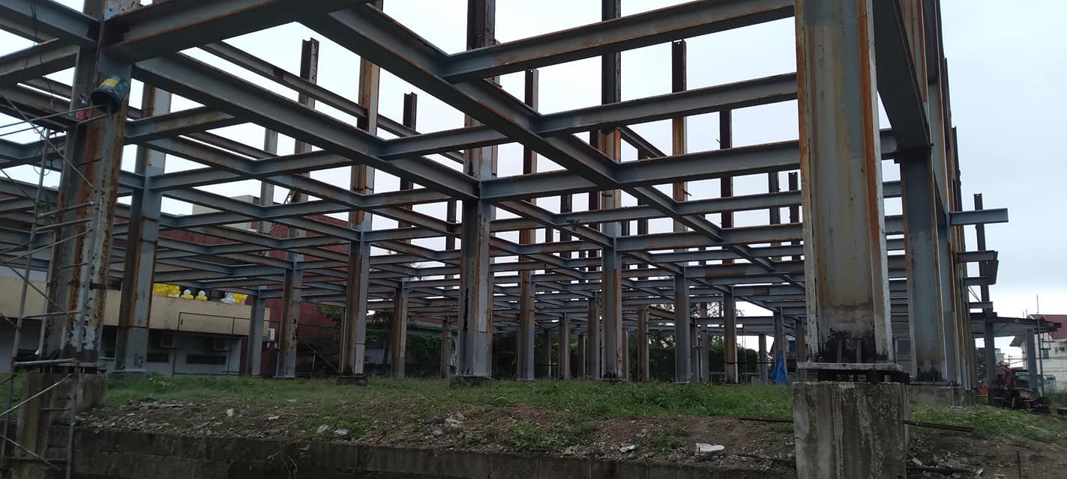

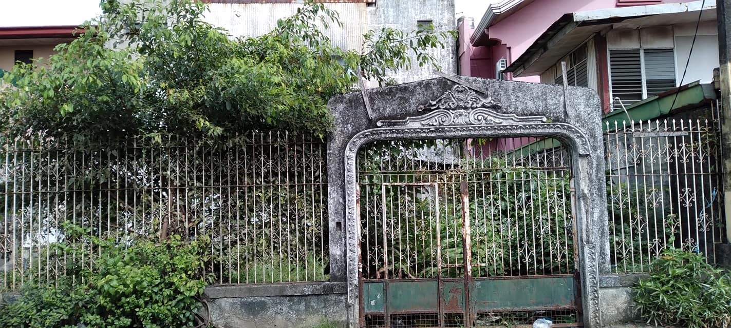

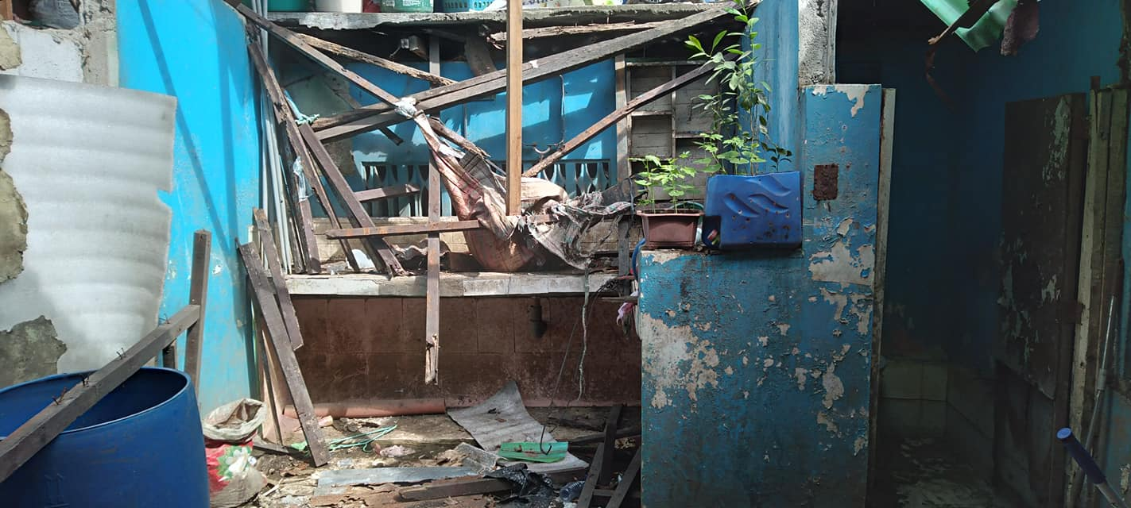

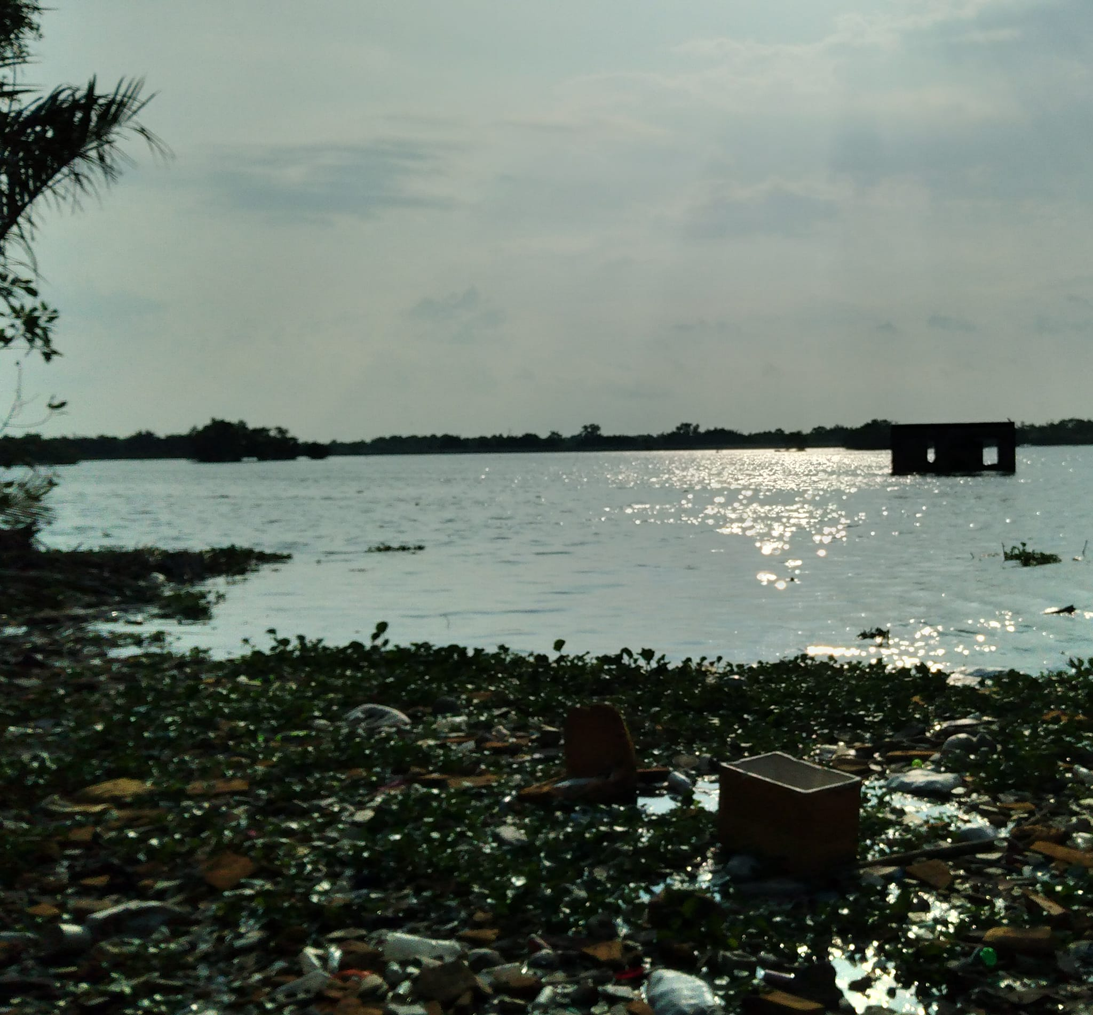

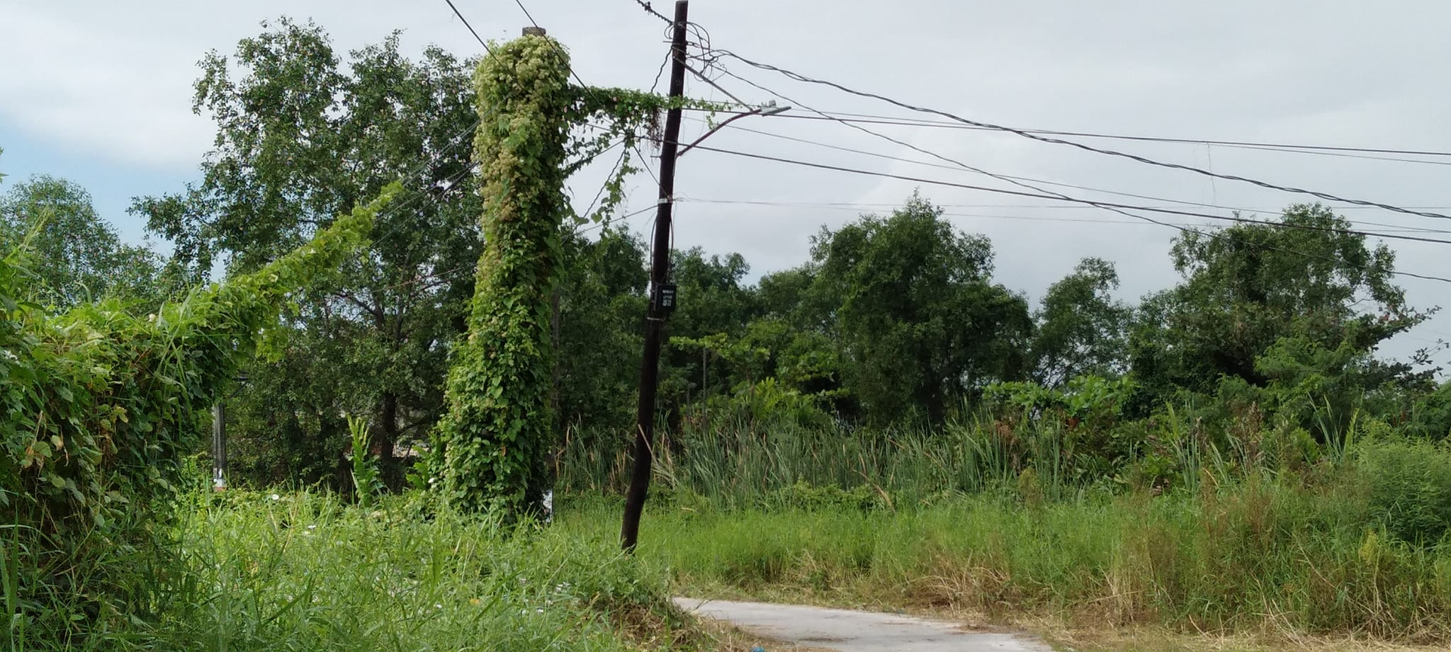

2024

Narrator:

After being able to save the missing child and able to retrieve from Dr. Ambervards Laboratory his memory records. Robo-explorer continued assisting out people after the great war. He also set out to find his missing family.