Java Development
Duration: 2 hours

Consider the Business Scenario as given below specified in the UML diagram. You are advised to solve the following 4 questions based on the same scenario given. Each question carries 12.5 marks.

ABC Comfort, a reputed 3 star hotel of Kolkata, wants to automate its room management and booking services for providing better service to their customers.

Define the classes as shown in the below class diagram, specifying all the getters and setters for each class.

Booking object can only be created by specifying the room number, guest name, guest email id and number of days guest would be staying at the hotel. Room object can be created only by passing room type (“S” - Standard, “D” - Deluxe and “L” - Luxury), daily rent and specifying whether the room has sea view or not. Room number will be assigned by the system as and when the room gets added (starting from room number 101). For every new room added, the default occupancy status will be set as false. Hotel object can be created without passing any arguments.

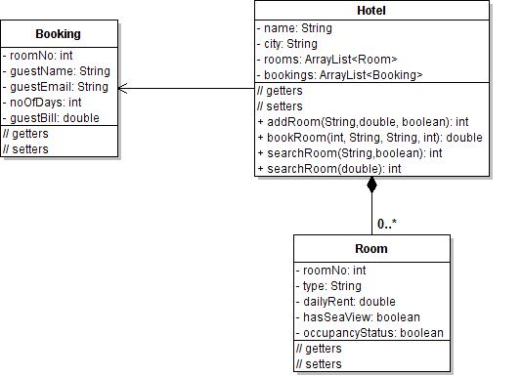

QNo. 1 : Create all the classes with their attributes and the class relationships depicting in the UML diagram above.
Define the Hotel class as public class and the other classes as default class. Add behaviors called:

addRoom: This behavior accepts 3 arguments, i.e. room type, daily room rent and sea view flag. It assigns a room number to the added room and returns the room number. The default occupancyStatus is set to false.

displayAllRooms : This method displays all the rooms added by iterating.

Add the main method to the Hotel class to Test your Code.

QNo. 2 : Create all the classes with their attributes and the class relationships depicting in the UML diagram above.
Define the Hotel class as public class and the other classes as default class. You may reuse the code developed by you in the previous question. Then add behaviors like:

bookRoom: This behavior accepts an unoccupied room number, guest’s name, email id and the number of days the guest wants to stay at the hotel room (in given order). The behavior sets the bill attribute and also returns the same. If the specified room is occupied, the behavior does not set the bill attribute and returns -1.

displayAllBookedRooms : This method displays all the rooms with “occupancyStatus” as true.

Add the main method to the Hotel class to Test your Code.

QNo. 3 : Create all the classes with their attributes and the class relationships depicting in the UML diagram above.
Define the Hotel class as public class and the other classes as default class. You may reuse the code developed by you in the previous question. Then add behaviors like:

searchRoom: This behavior allows to search with two different criteria:
  - It accepts the type of room desired and flag that specifies if sea view is also required.
  - It accepts the upper limit the guest would like to pay as daily rent for a room

For both (a) and (b) criteria, the behavior is supposed to return the number of unoccupied rooms matching the specified criteria.
Add the main method to the Hotel class to Test your Code.

QNo. 4 :
Create all the classes with their attributes and the class relationships depicting in the UML diagram above.
Define the Hotel class as public class and the other classes as default class. You may reuse the code developed by you in the previous question. Then add behavior(s) like:

displayGuestDetails : Display the details of the guest from the Booking object presently occupying the rooms.
Add the main method to the Hotel class to Test your Code.

