3GPP TSG-T2 #8 / ETSI SMG4 |  |  |  |  |  |  |  |  |  |  |  |  |  |  |  |  | Document |  |  |  |  |  |  |  |  | TSGT2#8(00)100
Puerto Vallarta, MEXICO, 1 - 4 Feb 2000 |  |  |  |  |  |  |  |  |  |  |  |  |  |  |  |  |  |  |  |  |  |  |  |  |  |  | e.g. for 3GPP use the format TP-99xxx  or for SMG, use the format P-99-xxx
CHANGE REQUEST |  |  |  |  |  |  |  |  |  |  |  |  |  |  |  |  |  |  | Please see embedded help file at the bottom of this  page for instructions on how to fill in this form correctly.
 |  |  |  |  |  |  | 23.040 |  |  |  |  |  | CR |  |  | 009 |  |  |  |  |  |  | Current Version: |  |  |  |  |  |  |  |  |  | 3.3.0
GSM (AA.BB) or 3G (AA.BBB) specification number ↑ |  |  |  |  |  |  |  |  |  |  |  |  |  |  |  |  |  | ↑ CR number as allocated by MCC support team
For submission to: |  |  |  | T#7 |  |  |  |  | for approval |  |  |  |  |  |  | X |  |  | strategic |  |  |  |  |  |  |  |  |  |  |  |  |  |  | (for SMG
list expected approval meeting # here ↑ |  |  |  |  |  | for information |  |  |  |  |  |  |  |  |  |  |  |  | non-strategic |  |  |  |  |  |  |  |  |  |  |  |  |  |  | use only)
Form: CR cover sheet, version 2 for 3GPP and SMG The latest version of this form is available from: ftp://ftp.3gpp.org/Information/CR-Form-v2.doc
Proposed change affects: |  |  |  |  |  |  | (U)SIM |  |  |  |  | ME |  |  |  | X |  | UTRAN / Radio |  |  |  |  |  |  |  |  |  |  | Core Network
(at least one should be marked with an X)
Source: |  |  | T2 |  |  |  |  |  |  |  |  |  |  |  |  |  |  |  |  |  |  |  |  | Date: |  |  |  |  |  |  |  | 28 Jan 2000
Subject: |  |  | Enhancement of the Message Content in SMS
Work item: |  |  | Messaging (Short Message Service (SMS))
Category: | F Correction |  |  |  |  |  |  |  |  |  |  |  |  |  |  |  |  |  |  |  |  |  |  |  | Release: |  |  |  |  |  | Phase 2
 | A Corresponds to a correction in an earlier release |  |  |  |  |  |  |  |  |  |  |  |  |  |  |  |  |  |  |  |  |  |  |  |  |  |  |  |  |  | Release 96
(only one category | B Addition of feature |  |  |  |  |  |  |  |  |  |  |  |  |  |  |  |  |  |  | X |  |  |  |  |  |  |  |  |  |  | Release 97
shall be marked | C Functional modification of feature |  |  |  |  |  |  |  |  |  |  |  |  |  |  |  |  |  |  |  |  |  |  |  |  |  |  |  |  |  | Release 98
with an X) | D Editorial modification |  |  |  |  |  |  |  |  |  |  |  |  |  |  |  |  |  |  |  |  |  |  |  |  |  |  |  |  |  | Release 99 |  |  |  | X
 |  |  |  |  |  |  |  |  |  |  |  |  |  |  |  |  |  |  |  |  |  |  |  |  |  |  |  |  |  |  | Release 00
Reason for  change: |  |  | This CR proposes an enhancement of the message-contents in SMS. At the moment SMS users are not able to send more than plain text to each other. This proposal provides the users to make more exciting messages with features like formatting the text, sounds, small pictures and simple animations.  This enhancement is based on standard mechanisms in GSM and is therefore backward compatible with older terminals. Terminals that do not have these extra features will still be able to present the text but not the extra information (e.g. formatting, pictures).
Clauses affected: |  |  |  |  | 2, 3.10, 9.2.3.24, 9.2.3.24.10
Other specs |  | Other 3G core specifications |  |  |  |  |  |  |  |  |  |  |  |  | → List of CRs:
affected: |  | Other GSM core specifications |  |  |  |  |  |  |  |  |  |  |  |  | → List of CRs:
 |  | MS test specifications |  |  |  |  |  |  |  |  |  |  |  |  | → List of CRs:
 |  | BSS test specifications |  |  |  |  |  |  |  |  |  |  |  |  | → List of CRs:
 |  | O&M specifications |  |  |  |  |  |  |  |  |  |  |  |  | → List of CRs:
Other
comments:

 <--------- double-click here for help and instructions on how to create a CR.

2 Normative references
The following documents contain provisions which, through reference in this text, constitute provisions of the present document.
- References are either specific (identified by date of publication, edition number, version number, etc.) or non-specific.
- For a specific reference, subsequent revisions do not apply.
- For a non-specific reference, the latest version applies.
- A non-specific reference to an ETS shall also be taken to refer to later versions published as an EN with the same number.
[1] GSM 01.04: "Digital cellular telecommunication system (Phase 2+); Abbreviations and acronyms".
[2] GSM 02.03: "Digital cellular telecommunication system (Phase 2+); Teleservices supported by a GSM Public Land Mobile Network (PLMN)".
[3] 3G TS 22.004: "General on supplementary services".
[4] 3G TS 22.041: " Operator determined barring".
[5] GSM 03.02: "Digital cellular telecommunication system (Phase 2+); Network architecture".
[6] 3G TS 23.008: "Organization of subscriber data".
[7] 3G TS 23.011: "Technical realization of supplementary services - General Aspects".
[8] 3G TS 23.015: "Technical realisation of Operator Determined Barring (ODB)".
[9] 3G TS 23.038: "Alphabets and language-specific information".
[10] 3G TS 23.041: "Technical realization of Cell Broadcast Service (CBS)".
[11] GSM 03.47 (ETR 354): "Digital cellular telecommunication system; Example protocol stacks for interconnecting Service Centre(s) (SC) and Mobile-services Switching Centre(s) (MSC)".
[12] GSM 04.08: "Digital cellular telecommunication system (Phase 2+); Mobile radio interface layer 3 specification".
[13] 3G TS 24.011: "Short Message Service (SMS) support on mobile radio interface".
[14] 3G TS 27.005: "Use of Data Terminal Equipment - Data Circuit terminating Equipment (DTE - DCE) interface for Short Message Service (SMS) and Cell Broadcast Service (CBS)".
[15] 3G TS 29.002: "Mobile Application Part (MAP) specification".
[16] GSM 11.11: "Digital cellular telecommunication system (Phase 2+); Specification of the Subscriber Identity Module - Mobile Equipment (SIM- ME) interface".
[17] CCITT Recommendation E.164 (Blue Book): "Numbering plan for the ISDN era".
[18] CCITT Recommendation E.163 (Blue Book): "Numbering plan for the international telephone service".
[19] CCITT Recommendation Q.771: "Specifications of Signalling System No.7; Functional description of transaction capabilities".
[20] CCITT Recommendation T.100 (Blue Book): "International information exchange for interactive videotex".
[21] CCITT Recommendation T.101 (Blue Book): "International interworking for videotex services".
[22] CCITT Recommendation X.121 (Blue Book): "International numbering plan for public data networks".
[23] CCITT Recommendation X.400 (Blue Book): "Message handling system and service overview".
[24] ISO/IEC10646, "Universal Multiple-Octet Coded Character Set (USC); UCS2, 16 bit coding".
[25] 3G TS 22.022: "Personalisation of GSM ME Mobile functionality specification - Stage 1".
[26] 3G TS 23.042: "Compression Algorithm for Text Messaging Services”
[27] 3G TS 23.060: "General Packet Radio Service (GPRS); Service description; Stage 2".
[28] GSM 03.48: "Digital cellular telecommunications system (Phase 2+); Security Mechanisms for the SIM application toolkit; Stage 2"
[29] 3G TR 21.905: "3G Vocabulary".
[30] 3G TS 31.102: "Characteristics of the USIM application"
[31] 3G TS 31.101: "UICC – Terminal interface; Physical and logical characteristics"
[32] 3G TS 22.105: "Services and Service Capabilites"
[33] Infrared Data Association. Specifications for Ir Mobile Communications (IrMC).
iMelody.

Enhanced Messaging Service
The Enhanced Messaging Service (EMS) is based upon the standard SMS, but with formatting added to the text. The formatting permits the message to contain simple animations, small pictures, small melodies and formatting of the text, everything mixed together into one message. This section lists the supported features. The coding mechanisms and formats are specified in section 9.2.3.24.10

3.10.1 Text formatting

The following text formatting features are supported:

Alignment
- Left (default)
- Centre
- Right

Font size
- Normal (default)
- Large
- Small

Style
- Normal (default)
- Bold
- Italic
- Underlined
- Strikethrough

3.10.2 Pictures
It is possible to include either a small (16*16 pixels ), large (32*32 pixels) or pictures of variable size. These pictures have neither animation nor grey scales, it is plain black and white. All pictures are user defined.
If multiple pictures are received side by side, then they will be stitched together with no inter-character spacing. If a <CR> is inserted in the middle of multiple pictures, then the left margin of the pictures are vertically aligned. If two pictures that are of the same size are logically separate, they should be separated by a space or other characters.
Maximum recommended pictures size usage of this technique : 96x64 (6 large pictures, with a CR in the middle). This unified picture is then formatted as one.

3.10.3 Animations

Predefined
There are number of predefined animations. These animations are not sent as animation over the air interface, only the identification of them. As soon as the position of the animation in the SM data is reached, the animation corresponding to the received number shall be displayed in a manner which is manufacturer specific..

User Defined
The user-defined animations consist of 4 pictures and there are two different sizes of these animations. The picture size of the small animations are 8*8 pixels and the large 16*16 pixels. These animations are sent over the air interface.

3.10.4 Sound

Predefined
There are a number of predefined sounds. These sounds are not transferred over the air interface, only the identification of them. There are 10 different sounds that can be added in the message, and as soon as the sound mark is in focus (on the display), the sound will be played.

User Defined
The sender can define own melodies according to the iMelody format [33]. These melodies are transferred in the SM and can take up to 128 bytes.

9.2.3.9 TP-Protocol-Identifier (TP-PID)
The TP-Protocol-Identifier parameter serves the purposes indicated in subclause 3.2.3. It consists of one octet, and the bits in the octet are used as follows:
The MS shall interpret reserved or unsupported values as the value 00000000 but shall store them exactly as received.
The SC may reject messages with a TP-Protocol-Identifier containing a reserved value or one which is not supported.
bits usage
7 6
0 0 Assigns bits 0..5 as defined below
0 1 Assigns bits 0..5 as defined below
1 0 reserved
1 1 Assigns bits 0-5 for SC specific use
In the case where bit 7 = 0 and bit 6 = 0,
bit 5 indicates telematic interworking:
value = 0 : no interworking, but SME-to-SME protocol
value = 1 : telematic interworking
In the case of telematic interworking, the following five bit patterns in bits 4..0 are used to indicate different types of telematic devices:
4.. .0
00000 implicit - device type is specific to this SC, or can be concluded on the basis of the address
00001 telex (or teletex reduced to telex format)
00010 group 3 telefax
00011 group 4 telefax
00100 voice telephone (i.e. conversion to speech)
00101 ERMES (European Radio Messaging System)
00110 National Paging system (known to the SC)
00111 Videotex (T.100 [20] /T.101 [21])
01000 teletex, carrier unspecified
01001 teletex, in PSPDN
01010 teletex, in CSPDN
01011 teletex, in analog PSTN
01100 teletex, in digital ISDN
01101 UCI (Universal Computer Interface, ETSI DE/PS 3 01-3)
01110..01111 (reserved, 2 combinations)
10000 a message handling facility (known to the SC)
10001 any public X.400-based message handling system
10010 Internet Electronic Mail
10011..10111 (reserved, 5 combinations)
11000..11110 values specific to each SC, usage based on mutual agreement between the SME and the SC (7 combinations available for each SC)
11111 A GSM/UMTS mobile station. The SC converts the SM from the received TP-Data-Coding-Scheme to any data coding scheme supported by that MS (e.g. the default).

If bit 5 has value 1 in an SMS-SUBMIT PDU, it indicates that the SME is a telematic device of a type which is indicated in bits 4..0, and requests the SC to convert the SM into a form suited for that device type. If the destination network is ISDN, the SC must also select the proper service indicators for connecting to a device of that type.
If bit 5 has value 1 in an SMS-DELIVER PDU, it indicates that the SME is a telematic device of a type which is indicated in bits 4..0.
If bit 5 has value 0 in an SMS-DELIVER PDU, the value in bits 4..0 identifies the SM-AL protocol being used between the SME and the MS.
Note that for the straightforward case of simple MS-to-SC short message transfer the Protocol Identifier is set to the value 0.
In the case where bit 7 = 0, bit 6 = 1, bits 5..0 are used as defined below
5 .. . .0
000000 Short Message Type 0
000001 Replace Short Message Type 1
000010 Replace Short Message Type 2
000011 Replace Short Message Type 3
000100 Replace Short Message Type 4
000101 Replace Short Message Type 5
000110 Replace Short Message Type 6
000111 Replace Short Message Type 7
001000..011101 Reserved
011110 Enhanced Message Service (EMS. Refer section 3.10)
011111 Return Call Message
100000..111011 Reserved
111100 ANSI-136 R-DATA
111101 ME Data download
111110 ME De-personalization Short Message
111111 (U)SIM Data download

A short message type 0 indicates that the ME must acknowledge receipt of the short message but may discard its contents.
The Replace Short Message feature is optional for the ME and the (U)SIM but if implemented it shall be performed as described here.
For MT short messages, on receipt of a short message from the SC, the MS shall check to see if the associated Protocol Identifier contains a Replace Short Message Type code.
If such a code is present, then the MS shall check the originating address and replace any existing stored message having the same Protocol Identifier code and originating address with the new short message and other parameter values. If there is no message to be replaced, the MS shall store the message in the normal way. The MS may also check the SC address as well as the Originating Address. However, in a network which has multiple SCs, it is possible for a Replace Message type for a SM to be sent via different SCs and so it is recommended that the SC address should not be checked by the MS unless the application specifically requires such a check.
If a Replace Short Message Type code is not present then the MS shall store the message in the normal way.
In MO short messages the SC reacts similarly but only the address of the originating MS or any other source is checked
The Enhanced Message Service PID value shall be set in a MO enhanced short message unless there is a need to set the PID to any other value (e.g for telematic interworking). In the event where the message contains one or more IE that could not be understood by the receiving SME, this PID value may be used to assist the receiving SME and/or the SMSC to identify such a message ( e.g for diagnostic purposes). It is not a mandatory requirement for the SMSC or receiving SME to process this PID value or for the SMSC to pass the value to the receiving SME.
A Return Call Message indicates to the MS to inform the user that a call (e.g. a telephone call) can be established to the address specified within the TP-OA. The RP-OA contains the address of the SC as usual. The message content (if present) gives displayable information (e.g. the number of waiting voice messages). The message is handled in the same way as all other messages of the Replace Short Message Types.
The ME De-personalization Short Message is a ME-specific message which instructs the ME to de-personalities the ME (see 3G TS 22.022 [25] ). The TP-DCS shall be set to Uncompressed, Default Alphabet, and Message Class 1 (ME-specific), which corresponds to a bit coding of 00010001. The TP-UD field contains de-personalization information coded according to 3G TS 22.022 [25]. This information shall not be displayed by an ME which supports the scheme. The acknowledgement to this message is a SMS-DELIVER-REPORT for RP-ACK in which the TP-User-Data shall be coded according to 3G TS 22.022 [25].
(U)SIM Data download is a facility whereby the ME must pass the short message in its entirety including all SMS elements contained in the SMS deliver to the (U)SIM using the mechanism described in GSM TS 11.11 [16] and 3G TS 31.102 [30]. The DCS shall be set to 8 bit message class 2 (either bit coding 1111 0110 or 00010110). The entire user data field is available for (U)SIM Data download. If the DCS is not set to 8-bit message class 2 then the message shall be handled in the normal way by the ME.
ME Data download is a facility whereby the ME shall process the short message in its entirety including all SMS elements contained in the SMS deliver to the ME. The DCS shall be set to message class 1. The entire user data field is available for ME data download.
ANSI-136 R-DATA is a facility whereby the ME must pass the short message in its entirety, including all elements contained in the SMS DELIVER, to the (U)SIM using the mechanism described in GSM TS 11.14 [16] and 3G TS 31.102 [30]. The DCS shall be set to 8-bit message class 2 (either bit coding 11110110 or 00010110). If the DCS is not set to 8-bit message class 2 then the message shall be handled in the normal way by the ME.

9.2.3.24 TP-User Data (TP-UD)
The length of the TP-User-Data field is defined in the PDU’s of the SM-TL ( see subclause 9.2.2 ).
The TP-User-Data field may comprise just the short message itself or a Header in addition to the short message depending upon the setting of TP-UDHI.
Where the TP-UDHI value is set to 0 the TP-User-Data field comprises the short message only, where the user data can be 7 bit (default alphabet) data, 8 bit data, or 16 bit (UCS2 [24]) data.
Where the TP-UDHI value is set to 1 the first octets of the TP-User-Data field contains a Header in the following order starting at the first octet of the TP-User-Data field.
Irrespective of whether any part of the User Data Header is ignored or discarded, the MS shall always store the entire TPDU exactly as received.
FIELD LENGTH
Length of User Data Header 1 octet
Information-Element-Identifier "A" 1 octet
Length of Information-Element "A" 1 octet
Information-Element "A" Data 1 to "n" octets
Information-Element-Identifier "B" 1 octet
Length of Information-Element "B" 1 octet
Information-Element "B" Data 1 to "n" octets
Information-Element-Identifier "n" 1 octet
Length of Information-Element "n" 1 octet
Information-Element "n" Data 1 to "n" octets
The diagram below shows the layout of the TP-User-Data-Length and the TP-User-Data for uncompressed GSM 7 bit default alphabet data. The UDHL field is the first octet of the TP-User-Data content of the Short Message.
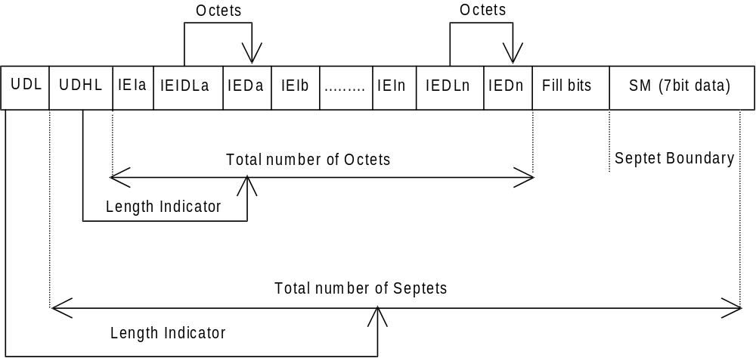
Figure 9.2.3.24 (a)
The diagram below shows the layout of the TP-User-Data-Length and the TP-User-Data for uncompressed 8 bit data or uncompressed UCS2 data. The UDHL field is the first octet of the TP-User-Data content of the Short Message.
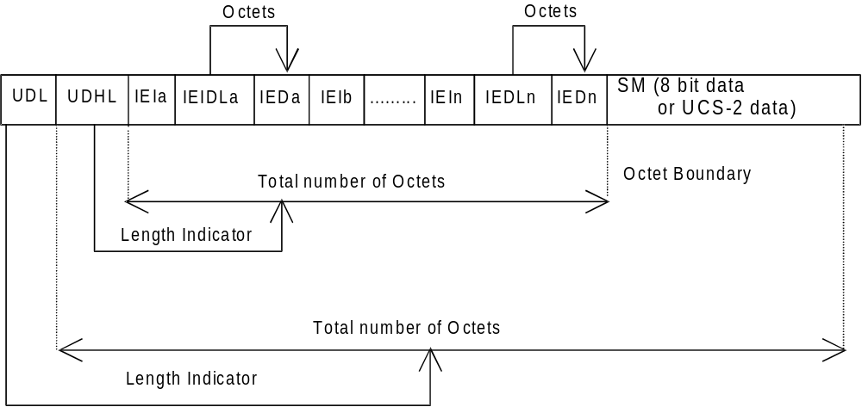
Figure 9.2.3.24 (b)
The diagram below shows the layout of the TP-User-Data-Length and the TP-User-Data for compressed GSM 7 bit default alphabet data, compressed 8 bit data or compressed UCS2 data. The UDHL field is the first octet of the TP-User-Data content of the Short Message.
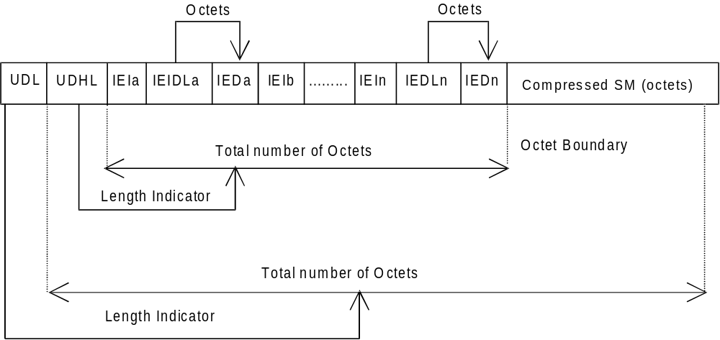
Figure 9.2.3.24 (c)
The definition of the TP-User-Data-Length field which immediately precedes the "Length of User Data Header" is unchanged and shall therefore be the total length of the TP-User-Data field including the Header, if present. (see 9.2.3.16)
The "Length-of-Information-Element" fields shall be the integer representation of the number of octets within its associated "Information-Element-Data" field which follows and shall not include itself in its count value.
The "Length-of-User-Data-Header" field shall be the integer representation of the number of octets within the "User-Data-Header" information fields which follow and shall not include itself in its count or any fill bits which may be present (see text below).
Information Elements may appear in any order and need not necessarily follow the order used in this specification. If Information Elements are duplicated (either with the same or different content) then the contents of the last occurrence of the Information Element shall be used. If the length of the User Data Header overall is such that there appear to be too few or too many octets in the final Information Element then the whole User Data Header shall be ignored.
If any reserved values are received within the content of any Information Element then that part of the Information Element shall be ignored.
The Information Element Identifier octet shall be coded as follows:
VALUE (hex) | MEANING
00 | Concatenated short messages, 8-bit reference number
01 | Special SMS Message Indication
02 | Reserved
03 | Value not used to avoid misinterpretation as <LF> character
04 | Application port addressing scheme, 8 bit address
05 | Application port addressing scheme, 16 bit address
06 | SMSC Control Parameters
07 | UDH Source Indicator
08 | Concatenated short message, 16-bit reference number
09 | Wireless Control Message Protocol
0A | Text Formatting
0B | Predefined Sound
0C | User Defined Sound (iMelody max 128 bytes)
0D | Predefined Animation
0E | Large Animation (16*16 times 4 = 32*4 =128 bytes)
0F | Small Animation (8*8 times 4 = 8*4 =32 bytes )
10 | Large Picture (32*32 = 128 bytes)
11 | Small Picture (16*16 = 32 bytes)
12 | Variable Picture
13-1F | Reserved for future EMS features (see section 3.10)
20-6F | Reserved for future use
70-7F | (U)SIM Toolkit Security Headers
80 - 9F | SME to SME specific use
A0 - BF | Reserved for future use
C0 - DF | SC specific use
E0 - FF | Reserved for future use
A receiving entity shall ignore (i.e. skip over and commence processing at the next information element) any information element where the IEI is Reserved or not supported. The receiving entity calculates the start of the next information element by looking at the length of the current information element and skipping that number of octets.
The SM itself may be coded as 7, 8 or 16 bit data.
If 7 bit data is used and the TP-UD-Header does not finish on a septet boundary then fill bits are inserted after the last Information Element Data octet up to the next septet boundary so that there is an integral number of septets for the entire TP-UD header. This is to ensure that the SM itself starts on an septet boundary so that an earlier Phase mobile shall be capable of displaying the SM itself although the TP-UD Header in the TP-UD field may not be understood.
It is optional to make the first character of the SM itself a Carriage Return character encoded according to the default 7 bit alphabet so that earlier Phase mobiles, which do not understand the TP-UD-Header, shall over-write the displayed TP-UD-Header with the SM itself.
If 16 bit (USC2) data is used then padding octets are not necessary. The SM itself shall start on an octet boundary.
If 8 bit data is used then padding is not necessary. An earlier Phase mobile shall be able to display the SM itself although the TP-UD header may not be understood.
It is also possible for mobiles not wishing to support the TP-UD header to check the value of the TP-UDHI bit in the SMS-Deliver PDU and the first octet of the TP-UD field and skip to the start of the SM and ignore the TP-UD header.

9.2.3.24.10 Enhanced Messaging Service

9.2.3.24.10.1 EMS Coding
Enhanced Messaging is based on standard mechanism in GSM SMS messaging. The first mechanism is called user data header (TP-UDH), which makes it possible to include binary data in a normal SM prior the text message itself (chapter 9.2.3.24). The binary data is in the TP-UD field (message), which means that it steels a part of the 140 bytes.
Each object within the SM shall be identified by a IE in the TP-UD Header. The IE will contain a octet (refer to
section 9.2.3.24.10.1) that identifies the absolute position of the object within and from the beginning of the SM data. In case of formatting text, an additional octet will give the number of characters for which the formatting applies.
Next mechanism that is used is concatenation, see chapter 9.2.3.24.1. This mechanism permits longer messages than 140 bytes, in fact 255 messages a 140 bytes each can be concatenated to one message up to about 38k bytes.
EMS IEs of the same type may occur more than once in a single message or one segment of a concatenated SM.

9.2.3.24.10.1.1 Text Formatting

The Information-Element-Data octet(s) shall be coded as follows.
Octet 1 Start position of the text formatting. Set to the number of characters after the formatting shall be applied from the beginning of the SM data.
This octet shall be coded as an integer value in the range 0 (beginning of the SM data) to the maximum number of characters included in the SM data of one single SM or one segment of a concatenated SM
Octet 2 Text formatting length. Gives the number of formatted characters
This octet shall be coded as an integer value in the range 1 to the maximum number of characters for which the formatting applies in one single SM or one segment of a concatenated SM.
Octet 3 formatting mode value coded as following :

Octet 3 : Bit 7 Bit 6 Bit 5 Bit 4 Bit 3 Bit 2 Bit 1 Bit 0

Bit 1 Bit 0 *Alignment
0 0 Left (default)
0 1 Center
1 0 Right
1 1 reserved

*in case formatting text is inserted on the same line as previous non formatting text or with a different mode value, the alignment value shall be set to the same value as the previous formatted predefined object.

Bit 3 Bit 2 Font Size
0 0 Normal (default)
0 1 Large
1 0 Small
1 1 reserved

Bit 4 Style bold
1 Bold on
0 Bold off

Bit 5 Style Italic
1 Italic on
0 Italic off

Bit 6 Style Underlined
1 Underlined on
0 Underlined off

Bit 7 Style Strikethrough
1 Strikethrough on
0 Strikethrough off

If bit 4,5,6 and 7 are set to 0, it will mean normal style (default).

9.2.3.24.10.1.2 Predefined Sound

The Information-Element-Data octet(s) shall be coded as follows.

Octet 1 position indicating in the SM data the instant after which the sound shall be played. It will be set to the number of characters from the beginning of the SM data after which the sound shall be played.

This octet shall be coded as an integer value in the range 0 (beginning of the SM data) to the maximum number of characters included in the SM data of one single SM or one segment of a concatenated SM

Octet 2 sound number. Shall be encoded as a integer value.

9.2.3.24.10.1.3 User Defined Sound

The Information-Element-Data octet(s) shall be coded as follows.

Octet 1 position indicating in the SM data the instant the after which the sound shall be played (refer to section
9.2.3.24.10.1.2).

Octet 2-n Protocol Data Unit as described in section 9.2.3.24.10.3.1
This octet(s) shall contain a User Defined Sound.

9.2.3.24.10.1.4 Predefined Animation

The Information-Element-Data octet(s) shall be coded as follows.
Octet 1 position indicating in the SM data the instant the animation shall be displayed. Set to the number of
characters from the beginning of the SM data after which the animation shall be displayed.
This octet shall be coded as an integer value in the range 0 (beginning of the SM data) to the maximum number of characters included in the SM data of one single SM or one segment of a concatenated SM
Octet 2 animation number. Shall be encoded as an integer value.
9.2.3.24.10.1.5 Large Animation

The Information-Element-Data octet(s) shall be coded as follows.

Octet 1 position indicating the instant the animation shall be displayed in the SM data
(refer section 9.2.3.24.10.1.4).

Octet 2-n Protocol Data Unit as described in section 9.2.3.24.10.3.3
This octet(s) shall contain a Large Animation.

9.2.3.24.10.1.6 Small Animation

The Information-Element-Data octet(s) shall be coded as follows.

Octet 1 position indicating the instant the animation shall be displayed in the SM data
(refer section 9.2.3.24.10.1.4).

Octet 2-n Protocol Data Unit as described in section 9.2.3.24.10.3.3
This octet(s) shall contain a Small Animation.

9.2.3.24.10.1.7 Large Picture

The Information-Element-Data octet(s) shall be coded as follows.

Octet 1 position indicating in the SM data the instant the picture shall be displayed. Set to the number of
characters from the beginning of the SM data after which the picture shall be displayed.

This octet shall be coded as an integer value in the range 0 (beginning of the SM data) to the maximum number of characters included in the SM data of one single SM or one segment of a concatenated SM
Octet 2-n Protocol Data Unit as described in 9.2.3.24.10.3.2
This octet(s) shall contain a Large Picture.

9.2.3.24.10.1.8 Small Picture

The Information-Element-Data octet(s) shall be coded as follows.

Octet 1 position indicating in the SM data the instant the picture shall be displayed in the SM data
(refer section 9.2.3.24.10.1.7)

Octet 2-n Protocol Data Unit as described in section 9.2.3.24.10.3.2
This octet(s) shall contain a Small Picture.

9.2.3.24.10.1.9 Variable Picture

The Information-Element-Data octet(s) shall be coded as follows.

Octet 1 position indicating in the SM data the instant the picture shall be displayed in the SM data
(refer section 9.2.3.24.10.1.7)

Octet 2 Horizontal dimension of the picture.
This octet shall contain the horizontal number of 8 pixels i.e. this value shall be multiplied by 8 to get the whole number of horizontal pixels.
Octet 3 Vertical dimension of the picture.
This octet shall contain the vertical number of pixels.
Octet 4-n Protocol Data Unit as described in section 9.2.3.24.10.3.2
This octet(s) shall contain a Variable Picture line by line from top left to bottom right.
The values of the horizontal and vertical dimensions must be chosen properly by the sending entity. If the calculated size of this IE exceeds the limits of a single SM or segment it shall be discarded by the receiving entity.

Examples of EMS coding

All IE values in the TP-UD are hexadecimal values.

9.2.3.24.10.2.1 Example of Basic text formatting and predefined EMS coding

An example of the basic concept of coding is given as follows:

TP-UDHI=1

SMS User Data Header: UDHL=05, IEI=0A, IEDL=03, IED₁=0F, IED₂=12, IED₃=10

SMS User Data: This is a text with bold option on following with normal text.

Should be displayed as:

This is a text with bold option on following with normal text.

It is also possible to add predefined sounds in the message.

Example:

TP-UDHI=1

SMS User Data Header: UDHL=08, IEI=0B, IEDL=02, IED₁=09,<sound5>, IEI=0B, IEDL=2, IED₁=1C,
<sound7>

SMS User Data: This is a message with two different sounds
The sound nr5 shall be played after the 9th received character (“a”) and sound nr7 shall be played after the 28th received character (“e”).

9.2.3.24.10.2.2 Example of User defined Objects EMS coding

Example of a message including one small picture is coded as follows:

TP UDHI=1

SMS User Data Header: UDHL=24, IEI=11, IEIDL=22, IED₁=08, <  (small picture 32bytes)>

SMS User Data: Hello!<CR><LF><CR><LF>One small picture in here
Should be displayed as :
Hello!

One small picture in here

If the message starts with <CR>, then the “unreadable” data in an old terminal will be overwritten by the text, and the user will not see any strange characters. It is possible to insert the same picture several times in the same message. In that case, the TP-UD header shall contain as many IE as the number of occurrences contained in the SM or one segment of a concatenated message. Using defined elements will normally imply that more than one SM is required and therefore concatenation is required.

9.2.3.24.10.2.3 Concatenation of SMS messages
Concatenated messages are required in most cases required when using several types of EMS elements, since it is only possible to send one large picture/large animation/melody in one single SM. After including either of these elements, there are only 4 (or 9 if no concatenation is used) characters left to the text part, and this is usually too little.
If one or more objects are embedded in one segment of a concatenated message, the IE octet indicating its/their position within the SM data cannot be set to a value that would refer to a position in the next segment(s) so that received segments should be processed before all of them have been received. It means that a formatting text that could not be conveyed in one segment shall be split in as many segments as necessary . In that case, the IE relating to the formatting shall be repeated in all the segments in which it will apply.
Example of a message including 2 Large Pictures, 4 Small animations and 2 User defined Melodies together with some text.
The EMS message: <Large Picture1> <User Defined Melody 1> Hello All, This is a real Enhanced Message <Small Animation 1>. I can send <Small Animation 2> and receive <Small Animation 3> really advanced EMS messages <Animation 4> Isn’t it impressive? /Lars <User Defined Melody2> <Large Picture 2>

This EMS message has to use concatenated messages and the SM will typically contain the following data:
SM | User Data Header | User Data
1 | IEI=10 (Large Picture)  IED₁=00 (beginning of the SM)  <Large Picture 1 (128 bytes)> | [<CR><LF>]
2 | IEI=0C (User Defined Sound)  IED₁=00 (beginning of the SM)  <User Melody 1 (129bytes max)> | Hello
3 | IEI=0F (Small Animation)  IED₁=24 (36th position)  <Small Animation 1 (32 bytes)>  IEI=0F (Small Animation)  IED₁=2F (47th position)  <Small Animation 2 (32 bytes)> | All, This is a real Enhanced Message.I can send and
4 | IEI=0F (Small Animation)  IED₁=07 (7th position)  <Small Animation 3 (32 bytes)>  IEI=0F (Small Animation)  IED₁=25 (37th position)  <Small Animation 4 (32 bytes)> | receive really advanced EMS messages. Isn’t it impressive? /Lars.
5 | IEI=0C (User Defined Sound)  IED₁=00 (beginning of the SM)  <User Melody 1 (128 bytes max)> | [<CR><LF>]
6 | IEI=10 (Large Picture)  IED₁=00 (beginning of the SM)  <Large Picture 2 (128 bytes)>

9.2.3.24.10.3 EMS Formats

9.2.3.24.10.3.1 Sounds

Predefined Sounds
There are a number of fixed predefined sounds. Each sound nr corresponds to a specific sound according to the table below. The presentations of these sounds are manufacturer specific.
Sound nr | Description
0 | Chimes high
1 | Chimes low
2 | Ding
3 | TaDa
4 | Notify
5 | Drum
6 | Claps
7 | FanFar
8 | Chord high
9 | Chord low

User defined sounds

The user defined sounds are coded according to the iMelody format[33]. The maximum length of a sound is 128 bytes.

9.2.3.24.10.3.2 Pictures
Pictures are coded from upper left to lower right and in each byte the most significant bit represent the pixel at the left. The pictures are plain black and white, no colours or grey scales are supported. The bitvalue “0” represents a white pixel and the bitvalue “1” represents a black pixel.

Example 16*16 picture
Byte 1 | Byte 2
Byte 3 | Byte 4
… | …
… | …
Byte 31 | Byte 32

9.2.3.24.10.3.3 Animation

Predefined
There are a number of predefined animations. Each animation nr corresponds to a specific animation according to the table below. The way of displaying the animation is manufacturer specific.
Animation nr | Description
0 | I am ironic, flirty
1 | I am glad
2 | I am sceptic
3 | I am sad
4 | WOW!
5 | I am crying

User Defined

Animations are coded as 4 sequential pictures, with the first picture sent first.

