3GPP/SMG Meeting T2 #8 / ETSI SMG4 |  |  |  |  |  |  |  |  |  |  |  |  |  |  |  |  |  | Document |  |  |  |  |  |  |  |  |  |  | T2-000136
Puerto Vallarta, Mexico, 1-4 Feb 2000 |  |  |  |  |  |  |  |  |  |  |  |  |  |  |  |  |  |  |  |  |  |  |  |  |  | e.g. for 3GPP use the format TP-99xxx  or for SMG, use the format P-99-xxx
CHANGE REQUEST |  |  |  |  |  |  |  |  |  |  |  |  |  |  |  |  |  |  | Please see embedded help file at the bottom of this  page for instructions on how to fill in this form correctly.
 |  |  |  |  |  |  | 23.040 |  |  |  |  |  | CR |  |  | 010 |  |  |  |  |  |  | Current Version: |  |  |  |  |  |  |  |  | 3.3.0
GSM (AA.BB) or 3G (AA.BBB) specification number ↑ |  |  |  |  |  |  |  |  |  |  |  |  |  |  |  |  | ↑ CR number as allocated by MCC support team
For submission to: |  |  |  | T#7 |  |  |  |  | for approval |  |  |  |  |  |  | X |  |  | strategic |  |  |  |  |  |  |  |  |  |  |  |  |  | (for SMG
list expected approval meeting # here ↑ |  |  |  |  |  | for information |  |  |  |  |  |  |  |  |  |  |  |  | non-strategic |  |  |  |  |  |  |  |  |  |  |  |  |  | use only)
Form: CR cover sheet, version 2 for 3GPP and SMG The latest version of this form is available from: ftp://ftp.3gpp.org/Information/CR-Form-v2.doc
Proposed change affects: |  |  |  |  |  |  | (U)SIM |  |  |  |  | ME |  |  |  | X | UTRAN / Radio |  |  |  |  |  |  |  |  |  |  | Core Network
(at least one should be marked with an X)
Source: |  |  | T2 |  |  |  |  |  |  |  |  |  |  |  |  |  |  |  |  |  |  |  |  | Date: |  |  |  |  |  |  | 02.02.2000
Subject: |  |  | Multiple Information Elements
Work item: |  |  | SMS ENHANCEMENTS AND IMPROVEMENTS
Category: | F Correction |  |  |  |  |  |  |  |  |  |  |  |  |  |  |  |  |  |  |  |  |  |  |  | Release: |  |  |  |  | Phase 2
 | A Corresponds to a correction in an earlier release |  |  |  |  |  |  |  |  |  |  |  |  |  |  |  |  |  |  |  |  |  |  |  |  |  |  |  |  | Release 96
(only one category | B Addition of feature |  |  |  |  |  |  |  |  |  |  |  |  |  |  |  |  |  |  | X |  |  |  |  |  |  |  |  |  | Release 97
shall be marked | C Functional modification of feature |  |  |  |  |  |  |  |  |  |  |  |  |  |  |  |  |  |  |  |  |  |  |  |  |  |  |  |  | Release 98
with an X) | D Editorial modification |  |  |  |  |  |  |  |  |  |  |  |  |  |  |  |  |  |  |  |  |  |  |  |  |  |  |  |  | Release 99 |  |  |  | x
 |  |  |  |  |  |  |  |  |  |  |  |  |  |  |  |  |  |  |  |  |  |  |  |  |  |  |  |  |  | Release 00
Reason for  change: |  |  | The existing specification does not permit multiple instances of any Information Element type to be used within a User-Data-Header. SMS enhancements that benefit from the possibility of multiple use of new Information Elements are now being introduced, and consequently this overall restriction should be relaxed.
Clauses affected: |  |  |  |  | 9.2.3.24
Other specs |  | Other 3G core specifications |  |  |  |  |  |  |  |  |  |  |  |  | → List of CRs:
affected: |  | Other GSM core specifications |  |  |  |  |  |  |  |  |  |  |  |  | → List of CRs:
 |  | MS test specifications |  |  |  |  |  |  |  |  |  |  |  |  | → List of CRs:
 |  | BSS test specifications |  |  |  |  |  |  |  |  |  |  |  |  | → List of CRs:
 |  | O&M specifications |  |  |  |  |  |  |  |  |  |  |  |  | → List of CRs:
Other  comments: |  | The handling of Information Elements defined in the existing specification is unchanged by this CR. Therefore the CR is proposed as Category B.  Note: Although change bars appear at the diagrams in this CR the diagrams are unchanged.

 <--------- double-click here for help and instructions on how to create a CR.

9.2.3.24 TP-User Data (TP-UD)
The length of the TP-User-Data field is defined in the PDU’s of the SM-TL ( see subclause 9.2.2 ).
The TP-User-Data field may comprise just the short message itself or a Header in addition to the short message depending upon the setting of TP-UDHI.
Where the TP-UDHI value is set to 0 the TP-User-Data field comprises the short message only, where the user data can be 7 bit (default alphabet) data, 8 bit data, or 16 bit (UCS2) data.
Where the TP-UDHI value is set to 1 the first octets of the TP-User-Data field contains a Header in the following order starting at the first octet of the TP-User-Data field.
Irrespective of whether any part of the User Data Header is ignored or discarded, the MS shall always store the entire TPDU exactly as received.
FIELD LENGTH
Length of User Data Header 1 octet
Information-Element-Identifier "A" 1 octet
Length of Information-Element "A" 1 octet
Information-Element "A" Data 1 to "n" octets
Information-Element-Identifier "B" 1 octet
Length of Information-Element "B" 1 octet
Information-Element "B" Data 1 to "n" octets
Information-Element-Identifier "n" 1 octet
Length of Information-Element "n" 1 octet
Information-Element "n" Data 1 to "n" octets
The diagram below shows the layout of the TP-User-Data-Length and the TP-User-Data for uncompressed GSM 7 bit default alphabet data. The UDHL field is the first octet of the TP-User-Data content of the Short Message.
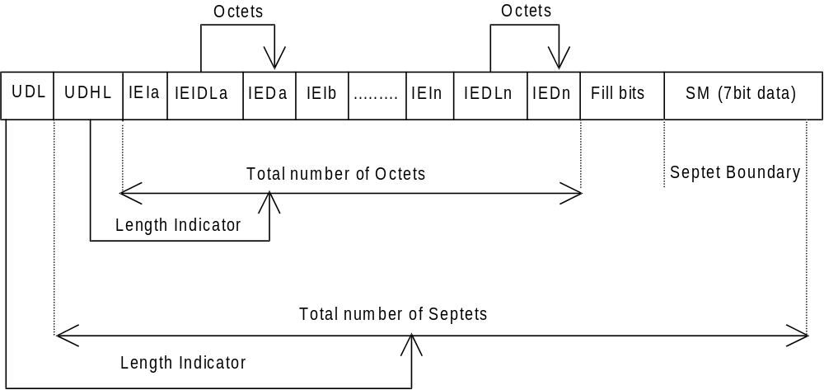
Figure 9.2.3.24 (a)
The diagram below shows the layout of the TP-User-Data-Length and the TP-User-Data for uncompressed 8 bit data or uncompressed UCS2 data. The UDHL field is the first octet of the TP-User-Data content of the Short Message.
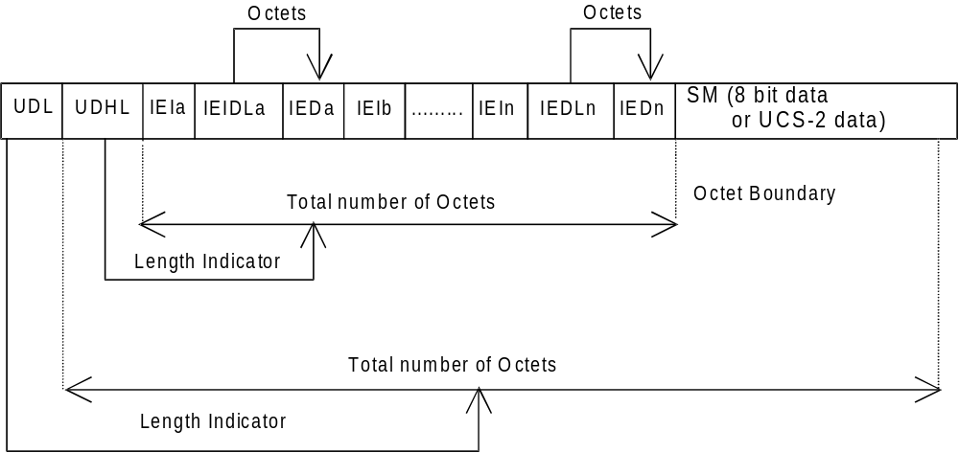
Figure 9.2.3.24 (b)
The diagram below shows the layout of the TP-User-Data-Length and the TP-User-Data for compressed GSM 7 bit default alphabet data, compressed 8 bit data or compressed UCS2 data. The UDHL field is the first octet of the TP-User-Data content of the Short Message.
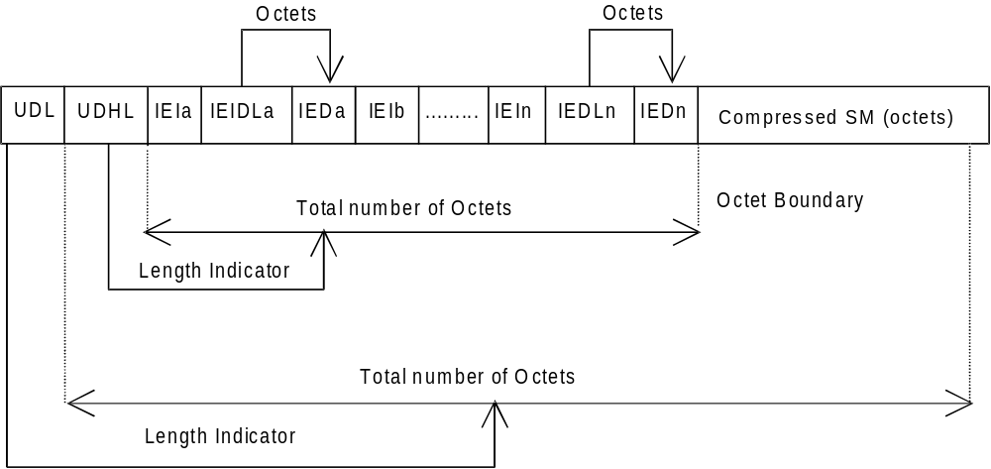
Figure 9.2.3.24 (c)
The definition of the TP-User-Data-Length field which immediately precedes the "Length of User Data Header" is unchanged and will therefore be the total length of the TP-User-Data field including the Header, if present. (see 9.2.3.16)
The "Length-of-Information-Element" fields shall be the integer representation of the number of octets within its associated "Information-Element-Data" field which follows and shall not include itself in its count value.
The "Length-of-User-Data-Header" field shall be the integer representation of the number of octets within the "User-Data-Header" information fields which follow and shall not include itself in its count or any fill bits which may be present (see text below).

Information Elements may appear in any order and need not necessarily follow the order used in this specification.

In the case where there are no multiple instances of any Information Element type: If Information Elements are duplicated (either with the same or different content),within one single SM or within one segment of a concatenated message then the contents of the last occurrence of the Information Element shall be used.

In the case where there are multiple instances of any Information Element type: If certain types of Information Elements are duplicated (either with the same or different content) within one single SM or within one segment of a concatenated message and there is a contradiction in meaning (e.g. more than one Special Message Indication for voice) or there is a contradiction of Information Element types (e.g. an 8bit port address and a 16bit port address), then the contents of the last occurrence of the Information Element shall be used. Other types of Information Elements may occur more than once when there is additional information of the same type to be conveyed. The individual specifications for each Information Element will state if multiple use is permitted and in such a case will also indicate the maximum number of occurrences within one User Data Header.

If the length of the User Data Header overall is such that there appear to be too few or too many octets in the final Information Element then the whole User Data Header shall be ignored.
If any reserved values are received within the content of any Information Element then that part of the Information Element shall be ignored.
The Information Element Identifier octet shall be coded as follows:

VALUE (hex) | MEANING
00 | Concatenated short messages, 8-bit reference number
01 | Special SMS Message Indication
02 | Reserved
03 | Value not used to avoid misinterpretation as <LF> character
04 | Application port addressing scheme, 8 bit address
05 | Application port addressing scheme, 16 bit address
06 | SMSC Control Parameters
07 | UDH Source Indicator
08 | Concatenated short message, 16-bit reference number
09 | Wireless Control Message Protocol
0A-6F | Reserved for future use
70-7F | SIM Toolkit Security Headers
80 - 9F | SME to SME specific use
A0 - BF | Reserved for future use
C0 - DF | SC specific use
E0 - FF | Reserved for future use
A receiving entity shall ignore (i.e. skip over and commence processing at the next information element) any information element where the IEI is Reserved or not supported. The receiving entity calculates the start of the next information element by looking at the length of the current information element and skipping that number of octets.
The SM itself may be coded as 7, 8 or 16 bit data.
If 7 bit data is used and the TP-UD-Header does not finish on a septet boundary then fill bits are inserted after the last Information Element Data octet up to the next septet boundary so that there is an integral number of septets for the entire TP-UD header. This is to ensure that the SM itself starts on an septet boundary so that an earlier Phase mobile will be capable of displaying the SM itself although the TP-UD Header in the TP-UD field may not be understood.
It is optional to make the first character of the SM itself a Carriage Return character encoded according to the default 7 bit alphabet so that earlier Phase mobiles, which do not understand the TP-UD-Header, will over-write the displayed TP-UD-Header with the SM itself.
If 16 bit (USC2) data is used then padding octets are not necessary. The SM itself will start on an octet boundary.
If 8 bit data is used then padding is not necessary. An earlier Phase mobile will be able to display the SM itself although the TP-UD header may not be understood.
It is also possible for mobiles not wishing to support the TP-UD header to check the value of the TP-UDHI bit in the SMS-Deliver PDU and the first octet of the TP-UD field and skip to the start of the SM and ignore the TP-UD header.

