3GPP/SMG Meeting T2 #8 / ETSI SMG4 |  |  |  |  |  |  |  |  |  |  |  |  |  |  |  |  |  | Document |  |  |  |  |  |  |  |  |  | T2(00)0129
Puerto Vallarta, Mexico, 1 - 4 Feb 2000 |  |  |  |  |  |  |  |  |  |  |  |  |  |  |  |  |  |  |  |  |  |  |  |  |  | e.g. for 3GPP use the format TP-99xxx  or for SMG, use the format P-99-xxx
CHANGE REQUEST |  |  |  |  |  |  |  |  |  |  |  |  |  |  |  |  |  |  | Please see embedded help file at the bottom of this  page for instructions on how to fill in this form correctly.
 |  |  |  |  |  |  | 23.040 |  |  |  |  |  | CR |  |  | 011 |  |  |  |  |  |  | Current Version: |  |  |  |  |  |  |  |  |  | 3.3.0
GSM (AA.BB) or 3G (AA.BBB) specification number ↑ |  |  |  |  |  |  |  |  |  |  |  |  |  |  |  |  | ↑ CR number as allocated by MCC support team
For submission to: |  |  |  | TSG-T#7 |  |  |  |  | for approval |  |  |  |  |  |  | X |  |  | Strategic |  |  |  |  |  |  |  |  |  |  |  |  |  |  | (for SMG
list expected approval meeting # here ↑ |  |  |  |  |  | for information |  |  |  |  |  |  |  |  |  |  |  |  | non-strategic |  |  |  |  |  |  |  |  |  |  |  |  |  |  | use only)
Form: CR cover sheet, version 2 for 3GPP and SMG The latest version of this form is available from: ftp://ftp.3gpp.org/Information/CR-Form-v2.doc
Proposed change affects: |  |  |  |  |  |  | (U)SIM |  |  |  |  | ME |  |  |  | X | UTRAN / Radio |  |  |  |  |  |  |  |  |  |  |  | Core Network
(at least one should be marked with an X)
Source: |  |  | T2 |  |  |  |  |  |  |  |  |  |  |  |  |  |  |  |  |  |  |  |  | Date: |  |  |  |  |  |  |  | 30.1.2000
Subject: |  |  | SMS E-MAIL PARAMETERS
Work item: |  |  | SMS ENHANCEMENTS AND IMPROVEMENTS
Category: | F Correction |  |  |  |  |  |  |  |  |  |  |  |  |  |  |  |  |  |  |  |  |  |  |  | Release: |  |  |  |  |  | Phase 2
 | A Corresponds to a correction in an earlier release |  |  |  |  |  |  |  |  |  |  |  |  |  |  |  |  |  |  |  |  |  |  |  |  |  |  |  |  |  | Release 96
(only one category | B Addition of feature |  |  |  |  |  |  |  |  |  |  |  |  |  |  |  |  |  |  | X |  |  |  |  |  |  |  |  |  |  | Release 97
shall be marked | C Functional modification of feature |  |  |  |  |  |  |  |  |  |  |  |  |  |  |  |  |  |  |  |  |  |  |  |  |  |  |  |  |  | Release 98
with an X) | D Editorial modification |  |  |  |  |  |  |  |  |  |  |  |  |  |  |  |  |  |  |  |  |  |  |  |  |  |  |  |  |  | Release 99 |  |  |  | x
 |  |  |  |  |  |  |  |  |  |  |  |  |  |  |  |  |  |  |  |  |  |  |  |  |  |  |  |  |  |  | Release 00
Reason for  change: |  |  | The existing 23.040 defines how certain e-mail parameters, such as an e-mail address and an e-mail subject, may be conveyed within the user-data of a short message. However, this mechanism is really only suitable for mobiles with simple text messaging facilities where the input/output is directly controlled by the human user.  In the case of more advanced mobile equipment which supports concatenated short messages and has a higher layer application process for e-mail, it is very desirable to support the full RFC 822 e-mail header parameters within User-Data-Header mechanism. The improved structure should guarantee unambiguous processing as well as smooth and simple interworking between the internet and the mobile environment.
Clauses affected: |  |  |  |  | 2. / 3.8 / 9.2.3.24
Other specs |  | Other 3G core specifications |  |  |  |  |  |  |  |  |  |  |  |  | → List of CRs:
affected: |  | Other GSM core specifications |  |  |  |  |  |  |  |  |  |  |  |  | → List of CRs:
 |  | MS test specifications |  |  |  |  |  |  |  |  |  |  |  |  | → List of CRs:
 |  | BSS test specifications |  |  |  |  |  |  |  |  |  |  |  |  | → List of CRs:
 |  | O&M specifications |  |  |  |  |  |  |  |  |  |  |  |  | → List of CRs:
Other
comments:

 <--------- double-click here for help and instructions on how to create a CR.

2 Normative references
The following documents contain provisions which, through reference in this text, constitute provisions of the present document.
- References are either specific (identified by date of publication, edition number, version number, etc.) or non-specific.
- For a specific reference, subsequent revisions do not apply.
- For a non-specific reference, the latest version applies.
- A non-specific reference to an ETS shall also be taken to refer to later versions published as an EN with the same number.
[1] GSM 01.04: "Digital cellular telecommunication system (Phase 2+); Abbreviations and acronyms".
[2] GSM 02.03: "Digital cellular telecommunication system (Phase 2+); Teleservices supported by a GSM Public Land Mobile Network (PLMN)".
[3] 3G TS 22.004: "General on supplementary services".
[4] 3G TS 22.041: " Operator determined barring".
[5] GSM 03.02: "Digital cellular telecommunication system (Phase 2+); Network architecture".
[6] 3G TS 23.008: "Organization of subscriber data".
[7] 3G TS 23.011: "Technical realization of supplementary services - General Aspects".
[8] 3G TS 23.015: "Technical realisation of Operator Determined Barring (ODB)".
[9] 3G TS 23.038: "Alphabets and language-specific information".
[10] 3G TS 23.041: "Technical realization of Cell Broadcast Service (CBS)".
[11] GSM 03.47 (ETR 354): "Digital cellular telecommunication system; Example protocol stacks for interconnecting Service Centre(s) (SC) and Mobile-services Switching Centre(s) (MSC)".
[12] GSM 04.08: "Digital cellular telecommunication system (Phase 2+); Mobile radio interface layer 3 specification".
[13] 3G TS 24.011: "Short Message Service (SMS) support on mobile radio interface".
[14] 3G TS 27.005: "Use of Data Terminal Equipment - Data Circuit terminating Equipment (DTE - DCE) interface for Short Message Service (SMS) and Cell Broadcast Service (CBS)".
[15] 3G TS 29.002: "Mobile Application Part (MAP) specification".
[16] GSM 11.11: "Digital cellular telecommunication system (Phase 2+); Specification of the Subscriber Identity Module - Mobile Equipment (SIM- ME) interface".
[17] CCITT Recommendation E.164 (Blue Book): "Numbering plan for the ISDN era".
[18] CCITT Recommendation E.163 (Blue Book): "Numbering plan for the international telephone service".
[19] CCITT Recommendation Q.771: "Specifications of Signalling System No.7; Functional description of transaction capabilities".
[20] CCITT Recommendation T.100 (Blue Book): "International information exchange for interactive videotex".
[21] CCITT Recommendation T.101 (Blue Book): "International interworking for videotex services".
[22] CCITT Recommendation X.121 (Blue Book): "International numbering plan for public data networks".
[23] CCITT Recommendation X.400 (Blue Book): "Message handling system and service overview".
[24] ISO/IEC10646, "Universal Multiple-Octet Coded Character Set (USC); UCS2, 16 bit coding".
[25] 3G TS 22.022: "Personalisation of GSM ME Mobile functionality specification - Stage 1".
[26] 3G TS 23.042: "Compression Algorithm for Text Messaging Services”
[27] 3G TS 23.060: "General Packet Radio Service (GPRS); Service description; Stage 2".
[28] GSM 03.48: "Digital cellular telecommunications system (Phase 2+); Security Mechanisms for the SIM application toolkit; Stage 2"
[29] 3G TR 21.905: "3G Vocabulary".
[30] 3G TS 31.102: "Characteristics of the USIM application"
[31] 3G TS 31.101: "UICC – Terminal interface; Physical and logical characteristics"
[32] 3G TS 22.105: "Services and Service Capabilites"
[33] IETF RFC 822: "Standard for the format of ARPA Internet text messages"

3.8 SMS and Internet Electronic Mail interworking
The interworking between Internet electronic mail and SMS is offered in both directions which enables new and old mobiles to send/receive Internet electronic mails via SMS. The interworking is according to the following procedures:
- An SMS message which is required to interwork with Internet email may have its TP-PID value set for Internet electronic mail;
NOTE: There is an alternative mechanism described in 9.2.3.24 providing full RFC 822[33] internet electronic mail interworking.
- Either single or concatenated SMS can be used to transport the email;
- Concatenation may be achieved by the TPUDH mechanism or text-based means described below;
- Email cc fields are not supported;
- Where multiple fields are present, additional spaces may be inserted by the sender to improve presentation of the message. Spaces may not be inserted into the actual email address (e.g. user@domain1.domain2).

9.2.3.24 TP-User Data (TP-UD)
The length of the TP-User-Data field is defined in the PDU’s of the SM-TL ( see subclause 9.2.2 ).
The TP-User-Data field may comprise just the short message itself or a Header in addition to the short message depending upon the setting of TP-UDHI.
Where the TP-UDHI value is set to 0 the TP-User-Data field comprises the short message only, where the user data can be 7 bit (default alphabet) data, 8 bit data, or 16 bit (UCS2 [24]) data.
Where the TP-UDHI value is set to 1 the first octets of the TP-User-Data field contains a Header in the following order starting at the first octet of the TP-User-Data field.
Irrespective of whether any part of the User Data Header is ignored or discarded, the MS shall always store the entire TPDU exactly as received.
FIELD LENGTH
Length of User Data Header 1 octet
Information-Element-Identifier "A" 1 octet
Length of Information-Element "A" 1 octet
Information-Element "A" Data 1 to "n" octets
Information-Element-Identifier "B" 1 octet
Length of Information-Element "B" 1 octet
Information-Element "B" Data 1 to "n" octets
Information-Element-Identifier "n" 1 octet
Length of Information-Element "n" 1 octet
Information-Element "n" Data 1 to "n" octets
The diagram below shows the layout of the TP-User-Data-Length and the TP-User-Data for uncompressed GSM 7 bit default alphabet data. The UDHL field is the first octet of the TP-User-Data content of the Short Message.
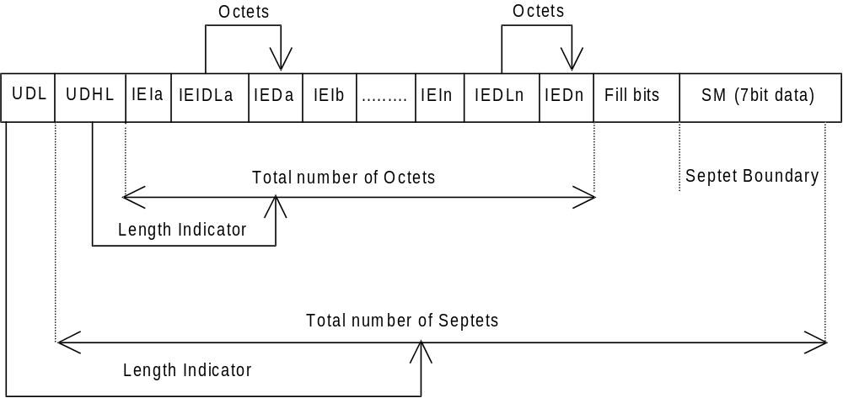
Figure 9.2.3.24 (a)
The diagram below shows the layout of the TP-User-Data-Length and the TP-User-Data for uncompressed 8 bit data or uncompressed UCS2 data. The UDHL field is the first octet of the TP-User-Data content of the Short Message.
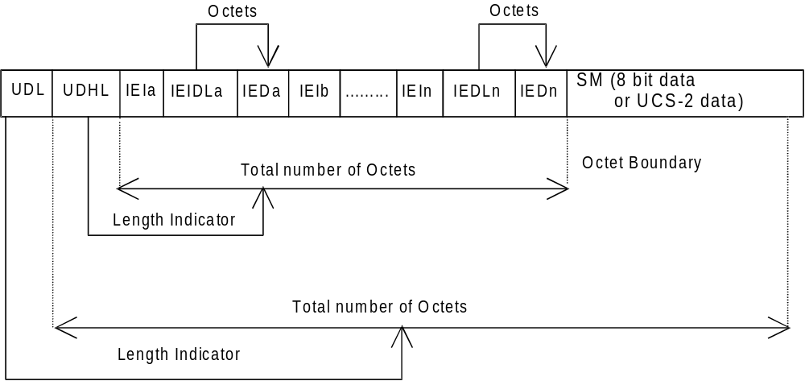
Figure 9.2.3.24 (b)
The diagram below shows the layout of the TP-User-Data-Length and the TP-User-Data for compressed GSM 7 bit default alphabet data, compressed 8 bit data or compressed UCS2 data. The UDHL field is the first octet of the TP-User-Data content of the Short Message.
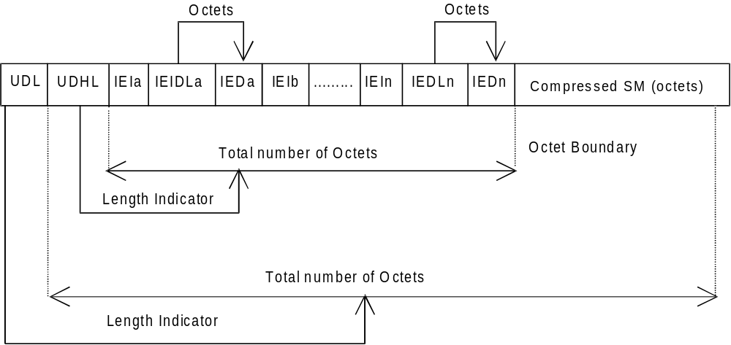
Figure 9.2.3.24 (c)
The definition of the TP-User-Data-Length field which immediately precedes the "Length of User Data Header" is unchanged and shall therefore be the total length of the TP-User-Data field including the Header, if present. (see 9.2.3.16)
The "Length-of-Information-Element" fields shall be the integer representation of the number of octets within its associated "Information-Element-Data" field which follows and shall not include itself in its count value.
The "Length-of-User-Data-Header" field shall be the integer representation of the number of octets within the "User-Data-Header" information fields which follow and shall not include itself in its count or any fill bits which may be present (see text below).
Information Elements may appear in any order and need not necessarily follow the order used in this specification. If Information Elements are duplicated (either with the same or different content) then the contents of the last occurrence of the Information Element shall be used. If the length of the User Data Header overall is such that there appear to be too few or too many octets in the final Information Element then the whole User Data Header shall be ignored.
If any reserved values are received within the content of any Information Element then that part of the Information Element shall be ignored.
The Information Element Identifier octet shall be coded as follows:
VALUE (hex) | MEANING
00 | Concatenated short messages, 8-bit reference number
01 | Special SMS Message Indication
02 | Reserved
03 | Value not used to avoid misinterpretation as <LF> character
04 | Application port addressing scheme, 8 bit address
05 | Application port addressing scheme, 16 bit address
06 | SMSC Control Parameters
07 | UDH Source Indicator
08 | Concatenated short message, 16-bit reference number
09 | Wireless Control Message Protocol
0A-1F | Reserved for future use
20 | RFC 822 E-Mail Header
21-6F | Reserved for future use
70-7F | (U)SIM Toolkit Security Headers
80 – 9F | SME to SME specific use
A0 – BF | Reserved for future use
C0 – DF | SC specific use
E0 – FF | Reserved for future use
A receiving entity shall ignore (i.e. skip over and commence processing at the next information element) any information element where the IEI is Reserved or not supported. The receiving entity calculates the start of the next information element by looking at the length of the current information element and skipping that number of octets.
The SM itself may be coded as 7, 8 or 16 bit data.
If 7 bit data is used and the TP-UD-Header does not finish on a septet boundary then fill bits are inserted after the last Information Element Data octet up to the next septet boundary so that there is an integral number of septets for the entire TP-UD header. This is to ensure that the SM itself starts on an septet boundary so that an earlier Phase mobile shall be capable of displaying the SM itself although the TP-UD Header in the TP-UD field may not be understood.
It is optional to make the first character of the SM itself a Carriage Return character encoded according to the default 7 bit alphabet so that earlier Phase mobiles, which do not understand the TP-UD-Header, shall over-write the displayed TP-UD-Header with the SM itself.
If 16 bit (USC2) data is used then padding octets are not necessary. The SM itself shall start on an octet boundary.
If 8 bit data is used then padding is not necessary. An earlier Phase mobile shall be able to display the SM itself although the TP-UD header may not be understood.
It is also possible for mobiles not wishing to support the TP-UD header to check the value of the TP-UDHI bit in the SMS-Deliver PDU and the first octet of the TP-UD field and skip to the start of the SM and ignore the TP-UD header.

9.2.3.24.10 RFC 822 E-Mail Header

This information element is used to indicate the existence of an RFC 822 Internet electronic mail in the data part of the short message. Both, E-Mail Header and (optional) E-Mail Body shall be parts of the SM’s data and shall be compliant with the syntax specified in RFC 822 [33]. The character set used for encoding of E-Mail Header and E-Mail body, however, shall be according to 3G TS 23.038 [9]. Encoding of E-Mail Header and E-Mail Body shall be done using the same character set.

In compliance with RFC 822 [33] the E-Mail Header shall always be located at the very beginning of the SM’s data part. It shall always be present in the “unfolded” format as it is specified in RFC 822 [33]. Not the <CRLF> character defined in RFC 822 [33] but the <LF> character according to 3G TS 23.038 [9] shall be used for the separation of different E-Mail Header fields.

If an RFC 822 E-Mail Body exists, it shall immediately follow the E-Mail Header in the SM’s data part.

NOTE: The null line defined in RFC 822 for the separation of E-Mail Header and E-Mail Body may be discarded.
NOTE: The sending of extended SMTP headers is allowed and the MS should not reject the message if there are header fields in the email header part that are not specified in RFC.822.
In case of an RFC 822 E-Mail Header exceeding the data part of a single SM, concatenation shall be used. In this case the E-Mail Header starts in the first segment of a concatenated SM and continues in one or several subsequent segments. The RFC 822 E-Mail Body shall immediately follow the final fraction of the RFC 822 E-Mail Header and may also be spread over several segments of the concatenated SM.

In case where this IEI is to be used in a concatenated SM then the IEI, its associated IEDL, and IED fields shall be contained in the first segment of the concatenated SM and shall also be contained in every subsequent segment of the concatenated SM.

The Information-Element-Data octet shall be coded as follows:

Octet 1 RFC 822 E-Mail Header length indicator

This octet shall indicate the length of the RFC 822 E-Mail Header that is located at the beginning of the data part of the SM. In case of an E-Mail Header exceeding the data part of a single SM, this octet shall indicate the length of that fraction of the RFC 822 E-Mail Header that is located at the beginning of the data part of the current segment of the concatenated SM.

If the user data is coded using the GSM 7 bit default alphabet, this IED octet shall give an integer representation of the number of septets within (that fraction of) the RFC 822 E-Mail Header that is located at the beginning of the data part of the current (segment of the concatenated) SM. See figure 9.2.3.24.10 (a).

If the user data is coded using 8-bit data, this IED octet shall give an integer representation of the number of octets within (that fraction of) the RFC 822 E-Mail Header that is located at the beginning of the data part of the current (segment of the concatenated) SM. See figure 9.2.3.24.10 (b).

If the user data is coded using UCS2 [24] data, this IED octet shall give an integer representation of the number of UCS2 characters (consisting of 2 octets) within (that fraction of) the RFC 822 E-Mail Header that is located at the beginning of the data part of the current (segment of the concatenated) SM. See figure 9.2.3.24.10 (c).

NOTE: If the user data is coded using compressed GSM 7 bit default alphabet or compressed 8 bit data or compressed UCS2 [24] data the RFC 822 E-Mail Header length indicator’s value shall be based on the amount of uncompressed data, i.e. before compression is performed.

The diagram below shows the layout of the IED for GSM 7 bit default alphabet data.

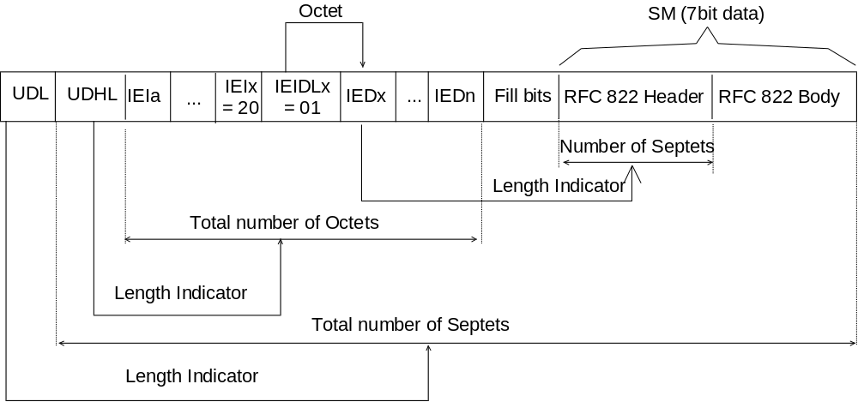
Figure 9.2.3.24.10 (a)

The diagram below shows the layout of the IED for 8 bit data.

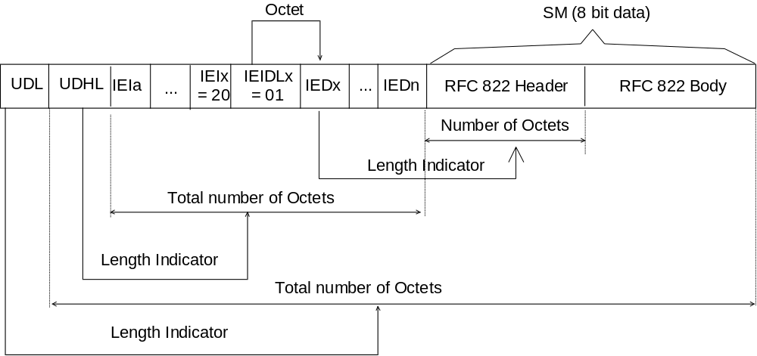
Figure 9.2.3.24.10 (b)

The diagram below shows the layout of the IED for UCS2 data.

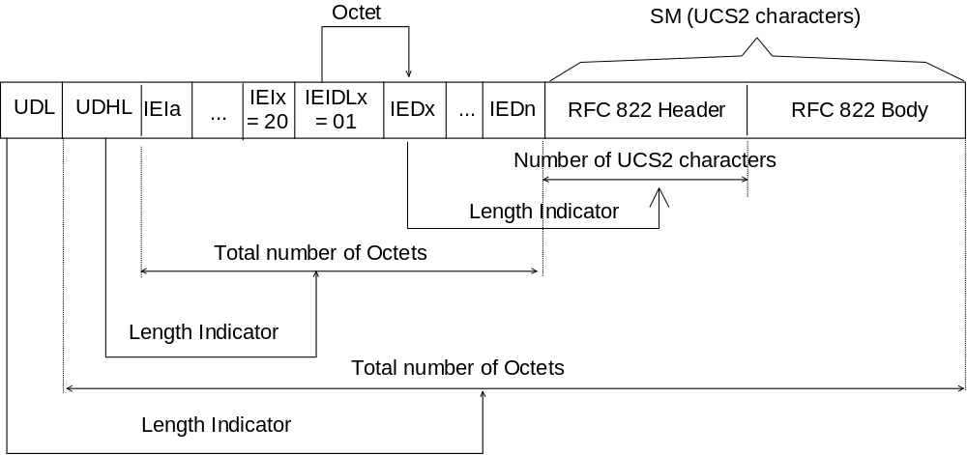
Figure 9.2.3.24.10 (c)

