3GPP TSG-T2 #8 / ETSI SMG4  Mexico, Puerto Vallarta, 1-4 February 2000 |  |  |  |  |  |  |  |  |  |  |  |  |  |  |  |  |  |  | TSGT2#8(00)49
CHANGE REQUEST |  |  |  |  |  |  |  |  |  |  |  |  |  |  |  |  |  |  | Please see embedded help file at the bottom of this  page for instructions on how to fill in this form correctly.
 |  |  |  |  |  |  | 23.057 |  |  |  |  |  | CR |  |  | 002 |  |  |  |  |  |  | Current Version: |  |  |  |  |  |  |  |  | 3.0.0
GSM (AA.BB) or 3G (AA.BBB) specification number ↑ |  |  |  |  |  |  |  |  |  |  |  |  |  |  |  |  | ↑ CR number as allocated by MCC support team
For submission to: |  |  |  | TSG-T#7 |  |  |  |  | for approval |  |  |  |  |  |  | X |  |  | strategic |  |  |  |  |  |  |  |  |  |  |  |  |  | (for SMG
list expected approval meeting # here ↑ |  |  |  |  |  | for information |  |  |  |  |  |  |  |  |  |  |  |  | non-strategic |  |  |  |  |  |  |  |  |  |  |  |  |  | use only)
Form: CR cover sheet, version 2 for 3GPP and SMG The latest version of this form is available from: ftp://ftp.3gpp.org/Information/CR-Form-v2.doc
Proposed change affects: |  |  |  |  |  |  | (U)SIM |  |  |  |  | ME |  |  |  | X | UTRAN / Radio |  |  |  |  |  |  |  |  |  |  | Core Network
(at least one should be marked with an X)
Source: |  |  | T2 |  |  |  |  |  |  |  |  |  |  |  |  |  |  |  |  |  |  |  |  | Date: |  |  |  |  |  |  | 02.02.2000
Subject: |  |  | QoS
Work item: |  |  | MExE
Category: | F Correction |  |  |  |  |  |  |  |  |  |  |  |  |  |  |  |  |  |  |  |  |  |  |  | Release: |  |  |  |  | Phase 2
 | A Corresponds to a correction in an earlier release |  |  |  |  |  |  |  |  |  |  |  |  |  |  |  |  |  |  | X |  |  |  |  |  |  |  |  |  | Release 96
(only one category | B Addition of feature |  |  |  |  |  |  |  |  |  |  |  |  |  |  |  |  |  |  |  |  |  |  |  |  |  |  |  |  | Release 97
shall be marked | C Functional modification of feature |  |  |  |  |  |  |  |  |  |  |  |  |  |  |  |  |  |  |  |  |  |  |  |  |  |  |  |  | Release 98
with an X) | D Editorial modification |  |  |  |  |  |  |  |  |  |  |  |  |  |  |  |  |  |  |  |  |  |  |  |  |  |  |  |  | Release 99 |  |  |  | x
 |  |  |  |  |  |  |  |  |  |  |  |  |  |  |  |  |  |  |  |  |  |  |  |  |  |  |  |  |  | Release 00
Reason for  change: |  |  | Clarification of the definitions.
Clauses affected: |  |  |  |  | 3.1,3.2, 9
Other specs |  | Other 3G core specifications |  |  |  |  |  |  |  |  |  |  |  |  | → List of CRs:
affected: |  | Other GSM core specifications |  |  |  |  |  |  |  |  |  |  |  |  | → List of CRs:
 |  | MS test specifications |  |  |  |  |  |  |  |  |  |  |  |  | → List of CRs:
 |  | BSS test specifications |  |  |  |  |  |  |  |  |  |  |  |  | → List of CRs:
 |  | O&M specifications |  |  |  |  |  |  |  |  |  |  |  |  | → List of CRs:
Other
comments:

 <--------- double-click here for help and instructions on how to create a CR.

3 Definitions and abbreviations

3.1 Definitions
For the purposes of this TS the following definitions apply:
administrator: The administrator of the MExE MS is the entity which has the control of the third party trusted domain, and all resources associated with the domain. The administrator of the device could be the user, the operator, the manufacturer, the service provider, or a third party as designated by the owner of the device.
best effort QoS (Quality of Service): The best effort QoS refers to the lowest of all QoS traffic classes. If the guaranteed QoS cannot be delivered, the bearer network delivers the QoS which can also be called best effort QoS.[28].
certificate: An entity that contains the issuer's public key, identification of the issuer, identification of the signer, and possibly other relevant information. Also, a certificate contains a signed hash of the contents. The signer can be a 3rd. party other than the issuer.
delivered QoS: Actual QoS parameter values with which the content was delivered over the lifetime of a QoS session. [28]
fine grain: Refers to the capabilities of the Java security system to allow applications, sections of code or Java classes to be assigned permissions to perform a specific set of privileged operations. The smallest programming element that can be given permission attributes is a Java class [19]
key pair: Key pairs are matching private and public keys. If a block of data is encrypted using the private key, the public key from the pair can be used to decrypt it. The private key is never divulged to any other party, but the public key is available, e.g. in a certificate.
negotiated QoS: In response to a QoS request, the network shall negotiate each QoS attribute to a level that is in accordance with the available network resources. After QoS negotiation, the bearer network shall always attempt to provide adequate resources to support all of the negotiated QoS profiles. [31]
personal certificate: This is a certificate loaded by the user or a user application which is limited to the application that it is intended for, and is not a MExE Certificate. E.g. an e-mail application could load certificates for its usage. Personal certificates are out of scope for MExE.
phonebook: A phonebook is a dataset of personal or entity attributes. The simplest form is a set of name-number pairs as supported by GSM SIMs.
MExE: MExE (Mobile station application Execution Environment) is defined in detail in this document, but the scope of MExE does not include the operating system, or the manufacturer’s execution environment.
MExE certificate: This is a certificate used in the realisation of MExE security domains. A MExE Certificate can be used to verify downloaded MExE executables. Use of the word "certificate" in this document implies a MExE certificate. Other varieties of certificate will be explicitly qualified as a e.g. "Personal Certificate".
MExE executable: An executable is an applet, application, or executable content, which conforms to the MExE specification and may execute on the ME.
MExE Java VM: This is a standard Java virtual machine used to execute MExE Java applets and applications
MExE native library: This is a downloaded native library that can be accessed by MExE executables
MExE-SIM: A SIM that is capable of storing a security certificate that is accessible using standard mechanisms..
owner: An owner of the MExE MS. An owner could be a user, operator (e.g. where the MS is obtained as part of a subscription and the cost of the MS is subsidised), service provider, or a third party (e.g. the MS is owned by the user’s company and this company wishes to control how the MS is used)
power up event: An abstract event that occurs when the MExE MS is cold started (i.e. switched on).
QoS session: Lifetime of PDP context. The period between the opening and closing of a network connection whose characteristics are defined by a QoS profile. Multiple QoS sessions may exist, each with a different QoS profile. [28]
QoS profile: A QoS profile comprises of a number of QoS parameters. A QoS profile is associated with each QoS session. The QoS profile defines the performance expectations placed on the bearer network. [28]
requested QoS: A QoS profile is requested at the beginning of a QoS session. QoS modification requests are also possible during the lifetime of a QoS session. [28],[31]
sandbox: A sandbox is a safe area to run Java code. Untrusted Java code executing in a sandbox has access to only certain resources [18]
service: A service (which may consist of an application or applet, and its related content) is a set of functions offered to a user by an organisation, and may be performed on the MExE MS and/or remotely
service name: An identifier associated with a service, which could be a string, a fully qualified Java class name, a unique URI or other identifier.
session: The period between the launching of a MExE executable and its execution termination. A WAP-session is established between the mobile and the WAP Gateway. The duration of a WAP-session can range from a second to years. The WAP-session can be associated with a particular subscription in the WAP Gateway.
signature: "Signing" is the process of encrypting a hash of the data using a private key. If the signature can be decrypted using the public key, then the signature is valid.
signed JAR file: Archives of Java classes or data that contain signatures that also include a way to identify the signer in the manifest. (The Manifest contains a file which has attributes defined in it.)
subscribed QoS: The network will not grant a QoS greater than that subscribed. The QoS profile subscription parameters are held in the HLR. An end user may have several QoS subscriptions. For security and the prevention of damage to the network, the end user cannot directly modify the QoS subscription profile data. [31]
user: The user of the MExE MS
Further definitions specific to MExE are in GSM given in 3G TS 22.057 (MExE stage 1) [2].

3.2 Abbreviations
For the purposes of this TS the following abbreviations apply:

API Application Programming Interface
APDU Application protocol data unit
CA Certification Authority
CC/PP Composite Capability/Preference Profiles
Diff-serv Differentiated Services
CGI Common Gateway Interface
CCM Certificate Configuration Message
CP-Admin Certificate Present (in the MExE SIM) - Administrator
CP-TP Certificate Present (in the MExE SIM) - Third Party
DHCP Dynamic Host Configuration Protocol
GSM Global System for Mobile Communication
GPRS General Packet Radio Service
HTTP HyperText Transfer Protocol
HTTPS HyperText Transport Protocol Secure (https is http/1.1 over SSL, i.e. port 443)
IETF Internet Engineering Task Force
IP Internet Protocol
JNDI Java Naming Directory Interface
JTAPI Java Telephony Application Programming Interface
JAR file Java Archive File
MMI Man-Machine Interface
MSE MExE Service Environment
OCF OpenCard Framework
QoS Quality of Service
PDP Packet Data Protocol
RDF Resource Description Format
RFC Request For Comments
SAP Service Access Point
SMS Short Message Service
TLS Transport Layer Security
TP Third Party
UDP User Datagram Protocol
UE User Equipment
UI User Interface
UMTS Universal Mobile Telecommunications System
URL Uniform Resource Locator
URI Uniform Resource Identifier
USSD Unstructured Supplementary Service Data
WAE Wireless Application Environment
WAP Wireless Application Protocol
WDP Wireless Datagram Protocol
WSP Wireless Session Protocol
WTA Wireless Telephony Applications
WTAI Wireless Telephony Applications Interface
WTLS Wireless Transport Layer Security
WTP Wireless Transaction Protocol
WWW World Wide Web

Further abbreviations are given in 3G TS 22.057 (MExE stage 1) [2] and GSM 01.04 [1].

9 Quality of Service
QoS aware MExE executables may be executing on the MExE device. To ensure correct operation with the QoS provisioning of the bearer network(s) the associated API's and the MExE QoS manager shall be supported by MExE MS supporting bearers defined by QoS– see figure 13. Non QoS aware MExE executables shall operate with the defined QoS by the user or the network.
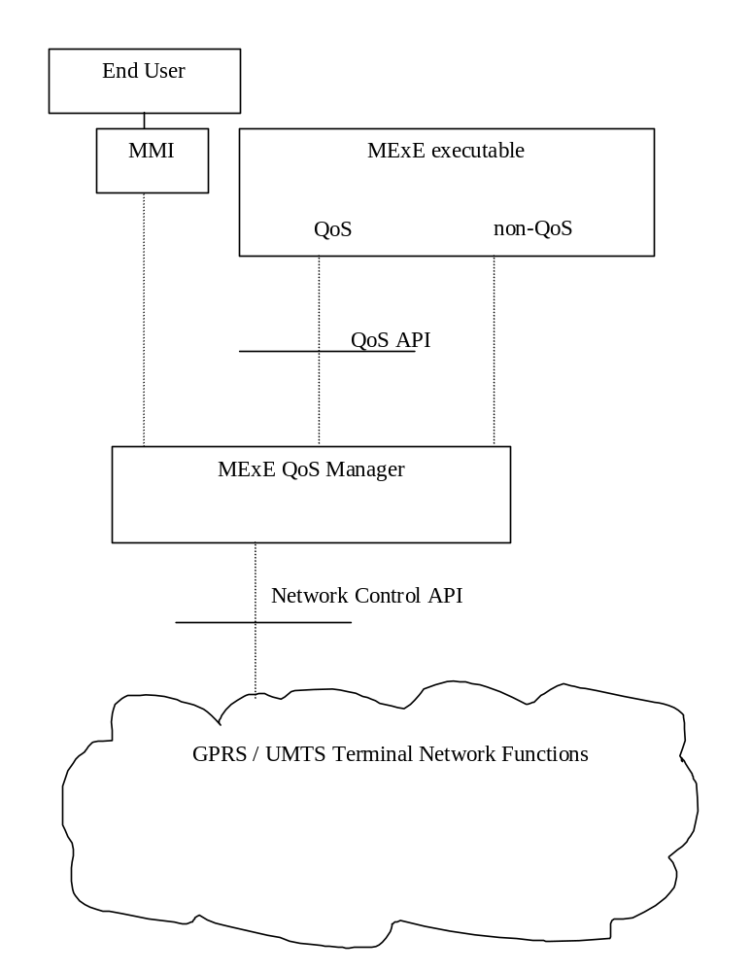
Figure 13: Logical MExE Terminal QoS manager elements

9.1 MExE QoS Support
A MExE QoS manager exists between the MExE executable and the Network Control API. To interface this, an API to the MExE executable is provided and another API to the network, see figure 13. The MExE QoS functions accommodates standard methods of end to end QoS provisioning – e.g. differentiated services (Diff-serv).
For MExE devices supporting bearers defined by QoS, the MExE device shall support the following basic QoS operations :-
a mapping between the QoS requirements of the MExE executable and the network layer
MExE executables shall be able to indicate and interpret QoS values of the network via the MExE QoS Manager

MExE executables shall be able to modify the QoS dynamically
MExE executables shall be able to react to changes in the provided QoS
The end user shall be able to manage the QoS directly via the MMI.
MExE introduces two new elements to cater for QoS – the MExE QoS manager and the QoS API. The MExE QoS manager shall handle the fact that the network may not have QoS capabilities.

9.2 MExE QoS Manager
The MExE QoS manager is responsible for:
Managing the QoS streams for MExE executables
Notification of the negotiated and delivered QoS to the end user / MExE executable
The MExE QoS manager shall support the MExE QoS API according to the bearer supported by the device, and provide functions such as:-
- insert additional QoS signalling parameters (e.g. Diff-serv)
- add the functionality of the MExE QoS API at best effort, if the network does not support it directly
- translate between the QoS parameters from the MExE executable and those of the network
- monitor the QoS delivered by the network and manage QoS requests between the MExE executable and the network
- be informed by the MExE executable of the requested QoS traffic class.
- be informed by the MExE executable of minimum the lowest QoS traffic class which can be accepted by the MexE executable.
- attempt to re-negotiate the QoS if it falls below the lowest QoS traffic class.
The MExE QoS manager may request information from the network regarding the QoS available.
The MExE QoS manager does not need to know the end user's subscribed QoS, this is held within the network and used to validate a requested QoS level.
The MExE QoS manager may also be accessed through the device's MMI.

9.3 Network Control API
The network control API shall provide the QoS manager with access to the network specific QoS control (defined for GPRS/UMTS in [29] and [30].
The MExE QoS manager may perform some QoS control, if it is not provided in the network control.

9.4 QoS API
The QoS API provides the MExE executable with an interface to the QoS management. It does not require the MExE executable to have any knowledge of the underlying network, or how QoS is implemented in the network.
The QoS API shall provide the MExE executable with a standard set of parameters . Refer to [28] for details of these parameters.
Table 5 shows the set of example parameters.

Parameter | Units | Type
Token Bucket Rate | bytes /sec | 32-bit IEEE floating point number
Token Bucket Size | bytes | 32-bit IEEE floating point number
Peak Data Rate | bytes/sec | 32-bit IEEE floating point number
Minimum Policed Unit | bytes | 32-bit integer
Maximum Packet Size | bytes | 32-bit integer
Latency | micro secs | 32-bit integer
Delay Variation | micro secs | 32-bit integer
Service Type |  | service type
Table 5: Example parameters

As a minimum the following three parameters shall be supported by the MExE QoS manager:-
Token Bucket Rate
Token Bucket Size
Peak Data Rate
Note: The discussion of UMTS bearer service parameters as well as radio access bearer parameters is still going on. Especially the bitrate parameters and reliability parameter are under discussion [28].

If the MExE executable does not provide a full set of QoS parameters, then the MExE QoS manager shall the provide QoS parameters based on information available to it (e.g. from the MMI settings), see subclause 'Sources of UMTS Bearer Service Parameters'.

9.5 Sources of Bearer Service Parameters
A set of QoS parameters (QoS profile) specify the service provided to the user by the network. At bearer service establishment or modification different QoS profiles have to be taken into account. This is based on:-
- The UE capabilities
- The UE or the TE within the terminating network
- A QoS profile in the QoS subscription (describes the upper limits)
- Default QoS profile (of the user or network)
- A Network specific QoS profile characterising for example the current resource availability or other network capabilities.

9.6 QoS Streams
Several MExE executables may be executing in the MExE device, each with a different QoS requirement. Also, a MExE executable may operate several QoS streams, each with different parameter settings. The MExE QoS manager within the MExE device shall be able to deal with each stream independently.

9.7 QoS Security
Only the end user, MExE executable or the network using a QoS stream should be able to modify the QoS of that stream.

The FLOWSPEC parameters, defined by the IETF Integrated Services Working Group, provide the QoS information required by QoS capable network elements.

