3GPP TSG-T2 #9 / ETSI SMG4 |  |  |  |  |  |  |  |  |  |  |  |  |  |  |  |  |  |  | TSGT2#9(00)0304
Utrecht, Netherlands, 15-19 May 2000 |  |  |  |  |  |  |  |  |  |  |  |  |  |  |  |  |  |  |  |  |  |  |  |  |  | e.g. for 3GPP use the format TP-99xxx  or for SMG, use the format P-99-xxx
CHANGE REQUEST |  |  |  |  |  |  |  |  |  |  |  |  |  |  |  |  |  |  | Please see embedded help file at the bottom of this  page for instructions on how to fill in this form correctly.
 |  |  |  |  |  |  | 23.057 |  |  |  |  |  | CR |  |  | 005 |  |  |  |  |  |  | Current Version: |  |  |  |  |  |  |  |  | 3.1.1
GSM (AA.BB) or 3G (AA.BBB) specification number ↑ |  |  |  |  |  |  |  |  |  |  |  |  |  |  |  |  | ↑ CR number as allocated by MCC support team
For submission to: |  |  |  | TSG-T#8 |  |  |  |  | for approval |  |  |  |  |  |  | X |  |  | strategic |  |  |  |  |  |  |  |  |  |  |  |  |  | (for SMG
list expected approval meeting # here ↑ |  |  |  |  |  | for information |  |  |  |  |  |  |  |  |  |  |  |  | non-strategic |  |  |  |  |  |  |  |  |  |  |  |  |  | use only)
Form: CR cover sheet, version 2 for 3GPP and SMG The latest version of this form is available from: ftp://ftp.3gpp.org/Information/CR-Form-v2.doc
Proposed change affects: |  |  |  |  |  |  | (U)SIM |  |  |  |  | ME |  |  |  | X | UTRAN / Radio |  |  |  |  |  |  |  |  |  |  | Core Network
(at least one should be marked with an X)
Source: |  |  | T2 |  |  |  |  |  |  |  |  |  |  |  |  |  |  |  |  |  |  |  |  | Date: |  |  |  |  |  |  | 10.05.2000
Subject: |  |  | ME actions on SIM insertion and/or power up
Work item: |  |  | MExE
Category: | F Correction |  |  |  |  |  |  |  |  |  |  |  |  |  |  |  |  |  |  | x |  |  |  |  | Release: |  |  |  |  | Phase 2
 | A Corresponds to a correction in an earlier release |  |  |  |  |  |  |  |  |  |  |  |  |  |  |  |  |  |  |  |  |  |  |  |  |  |  |  |  | Release 96
(only one category | B Addition of feature |  |  |  |  |  |  |  |  |  |  |  |  |  |  |  |  |  |  |  |  |  |  |  |  |  |  |  |  | Release 97
shall be marked | C Functional modification of feature |  |  |  |  |  |  |  |  |  |  |  |  |  |  |  |  |  |  |  |  |  |  |  |  |  |  |  |  | Release 98
with an X) | D Editorial modification |  |  |  |  |  |  |  |  |  |  |  |  |  |  |  |  |  |  |  |  |  |  |  |  |  |  |  |  | Release 99 |  |  |  | X
 |  |  |  |  |  |  |  |  |  |  |  |  |  |  |  |  |  |  |  |  |  |  |  |  |  |  |  |  |  | Release 00
Reason for  change: |  |  | Correction
Clauses affected: |  |  |  |  | 8.5.1.1
Other specs |  | Other 3G core specifications |  |  |  |  |  |  |  |  |  |  |  |  | → List of CRs:
affected: |  | Other GSM core specifications |  |  |  |  |  |  |  |  |  |  |  |  | → List of CRs:
 |  | MS test specifications |  |  |  |  |  |  |  |  |  |  |  |  | → List of CRs:
 |  | BSS test specifications |  |  |  |  |  |  |  |  |  |  |  |  | → List of CRs:
 |  | O&M specifications |  |  |  |  |  |  |  |  |  |  |  |  | → List of CRs:
Other
comments:

 <--------- double-click here for help and instructions on how to create a CR.

8.5.1.1 ME actions on SIM insertion and/or power up.
The requirements in this sub-clause ensure that the operator domain on the ME belongs to the same operator as the operator that issued the SIM inserted in the ME and, if there is an operator root public key (ORPK) on the SIM, that trusted operator applications on the terminal were verified using that ORPK.
The ME shall support the use and management of an Operator root public key (ORPK) on the SIM. Note that this does not apply to MExE release 98.

On power up of the terminal, the terminal shall behave as dictated by figure 6 below.
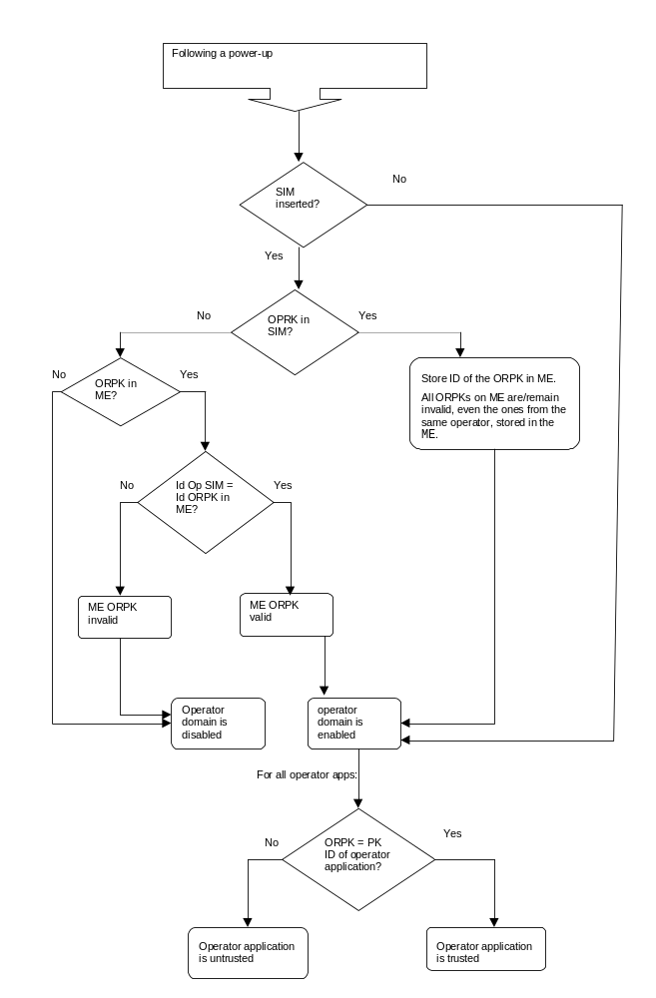
Figure 6: Terminal behaviour on power up

Note that in DCS1900 the MCC+MNC is 6 digits, but elsewhere it is 5 digits. The ME needs to know how many digits to use, however this is outside the scope of this specification. The identity of the root public key has to be defined.
The terminal shall only read the SIM ORPK from the SIM when required and shall not store a SIM ORPK on the terminal.
When an operator root public key stored on the ME is marked as invalid, all operator applications verified using that root public key or by certificates verified by a chain that terminates with that root public key, shall cease operation as soon as possible and shall be marked as untrusted.

