3GPP T2#12  Los Angeles, CA, USA  12 – 16 February 2001 |  |  |  |  |  |  |  |  |  |  |  | T2-010264
 | CR-Form-v3
 | CHANGE REQUEST
 |  | 23.140 |  |  |  |  | CR | 003 |  |  |  rev |  |  |  |  |  |  |  Current version: |  |  |  |  | 4.1.0 |  | 
 | For HELP on using this form, see bottom of this page or look at the pop-up text over the  symbols.
 | Proposed change affects:  |  |  |  |  |  | (U)SIM |  |  | ME/UE |  |  | x |  | Radio Access Network |  |  |  |  |  |  |  |  | Core Network
 | Title:  |  | High-level description of MMS - part II
 | Source:  |  | T2
 | Work item code:  |  | MMS |  |  |  |  |  |  |  |  |  |  |  |  |  |  |  | Date:  |  | 16.02.01
 | Category:  |  | B |  |  |  |  |  |  |  |  |  |  |  |  |  |  |  | Release:  |  | REL-4
 |  |  | Use one of the following categories:  F (essential correction)  A (corresponds to a correction in an earlier release)  B (Addition of feature),  C (Functional modification of feature)  D (Editorial modification)  Detailed explanations of the above categories can  be found in 3GPP TR 21.900. |  |  |  |  |  |  |  |  |  |  |  |  |  |  |  |  | Use one of the following releases:  2 (GSM Phase 2)  R96 (Release 1996)  R97 (Release 1997)  R98 (Release 1998)  R99 (Release 1999)  REL-4 (Release 4)  REL-5 (Release 5)
 | Reason for change:  |  |  | 1.) Corrections for the purpose of editorial and consistence check as well as to follow the recommendations given by the T2 chairman at T2#11  2.) A definitions section was inserted.  3.) Architecture description changed reflecting consensus reached for MMS R’4.  4.) Support for prepaid services was added.  5.) Unified Messaging use cases were added to the informative annex A.  6.) Interworking between MMSEs was further defined  7.) MMS support for streaming was revised  8.) Further elaboration of the address hiding feature  9.) Interworking with external servers (in particular IP-based) further defined  10.) Addressing scheme was further elaborated  11.) Address hiding (sender anonymity) was added  10.) Reply-charging feature was added  11.) Forwarding of MMs without prior download was inserted  12.) MMS interface for VAS Applications
 | Summary of change:  |  |  | Streaming, Prepaid, Addressing, Anonymity, Interworking with MMS and non-MMS systems, Reply-charging, Forwarding, VAS Applications
 | Consequences if   not approved: |  |  | MMS R’4 spec would not be consistent, some ambiguity of terms wouldn’t be resolved and essential features required for MMS R’4 wouldn’t be fulfilled.
 | Clauses affected: 
 | Other specs  |  |  |  | Other core specifications 
 | Affected: |  |  |  | Test specifications
 |  |  |  |  | O&M Specifications
 | Other comments: 

How to create CRs using this form:
Comprehensive information and tips about how to create CRs can be found at: http://www.3gpp.org/3G_Specs/CRs.htm. Below is a brief summary:
1) Fill out the above form. The symbols above marked  contain pop-up help information about the field that they are closest to.
2) Obtain the latest version for the release of the specification to which the change is proposed. Use the MS Word "revision marks" feature (also known as "track changes") when making the changes. All 3GPP specifications can be downloaded from the 3GPP server under ftp://www.3gpp.org/specs/ For the latest version, look for the directory name with the latest date e.g. 2000-09 contains the specifications resulting from the September 2000 TSG meetings.
3) With "track changes" disabled, paste the entire CR form (use CTRL-A to select it) into the specification just in front of the clause containing the first piece of changed text. Delete those parts of the specification which are not relevant to the change request.

Foreword
This Technical Specification (TS) has been produced by the 3rd Generation Partnership Project (3GPP).
The contents of the present document are subject to continuing work within the TSG and may change following formal TSG approval. Should the TSG modify the contents of the present document, it will be re-released by the TSG with an identifying change of release date and an increase in version number as follows:
Version x.y.z
where:
x the first digit:
1 presented to TSG for information;
2 presented to TSG for approval;
3 or greater indicates TSG approved document under change control.
y the second digit is incremented for all changes of substance, i.e. technical enhancements, corrections, updates, etc.
z the third digit is incremented when editorial only changes have been incorporated in the document.

1 Scope
The present document defines the stage 2 and stage 3 description of the non realtime Multimedia Messaging Service, MMS. Stage 2 identifies the functional capabilities and information flows needed to support the service described in stage 1.
The present document includes information applicable to network operators, service providers and terminal, switch and database manufacturers.
The present document contains the core functions for a non realtime Multimedia Messaging Service, MMS, which are sufficient to provide a basic service.
MMS uses a number of technologies to realise the requirements of the stage 1 description (3G TS 22.140) [1]. The present document describes how the service requirements are realised with the selected technologies. As far as possible existing protocols (e.g. WAP, SMTP, ESMTP as transfer protocols; lower layers to provide push, pull, notification) and existing message formats (e.g. SMIL, MIME) shall be used for the realisation of the Multimedia Messaging Service.
This specification serves as a foundation for the development of MMS. It describes a new service which has no direct equivalent in the previous ETSI/GSM world or in the fixed network world. In consequence readers may find that certain aspects are not clearly defined or open to misinterpretation. Where any such case is encountered it is essential that the issue is brought to the 3GPP TSG T2 standards body (see page 2 for contact information) for discussion and resolution in order to provide interoperable implementations.

2 References
The following documents contain provisions which, through reference in this text, constitute provisions of the present document.
- References are either specific (identified by date of publication, edition number, version number, etc.) or non-specific.
- For a specific reference, subsequent revisions do not apply.
- For a non-specific reference, the latest version applies. In the case of a reference to a 3GPP document (including a GSM document), a non-specific reference implicitly refers to the latest version of that document in the same Release as the present document.
[1] 3G TS 22.140: "Multimedia Messaging Service".
[2] 3G TR 21.905: "Vocabulary for 3GPP Specifications".
[3] "Wireless Application Environment Specification", WAP Forum. URL: http://www.wapforum.org/.
[4] 3G TS 23.057: "Mobile Station Application Execution Environment".
[5] STD 11 (RFC 822) Internet Message Standard Format, IETF.
[6] RFC 2046 Multipurpose Internet Mail extension (MIME) Part Two: Media Types, IETF.
[7] "The Unicode Standard", Version 2.0, Unicode Consortium, Addision-Wesley Dev. Press, 1996.
[8] US-ASCII: "Coded Character Set 7 Bit; American Standard Code for Information Interchange"; ANSI X3.4, 1986.
[9] ISO-8859-1 (1987): "Information Processing - 8-bit Single-Byte Coded Graphic Character Sets; Part 1: Latin Alphabet No. 1".
[10] RFC 2279, "UTF-8, A Transformation format of ISO 10646", IETF.
[11] 3G TS 24.011: "Point-to-Point (PP) Short Message Service (SMS) support on mobile radio interface".
[12] 3G TS 26.090: "AMR Speech Codec Speech Transcoding Functions".
[13] 3G TS 26.093 (V3.1.0): "AMR Speech Codec; Source Controlled Rate Operation".

[14] MP3, MPEG1-Audio ISO/IEC 11172-3, MPEG2-Audio ISO/IEC 11172-3.
[15] MIDI SDS, International Midi Association, 5316 West 57th Street, Los Angeles, CA 90056, (415) 321-MIDI.
[16] WAV: Waveform Audio File Format, MIME Sub-type Registration www.ietf.org
[17] ITU-T Recommendation T.81 | ISO/IEC 10918-1:1992, “Information Technology - Digital Compression and Coding of Continuous-Tone Still Images - Requirements and Guidelines”.
[18] Graphics Interchange Format (Version 89a), Compuserve, Inc., Columbus, Ohio, 1990.
[19] ISO/IEC 14496-1 (1999): Information Technology - Generic Coding of Audio-Visual Objects - Part 1: Systems. ISO/IEC 14496-2 (1999): Information Technology - Generic Coding of Audio-Visual Objects - Part 2: Visual.
[20] ITU-T Recommendation H.263 (1998): "Video coding for low bit rate communication".
[21] Quick-Time. URL: http://www.apple.com.
[22] STD 10 (RFC 821) "Simple Mail Transfer Protocol", IETF.
[23] "WAP Wireless Session Protocol", WAP Forum, November 1999. URL: http://www.wapforum.org/.
[24] "WAP Push Access Protocol", WAP Forum, November 1999. URL: http://www.wapforum.org/.
[25] "WAP User Agent Profile", WAP Forum, November 1999. URL: http://www.wapforum.org.
[26] "Resource Description Framework (RDF) Model and Syntax Specification", W3C Recommendation, 2/99. URL: http://www.w3c.org/TR/1999/PR-rdf-syntax-19990105.
[27] "WAP Wireless Markup Language 1.2", November 1999. URL: http://www.wapforum.org.
[28] Synchronized Multimedia Integration Language (SMIL) 1.0 Specification - http://www.w3.org/TR/smil-boston/.
[29] "WAP Wireless Transport Layer Security", November 1999. URL: http://www.wapforum.org.
[30] "WAP Identity Module", November 1999. URL: http://www.wapforum.org.
[31] ITU-T Recommendation T.37 (06/98): "Procedures for the transfer of facsimile data via store-and-forward on the Internet".
[32] ITU-T Recommendation T.30 (1996): "Procedures for document facsimile transmission in the general switched telephone network".
[33] RFC 2421 (Sept. 1998): Voice Profile for Internet Mail – version 2, VPIM.
[34] RFC 1957 POP 3, Post Office Protocol, Version 3.
[35] RFC 1730 (December 1994): IMAP4, Internet Message Access Protocol Version 4, IETF.
[36] Tag Image File Format (TIFF) Version 6: Adobe Systems, http://www.adobe.com.
[37] 3G TR 23.093: “Interface protocols for the connection of Short Message Service Centres (SMSCs) to Short Message Entities (SMEs)”

[38] 3G TR 26.911: "Codec(s) for Circuit Switched Multimedia Telephony Service; Terminal Implementor’s Guide".
[39] Internet draft “ RTP payload format for AMR”; IETF
URL: http://search.ietf.org/internet-drafts/draft-ietf-avt-rtp-amr-03.txt
NOTE: Reference [39] has to be replaced by the appropriate RFC number once the Internet draft is approved within the IETF (IETF approval is scheduled to spring 2001).
[40] 3G TS 26.233: "Packet-switched Streaming Service (PSS); General Description".
[41] 3G TS 26.234: "Packet-switched Streaming Service (PSS); Protocols and Codecs".
[42] Internet Draft “A TCP profile for W-CDMA: 3G wireless packet service”; IETF
URL: http://search.ietf.org/internet-drafts/draft-inamura-docomo-00.txt
NOTE: Reference [42] has to be replaced by the appropriate RFC number once the Internet draft is approved within the IETF.
[43] WAP Wireless profiled TCP, WAP-225-TCP, Draft Version 11-October-2000
NOTE: Reference [43] has to be replaced by the appropriate WAP specification once the specification is approved within the WAP Forum.
[44] RFC 2045, Multipurpose Internet Mail extension (MIME) Part One: Format of Internet Message Bodies, IETF, ftp://ftp.isi.edu/in-notes/rfc2045.txt
[45] RFC 2047, Multipurpose Internet Mail extension (MIME) Part Three: Message Header Extensions for Non-ASCII-Text, IETF, ftp://ftp.isi.edu/in-notes/rfc2047.txt
[46] RFC 2048, Multipurpose Internet Mail extension (MIME) Part Four: Registration Procedures, IETF, ftp://ftp.isi.edu/in-notes/rfc2048.txt
[47] RFC 2049, Multipurpose Internet Mail extension (MIME) Part Five: Conformance Criteria and Examples, IETF, ftp://ftp.isi.edu/in-notes/rfc2049.txt
[48] RFC 2616, Hypertext Transfer Protocol, HTTP/1.1, IETF, ftp://ftp.isi.edu/in-notes/rfc2616.txt
[49] STD 13 (RFC 1034, 1035), Domain Name System (DNS)
[50] STD 14 (RFC 947), Mail Routing and the Domain System
[51] RFC 2076, Common Internet Message Headers, IETF. http://www.ietf.org/rfc/rfc2076.txt
[52] RFC 1893, Enhanced Mail System Status Codes, IETF. http://www.ietf.org/rfc/rfc1893.txt
[53] RFC 1327, Mapping between X.400(1988) / ISO 10021 and RFC 822, IETF. http://www.faqs.org/rfcs/rfc1327.html

3 Definitions and Abbreviations

3.1 Definitions
For the purposes of the present document, the following terms and definitions apply in addition to those defined in 3G TR 21.905 [2] and 3G TS 22.140 [1]:
Abstract message: The information which is transferred between two MMS entities used to convey an MM and/or associated control information between these two entities. The application protocol framework and technical realisation of MMS service features is described in terms of abstract messages in this specification.
Delivery Report: feedback information provided to an originator MMS User Agent by an MMSE about the status of the delivery of an MM.
External Server: A network entity/application of an external system such as Internet email, unified messaging system or facsimile to which MMs may be sent to and/or from which MMs may be received by an MMS User Agent via an MMS service provider. An External Server is connected to that MMS Service Provider via non-MMS-specific protocols.
Forwarding MMS User Agent: An MMS User Agent that is the intended recipient of an MM, that requests forwarding of the MM for delivery to other recipient(s) without having to first download the MM.
Forwarded MM: An MM originally sent from a sender to an intended recipient which is then forwarded to other recipient(s) and to which a delivery report and/or read-reply report may refer and which may be subject to further forwarding.
MM Delivery: The act of a recipient MMSE delivering an MM to a recipient MMS User Agent.
MM Submission: The act of an originator MMS User Agent submitting an MM into the originator MMSE.
MMSE: A collection of MMS-specific elements under the control of a single administration.
MMS Relay/Server: An MMS-specific network entity/application that is under the control of an MMS service provider. An MMS Relay/Server transfers messages, provides operations of the MMS that are specific to or required by the mobile environment and provides (temporary and/or persistent) storage services to the MMS.
MMS User Agent: An application residing on a UE, an MS or an external device that performs MMS-specific operations on a user’s behalf. An MMS User Agent is not considered part of an MMSE.
MMS VAS Applications: Applications providing Value Added Services (e.g. news service or weather forecasts) to MMS users.
Original MM: An (initial) MM sent from a sender to a recipient and to which a delivery report and/or a read-reply report and/or a reply-MM may refer and/or which may be subject to being forwarded.
Originator MMSE: An MMSE associated with the sender of an MM.
Originator MMS Relay/Server: An MMS Relay/Server associated with the sender of an MM.
Originator MMS User Agent: An MMS User Agent associated with the sender of an MM.
Read-Reply Report: feedback information to an originator MMS User Agent by a recipient MMS User Agent about the status of handling/rendering of an original MM in a recipient MMS User Agent
Recipient MMSE: An MMSE associated with the recipient of an MM.
Recipient MMS Relay/Server: An MMS Relay/Server associated with the recipient of an MM.
Recipient MMS User Agent: An MMS User Agent associated with the recipient of an MM.
Reply-MM: In case of reply-charging the first reply accepted by the MMSE (after checking the reply charging limitations, such as the latest time of submission) is called a reply-MM.
Transaction: A message pair sent between an MMS User Agent and MMS Relay/Server, between MMS Relay/Servers, or between MMS Relay/Servers.

3.2 Abbreviations
For the purposes of the present document, the following abbreviations apply in addition to those defined in [1] and [2]:
CDR Call Data Record
DNS Domain Name System
EMA Electronic Message Association
E-Mail Electronic Mail
ENUM Electronic Numbering
FQDN Fully Qualified Domain Name
HTTP Hypertext Transfer Protocol
IANA Internet Assigned Numbering Authority
IETF Internet Engineering Task Force
IMAP4 Internet Message Access Protocol
GW Gateway
MIME Multipurpose Internet Mail Extensions
MM Multimedia Message
MMSE Multimedia Messaging Service Environment
MMS Multimedia Messaging Service
MTA Mail Transfer Agent
PDU Protocol Data Unit
POP3 Post Office Protocol Version 3
RDF Resource Description Format
RFC Request for Comments
SMIL Synchronised Multimedia Integration Language

SMTP Simple Mail Transfer Protocol
UA User Agent
UAProf User Agent Profile
URI Uniform Resource Identifiers
VAS Value Added Service
VPIM Voice Profile for Internet Mail
W3C WWW Consortium
WAP Wireless Application Protocol
WIM WAP Identity Module
WML Wireless Markup Language
WSP WAP Session Protocol
WTLS Wireless Transport Layer Security

4 General Architecture

4.1 Overview
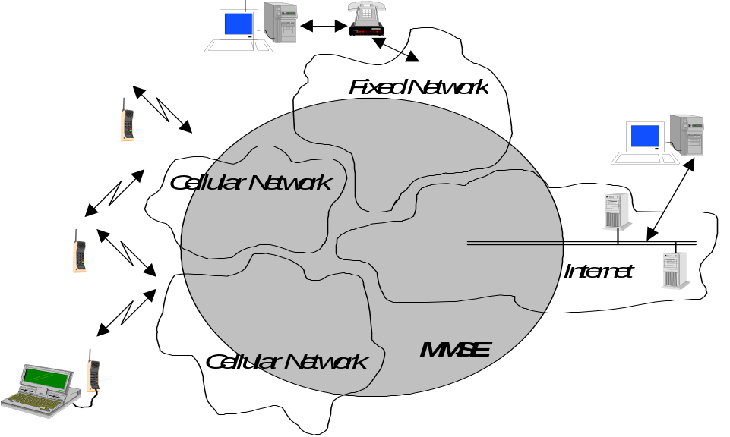

Figure 1: General view of MMS provision within the different networks
Figure 1 shows a generalised view of the Multimedia Messaging Service architecture. It shall combine different networks and network types and shall integrate messaging systems already existent within these networks. The terminal operates with the Multimedia Messaging Service Environment, MMSE. This environment may comprise 2G and 3G networks, 3G networks with islands of coverage within a 2G network and roamed networks. The MMSE provides all the necessary service elements, e.g. delivery, storage and notification functionality. These service elements may be located within one network or distributed across several networks or network types.

4.2 Involved MMS Elements
Figure 2 shows that multimedia messaging may encompass many different network types. The basis of connectivity between these different networks shall be provided by the Internet protocol and its associated set of messaging protocols. This approach enables messaging in 2G and 3G wireless networks to be compatible with messaging systems found on the Internet.
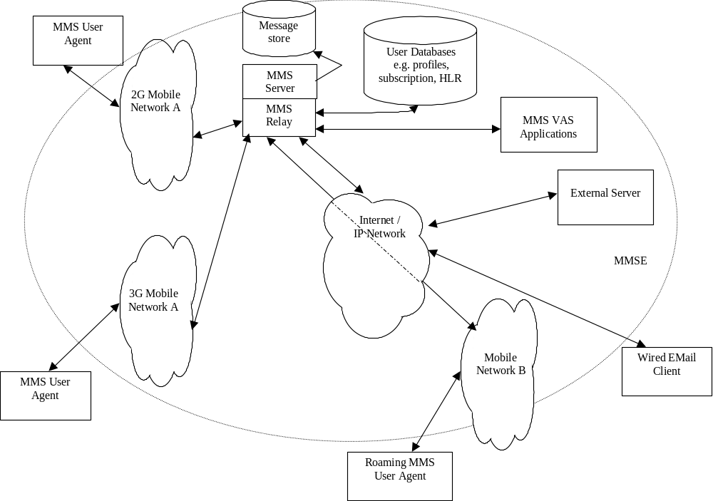

Figure 2: MMS Architectural Elements

MMSE
The Multimedia Message Service Environment encompasses all the various elements that provide a complete MMS to a user. In the case of roaming the visited network is considered a part of that user's MMSE. However, subscribers to the mobile network B are considered to be a part of a separate MMSE.
MMS Relay/Server
The MMS Relay/Server is responsible for storage and handling of incoming and outgoing messages and for the transfer of messages between different messaging systems. Depending on the business model, the MMS Relay/Server may be a single logical element or may be separated into MMS Relay and MMS Server elements. These may be distributed across different domains.
The MMS Relay/Server should be able to generate charging data (Call Data Record - CDR) when receiving MMs or when delivering MMs to the MMS User Agent or to another MMSE.
MMS User Databases
This element may be comprised of one or more entities that contain user related information such as subscription and configuration (e.g. user profile, HLR).
MMS User Agent
The MMS User Agent resides on a UE, an MS or on an external device connected to a UE/MS. It is an application layer function that provides the users with the ability to view, compose and handle MMs (e.g. submitting, receiving, deleting of MMs).
MMS VAS Applications
The MMS VAS Applications offer Value Added Services to MMS users. There could be several MMS VAS Applications included in or connected to an MMSE. MMS VAS Applications may be able to generate CDRs.

4.3 Protocol Framework
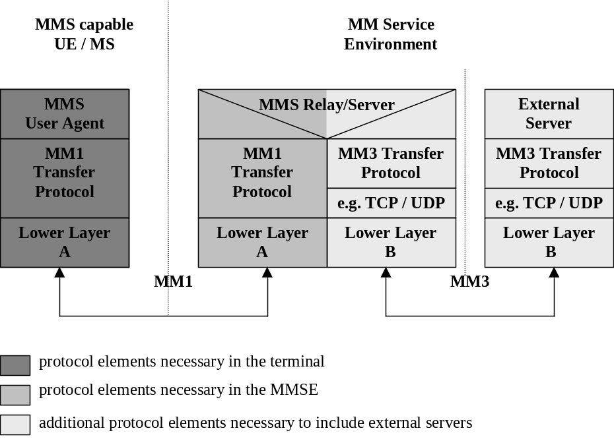

Figure 3: Protocol Framework to provide MMS
To provide implementation flexibility, integration of existing and new services together with interoperability across different networks and terminals, the MMS shall make use of the protocol framework outlined in figure 3. In this framework the MMS User Agent communicates with the MMS Relay/MMS Server, which may communicate with External Servers. This MMS Relay/Server may provide convergence functionality between External Servers and MMS User Agents and thus enables the integration of different server types across different networks.
Details for implementation of the MM1 transfer protocol using WAP [3] or applications conforming to MExE [4] (e.g. Java and TCP/IP) are elaborated within this specification. The WAP implementation option is described in Annex B.1. Implementations based on applications using MExE may be defined in detail in future releases. Other implementations (e.g. using other standardised Internet protocols) are not defined in this specification in this release.

4.4 Addressing
MMS shall support the use of E-Mail addresses (RFC 822) [5] or MSISDN (E.164) or both to address the recipient of an MM. MMS may support the use of service provider specific addresses to address the recipient of an MM. In the case of E-Mail addresses standard internet message routing should be used.
The usage of MSISDN for addressing a recipient in a different MMS service provider’s domain shall be possible. For that the need of MSISDN translation to a routable address has been identified. Service provider specific addresses may be used to e.g. deliver messages to MMS VAS Application within one MMSE.
MMS connectivity across different networks (MMSEs) is provided based on Internet protocols. According to this approach, each MMSE should be assigned a unique domain name (e.g. mms.operatora.net).
MMS recipient addresses provided by an MMS User Agent may be in a format of an RFC 822 routable address, e.g. E-Mail address, or other formats, such as E.164 or service provider specific addresses. In those cases where a non-routable address is used to specify a recipient and the recipient belongs to another MMSE or the recipient is outside of any MMSE, it is required to translate the address to an RFC 822 routable address format. It is the sender MMSE’s responsibility to make this mapping before routing forward the message to the recipient’s MMSE.
The mapping to the correct recipient's MMS Relay/Server domain name is left for standardisation in future releases. It is expected that ENUM (an IETF global numbering proposal) will be used in future releases as the mechanism to map MSISDN numbers to RFC 822 routable addresses. In the mean time, it is expected that MMS service providers or network operators may use solutions for their particular needs which may include static tables or other look-up methods.
MMS shall support address hiding i.e. anonymous messages where the sender’s address is not shown to the recipient MMS User Agent. If the peer entity is not known to be an MMSE the originator MMSE shall not provide the originator address. If the peer entity is known to be an MMSE, both the originator address and request of address hiding shall be forwarded to the recipient MMSE. The recipient MMSE is responsible not to show the originator address to the recipient MMS User Agent.

5 Functional Description of Involved MMS Elements

5.1 MMS User Agent

5.1.1 MMS User Agent operations
The MMS User Agent shall provide the following application layer functionalities:-

- the MM presentation;
- the presentation of notifications to the user;
- the retrieval of MMs (initiate MM delivery to the MMS User Agent).

The MMS User Agent may provide additional application layer functionalities such as:-
- the MM composition
- the MM submission
- the signing of an MM on an end-user to end-user basis;
- the decryption and encryption of an MM on an end-user to end-user basis;
- all aspects of storing MMs on the terminal and/or USIM;
- the handling of external devices;
- the user profile management.
This optional list of additional functionalities of the MMS User Agent is not exhaustive.

5.1.2 Minimum set of supported formats
Multiple media elements shall be combined into a composite single MM using MIME multipart format as defined in RFC 2046 [6]. The media type of a single MM element shall be identified by its appropriate MIME type whereas the media format shall be indicated by its appropriate MIME subtype.
In order to guarantee a minimum support and compatibility between multimedia messaging capable terminals, the following media formats shall be at least supported.

Minimum set of supported media type Text formats:-
- plain text. Any character encoding (charset) that contains a subset of the logical characters in Unicode [7] shall be used (e.g. US-ASCII [8], ISO-8859-1[9], UTF-8[10], Shift_JIS, etc.).
Unrecognised subtypes of "text" shall be treated as subtype "plain" as long as the MIME implementation knows how to handle the charset. Any other unrecognised subtype and unrecognised charset shall be treated as "application/octet - stream".
In order to guarantee SMS interoperability, SMS 3G TS 24.011 [11] RP-DATA RPDU encapsulation defined in subclause 7.3.1 shall be supported. MIME type application/x-sms shall be used for this purpose.
NOTE: SMS MIME type shall be used as soon as the MIME registration has been completed.

Minimum set of supported media formats or codecs for MMS User Agents supporting media type Audio:-
- AMR [12]; organised in the Bitstream Syntax as proposed by the IETF [39]

Minimum set of supported media formats or codecs for MMS User Agents supporting media type Image:-
- Baseline JPEG [17].
To ensure interoperability for the transport of speech, audio and/or video media associated with an MM, the MP4 file format shall be supported. The usage of the MP4 file format shall follow the technical specifications and the implementation guidelines specified in 3G TS 26.234 [41].
NOTE: 3G TS 26.234 [41] specifies a mechanism for the registration of AMR and H.263 codestreams to be included in MP4 files.
To ensure interoperability with formats widely used e.g. in the internet community the support of the following formats or codecs is suggested:-

Suggested formats or codecs for media type Audio:-
- MP3 [14]
- MIDI [15]
- WAV [16]

Suggested formats or codecs for media type Image:-
- GIF 89a [18].

Suggested formats or codecs for media type Video:-
- MPEG 4 (Visual Simple Profile, Level 1) [19] according to the restrictions specified in 3G TS 26.911 [38].
- ITU-T H.263 [20].
- Quicktime [21].

5.2 MMS Relay/Server
The MMS Relay/Server is responsible for storage and handling of messages. It may provide convergence functionality between External Servers and MMS User Agents and thus enable the integration of different server types across different networks.
An Example can be found in Annex A.

It should be possible to separate the MMS Relay/Server element into MMS Relay and MMS Server elements, but an allocation of the MMS Relay/Server functionalities to such elements is not defined in this release.
The MMS Relay/Server is responsible for the following functions:-
- receiving and sending MM;
- enabling/disabling MMS function;
- personalising MMS based on user profile information;
- MM deletion based on user profile or filtering information;
- media type conversion;
- media format conversion;
- conversion of messages arriving at the MMSE from legacy messaging systems to MM format (e.g. facsimile to MM)
- conversion of MMs leaving the MMSE to legacy messaging systems to the appropriate message format (e.g. MM to internet email)
- message content retrieval;
- MM forwarding;
- screening of MM;
- negotiation of terminal capabilities;
- checking terminal availability;
- MM notification to the MMS User Agent;
- generating call data records (CDR);
- address translation.
- address hiding
- managing the message properties on servers (e.g. voicemail or email server) integrated in the MMSE (consistency)

temporary and/or persistent storage of messages
- ensuring that messages are not lost until successfully delivered to another MMSE element
- controlling the reply-charging feature of MMS

5.3 External Servers
Several External Servers may be included within or connected to an MMSE, e.g. E-Mail Server, SMS Server (SMSC), Fax. Convergence functionality between External Servers and MMS User Agents is provided by the MMS Relay/Server which enables the integration of different server types across different networks. Several Examples can be found in Annex A.

5.4 MMS User Databases and HLR
The MMS may have access to several User databases. These may consist of e.g. user profile database, subscription database, HLR.
These User Databases shall provide:-
- MMS user subscription information;
- information for the control of access to the MMS;
- information for the control of the extent of available service capability (e.g. server storage space);
- a set of rules how to handle incoming messages and their delivery;
- information of the current capabilities of the users terminal.
The location of the User Databases and the access to them are outside the scope of this release.

5.5 MMS VAS Applications
The MMS VAS Applications provide value added services to the MMS users. In many ways MMS VAS Applications behave like a fixed MMS User Agent. However, MMS VAS Applications may provide some additional features like MM recall between MMS VAS Applications and MMS Relay/Server which are not available for MMS User Agents.
This specification does not cover what kind of applications might be available and how the MMS VAS Application provide these services.
MMS VAS Applications may be able to generate CDRs when receiving MMs from MMS Relay/Server and when submitting MMs to MMS Relay/Server. The interaction between an MMS Relay/Server and the MMS VAS Application should be provided through the MM7 interface, as described in chapter 7.8.

6 MMS Service Behaviour Description

6.1 MMS services offered

6.1.1 Submission of a Multimedia Message in the originator MMSE
When a user intends to send an MM to one or several destinations the MM shall be submitted to the originator MMS Relay/Server.
The support for submission of MMs is optional for MMS User Agents. The support for submission of MMs is mandatory for MMS Relay/Servers.
If an MMS User Agent supports submission of MMs the MMS User Agent shall be able to:
- Indicate the address of the MM recipient
- Identify the MIME content type of the message.

- If a MMS User Agent supports submission of MMs the MMS User Agent may be able to:
- Request a delivery report for the message
- Request a read-reply report for the message
- Provide a time stamp for the time of submission of the message
- Set the earliest desired time of delivery for the message
- Set the desired time of expiry for the message
- Indicate the address of the MM originator
- Set further message qualifications (e.g. priority, message class, subject)
- Request the MM originator’s address being hidden from the recipient MMS User Agent.

Upon reception of an MM from an originator MMS User Agent the originator MMSE
- shall assign a Message Identification to the MM and immediately provide the originator MMS User Agent with this Message Identification
- is responsible for retaining the MM until the earliest desired time of delivery, if the optional feature of earliest time of delivery is supported by the originator MMSE. If this feature is not supported then the MM is immediately routed forward.
- may provide a time stamp, i.e. it may also override the MMS User Agent’s time stamp,
- shall insert the originator’s address into the MM if not yet provided by the originator MMS User Agent
- shall pass the originator’s address to the peer entity if the peer entity is known to be a MMSE
- shall route forward the request for address hiding unaltered to the recipient MMSE if the peer entity is known to be an MMSE.
- shall pass the originator’s address to the peer entity if the peer entity is not known to be an MMSE and address hiding has not been requested by the originator MMS User Agent

- shall not pass the originator’s address to the peer entity and should override the address provided by the originator MMS User Agent in the MM to an "anonymous" address if the peer entity is not known to be an MMSE and address hiding has been requested by the originator MMS User Agent
- may override the address provided by the originator MMS User Agent in the MM (subject to MMS service provider’s preferences)
- is responsible for resolving the MM recipient’s address(es),
- is responsible to route the MM towards the MM recipients.
- should pass the indication whether or not a delivery report is requested unaltered when routing the MM towards the MM recipient(s)
- shall pass the indication whether or not a read-reply report is requested unaltered when routing the MM towards the MM recipient(s)
- shall pass the indication about MIME content type of the message and message qualifications (e.g. priority, message class, subject) unaltered when routing the MM towards the MM recipient(s)
- shall generate a delivery report indicating “indeterminate” status of the MM’s delivery if a delivery report was requested by the originator MMS User Agent and if the peer entity the MM is routed forward to is not known by the originator MMS Relay/Server.

A special case is where the recipient MMSE is also the originator MMSE. In this case the MM does not have to be routed forward.

6.1.2 Reception of a Multimedia Message in the recipient MMSE
Upon reception of an MM the recipient MMSE
- may verify the MM recipient’s user profile(s)
- shall store the MM at least until
- the associated time of expiry is reached,
- the MM is delivered,
- the recipient MMS User Agent requests the MM to be routed forward or
- the MM is rejected.
The term “associated time of expiry ” refers to either the desired time of expiry set by the originator MMS User Agent or an MMSE time of expiry setting.
- shall generate a notification to the recipient MMS User Agent.
Incoming messages from legacy systems may be expected to be converted to MMs.

6.1.2.1 Multimedia Message Notification
With the MM notification the recipient MMS User Agent shall receive a message reference that can be used for retrieving the MM from the recipient MMSE. The message reference that is conveyed in a notification shall at least be valid throughout the message expiry period, till the successful retrieval of the MM or until the MM was rejected.
With the MM notification the recipient MMS User Agent may receive additional information on the MM.
If the originator MMS User Agent has requested address hiding the recipient MMSE shall not include the originator address into the MM notification.

In a response to the notification the MMS User Agent shall be able to
- reject the MM or
- retrieve the MM, either immediately or at a later time, either manually or automatically, as possibly determined by the operator configuration and user profile.

6.1.3 Retrieval of a Multimedia Message in the recipient MMSE
The recipient MMS User Agent shall be able to request delivery of an MM from the recipient MMSE based on the information received in the notification.
Upon delivery request the recipient MMSE
- shall deliver the MM to the recipient MMS User Agent
- may perform data adaptation based on user profile and/or MMS User Agent capabilities
- shall not provide the MM originator address to the MM recipient if the originator MMS User Agent requested its address to be hidden from the MM recipient
- shall provide the MM originator address to the MM recipient if the originator MMS User Agent did not request its address to be hidden from the MM recipient and if the MM originator address is available at the recipient MMSE
- may provide an alias or clarifying text (e.g. “anonymous address” or “unknown address”) in the originator address field instead of providing the originator address to the recipient MMS User Agent, if the originator has requested address hiding or the original message does not contain the originator address
- shall give an indication to the recipient MMS User Agent that a delivery report is requested if such a delivery report has been requested by the originator MMS User Agent
- shall give an indication to the recipient MMS User Agent that a read-reply report is requested if such a read reply report has been requested by the originator MMS User Agent
- shall indicate the MIME content type of the MM to the recipient MMS User Agent
- shall provide other available message qualifications unaltered to the recipient MMS User Agent
- shall provide the time stamp of the MM unaltered to the recipient MMS User Agent
- shall be responsible for the storage of messages in the network until the recipient MMS User Agent becomes reachable (e.g. user moves back into coverage, switches MMS User Agent on) or until the MM expires.
- may provide the recipient MMS User Agent with a count of the number of times that the particular MM was forwarded, if the MM was forwarded and the counter information is available to the recipient MMSE.
- should provide the recipient MMS User Agent with a list of addresses of forwarding MMS User Agents for the MM if the MM was forwarded and the address information is available to the recipient MMSE.
In a response to an MM’s delivery the recipient MMS User Agent may be able to
- request a delivery report not to be generated by the MMSE.

6.1.4 Forwarding of a Multimedia Message without prior Retrieval
This part of the MMS service describes the mechanism by which an MMS User Agent may request the corresponding MMS Relay/Server, that an MM for which the MMS User Agent is the intended recipient (and is notified of the MM) be forwarded to other specified recipient(s) MMS User Agent(s) whose address(es) shall be specified by the forwarding MMS User Agent, without having to first retrieve the MM.
The support for originating a request that a specific MM be forwarded is optional for the MMS User Agent.
The support for forwarding an MM, in response to a request from a MMS User Agent that a specific MM be forwarded is optional for the MMS Relay/Server.
The original MM is forwarded to a new recipient(s) with the forwarding MMS User Agent’s address being provided but without additional content, and without affecting the elements of the original MM. Some additional information elements e.g. delivery report, read-reply report, i.e. requests for reports which are to provide feedback on the forwarded MM to the forwarding MMS User Agent, may be supplied.
MM Element Forwarding, where particular elements of an MM are requested to be forwarded, is left for standardisation in future releases.
If a forwarding MMS User Agent supports requesting MM forwarding the MMS User Agent shall:
- indicate the address of the MM recipient(s).
- provide the message reference provided in the MM Notification.
- not generate a read-reply report to the originator MMS User Agent even if a read-reply report is requested.
If a MMS User Agent supports requesting forwarding of MMs the forwarding MMS User Agent may:
- Indicate the address of the Forwarding MMS User Agent (i.e. it’s own address)
- Provide a time stamp for the time of submission of the request to forward the MM
- Set the desired time of expiry for the forwarded MM
- Set the earliest desired time of delivery for the forwarded MM
- Request a delivery report for the forwarded MM
- Request a read-reply report for the forwarded MM

Upon reception of a request from a forwarding MMS User Agent to forward an MM, the forwarding MMS Relay/Server
- shall assign a Message Identification to the forwarded MM and immediately provide the forwarding MMS User Agent with this Message Identification
- shall provide status information on the MM forward request to the forwarding MMS User Agent.
- is responsible for retaining the forwarded MM until the earliest desired time of delivery, if the optional feature of earliest time of delivery is supported by the MMSE of the forwarding MMS User Agent. If this feature is not supported then the MM is immediately routed forward.
- may provide a time stamp for the forwarded MM, i.e. it may also override the forwarding MMS User Agent’s time stamp,
- shall insert the forwarding MMS User Agent’s address into the forwarded MM if not yet provided
- may override the address provided by the forwarding MMS User Agent in the forwarded MM (subject to MMS service provider’s preferences)
- is responsible for resolving the recipient’s address(es) of the forwarded MM,
- is responsible to route the forwarded MM towards the MM recipients.
- shall pass the indication whether or not a delivery report is requested unaltered when routing the forwarded MM towards the MM recipients.
- shall pass the indication whether or not a read-reply report is requested unaltered when routing the forwarded MM towards the MM recipient(s)
- shall generate a delivery report indicating “indeterminate” status of the MM’s delivery if a delivery report was requested by the forwarding MMS User Agent and if the peer entity the MM is routed forward to is not known to the MMSE of the forwarding MMS User Agent.
- shall provide the recipient(s) MMSE with a count of the number of times that the particular MM was forwarded.
- shall provide the recipient(s) MMSE with a list of addresses of forwarding MMS User Agents for the MM.
- shall generate a delivery report to the originator MMS User Agent if a delivery report is requested.
A special case is where the recipient MMSE is also the forwarding MMSE. In this case the MM does not have to be routed forward.

6.1.5 Delivery Report
The MMSE shall support the delivery reporting service. Delivery reports shall only be generated for MMs.
The originator MMS User Agent may be able to request a delivery report for a specific MM.
Within an MM notification or upon MM retrieval the recipient MMS User Agent may receive an indication that a delivery report is requested for the MM.
Within either a response to a notification or a response to an MM’s delivery, the recipient MMS User Agent may request a delivery report not to be generated by the MMSE.
The originator MMSE shall generate a delivery report if a delivery report has been requested by the originator MMS User Agent
- upon routing forward the MM, in case the peer entity is not known by the MMSE
The recipient MMSE shall generate a delivery report if a delivery report has been requested by the originator MMS User Agent and if the recipient MMS User Agent did not request a delivery report not to be generated
- upon receipt of a response to a notification, in case the MM is rejected by the recipient MMS User Agent
- upon receipt of a forwarding request, in case the MM is forwarded by the recipient MMS User Agent to other MM recipient(s), without prior retrieval.
- upon receipt of a response to an MM’s delivery, in case the MM is retrieved by the MM recipient
- upon expiry of the MM, in case the MM is not rejected and not retrieved by the MM recipient before the expiry

The originator MMS User Agent, i.e. the MMS User Agent receiving the delivery report, may match the delivery report to the sent MM by retaining the message identification of the sent MM and comparing it to the received delivery report, which shall contain the message identification of the original MM. In case of multiple MM recipients, it is necessary for the originator MMS User Agent to retain the MM recipient addresses as well, to match the delivery report to the sent MM.
If a delivery report has been requested by the originator MMS User Agent and if the recipient MMS User Agent did not request a delivery report not to be generated, the recipient MMSE
- shall generate the delivery report
- shall deliver the delivery report to the originator MMSE.
- shall be responsible for the storage of delivery reports in the network until the originator MMSE becomes reachable or until the delivery report expires
Within the delivery report the recipient MMSE
- shall provide the MM originator address to the originator MMSE.
- shall provide the MM recipient address to the originator MMSE.
- shall provide the identification of the original MM for which the delivery report has been generated to the originator MMSE.
- shall provide status information how the MM was handled (e.g. expired, rejected, delivered, forwarded or indeterminate) to the originator MMSE
- shall provide a time stamp when the MM was handled to the originator MMSE

- For each MM recipient of the original MM for which the delivery report has been generated and becomes available at the originator MMSE, the originator MMSE
- shall deliver the delivery report to the originator MMS User Agent (i.e. the recipient MMS User Agent of the delivery report).
Within the delivery report the originator MMSE
- shall provide the MM recipient’s address to the originator MMS User Agent (the recipient MMS User Agent of the delivery report).
- shall provide the identification of the original MM for which the delivery report has been generated to the originator MMS User Agent (the recipient MMS User Agent of the delivery report).
- shall be responsible for the storage of delivery reports in the network until the originator MMS User Agent becomes reachable (e.g. user moves back into coverage, switches MMS User Agent on) or until the delivery report expires

6.1.6 Read-Reply Report
The MMSE shall support the read-reply reporting service. Read-reply reports shall only be generated for MMs.
Upon MM submission the originator MMS User Agent may be able to request a read-reply report for a specific MM.
Upon MM retrieval the recipient MMS User Agent may receive an indication that a read-reply report is requested for the MM.
After having handled/rendered the MM the recipient MMS User Agent may generate a read-reply report if requested by the originator MMS User Agent.
The originator MMS User Agent, i.e. the MMS User Agent receiving the read-reply report, may match the read-reply report to the sent MM by retaining the message identification of the sent MM and comparing it to the received read-reply report, which shall contain the message identification of the original MM. In case of multiple MM recipients, it is necessary for the originator MMS User Agent to retain the MM recipient addresses as well as to match the read-reply report to the sent MM.

If a read-reply report has been requested by the originator MMS User Agent and if the recipient MMS User Agent supports the read-reply feature and if the recipient allows its creation the recipient MMS User Agent shall submit the read-reply report to the recipient MMSE at the earliest opportunity.
NOTE: Since the MM recipient has the right to deny this service not receiving a read-reply report does not mean the message has not been rendered.
A read-reply report:
- shall contain the MM originator’s address
- shall contain the MM recipient’s address
- shall contain the message identification of the original MM for which the read-reply report has been generated.
- shall provide status information how the MM was rendered (e.g. read, deleted without being read)
- shall provide a time stamp for when the MM was rendered
The recipient MMS User Agent shall be responsible for the storage of read-reply reports in the UE until the recipient MMSE becomes reachable (subject to support of the read-reply reporting service by the recipient MMS User Agent and storage place being available).

Upon reception of a read-reply report from a recipient MMS User Agent the recipient MMSE
- may provide a time stamp for the read-reply report, i.e. it may also override the MMS User Agent’s time stamp,
- shall pass the MM originator address unaltered when routing the read-reply report towards the originator MMS User Agent (the recipient MMS User Agent of the read reply report)
- shall insert the MM recipient’s address into the read-reply report if not yet provided
- may override the address provided by the recipient MMS User Agent in the read-reply report (subject to MMS service provider’s preferences)
- is responsible for resolving the MM originator’s address,
- is responsible to route the read-reply report towards the originator MMS User Agent of the original MM.
A special case is where the recipient MMSE is also the originator MMSE. In this case the MM does not have to be routed forward.

6.1.7 Support for Streaming in MMS
This section defines the service behaviour specific to support for streaming in MMS. The term "According to the normal MMS framework.." indicates those paragraphs which are not specific to streaming but described elsewhere in chapter 6.
MMS supports streaming for the retrieval of MM contents (one or more MM elements). The use of streaming for the retrieval of MM contents is independent of the MM submission. The retrieval of MM contents to the recipient MMS User Agent depends on the configuration and the capability of the recipient MMS User Agent and the recipient MMS Relay/Server. MM contents may be either delivered as non-streaming MM elements, or made available for streaming retrieval. The recipient MMS Relay/Server decides whether to use streaming based on the media type and the media format of the subjected MM contents, capability negotiation and/or user settings/preferences. The recipient MMS Relay/Server may convert media types and/or formats of MM contents to make it available for streaming retrieval. If streaming retrieval is used, the streaming-specific protocols, codecs, presentation, session negotiation and control are according to [40] and [41].
According to the normal MMS framework, the recipient MMS Relay/Server shall generate a notification which contains information to enable the recipient MMS User Agent to request for the delivery of the corresponding MM
Upon delivery request, the recipient MMS Relay/Server shall deliver a modified MM with one or several presentation descriptions, as one or several MM elements, in place of the corresponding streamable MM contents to the recipient MMS User Agent, if it has made the MM contents available for streaming retrieval. The format of the presentation description is as defined in [41]. MIME type of the format of the presentation description shall be used to indicate the content type of the MM elements, which contain the corresponding presentation description. The presentation description carries all required information to initiate the streaming process by the recipient MMS User Agent in order to retrieve the streamable MM content.
According to the normal MMS framework, the recipient MMS Relay/server shall base the generation of a delivery report on the receipt of a response to the delivery of the modified MM from the recipient MMS User Agent.
After the successful reception of the MM, which includes the presentation description, the recipient MMS User Agent may initiate a streaming process to retrieve the streamable MM contents depending on the information in the presentation description. According to the normal MMS framework, the recipient MMS User Agent may base the generation of a read-reply report either on the rendering/handling of the modified MM, or on the rendering/handling of the streamable MM contents.

6.1.8 Support for Prepaid Service in MMS
An MMSE may support the prepaid concept. A prepaid customer may be charged for submitting or retrieving MMs/abstract messages.
In the submission case the originator MMS Relay/Server may first ascertain that the originator of the MM/abstract message is a prepaid customer. The MMS Relay/Server may then initiate a credit check and further processing of the MM/abstract message is put on hold. In the case the customers credit is insufficient for submitting this particular MM/abstract message the originator MMS Relay/Server may reject it. The check may be based on several criteria like:
- size of the MM
- content type
- settings of information elements
- type of the abstract message
In case an MM/abstract message can not be accepted, the originator MMS Relay/Server shall respond with an appropriate status value to the submit request. The MMS User Agent should bring this information to the user’s attention.
In case an MM/abstract message is accepted it is further processed by the MMSE
In the retrieving case the recipient MMS Relay/Server may first ascertain that the recipient of the MM/abstract message is a prepaid customer. The MMS Relay/Server may then initiate a credit check for the particular customer. The check may be performed at the time the MM/abstract message arrives at the recipient MMS Relay/Server. Based on the result the MMS Relay/Server may reject or accept the MM/abstract message. If the MM/abstract message was accepted (with or without previous check) the MMSE may perform a credit check at the time the MMS User Agent sends a retrieve request. The check may be based on several criteria as in the sending case.
In case an MM/abstract message can not be retrieved because the customers account balance is too low, the recipient MMS Relay/Server may respond with an appropriate status value to the retrieve request. The MMS User Agent should bring this information to the user’s attention.
Otherwise the MM/abstract message is delivered to the MMS User Agent.

6.1.9 Address Hiding in MMS
If the originator's MMSE does not allow address hiding (anonymous messages) (e.g. legislation does not permit anonymous messages) the message shall be rejected upon submission and the originator’s MMSE shall return an error information to the originator MMS User Agent.
In the case of originator's MMSE rejects the message because it does not allow address hiding the rejection information shall be delivered in a submit response together with optional status text.
In case the recipient MMSE rejects the message because it does not allow address hiding and the originator MMS User Agent has requested a delivery report, then the recipient MMSE shall inform the originator of the message rejection within the delivery report.
In case the recipient MMSE rejects the message because it does not allow address hiding and the originator MMS User Agent has not requested a delivery report, then the originator MMSE may inform the MM originator by generating a new MM which is sent back to the MM originator.
The originator MMSE may have the possibility to override the originator's requirement of address hiding without informing the originator.
Independent of whether or not the originator's address is shown or hidden to the recipient, the originator may be able to ask for a delivery report to an MM and also receive the delivery report according to the normal behaviour of the MMS framework.
If the recipient forwards the MM outside the MMSE and the peer entity is unknown to the forwarding MMSE the recipient MMSE shall not transfer the originator's address but replace it with either appropriate coded address or leave the originator address field blank.

6.1.10 Support for Reply-Charging in MMS
The MMS User Agent may support reply-charging. If the MMS User Agent supports this feature it is expected that the MMS User Agent supports the following behaviour.
The MMS Relay/Server may support reply-charging. If the MMS Relay/Server supports this feature it is expected that the MMS Relay/Server supports the following behaviour.
A User of the MMS may be able to take over the charge for the sending of a reply-MM to their submitted MM from the recipient(s). Therefore the originator of an MM should be able to mark the MM as reply-charged. The originator’s MMSE could either accept the user’s settings for reply-charging or not and should be able to convey feedback to the originator. It should be possible to take over the charge for reply-MMs from different recipients.
The recipient should be notified that the originator is willing to pay for a reply-MM to this particular MM. However, the indication of reply-charging covers only the willingness to pay for a reply-MM to an original MM, not for the retrieval of the original MM marked as reply-charged. Both the originator and the recipient MMSE shall be able to control that not more than one reply-MM per recipient is charged to the originator. The MMS User Agent may indicate to the user if an MM has already been replied to.
The request for reply-charging shall not be passed on to the recipient
- if the recipient is not known to belong to an MMSE peer entity or
- in the case the MM is forwarded.
NOTE: For this release the following limitations apply: Support for reply-charging in MMS is restricted to MMS User Agents belonging to the same MMSE, i.e. originator and recipient MMSE are identical. Reply-charging allows only one reply-MM per recipient, i.e. reply-charging applies to the first successful submission of an MM sent as a reply. Furthermore, a reply-MM is restricted to text only. These limitations may be elaborated further in future releases.
In addition to the service behaviour described in previous sections the following behaviour is expected to support reply-charging in MMS.
Within the submission of an MM the MM originator may indicate a willingness to pay the charge for one reply-MM per MM recipient. In this case the originator MMS User Agent:
- shall indicate the sender’s willingness to pay the charge for one reply-MM per MM recipient
- may define a reply-charging limitation request (e.g. may specify the latest time of submission of the reply-MMs or a maximum size of reply-MMs)
In a response to the MM submission the originator MMS Relay/Server shall inform the originator MMS User Agent whether or not it accepts
- the originator’s request for reply-charging in the original MM
- the reply-charging limitations set by the originator MMS User Agent in the original MM
Upon reception of an MM from an originator MMS User Agent the originator MMS Relay/Server
- may provide reply-charging limitations, i.e. it may also override the MMS User Agent’s reply-charging limitations
- shall pass the indication whether or not a reply-MM is requested unaltered when routing the original MM towards the MM recipient(s) if the peer entity is known to be the same MMSE.
- shall pass the latest time of submission for the reply-MM unaltered when routing the original MM towards the MM recipient(s) if the peer entity is known to be the same MMSE.
If the MM recipient has requested the original MM to be forwarded to some other address the recipient MMS Relay/Server
- shall not pass any information about the reply-charging request towards the addressee(s) of the forwarding request
If reply-charging has been requested by the MM originator the recipient MMS Relay/Server should inform the recipient MMS User Agent with the MM notification and upon MM delivery
- that the MM originator is willing to pay for reply-MM to this original MM.
- It may also notify the recipient about the reply-charging limitations set by the orginator (e.g. the latest time of submission of a reply-MM to the original MM).
When a user intends to send a reply-MM to the MM originator the recipient MMS User Agent (which is the originator MMS User Agent of the reply-MM):
- shall mark the MM as a reply-MM.
- shall provide the message-ID of the original MM which it replies to (if it is the reply-MM)
- shall submit the reply-MM to the recipient MMS Relay/Server
- may be able to indicate to the user whether this MM has already been replied to
- may be able to indicate to the user if the reply-charging limitations can not be met
Upon submission the recipient MMS Relay/Server
- shall reject the reply-MM and should convey this information back to the recipient MMS User Agent if the reply-MM does not meet the limitations set by the originator MMS User Agent
- shall be able to uniquely map the reply-MM to the original MM

6.2 MMSE Addressing responsibilities
Address parsing:
MMS Relay/Server should parse the recipient address field provided by the originator MMS User Agent upon MM submission. If an error is found in the address format, an error indication should be sent back to the MMS User Agent in the submit response.
Locating the recipient:
For each recipient that appears in an MM, the MMS Relay/Server shall be able to resolve whether the recipient belongs to the same MMSE, another MMSE or is not known to belong to any MMSE. If the recipient belongs to the same MMSE, the MMS Relay/Server shall notify the recipient of the new MM as described in chapter 6.1.2. If the recipient appears to belong to another MMSE, the MMS Relay/Server has to locate the external recipient’s MMSE domain. If the recipient is not known to belong to any MMSE, the MMS Relay/Server shall perform the necessary conversion and route forward the message to the recipient.

6.2.1 Address Formats on MM4
Resolving the recipient’s MMSE IP address:
For those recipients that appear in an MM and belong to an external MMSE, the MMS Relay/Server has to send the message to the recipient’s MMSE using the protocol described in chapter 7.7. The MMS Relay/Server has to resolve the recipient’s MMS Relay/Server domain name to an IP address, e.g. using DNS, based on the recipient’s address. The mapping for the recipient’s address to the recipient's MMS Relay/Server if the MM recipient belongs to another MMSE is left for standardisation in future releases. It is expected that ENUM mechanism will be used for this resolution. In the mean time, MMS service providers or network operators may use solutions for their particular needs, which may include static tables or other look-up methods.
Re-formatting the sender’s and recipient’s address to FQDN format
When delivering a message from an MMSE to another MMSE, both the sender and the recipient addresses shall be extended to include the FQDN to enable transport over SMTP. This FQDN format shall be used in the MM4 reference point. It is required that FQDN format address is used in “MAIL FROM: and “RCPT TO:” commands in SMTP, it is not necessary that the originator’s and recipient’s addresses in RFC 822 “From:” or “To:”–fields are re-formatted to FQDN format.
The encoding of FQDN addressing is defined in Chapter 8.4.5.1.

6.2.2 Address Formats on MM1
The MMS addressing model on MM1 contains three addresses: the address of the MMS Relay/Server, the address of the recipient and the address of the originator. The address of the MMS Relay/Server shall be the URI of the MMS Relay/Server given by the MMS service provider. Thus, the URI needs to be configurable in the MMS User Agent.
The originator’s and the recipient’s address could be either a user’s address or a user’s terminal address. For this release the user’s terminal addresses (e.g. terminal IP addresses) are not supported. The MMS User Agent’s responsibility is to format these addresses before it submits the message to the originator MMS Relay/Server.
The reference point MM1 should support E.164 (MSISDN) and/or RFC822 addressing, and it should support a way to indicate the used address type to enable future extension. The encoding of the addressing is up to the corresponding implementation.
E.g. the originator MMS User Agent may specify each of the address fields in one of the following formats:
- RFC 822 address (FQDN) ["/TYPE= rfc822"]
- +E.164 ["/TYPE= PLMN"] as [[CC] + NC] + SN
- Other "/TYPE= "
The "/TYPE= " field specifies the address type. When E.164 or RFC822 formats are used the type is optional. The "/TYPE= " convention provides flexibility for future enhancements.

7 MMSE Interfaces
This chapter defines the Multimedia Messaging framework. The application protocol framework described by the means of abstract messages and the technical realisation of MMS service features are defined in chapter 8.

7.1 MMS Reference Architecture
Figure 4 shows the MMS Reference Architecture and identifies reference points within an MMSE that are further described below. Abstract messages are indicated in chapter 8 that describe the logical message exchange on these reference points on a high-level basis.

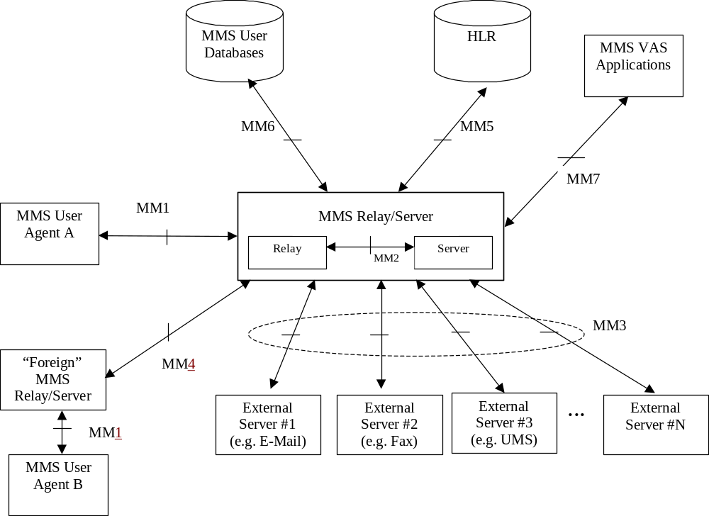

Figure 4: MMS Reference Architecture

7.2 MM1: MMS Relay/Server – MMS User Agent
Reference point MM1 is used to submit Multimedia Messages from MMS User Agent to MMS Relay/Server, to let the MMS User Agent pull MMs from the MMS Relay/Server, let the MMS Relay/Server push MMs to the UA and to exchange notifications and delivery reports between MMS Relay/Server and MMS User Agents.
Details for implementation of the MM1 transfer protocol using WAP [3] or applications conforming to MExE [4] (e.g. Java and TCP/IP) are elaborated within this specification. The WAP implementation option is described in Annex B.1. Implementations based on applications using MExE may be defined in detail in future releases. Other implementations (e.g. using other standardised Internet protocols) are not defined in this specification in this release.

7.3 MM2: MMS Relay – MMS Server

This reference point is not specified in this release of this specification. It may be specified in a future release of this specification.

7.4 MM3: MMS Relay/Server – External Servers
Reference point MM3 is used by the MMS Relay/Server to send Multimedia Messages to and retrieve MMs from servers of external (legacy) messaging systems that are connected to the service provider’s MMSE.

This reference point is further elaborated in chapter 8.3. In addition, several examples of realisations of reference point MM3 between the MMS Relay/Servers and External Servers can be found in Annex A.

7.5 MM6: MMS Relay/Server – MMS User Databases
This reference point is outside the scope of this release of this specification.

7.6 MM5: MMS Relay/Server – HLR
Reference point MM5 may be used to provide information to the MMS Relay/Server about the subscriber. If this reference point is provisioned then it shall use existing MAP operations (e.g. procedures for determining the location of the mobile, procedures for alerting SMS service centres). Future releases may elaborate this area further.
In case of using SMS as the bearer for notification this reference point is not necessary.

7.7 MM4: Interworking of different MMSEs
Reference point MM4 between MMS Relay/Servers belonging to different MMSEs is used to transfer messages between them. Interworking between MMSEs shall be based on SMTP according to STD 10 (RFC 821) [22] as depicted in figure 5.
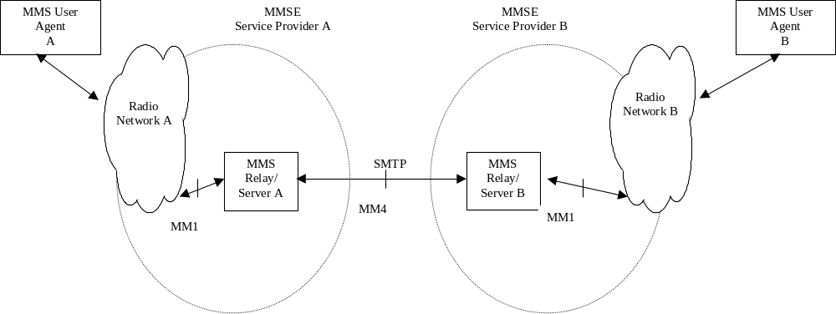

Figure 5: Interworking of different MMSEs
Interworking between different MMS service providers is further elaborated in chapter 8.4.

7.8 MM7: MMS Relay/Server – MMS VAS Applications
Reference point MM7 is used to transfer MMs from MMS Relay/Server to MMS VAS applications and to transfer MMs from MMS VAS applications to MMS Relay/Server. This reference point shall be based on existing protocols e.g. SMTP or HTTP for this release of the specification. Future releases may propose a mandatory protocol and encoding schemes. The service provider may decide to use an encoding format in this reference point, which uses the encoding implementation used in the MM1 reference point.

8 MMS Application Protocol Framework and Technical Realisation of MMS Service Features
This chapter defines the application protocol framework and describes the technical realisation of MMS service features in terms of abstract messages. The abstract messages can be categorised into transactions consisting of requests and responses. The labelling of the MMS abstract messages follows these conventions:
- the transactions between the MMS UA and MMS Relay/Server are prefixed with “MM1”;
- the transactions between the MMS Relay/Servers are prefixed with “MM4”;
- requests are identified with “.REQ” as a suffix;
- responses are identified with the “.RES” suffix.
Each abstract message carries with it certain information elements, which may vary according to the specific message. All messages shall carry, as information elements, a protocol version and message type, in order that the MMSE components may be able to properly identify and manage the message contents.
Specific information regarding the message encapsulation, including order, possible values, and encoding are beyond the scope of this chapter. These details will be defined within each MMSE protocol environment.
The mapping of abstract messages to specific protocols is not necessarily a one-to-one relationship. Depending on the MMS Implementation (WAP etc.), one or more abstract messages may be mapped to a single lower layer PDU, and a single abstract message may be mapped to multiple lower layer PDUs, if the information carried in the PDU(s) serve the purpose of required information in the subjected abstract message(s).
In MM1 responses that provide a status information, the status information returned has no correspondence to the Status information returned in MM4 responses; they are independent of each other.
The MM1 response status, which are limited by design to as small a set of values as possible, may correlate to status and errors occurring within the communications protocols underlying the implementation of the MM4 abstract messages. Similarly, the MM4 status may correlate to those occurring within the communications protocols underlying the implementation of the MM1 abstract messages. The definition of these correlations is out of scope of this document, and should be provided by the MMS implementations.
The MMS application protocol shall provide means to uniquely identify the version number and message type in each abstract message defined here. The order, possible values and encoding of the information elements for each abstract message are beyond the scope of this chapter, and shall be dictated by the protocol environment.
The following figure shows an example abstract message flow when a multimedia message is sent from an originator MMS User Agent to a recipient MMS User Agent. The scope of this figure is limited to abstract messages on reference points MM1 and MM4 only.
Delivery reports are sent by the recipient MMS Relay/Server. Read-reply reports are sent by the recipient MMS User Agent.

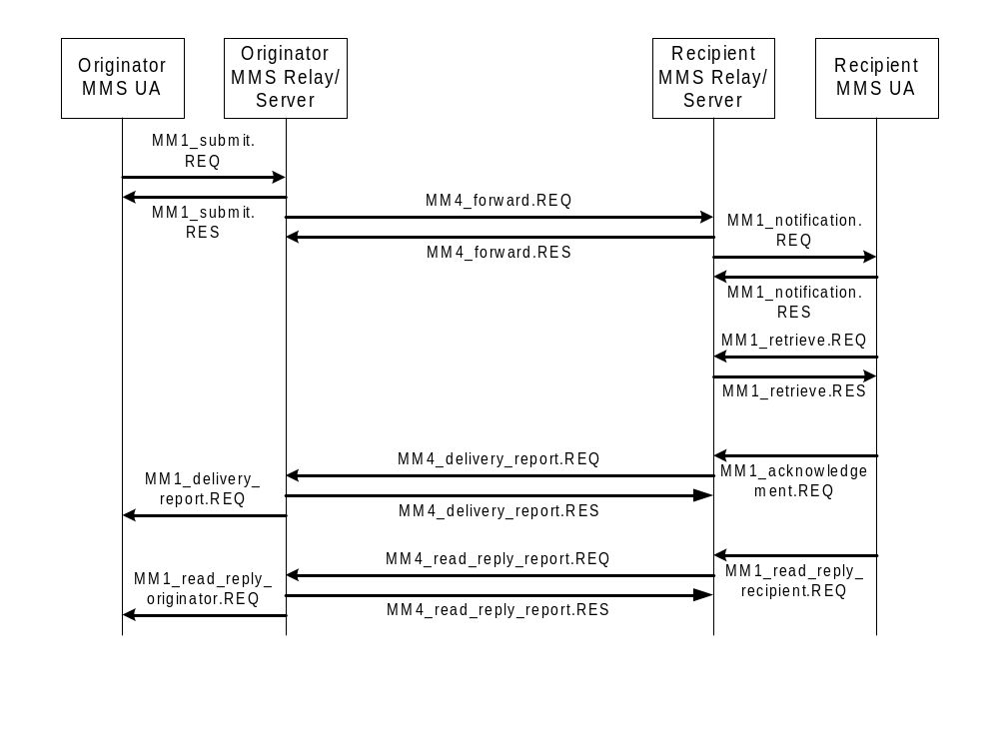Figure 6: Example Abstract Message Flow

8.1 Technical realisation of MMS on reference point MM1

8.1.1 Submission of Multimedia Message
This part of MMS service covers the submission of an MM. For sending purposes a terminal-originated MM shall always be submitted from the originator MMS User Agent to the corresponding MMS Relay/Server. Involved abstract messages are outlined in Table 1 from type and direction points of view.
Table 1: Abstract messages for submission of MM in MMS
Abstract messages | Type | Direction
MM1_submit.REQ | Request | MMS UA -> MMS Relay/Server
MM1_submit.RES | Response | MMS Relay/Server -> MMS UA

8.1.1.1 Normal operation
The originator MMS User Agent shall submit a terminal-originated MM to the originator MMS Relay/Server using the MM1_submit.REQ, which contains MMS control information and the MM content. The MMS Relay/Server shall respond with an MM1_submit.RES, which provides the status of the request. The MM1_submit.RES shall unambiguously refer to the corresponding MM1_submit.REQ.
Support for MM1_submit.REQ is optional for the MMS UA, support for MM1_submit.RES is mandatory for the MMS Relay/Server.

8.1.1.2 Abnormal Operation
In this case the originator MMS Relay/Server shall respond with a MM1_submit.RES encapsulating a status which indicates the reason the multimedia message was not accepted, e.g. no subscription, corrupt message structure, service not available.
If the MMS Relay/Server does not provide the MM1_submit.RES the MMS User Agent should be able to recover.

8.1.1.3 Features
Addressing: One or several MM recipients of a submitted MM shall be indicated in the addressing-relevant information field(s) of the MM1_submit.REQ. The originator of a submitted MM may be indicated in addressing-relevant information field(s) of the MM1_submit.REQ. The originator MMS User Agent may request to hide its identity from the MM recipient.
Time stamping: The originator MMS User Agent may time stamp the MM.
Time constraints: The originator MMS User Agent may also request an earliest desired time of delivery of the MM. The originator MMS User Agent may request a time of expiry for the MM. In case of reply-charging the originator MMS User Agent may also request a deadline for the latest time of submission of reply-MMs granted to the recipient(s).
Reply-Charging: The originator MMS User Agent may indicate that the sender wants to pay for a reply-MM in the MM1_submit.REQ.
Message class, priority and subject: The MM may be qualified further by adding a message class, priority and/or subject to the MM in the MM1_submit.REQ. Additional qualifiers may be added.
Reporting: The originator MMS User Agent may request a delivery report for the MM. In addition, the originator MMS User Agent may request a read-reply report when the user has viewed the MM.
Identification: The originator MMS Relay/Server shall always provide a message identification for an MM, which it has accepted for submission in the MM1_submit.RES. In case of reply-charging the MMS User Agent which submits a reply-MM (i.e. the MMS User Agent that received the original MM) shall provide the message-ID of the original MM which it replies to in the MM1_submit.REQ.
Content Type: The MIME type of the multimedia content shall always be identified in the MM1_submit.REQ.

Content: The originator MMS User Agent may add content in the MM1_submit.REQ.
Request Status: The originator MMS Relay/Server shall indicate the status of the MM1_submit.REQ in the associated MM1_submit.RES. The reason code given in the status information element of the MM1_submit.RES may be supported with an explanatory text further qualifying the status. If this text is available in the status text information element the MMS User Agent should bring it to the user’s attention. The choice of the language used in the status text information element is at the discretion of the MMS service provider.

8.1.1.4 Information Elements
Table 2: Information elements in the MM1_submit.REQ.
Information element | Presence | Description
Recipient address | Mandatory | The address of the recipient MMS User Agent. Multiple addresses are possible.
Content type | Mandatory | The content type of the MM’s content.
Sender address | Optional | The address of the MM originator.
Message class | Optional | The class of the MM (e.g., personal, advertisement, information service)
Date and time | Optional | The time and date of the submission of the MM (time stamp).
Time of Expiry | Optional | The desired time of expiry for the MM or reply-MM.
Earliest delivery time | Optional | The earliest desired time of delivery of the MM to the recipient.
Delivery report | Optional | A request for delivery report.
Reply-Charging | Optional | A request for reply-charging.
Reply-Deadline | Optional | In case of reply-charging the latest time of submission of replies granted to the recipient(s).
Priority | Optional | The priority (importance) of the message.
Sender visibility | Optional | A request to show or hide the sender's identity when the message is delivered to the recipient.
Read reply | Optional | A request for read reply report.
Subject | Optional | The title of the whole multimedia message.
Reply-Charging-ID | Optional | In case of reply-charging when the reply-MM is submitted within the MM1_submit.REQ this is the identification of the original MM that is replied to.
Content | Optional | The content of the multimedia message

Table 3: Information elements in the MM1_submit.RES.
Information element | Presence | Description
Request Status | Mandatory | The status of the MM submit request.
Request Status Text | Optional | Description which qualifies the status of the MM submit request.
Message ID | Mandatory | The identification of the MM given to an accepted MM.

8.1.2 Multimedia Message Notification
This part of the MMS service covers the notification about MM from the recipient MMS Relay/Server to the corresponding recipient MMS User Agent and involving abstract messages are outlined in Table 4 from type, and direction points of view.
Table 4: abstract messages for notification of MM in MMS
Abstract message | Type | Direction
MM1_notification.REQ | Request | MMS Relay/Server -> MMS UA
MM1_notification.RES | Response | MMS UA -> MMS Relay/Server

8.1.2.1 Normal Operation
Upon receiving the MM1_notification.REQ, the recipient MMS User Agent shall respond with the MM1_notification.RES to the recipient MMS Relay/Server to acknowledge the successful reception of the MM1_notification.REQ.
The MM1_notification.RES shall unambiguously refer to the corresponding MM1_notification.REQ.

8.1.2.2 Abnormal Operation
In this case the MMS UA shall respond with a MM1_notification.RES encapsulating a status which indicates the reason the notification could not be processed. If the MMS UA does not provide the MM1_notification.RES the MMS Relay/Server should be able to retransmit the notification at a later state.

8.1.2.3 Features
Addressing: The MM originator address may be provided to recipient MMS User Agent in the MM1_notification.REQ.
Time constraints: The recipient MMS User Agent shall be provided a time of expiry of the MM. In case of reply-charging the deadline for the latest time of submission of a reply-MM should be conveyed within the MM1_notification.REQ.
Reply-Charging: In case of reply-charging the MMS Relay/Server may indicate in the MM1_notification.REQ that a reply to the notified original MM is free of charge.
Message class, message size and subject: The MM shall be qualified further by adding a message class and an approximate size to the MM in the MM1_notification.REQ. The MM may be qualified further by adding a subject to the MM. Additional qualifiers may be added.
Reporting: If the originator MMS User Agent has requested to have a delivery report, the recipient MMS Relay/Server may convey this information to the recipient MMS User Agent in the MM1_notification.REQ. The recipient MMS User Agent may indicate in the MM1_notification.RES that it would not wish a delivery report to be created.
Identification: In case of reply-charging when a reply-MM is notified within the MM1_notification.REQ the MMS Relay/Server should convey the identification of the original MM replied to within the same MM1_notification.REQ.
Message Reference: The recipient MMS Relay/Server shall always provide a reference, e.g., URI, for the MM in the MM1_notification.REQ.
MM Status: The recipient MMS User Agent may indicate in the MM1_notification.RES how it intends the MM to be handled, e.g. the immediate rejection of the MM.

8.1.2.4 Information Elements
Table 5: Information elements in the MM1_notification.REQ.
Information element | Presence | Description
Message class | Mandatory | The class of the MM (e.g., personal, advertisement, information service; default = personal)
Message size | Mandatory | The approximate size of the MM
Time of expiry | Mandatory | The time of expiry for the MM.
Message Reference | Mandatory | a reference, e.g., URI, for the MM
Subject | Optional | The title of the whole MM.
Sender address | Optional | The address of the MM originator.
Delivery report | Optional | Request for delivery report
Reply-Charging | Optional | Information that a reply to this particular original MM is free of charge.
Reply-Deadline | Optional | In case of reply-charging the latest time of submission of a reply granted to the recipient.
Reply-Charging-ID | Optional | The identification of the original MM replied to if this notification indicates a reply-MM.

Table 6: Information elements in the MM1_notification.RES.
Information element | Presence | Description
MM Status | Optional | The status of the MM’s retrieval
Report allowed | Optional | Request to allow or disallow the sending of a delivery report to the MM originator

8.1.3 Retrieval of Multimedia Message
This part of MMS service covers the retrieval of an MM. For retrieval purposes an MM shall always be retrieved by the recipient MMS User Agent from the recipient MMS Relay/Server. Involved abstract messages are outlined in Table 7 from type and direction points of view.
Table 7: Abstract messages for retrieval of MM in MMS
Abstract messages | Type | Direction
MM1_retrieve.REQ | Request | MMS UA -> MMS Relay/Server
MM1_retrieve.RES | Response | MMS Relay/Server -> MMS UA
MM1_acknowledgement.REQ | Request | MMS UA -> MMS Relay/Server

8.1.3.1 Normal Operation
The recipient MMS User Agent shall issue an MM1_ retrieve.REQ to the recipient MMS Relay/Server to initiate the retrieval process. The MMS Relay/Server shall respond with an MM1_retrieve.RES, which contains MMs control information and the MM content.
After receiving the MM1_retrieve.RES, the recipient MMS User Agent shall send an MM1_acknowledgement.REQ to the corresponding MMS Relay/Server, if requested by the MMS Relay/Server. The MM1_acknowledgement.REQ shall unambiguously refer to the corresponding MM1_retrieve.RES.

8.1.3.2 Abnormal Operation
If the recipient MMS Relay/Server can not process the MM1_retrieve.REQ, for example due to invalid content location or expiration of the message, the recipient MMS Relay/Server shall respond with either an MM1_retrieve.RES or a lower protocol layer error message encapsulating a status which indicates the reason to the MMS User Agent the multimedia message was not delivered.
If the MMS Relay/Server does not provide the MM1_retrieve.RES or the lower protocol layer error message the MMS User Agent should be able to recover.

8.1.3.3 Features
Message Reference: The recipient MMS User Agent shall always provide a reference, e.g., URI, for the MM in the MM1_retrieve.REQ.
Addressing: The MM originator address may be provided to the recipient MMS User Agent in the addressing-relevant information field of MM1_retrieve.RES. The MM originator address shall not be provided to the recipient MMS User Agent if the MM originator has requested her address to be hidden from the MM recipient. One or several address(es) of the MM recipient(s) may be provided to the recipient MMS User Agent in the addressing-relevant information field(s) of the MM1_retrieve.RES.
Time stamping: The MM1_retrieve.RES shall carry the time and date of submission of the MM or the time and date of the forwarding of the MM.
Time constraints: In case of reply-charging the deadline for the latest time of submission of a reply-MM shall be conveyed within the MM1_retrieve.RES.
Message class, priority and subject: Information about class, priority, subject of the MM shall be included in the MM1_retrieve.RES according to their presence and value received at the MMS Relay/Server. Information about additional end-to-end qualifiers of the MM should be included in the MM1_retrieve.RES according to their presence and value received at the MMS Relay/Server.
Reporting: If the originator MMS User Agent has requested to have a read-reply report, the recipient MMS Relay/Server shall convey this information in the MM1_retrieve.RES. If the originator MMS User Agent has requested to have a delivery report, the recipient MMS Relay/Server may convey this information to the recipient MMS User Agent in the MM1_retrieve.RES. If a request for a delivery report is included in the MM1_retrieve.RES the recipient MMS User Agent shall convey the information whether it accepts or denies the sending of a delivery report to the MM originator in MM1_acknowledgement.REQ. If a delivery report is not requested, it is up to the recipient MMS User Agent to include this information in MM1_acknowledgement.REQ or not.
Reply-Charging: In case of reply-charging the MMS Relay/Server should indicate in the MM1_retrieve.RES that a reply to this particular original MM is free of charge
Identification: The MMS Relay/Server shall provide a message identification for a message, which it has accepted for delivery in the MM1_retrieve.RES. In case of reply-charging the MMS Relay/Server shall provide the message-ID of the original MM which is replied to in the MM1_retrieve.RES.
Content Type: The type of the MM’s content shall always be identified in the MM1_retrieve.RES.

Content: The content of the multimedia message if added by the originator MMS User Agent of the MM may be conveyed in the MM1_retrieve.RES.
Status: In case of normal operation the recipient MMS Relay/Server may indicate in the MM1_retrieve.RES that the retrieval of the MM was processed correctly. In case of abnormal operation the recipient MMS Relay/Server shall indicate in the MM1_retrieve.RES the reason why the multimedia message could not be retrieved. The corresponding reason codes should cover application level errors (e.g. ‘the media format could not be converted’, ‘insufficient credit for retrieval’). Lower layer errors may be handled by corresponding protocols.
Forward_Counter: A Counter indicating the number of times the particular MM was forwarded.
Forwarded_by: The address of the forwarding MMS User Agent. Multiple addresses are possible. In the multiple address case this is a sequential list of the address(es) of the forwarding MMS User Agents who forwarded the same MM.

8.1.3.4 Information Elements
Table 8: Information elements in the MM1_retrieve.REQ .
Information element | Presence | Description
Message Reference | Mandatory | Location of the content of the MM to be retrieved.

Table 9: Information elements in the MM1_retrieve.RES .
Information element | Presence | Description
Message ID | Mandatory | The message ID of the MM.
Sender address | Conditional | The address of the originator of MM unless the originator MMS User Agent has requested her address to be hidden from the MM recipient.
Content type | Mandatory | The content type of the MM’s content.
Recipient address | Optional | The address of the MM recipient. Multiple addresses are possible.
Message class | Optional | The class of the message (e.g., personal, advertisement, information service)
Date and time | Mandatory | The time and date of the submission of the MM or the time and date of the forwarding of the MM (time stamp)
Delivery report | Optional | A request for delivery report.
Priority | Conditional | The priority (importance) of the message if specified by the originator MMS User Agent..
Read reply | Conditional | A request for read-reply report if the originator MMS User Agent of the MM has requested a read-reply report.
Subject | Conditional | The title of the whole multimedia message if specified by the originator MMS User Agent of the MM.
Status | Optional | The status of the MM retrieve request.
Status Text | Optional | Description which qualifies the status of the MM retrieve request.
Reply-Charging | Optional | Information that a reply to this particular original MM is free of charge.
Reply-Charging-ID | Optional | In case of reply-charging this is the identification of the original MM replied to.
Reply-Deadline | Optional | In case of reply-charging the latest time of submission of a reply granted to the recipient.
Forward_counter | Conditional | A Counter indicating the number of times the particular MM was forwarded.
Forwarded_by | Conditional | The address of the forwarding MMS User Agent. Multiple addresses are possible. In the multiple address case this is a Sequential list of the address(es) of the forwarding MMS User Agents who forwarded the same MM.
Content | Conditional | The content of the multimedia message if specified by the originator MMS User Agent of the MM.

Table 10: Information elements in the MM1_acknowledgement.REQ .
Information element | Presence | Description
Report allowed | Optional | Request to allow or disallow the sending of a delivery report to the MM originator

Forwarding of Multimedia Message
This part of the MMS service describes the mechanism by which a forwarding MMS User Agent can request from the corresponding MMS Relay/Server, that an MM for which the MMS User Agent is the intended recipient (and is notified of the MM) be forwarded to other specified recipient(s) MMS User Agent(s) whose address(es) shall be specified by the forwarding MMS User Agent, without having to first retrieve the MM.
For forwarding purposes an MM forward request shall always be requested by the forwarding MMS User Agent from the forwarding MMS Relay/Server. Involved abstract messages are outlined in Table 11 from type and direction points of view.

Table 11: Abstract messages for forwarding of MM without prior retrieval
Abstract messages | Type | Direction
MM1_forward.REQ | Request | MMS UA -> MMS Relay/Server
MM1_forward.RES | Response | MMS Relay/Server -> MMS UA

8.1.4.1 Normal operation
The forwarding MMS User Agent shall issue an MM1_forward.REQ to the forwarding MMS Relay/Server, which contains MMS control information. The MMS Relay/Server shall respond with an MM1_forward.RES, which provides the status of the request. The MM1_forward.RES shall unambiguously refer to the corresponding MM1_forward.REQ. Support for MM1_forward.REQ is optional for the MMS User Agent. Support for MM1_forward.RES is optional for the MMS Relay/Server.

8.1.4.2 Abnormal Operation
In this case the MMS Relay/Server shall respond with an MM1_forward.RES encapsulating a status which indicates the reason the request for forwarding was not accepted, e.g. no subscription, service not available, invalid content location, message expired.
If the MMS Relay/Server does not provide the MM1_forward.RES the MMS User Agent should be able to recover.

8.1.4.3 Features
Addressing: One or several recipients of an MM forward request shall be indicated in the addressing-relevant information field(s) of the MM1_forward.REQ. The forwarding MMS User Agent may be indicated in addressing-relevant information field(s) of the MM1_forward.REQ.
Time stamping: The forwarding MMS User Agent may time stamp the MM.
Time constraints: The forwarding MMS User Agent may request an earliest desired time of delivery of the MM. The forwarding MMS User Agent may request a time of expiry for the MM.
Reporting: The forwarding MMS User Agent may request a delivery report for the MM. In addition, the forwarding MMS User Agent may request a read-reply report when the user has viewed the MM.
Identification: The MMS Relay/Server of the forwarding MMS User Agent shall always provide a message identification for an MM forward request, which it has accepted for being forwarded in the MM1_forward.RES.
Message Reference: The forwarding MMS User Agent shall always provide the reference, e.g., URI, for the MM in the MM1_forward.REQ which was provided in MM1_notification.REQ.
Status: The MMS Relay/Server of the forwarding MMS User Agent shall indicate the status of the MM1_forward.REQ in the MM1_forward.RES. The reason code given in the status information element of the MM1_forward.RES may be supported with an explanatory text further qualifying the status. If this text is available in the status text information element the MMS User Agent should bring it to the user’s attention. The choice of the language used in the status text information element is at the discretion of the MMS service provider.

8.1.4.4 Information Elements
Table 12: Information elements in the MM1_forward.REQ.
Information element | Presence | Description
Recipient address | Mandatory | The address of the recipient of the forwarded MM. Multiple addresses are possible.
Forwarding address | Optional | The address of the forwarding MMS User Agent.
Date and time | Optional | The time and date of the forwarding of the MM.
Time of Expiry | Optional | The desired time of expiry for the forwarded MM.
Earliest delivery time | Optional | The earliest desired time of delivery of the MM to the recipient.
Delivery report | Optional | A request for delivery report for the forwarded MM.
Read reply | Optional | A request for read reply report.
Message Reference | Mandatory | A reference, e.g., URI, for the MM

Table 13: Information elements in the MM1_forward.RES.
Information element | Presence | Description
Status | Mandatory | The status of the MM Forward request.
Status Text | Optional | Description which qualifies the status of the MM Forward request.
Message ID | Mandatory | The identification of the MM given to an accepted MM.

8.1.5 Delivery Report
This part of MMS service covers the sending of delivery report from originator MMS Relay/Server to the originator MMS User Agent. The involved abstract message is outlined in Table 14 from type and direction points of view.
Table 14: abstract message for sending delivery reports in MMS
Abstract Message | Type | Direction
MM1_delivery_report.REQ | Request | MMS Relay/Server -> MMS UA

8.1.5.1 Normal Operation
The originator MMS Relay/Server shall (subject to user, MMS service provider and/or operator preferences) create the MM1_delivery_report.REQ and send it to the originator MMS User Agent when the appropriate information for the creation of a delivery report is available. Support for MM1_delivery_report.REQ is optional for the MMS User Agent but mandatory for the MMS Relay/Server.

8.1.5.2 Abnormal Operation
The MMS protocol framework does not provide mechanisms to cover and handle the unsuccessful delivery of MM1_delivery_report.REQ. The underlying protocols shall provide reliable transport of MM1_delivery_report.REQ.

8.1.5.3 Features
Identification: In the MM1_delivery_report.REQ the MMS Relay/Server shall always provide the original message identification of the MM that the delivery report corresponds to.
Addressing: The MM recipient address shall be provided to the originator MMS User Agent in the addressing-relevant information field of MM1_delivery_report.REQ.
Time stamping: The MM1_delivery_report.REQ shall carry the time and date of handling of the MM (e.g. retrieval, expiry, rejection).
MM Status: The MM1_delivery_report.REQ shall carry the status of the MM delivery, e.g. retrieved, forwarded, rejected, expired or indeterminate.

8.1.5.4 Information Elements
Table 15: Information elements in the MM1_delivery_report.REQ.
Information element | Presence | Description
Message ID | Mandatory | The identification of the original MM.
Recipient address | Mandatory | The address of the MM recipient of the original MM.
Event Date | Mandatory | Date and time the MM was handled (retrieved, expired, rejected, etc.) (time stamp)
MM Status | Mandatory | Status of the MM, e.g. retrieved, forwarded, expired, rejected

8.1.6 Read-Reply Report

This part of MMS service covers the sending of read-reply report from the recipient MMS User Agent to the recipient MMS Relay/Server and the sending of read-reply report from the originator MMS Relay/Server to the originator MMS User Agent. The involved abstract messages are outlined in Table 16 from type and direction points of view.
Table 16: Abstract messages for sending and receiving read-reply report in MMS
Abstract messages | Type | Direction
MM1_read_reply_recipient.REQ | Request | MMS UA -> MMS Relay/Server
MM1_read_reply_originator.REQ | Request | MMS Relay/Server -> MMS UA

8.1.6.1 Normal Operation
If a read-reply report is requested for an MM, the recipient MMS User Agent may create the MM1_read_reply_recipient.REQ and send it to the recipient MMS Relay/Server.
The originator MMS Relay/Server shall (subject to user, MMS service provider and/or operator preferences) create the MM1_read_reply_originator.REQ and send it to the originator MMS User Agent when the appropriate information for the creation of a read-reply report is available.
Support for MM1_read_reply_recipient.REQ and MM1_read_reply_originator.REQ is optional for the MMS User Agent but mandatory for the MMS Relay/Server.

8.1.6.2 Abnormal Operation
The MMS protocol framework does not provide mechanisms to cover and handle the unsuccessful delivery of MM1_read_reply_recipient.REQ and MM1_read_reply_originator.REQ.

8.1.6.3 Features
Identification: In the MM1_read_reply_recipient.REQ the recipient MMS User Agent shall provide the original message identification of the MM that the read-reply report corresponds to. In the MM1_read_reply_originator.REQ the originator MMS Relay/Server shall provide the original message identification of the MM that the read-reply report corresponds to.
Addressing: The MM originator address shall be provided in the addressing-relevant information field(s) of MM1_read_reply_recipient.REQ. The MM recipient address shall be provided in the addressing-relevant information field(s) of MM1_read_reply_recipient.REQ. Both, the MM recipient and MM originator addresses shall be provided in the addressing-relevant information field(s) of the MM1_read_reply_originator.REQ. If the MM recipient address is not yet provided in the MM1_read_reply_recipient.REQ the MM1_read_reply_originator.REQ shall carry the MM recipient address set by the recipient MMS Relay/Server.
Time stamping: The MM1_read_reply_recipient.REQ may carry the time and date of user handling the MM depending on the status of the MM. The MM1_read_reply_originator.REQ shall carry the time-stamp from the corresponding MM1_read_reply_recipient.REQ if provided. If this time-stamp is not yet provided the MM1_read_reply_originator.REQ shall carry the time-stamp set by the recipient MMS Relay/Server.
MM Status: Both the MM1_read_reply_recipient.REQ and MM1_read_reply_originator.REQ shall carry the status of the MM retrieval, e.g. read or without being read.

8.1.6.4 Information Elements
Table 17: Information elements in the MM1_read_reply_recipient.REQ.
Information element | Presence | Description
Recipient address | Mandatory | The address of the MM recipient of the original MM, i,e, the originator of the read-reply report.
Originator address | Mandatory | The address of the MM originator of the original MM, i,e, the recipient of the read-reply report.
Message-ID | Mandatory | The message ID of the original MM.
Date and Time | Optional | Date and time the MM was handled (read, deleted without being read, etc.) (time stamp)
Status | Mandatory | Status of the MM, e.g. Read, Deleted without being read

Table 18: Information elements in the MM1_read_reply_originator.REQ.
Information element | Presence | Description
Recipient address | Mandatory | The address of the MM recipient of the original MM, i,e, the originator of the read-reply report.
Originator address | Mandatory | The address of the MM originator of the original MM, i,e, the recipient of the read-reply report.
Message-ID | Mandatory | The message ID of the original MM.
Date and Time | Mandatory | Date and time the MM was handled (read, deleted without being read, etc.) (time stamp)
MM Status | Mandatory | Status of the MM, e.g. Read, Deleted without being read

8.2 Technical realisation of MMS on reference point MM2
This chapter may be specified further in future releases.

8.3 Technical realisation of MMS on reference point MM3

This subclause defines the interworking between MMS Relay/Servers and External Servers. The interworking with these External Servers may be based on the Internet Protocol, IP.
Reference point MM3 should be based upon existing standards e.g. HTTP, SMTP. Several examples of realisations can be found in Annex A. In addition, MMS service providers or network operators may develop solutions for their particular needs.

Sending of MMs
For the purpose of sending an MM to an external messaging system the originator MMS Relay/Server should convert the MM into a format appropriate for the external messaging system.
The originator MMS Relay/Server should use the information elements associated with the MM to define the control information needed for the transfer protocol in use. The originator MMS Relay/Server may use the information elements associated with the MM to convey these as part of the converted message.
E.g., the originator MMS Relay/Server should use the recipient’s address(es) as indicated in the corresponding MM to route the converted message towards its recipient(s). In addition to this, it may e.g. convey message class, priority and subject of the associated MM as part of the converted message.

Receiving of messages
For the purpose of receiving a message from an external messaging system the recipient MMS Relay/Server should convert incoming messages to the MM format in use by the recipient(s) that form part of the recipient MMS Service Provider’s domain.
The recipient MMS Relay/Server may convert control information received from the External Server into appropriate information elements of an MM.
E.g., the recipient MMS Relay/Server should use the MSISDNs associated with an SMS-Short Message to define the sender’s and recipient’s addresses of the MM. In addition to this, it may e.g. map a priority assigned to an incoming SMS-Short Message to the MM’s priority.

Discovery of new messages on External Servers
For discovery of incoming messages from external messaging systems different mechanisms may be utilised, e.g.:
- Forwarding of messages from External Server to MMS Relay/Server, based on criteria defined by the user or application.
- Notification of messages from an External Server, followed by retrieval by the MMS User Agent via the MMS Relay/Server.
- Periodic polling for messages on External Server, followed by retrieval by the MMS User Agent via the MMS Relay/Server.
More detailed specification of these mechanisms should be further elaborated in future versions of this specification.

8.4 Technical realisation of MMS on reference point MM4
An MMSE may be able to discover a peer MMSE. This subclause defines the interworking between MMSE once the peer systems are aware of each other being an MMSE.
Future releases may elaborate how peer MMSEs discover each other. In the mean time, it is expected that MMS service providers or network operators will develop solutions for their particular needs which may include static tables or other look-up methods.

8.4.1 Routing Forward of a Multimedia Message
This part of MMS service covers the routing forward of an MM from an originator MMS Relay/Server to a recipient MMS Relay/Server of different MMSEs. Involved abstract messages are outlined in Table 19 from type and direction points of view.
Table 19: Abstract messages for forwarding of MM in MMS
Abstract messages | Type | Direction
MM4_forward.REQ | Request | Originator MMS Relay/Server -> recipient MMS Relay/Server
MM4_forward.RES | Response | Recipient MMS Relay/Server -> originator MMS Relay/Server

8.4.1.1 Normal operation
After successful discovery of its peer entity the originator MMS Relay/Server shall route an MM forward to the recipient MMS Relay/Server using the MM4_forward.REQ, which contains MMS control information and the MM content. The recipient MMS Relay/Server shall respond with a MM4_forward.RES, which provides the status of the request if an MM4_forward.RES was requested.
Support for MM4_forward.REQ and MM4_forward.RES is mandatory for the MMS Relay/Server.

8.4.1.2 Abnormal Operation
In this case the recipient MMS Relay/Server shall respond with a MM4_forward.RES, which includes a status that indicates the reason the multimedia message was not accepted, e.g. no subscription, bad address, network not reachable, etc., if an MM4_forward.RES was requested.

8.4.1.3 Features
Addressing: The recipient(s) of a routed forward MM shall be indicated in the addressing-relevant information field(s) of the MM4_forward.REQ. If the addresses of several MM recipients of the MM are associated with a single MMSE then more than one MM recipient may be indicated in the addressing-relevant information field(s) of the MM4_forward.REQ. Addresses of all MM recipients of the MM (including those that are not associated with the MMSE the MM is forwarded to) shall be conveyed in the MM4_forward.REQ for the MM recipient’s informational purposes.
The MM originator of a routed forward MM shall be indicated in addressing-relevant information field(s) of the MM4_forward.REQ. If the originator MMS User Agent requested to hide its identity from the MM recipient then the information about this request shall also be conveyed in the MM4_forward.REQ.
Time stamping: The MM4_forward.REQ shall carry the time-stamp associated with the MM.
Time constraints: If the originator MMS User Agent requested a time of expiry for the MM then this information shall be conveyed in the MM4_forward.REQ.
Message class, priority and subject: If the MM is qualified further by message class, priority, subject and/or additional qualifiers then this information shall be conveyed in the MM4_forward.REQ.
Reporting: If the originator MMS User Agent requested a delivery report for the MM then the information about this request shall be conveyed in the MM4_forward.REQ. If, in addition, the originator MMS User Agent requested a read-reply report then the information about this request shall be conveyed in the MM4_forward.REQ.
Identification: The originator MMS Relay/Server shall always provide a unique message identification for an MM, which it routed forward to a peer MMS Relay/Server in the MM4_forward.REQ.
Content Type: The type of the multimedia content shall always be identified in the MM4_forward.REQ.
Acknowledgement Request: The originator MMS Relay/Server may request a MM4_forward.RES from the recipient MMS Relay/Server acknowledging the successful reception of the MM.
Request Status: The recipient MMS Relay/Server shall indicate the status of the MM4_forward.REQ in the associated MM4_forward.RES if requested.
Message Type: The type of message used on reference point MM4 indicating MM4_forward.REQ and MM4_forward.RES as such.
Transaction Identification: If the originator MMS Relay/Server requests an MM4_forward.RES from the recipient MMS Relay/Server it shall provide a transaction identification within an MM4_forward.REQ. The MM4_forward.RES shall unambiguously refer to the corresponding MM4_forward.REQ using the same transaction identification.
Forward_Counter: A Counter indicating the number of times the particular MM was forwarded.
Forwarded_by: The address of the forwarding MMS User Agent. Multiple addresses are possible. In the multiple address case this is a Sequential list of the address(es) of the forwarding MMS User Agents who forwarded the same MM.
Version: The MMS protocol shall provide unique means to identify the current version in the particular protocol environment.

8.4.1.4 Information Elements
Table 20: Information elements in the MM4_forward.REQ.
Information element | Presence | Description
3GPP MMS Version | Mandatory | The MMS version of the originator MMS Relay/Server as defined by this specification.
Message Type | Mandatory | The type of message used on reference point MM4: “MM4_forward.REQ”.
Transaction ID | Mandatory | The identification of the MM4_forward.REQ/ MM4_forward.RES pair.
Message ID | Mandatory | The identification of the MM.
Recipient(s) address | Mandatory | The address(es) of the MM recipient(s). Multiple addresses are possible.
Sender address | Mandatory | The address of the MM originator.
Content type | Mandatory | The content type of the MM’s content.
Message class | Conditional | The class of the MM (e.g., personal, advertisement, information service) if specified by the originator MMS User Agent
Date and time | Mandatory | The time and date of the submission of the Mm (time stamp) or the time and date of the forwarding of the MM..
Time of Expiry | Conditional | The desired time of expiry for the MM if specified by the originator MMS User Agent.
Delivery report | Conditional | A request for delivery report if the originator MMS User Agent has requested a delivery report for the MM.
Priority | Conditional | The priority (importance) of the message if specified by the originator MMS User Agent.
Sender visibility | Conditional | A request to show or hide the sender's identity when the message is delivered to the MM recipient if the originator MMS User Agent has requested her address to be hidden from the recipient.
Read reply | Conditional | A request for read reply report if the originator MMS User Agent has requested a read-reply report for the MM..
Subject | Conditional | The title of the whole MM if specified by the originator MMS User Agent.
Acknowledgement Request | Optional | Request for MM4_forward.RES
Forward_counter | Conditional | A counter indicating the number of times the particular MM was forwarded.
Forwarded_by | Conditional | The address of the forwarding MMS User Agent. Multiple addresses are possible. In the multiple address case this is a Sequential list of the address(es) of the forwarding MMS User Agents who forwarded the same MM.
Content | Conditional | The unaltered content of the multimedia message if specified by the originator MMS User Agent.

Table 21: Information elements in the MM4_forward.RES.
Information element | Presence | Description
3GPP MMS Version | Mandatory | The MMS version of the recipient MMS Relay/Server as defined by this specification.
Message Type | Mandatory | The type of message used on reference point MM4: “MM4_forward.RES”.
Transaction ID | Mandatory | The identification of the MM4_forward.REQ/ MM4_forward.RES pair.
Message ID | Mandatory | The Message ID of the MM which has been forwarded within the corresponding MM4_forward.REQ
Request Status Code | Mandatory | The status of the request to route forward the MM.
Status text | Optional | Status text corresponding to the code

8.4.2 Routing Forward of a Delivery Report

This part of MMS service covers the routing forward of a delivery report from recipient MMS Relay/Server to originator MMS Relay/Server. The involved abstract messages are outlined in Table 22 from type and direction points of view.
Table 22: Abstract messages for routing delivery reports forward in MMS
Abstract Message | Type | Direction
MM4_delivery_report.REQ | Request | Recipient MMS Relay/Server -> originator MMS Relay/Server
MM4_delivery_report.RES | Response | Originator MMS Relay/Server -> recipient MMS Relay/Server

8.4.2.1 Normal Operation
After successful discovery of its peer entity the recipient MMS Relay/Server shall route a previously created delivery report forward to the originator MMS Relay/Server using the MM4_delivery_report.REQ which contains MMS control information only. The recipient MMS Relay/Server shall respond with a MM4_delivery_report.RES, which provides the status of the MM4_delivery_report.REQ if an MM4_delivery_report.RES was requested.
Support for MM4_delivery_report.REQ and MM4_delivery_report.RES is mandatory for the MMS Relay/Server.

8.4.2.2 Abnormal Operation
In this case the originator MMS Relay/Server shall respond with a MM4_delivery_report.RES encapsulating a status which indicates the reason the delivery report was not accepted, if an MM4_delivery_report.RES was requested.

8.4.2.3 Features
Addressing: Both the address of the recipient (which is the MM originator) and the address of the originator (which is the MM recipient) of a routed forward delivery report shall be provided to the originator MMS Relay/Server in the addressing-relevant information field of MM4_delivery_report.REQ.
Identification: In the MM4_delivery_report.REQ the recipient MMS Relay/Server shall always provide the original message identification of the MM that the delivery report corresponds to as obtained from the associated MM4_forward.req.
MM Time stamping: The MM4_delivery_report.REQ shall carry the time and date of handling of the MM (e.g. retrieval, expiry, rejection).
MM Status: The MM4_delivery_report.REQ shall carry the status of the MM delivery, e.g. retrieved, rejected, expired or indeterminate.
Acknowledgement Request: The recipient MMS Relay/Server may request a MM4_delivery_report.RES from the originator MMS Relay/Server acknowledging the successful reception of the delivery report.
Request Status: The originator MMS Relay/Server shall indicate the status of the MM4_delivery_report.REQ in the associated MM4_delivery_report.RES if requested.
Version: The MMS protocol shall provide unique means to identify the current version in the particular protocol environment.
Message Type: The type of message used on reference point MM4 indicating MM4_delivery_report.REQ and MM4_delivery_report.RES as such.
Transaction Identification: If the originator MMS Relay/Server requests an MM4_delivery_report.RES from the recipient MMS Relay/Server it shall provide a transaction identification within an MM4_delivery_report.REQ. The MM4_delivery_report.RES shall unambiguously refer to the corresponding MM4_delivery_report.REQ using the same transaction identification.

8.4.2.4 Information Elements
Table 23: Information elements in the MM4_delivery_report.REQ.
Information element |  |  | Presence |  |  | Description
3GPP MMS Version |  | Mandatory |  |  | The MMS version of the recipient MMS Relay/Server as defined by this specification.
Message Type |  | Mandatory |  |  | The type of message used on reference point MM4: “ MM4_delivery_report.REQ”.
Transaction ID | Mandatory |  |  | The identification of the MM4_delivery_report.REQ/ MM4_delivery_report.RES pair.
MM Message ID |  |  | Mandatory |  |  | The identification of the original MM.
Recipient address |  |  | Mandatory |  |  | The address of the MM recipient of the original MM.
Sender address |  |  | Mandatory |  |  | The address of the MM originator of the original MM.
MM Date and time |  |  | Mandatory |  |  | Date and time the MM was handled (retrieved, expired, rejected, etc.)
Acknowledgement Request |  |  | Optional |  |  | Request for MM4_delivery_report.RES
MM Status Code |  |  | Mandatory |  |  | Status of the MM, e.g. retrieved, expired, rejected
Status text |  |  | Optional |  |  | Status text corresponding to the Status code

Table 24: Information elements in the MM4_delivery_report.RES.
Information element |  | Presence |  | Description
3GPP MMS Version |  | Mandatory |  | The MMS version of the recipient MMS Relay/Server as defined by this specification.
Message Type |  | Mandatory |  | The type of message used on reference point MM4: “ MM4_delivery_report.RES”.
Transaction ID | Mandatory |  | The identification of the MM4_delivery_report.REQ/ MM4_delivery_report.RES pair.
Message ID |  | Mandatory |  | The Message ID of the MM which caused the delivery report
Request Status Code |  | Mandatory |  | The status of the associated MM4_delivery_report.REQ.
Status text | Optional |  | The text explanation corresponding to the Status code

8.4.3 Routing Forward of a Read-Reply Report

This part of MMS service covers the routing forward of a read-reply report from the recipient MMS Relay/Server to the originator MMS Relay/Server. The involved abstract messages are outlined in Table 25 from type and direction points of view.
Table 25: Abstract messages for sending and receiving read-reply reports in MMS
Abstract messages | Type | Direction
MM4_read_reply.REQ | Request | Recipient MMS Relay/Server -> originator MMS Relay/Server
MM4_read_reply.RES | Response | Originator MMS Relay/Server -> recipient MMS Relay/Server

8.4.3.1 Normal Operation
After successful discovery of its peer entity the recipient MMS Relay/Server shall route a read-reply report forward, that has been previously submitted by the recipient MMS User Agent, to the originator MMS Relay/Server using the MM4_read_reply_report.REQ which contains MMS control information only. The recipient MMS Relay/Server shall respond with a MM4_read_reply_report.RES, which provides the status of the MM4_read_reply_report.REQ if an MM4_read_reply_report.RES was requested.
Support for MM4_read_reply_report.REQ and MM4_read_reply_report.RES is mandatory for the MMS Relay/Server.

8.4.3.2 Abnormal Operation
In this case the originator MMS Relay/Server shall respond with a MM4_read_reply_report.RES encapsulating a status which indicates the reason the read-reply report was not accepted, if an MM4_read_reply_report.RES was requested.

8.4.3.3 Features
Addressing: Both, the address of the recipient (which is the MM originator) and the address of the originator (which is the MM recipient) of a routed forward read-reply report shall be provided to the originator MMS Relay/Server in the addressing-relevant information field of MM4_read_reply_report.REQ.
Identification: In the MM4_read_reply_report.REQ the recipient MMS Relay/Server shall always provide the original message identification of the MM that the read-reply report corresponds to as obtained from the associated MM4_forward.req.
MM Time Stamping: The MM4_read_reply_report.REQ shall carry the time-stamp associated with the read-reply report.
MM Status: The MM4_read_reply_report.REQ shall carry the status of the MM retrieval, e.g. read or without being read.
Acknowledgement Request: The recipient MMS Relay/Server may request a MM4_read_reply_report.RES from the originator MMS Relay/Server acknowledging the successful reception of the read-reply report.
Request Status: The originator MMS Relay/Server shall indicate the status of the MM4_read_reply.REQ in the associated MM4_read_reply.RES if requested.
Version: The MMS protocol shall provide unique means to identify the current version in the particular protocol environment.
Message Type: The type of message used on reference point MM4 indicating MM4_read_reply.REQ and MM4_read_reply.RES as such.
Transaction Identification: If the originator MMS Relay/Server requests an MM4_read_reply_report.RES from the recipient MMS Relay/Server it shall provide a transaction identification within an MM4_read_reply_report.REQ. The MM4_read_reply_report.RES shall unambiguously refer to the corresponding MM4_read_reply_report.REQ using the same transaction identification.

8.4.3.4 Information Elements
Table 26: Information elements in the MM4_read_reply_report.REQ.
Information element |  | Presence |  | Description
3GPP MMS Version |  | Mandatory |  | The MMS version of the recipient MMS Relay/Server as defined by this specification.
Message Type |  | Mandatory |  | The type of message used on reference point MM4: “MM4_read_reply_report.REQ”.
Transaction ID |  | Mandatory |  | The identification of the MM4_read_reply_report.REQ/ MM4_read_reply_report.RES pair.
Recipient address |  | Mandatory |  | The address of the MM recipient of the original MM, i,e, the originator of the read-reply report.
Sender address |  | Mandatory |  | The address of the MM originator of the original MM, i,e, the recipient of the read-reply report.
Message-ID |  | Mandatory |  | The message ID of the original MM.
Date and time |  | Mandatory |  | Date and time the MM was handled (read, deleted without being read, etc.) (time stamp)
Acknowledgement Request | Optional |  | Request for MM4_delivery_report.RES
MM Status Code |  | Mandatory |  | Status of the MM, e.g. Read, Deleted without being read
Status text |  | Optional |  | The text explanation corresponding to the Status code

Table 27: Information elements in the MM4_read_reply_report.RES.
Information element | Presence |  | Description
3GPP MMS Version | Mandatory |  | The MMS version of the recipient MMS Relay/Server as defined by this specification.
MM Message Type | Mandatory |  | The type of message used on reference point MM4: “MM4_read_reply_report.RES”.
Transaction ID |  | Mandatory |  | The identification of the MM4_read_reply_report.REQ/ MM4_read_reply_report.RES pair.
Request Status Code | Mandatory |  | The status of the associated MM4_read_reply_report.REQ.
Status text |  | Optional |  | The textual explanation for the Status code

8.4.4 Message format on MM4
All elements of an MM shall be included within a single SMTP “mail” message which shall be organised as MIME type application/multipart. All MM elements shall be of standard MIME content types. In addition to the MM elements this SMTP “mail” message should reflect all MMS information elements according to the definitions in chapters 6 and 8.4.
All other MMS-related messages, such as delivery reports, read-reply reports, transfer acknowledgements shall each be transferred as a single SMTP “mail” message which shall be organised as MIME type text/plain. This SMTP “mail” message should reflect all MMS information elements as defined above.

Message header fields
MMS information elements should be reflected as “header fields” according to STD 11 in the SMTP “mail” message. See RFC 1327 [53] for a detailed description of the X.400 header to STD 11 headers mappings. Some of the mappings are context dependent.
For those information elements that cannot be mapped to standard STD 11 “header fields” the “X-“ extensions mechanism shall be used with an “X-MMS-” prefix.
The mapping of information elements to commonly used (RFC 1327) [53] or standard STD 11 “header fields” is shown in following tables.

MM4_Forward.REQ Header Mappings
The MM4 Forward request header mappings are detailed below.
Table 28 - MM4_Forward.REQ Information Elements to
STD 11 Header Mappings
Information element | STD 11 Headers
3GPP MMS Version | X-Mms-3GPP-MMS-Version:
Message Type | X-Mms-Message-Type:
Transaction ID | X-Mms-Transaction-ID:
Message ID | X-Mms-Message-ID:
Recipient(s) address | To:, CC:
Sender address | From:
Content type | Content-Type:
Message class | X-Mms-Message-Class:
Date and time | Date:
Time of Expiry | X-Mms-Expiry:
Delivery report | X-Mms-Delivery-Report:
Priority | X-Mms-Priority:
Sender visibility | X-Mms-Sender-Visibility:
Read reply | X-Mms-Read-Reply:
Subject | Subject:
Acknowledgement Request | X-Mms-Ack-Request:
Content | <message body>
- | Sender:
- | Message-ID:

The table above indicates the mappings from MM4_Forward.REQ information elements to the corresponding STD 11 headers.
The MM Message-ID is not directly mapped to a corresponding STD 11 [5] “Message-ID:” header. Each STD 11 message must have a unique message id, which is carried in the “Message-ID:” header.
Content-type maps directly since both are defined as being MIME content types as specified in RFC 2046 [6].
The STD 11 “From:” header is determined by the mail user agent, or, in this case, the MMS User Agent. This corresponds to the MM “Sender address”, as set by the MMS User Agent or MMS Relay/Server.
STD 11 messages are required to have a Sender: header that indicates the originator address (as determined by the SMTP “MAIL From” command).

MM4_Forward.RES Header Mappings
The MM4 Forward response information element mappings are detailed in the table below.
The transmission of the Forward Response from the recipient MMS Relay/Server requires a properly addressed STD 11 message. While the addressing of the MM4_Forward.REQ is clearly that of the intended recipients and originator, the MM4_Forward.RES addressing is related to neither the recipients nor the originator of the original MM. Instead, the MM4_Forward.RES addressing is based on special systems addresses. MMS Service Provider should configure appropriate system addresses which will be used as both the recipient and originator of these administrative messages. It is suggested that the administrative addressing be based on the pattern:
system-user@mms-relay-host.mmse-domain.

Table 29 - MM4_Forward.RES Information Elements to
STD 11 Header Mappings
Information element | STD Header
3GPP MMS Version | X-Mms-3GPP-MMS-Version:
Message Type | X-Mms-Message-Type:
Transaction ID | X-Mms-Transaction-ID:
Message ID | X-Mms-Message-ID:
Request Status Code | X-Mms-Request-Status-Code:
Status text | X-Mms-Status-Text:
- | Sender:
- | To:
- | Message-ID:
- | Date:

The Sender: and To: headers contain system addresses as described above, and do not map to MM4_Forward.RES information elements. The STD 11 message requires a Date: header, but there currently is no corresponding MM4_Forward.RES information element.

MM4_Delivery_report.REQ Header Mappings
The mappings of the MM4_Delivery_report.REQ information elements to STD 11 headers is detailed in the table below.
Table 30: MM4_Delivery_report.REQ Information Elements to
STD 11 Header Mappings
Information element | STD 11 Header
3GPP MMS Version | X-Mms-3GPP-MMS-Version:
Message Type | X-Mms-Message-Type:
Transaction ID | X-Mms-Transaction-ID:
MM Message ID | X-Mms-Message-ID:
Recipient address | From:
Sender address | To:
MM Date and time | Date:
Acknowledgement Request | X-Mms-Ack-Request:
MM Status Code | X-Mms-MM-Status-Code:
Status Text | X-Mms-Status-text:
- | Sender:
- | Message-ID:

The meaning of Recipient address is that of the original MM, from whose MMS User Agent this Delivery-report is being generated. The meaning of Sender address is that of the original MM, to whom the Delivery-report is being sent.
The value of the STD 11 Sender: header is a system administration address, to which the corresponding response will be sent.
The Sender: header value is automatically set to the system address of the MMS Relay/Server.
The Message-ID: value is automatically generated by the MMS Relay/Server, in conformance to STD 11 [5].
The other header mappings from information elements are similar to those already described above.

MM4_Delivery_report.RES Header Mappings
The mappings of the M4_Delivery_report.RES information elements to STD 11 headers is detailed in the table below.
Table 31: MM4_Delivery_report.RES Information Elements
to STD 11 Header Mappings
Information element | STD 11 Header
3GPP MMS Version | X-Mms-3GPP-MMS-Version:
MM Message Type | X-Mms-Message-Type:
Transaction ID | X-Mms-Transaction-ID:
Message ID | X-Mms-Message-ID:
Request Status Code | X-Mms-Request-Status-Code:
Status text | X-Mms-Status-Text:
- | Sender:
- | To:
- | Message-ID:
- | Date:

The Sender: header value is automatically set to the system address of the MMS Relay/Server that is replying to the MM4_Delivery_report.REQ.
The To: header value of the MM4_Delivery_report.RES abstract message is obtained from the Sender: header value of the corresponding MM4_Delivery_report.REQ.
The Date and Message-ID headers, which have no corresponding MM4_Forward.RES information attributes, are automatically provided values by the MMS Relay/Server.

MM4_Read_reply_report.REQ Header Mappings
The mappings of the MM4_Read_reply_report.REQ information elements to STD 11 headers is detailed in the table below.
Table 32: MM4_Read_reply_report.REQ Information Elements
to STD 11 Header Mappings
Information element | STD 11 Header
3GPP MMS Version | X-Mms-3GPP-MMS-Version:
Message Type | X-Mms-Message-Type:
Transaction ID | X-Mms-Transaction-ID:
Recipient address | From:
Sender address | To:
Message-ID | X-Mms-Message-ID:
Date and time | Date:
Acknowledgement Request | X-Mms-Ack-Request:
MM Status Code | X-Mms-MM-Status-Code:
Status text | X-Mms-Status-Text:
- | Sender:
- | Message-ID:
- | Date:

The meaning of Recipient address is that of the original MM, from whose MMS User Agent this Read-reply-report is being generated. The meaning of Sender address is that of the original MM, to whom the Read-reply-report is being sent.
The value of the Sender: header is a system address, to which the corresponding MM4_Read_reply_report.RES shall be sent.
The Message-ID:, and Date: headers, which have no corresponding information attribute in the MM4_Read_reply_report.REQ, are automatically provided appropriate values by the MMS Relay/Server.

MM4_Read_reply_report.RES Header Mappings
The mappings of the MM4_Read_reply_report.RES information elements to STD 11 headers is detailed in the table below.
Table 33: MM4_Read_reply_report.RES Information Elements
to STD 11 Header Mappings
Information element | STD 11 Header
3GPP MMS Version | X-Mms-3GPP-MMS-Version:
MM Message Type | X-Mms-Message-Type:
Transaction ID |  | X-Mms-Transaction-ID:
Request Status Code | X-Mms-Request-Status-Code:
Status text |  | X-Mms-Status-Text:
- |  | Sender:
- |  | To:
- |  | Message-ID:
- |  | Date:

The Sender: header value shall be the system address of the MMS Relay/Server that is replying to the MM4_Delivery_report.REQ.
The To: header value of the MM4_Delivery_report.RES abstract message shall be obtained from the corresponding MM4_Delivery_report.REQ Sender: header value.
The Date: and Message-ID: headers, which do not have corresponding information elements, shall be provided appropriate values automatically by the MMS Server/Relay.

Header Field Value Range
MMS information elements that are mapped to standard STD 11 “header fields”, i.e. which do not have an “X-MMS-” prefix, should be used according to [5].
The rest of the header definitions used in this section, including the mechanisms and pre-defined tokens, are described in an augmented Backus-Naur Form (BNF) defined in [48], similar to that used by RFC 822 [5]. Implementors will need to be familiar with the notation in order to understand these definitions.

For the residual MMS information elements the following applies:
X-Mms-3GPP-MMS-Version:
3GPP-MMS-Version = "X-Mms-3GPP-MMS-Version" ":" 1*DIGIT "." 1*DIGIT "." 1*DIGIT
Note that the numbers MUST be treated as separate integers and that each may be incremented higher than a single digit. Thus, 2.1.4 is a lower version than 2.1.13, which in turn is lower than 2.3.0 Leading zeros shall be ignored by recipient MMSE and shall NOT be sent. The version is according to the version of this specification (see also chapter “Foreword”).
X-Mms-Message-Type:
Message-type = "X-Mms-Message-Type" ":" ( "MM4_forward.REQ" | "MM4_forward.RES" | "MM4_delivery_report.REQ" | "MM4_delivery_report.RES" | "MM4_read_reply_report.REQ" | "MM4_read_reply_report.RES" )
X-Mms-Transaction-Id :
Transaction-id = "X-Mms-Transaction-ID" ":" quoted-string
X-Mms-Message-Id :
Message-id = "X-Mms-Message-ID" ":" quoted-string
X-Mms-Message-Class:
Message-class = "X-Mms-Message-Class" ":" ( Class-identifier | quoted-string )
Class-identifier = "Personal" | "Advertisement" | "Informational" | "Auto"
X-Mms-Expiry:
Expiry-value = "X-Mms-Expiry" ":" ( HTTP-date | delta-seconds )
X-Mms-Delivery-Report:
Delivery-report = "X-Mms-Delivery-Report" ":" ( "Yes" | "No" )
X-Mms-Priority:
Priority = "X-Mms-Priority" ":" ( "Low" | "Normal" | "High" )
X-Mms-Sender-Visibility:
Sender-visibility = "X-Mms-Sender-Visibility" ":" ( "Hide" | "Show" )
X-Mms-Read-Reply:
Read-reply = "X-Mms-Read-Reply" ":" ( "Yes" | "No" )
X-Mms-Ack-Request:
Ack-Request = "X-Mms-Ack-Request" ":" ( "Yes" | "No" )
X-Mms-Request-Status-Code:
Request-status-Code = "X-Mms-Request-Status-Code" ":" ( "Ok" | "Error-unspecified" | "Error-service-denied" | "Error-message-format-corrupt" | "Error-sending-address-unresolved" | "Error-message-not-found" | "Error-network-problem" | "Error-content-not-accepted" | "Error-unsupported-message" )
X-Mms-MM-Status-Code:
MM-Status-Code = "X-Mms-MM-Status-Code" ":" ( "Expired" | "Retrieved" | "Rejected" | "Deferred" | "Intermediate" | "Forwarded" | "Unrecognised" )

Message Encoding on MM4
The SMTP “mail” message shall be encoded according to STD 11 [5].

8.4.5 Message Transfer Protocol on MM4
Interworking between different MMSEs shall be based on SMTP according to STD 10 [22] as depicted in figure 5.
The originator MMS Relay/Server should use an SMTP connection to transfer MMs/abstract messages. The originator MMS Relay/Server should use the sender’s address as indicated in the corresponding MM/abstract message in the SMTP “MAIL FROM:” command (subject to the sender’s visibility) and should use the recipient’s address(es) as indicated in the corresponding MM/abstract message in the SMTP “RCPT TO:” command. The originator MMS Relay/Server should use SMTP “DATA” command to transfer the message.
Private agreements may utilise additional connection and security (e.g. IPSec) methods. Such methods are out of the scope of standardisation for this release.

Address Encoding
In the case where E.164 addressing is used and the address resolution returns the domain of the recipient MMSE, the addresses shall be encoded in the following way:
SMTP protocol level:
SMTP-address = MMS-address "@" domain
MMS-address = "+" E.164 "/TYPE=PLMN"
E.164 = 1*DIGIT
domain = dom-fragment *( "." dom-fragment )
dom-fragment = ( ALPHA | DIGIT ) *( ALPHA | DIGIT | "-" )
Example:
If the originator’s address was an E.164 address, the address fields used in RCPT shall be converted to the following format by the sender’s MMSE:
+E.164/TYPE=PLMN@recipient-mmse
where recipient-mmse is a FQDN of the recipient’s MMS Relay/Server, e.g.
+358401234567/TYPE=PLMN@mmse.sonera.net
SMTP commands:
SMTP commands should be then used in the following way:
MAIL FROM: SMTP-address
RCPT TO: SMTP-address
DATA
From: MMS-address
To: MMS-address
Subject: Pictures from Greece

Hi, …
.

8.5 Technical realisation of MMS on reference point MM5
This chapter may be specified further in future releases.

8.6 Technical realisation of MMS on reference point MM6
This reference point is outside the scope of this release of this specification.

8.7 Technical realisation of MMS on reference point MM7
This chapter may be specified further in future releases.

Annex A (Informative):
Examples of MMS architectural implementations

A.1 Introduction
This informative annex is intended to provide architectural examples based on the general architecture as outlined in clause 4 to show implementations for different business models. The focus is upon the various MMS Relay - MMS Server and MMS Relay/Server – External Server scenarios, whereas the MMS Relay/Server - MMS User Agent interface is assumed to be as stated in subclause 7.2. Each of the following subsubclauses provides only one possible scenario, however a combination could be feasible. Please note that each functional element should be understood as a logical entity and may be combined due to implementation reasons.

A.2 Example of combined MMS-RelayServer
This scenario shows the case where the two logical entities, MMS Relay and MMS Server, are combined into a single physical entity.
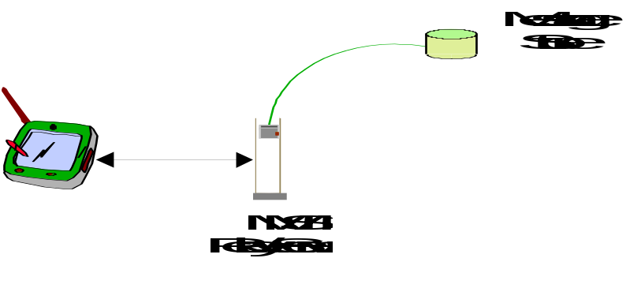

Figure A.1: Example of combined MMS-Relay/Server

A.3 Example of non-combined MMS-Relay and MMS-Server
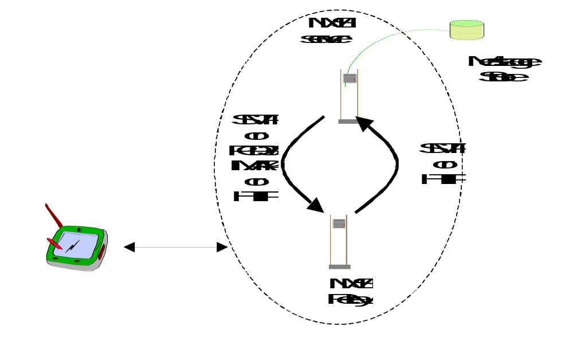

Figure A.2: Example of non-combined MMS-Relay and MMS-Server
For the transfer of messages between an MMS-Relay and an MMS-Server the use of SMTP and POP3[34]/IMAP4[35] or HTTP as illustrated in Figure A.2 is identified as appropriate.
If the protocol is SMTP for up- and download of messages to the server, then it may be identical to the one used between different MMSEs as specified in the subclause 7.7.

A.4 Example of MMS interaction with T.30 Facsimile Services
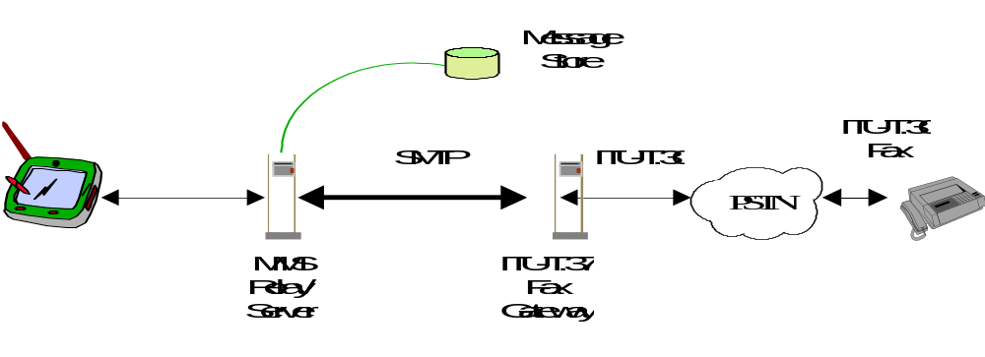

Figure A.3: Example of MMS interaction with Facsimile Services based on ITU-T.37
For the transfer of facsimile data via store-and-forward mechanisms ITU-T.37 [31] procedures have been standardised. These are identified as appropriate in the MMS environment for the interworking with T.30 [32] facsimile services. What the relevant MMSE parts are supposed to look like for a T.37 approach is depicted in figure A.3. The MMS Relay/Server interfaces with a T.37 Fax Gateway. For the Gateway’s communication with the MMS Relay/Server the appropriate protocol is SMTP. I.e., the protocol to be used on the interface between MMS-Relay/Server and the Fax GW is identical to the one used between different MMSEs as specified in subclause 7.7.

Towards the PSTN the Fax-GW terminates the T.30 facsimile protocol. Mobile terminated fax data will be converted into TIFF[36] image format and forwarded to the MMS Relay/Server as an attachment in an IETF internet email. In case of mobile originated fax messages the Fax-GW receives a written email provided with the receiver’s fax number from the MMS Relay/Server. Depending on the functions of the Fax-GW this email may contain plain text only or additional attachments, too. Although T.37 requires only TIFF format support there are Fax-GWs out on the market that permit many different formats to be included.

A.5 Example of MMS interaction with 2G/3G Voice Mailboxes
MMS interaction with voice mailbox systems should be performed on a non-realtime basis. Figure A.4 illustrates an example architecture for the incorporation of voice mailboxes.
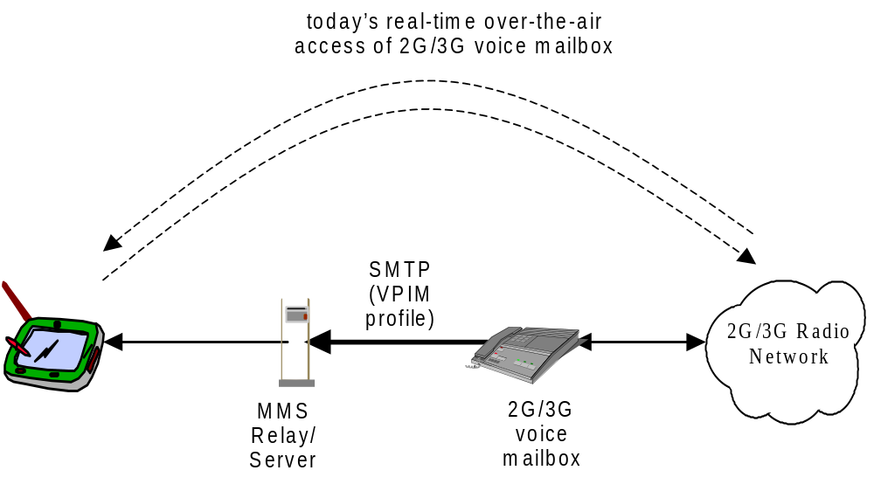

Figure A.4: First Example of MMS interaction with 2G/3G Voice Mailbox based on VPIM
The Voice Profile for Internet Mail Version 2, VPIMv2, provides format extensions for MIME supporting the transmission of voice messages over standard Internet E-Mail systems. The VPIM concept was developed by the Electronic Messaging Association (EMA). After VPIMv2 had been reviewed by the IETF it became RFC 2421 [33].
The VPIM specification allows voice records to be MIME encapsulated and sent as Internet mail attachments via SMTP or retrieved as Internet mail attachments via POP3 [34] or IMAP4[35]. The MIME type used for voice messages is “audio/*”.
For the interaction of MMS with voice mailboxes, the voice mailbox may forward received voice records as VPIM messages via SMTP to the MMS Relay/Server. This implies that voice messages’ download is always done via the MMS service. In this case the protocol to be used on the interface between MMS-Relay/Server and the voice mailbox is SMTP and thus identical to the one used between different MMSEs as specified in subclause 7.7.
Alternatively, the MMS Relay/Server may poll the voice mailbox via POP3 or IMAP4 for new messages received. Messages the user wants to retrieve via the MMS service can then be downloaded via POP3/IMAP4 from the voice mailbox to the MMS Relay/Server from where they are delivered to the MMS User Agent. This enables the user to do both, retrieve voice messages via today’s realtime voice mail services or as an MM. In any case it is expected that the voice mailbox is still the owner of the message and as a consequence responsible for the storage.
As an alternative the MMS interworking with a 2G/3G Voice Mailbox System could be envisaged via an HTTP interface as depicted in figure A.5.
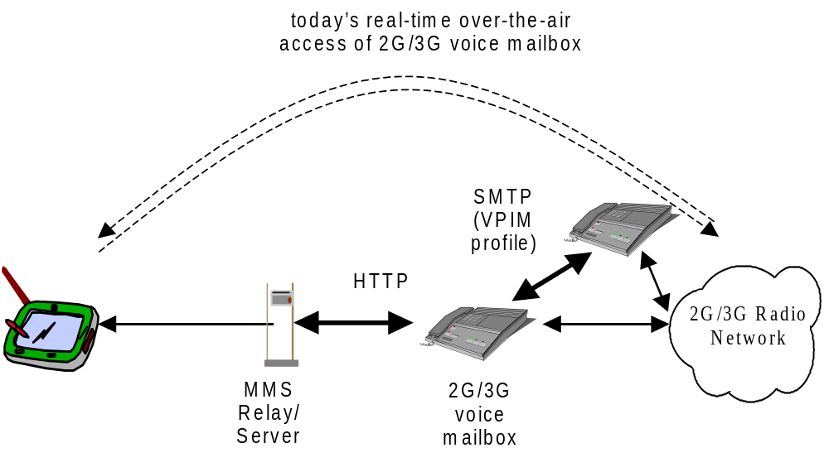

Figure A.5: Second example of MMS interaction with 2G/3G Voice Mailbox based on HTTP

A.6 Example of interaction with Internet E-Mail Messaging
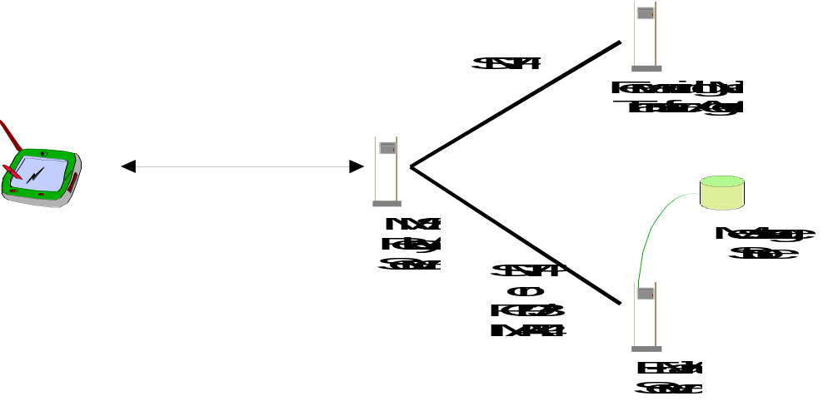

Figure A.6 Example of interaction with Internet E-Mail messaging
In this architecture the server will be an E-Mail server providing post office services which are accessible e.g. via POP3 [34] or IMAP[35] for Internet E-Mail retrieval in the MMSE or are accessible to the MMS Relay/Server using SMTP. The MMS Relay/Server will send messages that are to be transmitted as Internet E-Mail via SMTP.
In the case of retrieval and sending of MMs from and to the Internet Email service is done via SMTP, the protocol to be used on the interface between MMS Relay/Server and the Mail Transfer Agent, MTA/Email Server is identical to the one used between different MMS-Relays as specified in subclause 7.7.

A.7 Example of interaction with Short Message Service, SMS
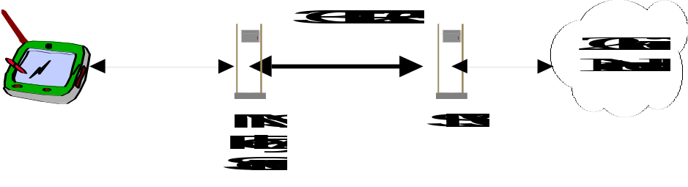

Figure A.7: Example of MMS interaction with SMSC

Depending on the SMSC manufacturer the MMS Relay/Server either can be directly connected to the SMSC (as shown in figure A.7) or an additional SMS-Gateway has to be added. In the latter case the SMS-GW has to be located between the MMS Relay/Server and the SMSC and provides the mapping of one or several SMSC access protocol (mapping between MMS Relay/Server SMSC access protocol and operator’s existing SMSC access protocol). Currently several different SMSC access protocols are defined in 3G TR 23.039 [37].

A.8 Example of Integration with Unified Messaging System (UMS)
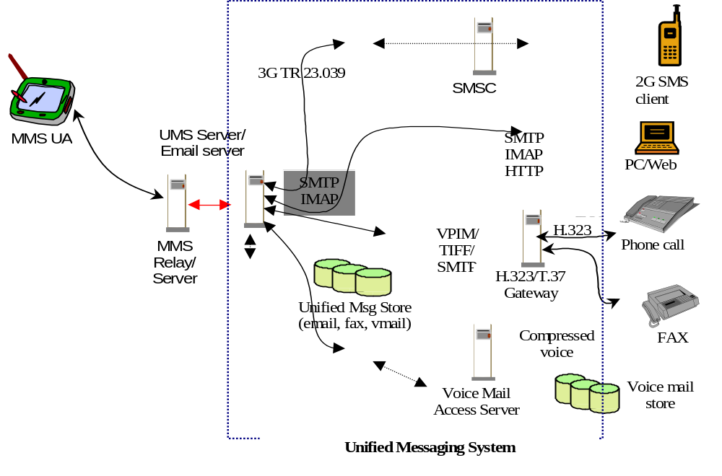
Figure 16: Example of MMS integration with UMS
Many carriers are operating or planning to operate Unified Messaging System (UMS) platforms, as well as conform to 3GPP specifications. Ideally, newly deployed UMS platforms will use MMS as their wireless access User Agents. However, newly deployed MMS systems will likely co-exist and integrate with Unified Messaging systems, (UMS), voice mail systems (VMS), and email systems. UMS will involve other access methods, such as PC mail access, Web browser access, PSTN voice phone access, etc., all of which are outside the scope of 3GPP standardization efforts.
Some operators may choose to integrate their MMS and UMS services. Even with a complete migration strategy, large email systems and VMS systems may require lengthy migration periods during which an integrated operation between the 3GPP and legacy systems must occur. Also, some installations will require permanent integrations, where 3GPP systems continuously interoperate with a legacy UMS or a legacy VMS.
The above diagram depicts a possible integrated architecture, building on the previous use cases, where a 3GPP MMSE interoperates with a UMS that connects to VMS, SMS, fax, and email.
Access from MMS UA occurs through the MMS Relay/Server. The MMS Relay/Server obtains email, voice, and/or fax messages from the UMS. PC clients access through the UM servers which may be integrated with the MMS servers by some operators. In this case a unified mailbox will be presented to both MMS users and others who access the system via other devices.
In addition, the UMS Server could possibly stream compressed voice from the VMS, assuming that streaming support is available in the servers as well as the clients. It could also establish a CS connection (using for example WTA methods to the wireless terminal.)
Voice mail and faxes can also originate from a voice/fax gateway server, which exists in both the legacy VMS as well as a UMS. Faxes can be sent out to remote fax numbers via the fax gateway. In that case the gateway would convert the VM or Fax to VPIM based email messages.
Access to the VMS and UMS should occur via open standard protocols, such as POP3, IMAP4, WebDAV, T.30, H.323, etc.

Annex B (Informative): MMS Implementations
This annex contains examples of protocols which support MMS at the interface between the MMS Relay/Server and the MMS User Agent

B.1 WAP Implementation of MMS
This informative annex shows how MMS will be implemented using the WAP MMS specifications suite. The WAP Forum has created MMS specifications in response to a request from 3GPP to include MMS as part of WAP. At the time of writing, the WAP MMS specifications are still under development in the WAP forum.
It is not expected that implementations of MMS based upon WAP will be realised until the WAP MMS specifications are approved and published by the WAP forum.
WAP provides significant support for MMS, both in direct service specification and in the underlying technologies. While the WAP MMS service specification work is new and is therefore unavailable for direct reference, its basic approach and limitations are based on WAP documents describing MMS architecture and message encapsulation. This should be done based on the underlying WAP technologies that have been published, and can therefore be referenced.

B.1.1 Protocol Framework
In reference to subclause 4.3, the protocol framework applied to WAP implementation of MMS on reference point MM1 is provided in figure B.1.
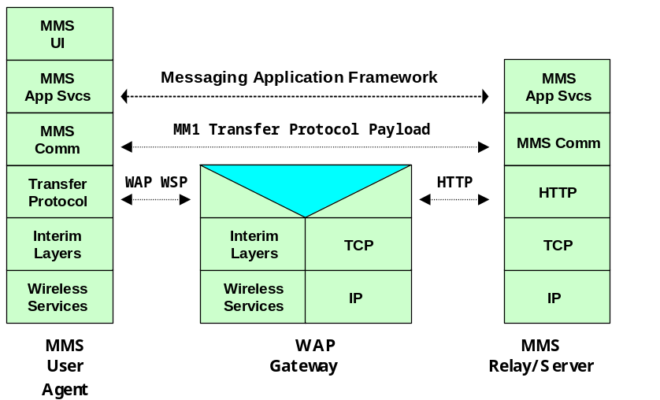

Figure B.1: Protocol Framework applied to WAP implementation of MMS

B.1.2 Architectural Support for MMS
WAP support for MMS is based upon the services of its supporting technology. Therefore, the scope of WAP, as it addresses MMS, is as shown in figure B.2. It does not cover activities or network elements beyond those shown and no such dependencies or expectations should be inferred or implied.
Figure B.2 shows an MMS Relay/Server which in the WAP architecture's terminology is referred to as an MMS Server. The WAP architecture also refers to the MMS User Agent as an MM Client. These cover equivalent functionalities.
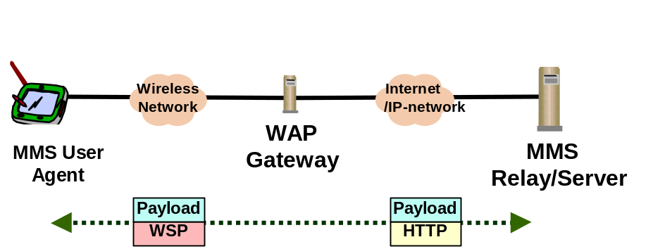

Figure B.2: Scope of WAP Support for MMS
Figure B.2 shows two links. The first, between the wireless MMS User Agent and the WAP Gateway, is where the "WAP Stack" is used to provide a common set of services over a variety of wireless bearers. For application oriented services, like MMS, the interest is primarily in services offered by WAP Session Protocol (WSP) [23].
The second link connects the WAP Gateway and the MMS Relay/Server. In the WAP architecture the MMS Relay/Server is considered an Origin Server. These entities are connected over an IP network such as the Internet or a local Intranet. HTTP is used for data transfer and data can be originated from either entity.
End-to-end connectivity, for the MMS application, between the wireless MMS User Agent and the MMS Relay/Server is accomplished by sending data over WSP and HTTP. This is accomplished using the WSP/HTTP POST method for data originating at the wireless MMS User Agent and by using the WAP Push Access Protocol [24] in the other direction.
The WAP Gateway, which enables the needed interworking, should not modify the data transfer via these transactions.
The WAP view of MMS is constrained to the interactions between the MMS User Agent and the MMS Relay/Server. It makes no representations as to services that are provided to or required of any other network elements.

B.1.3 Transaction Flows Supporting MMS
NOTE: The WAP MMS work is ongoing and the descriptions in this section are based upon preliminary material that is expected to remain stable.
The WAP MMS work describes the end-to-end transactions that occur between the MMS User Agent and the MMS Relay/Server. These transactions accomplish the following services:
- MMS User Agent originates a Multimedia Message (MM).
- MMS Relay/Server notification to an MMS User Agent about an available MM.
- MMS User Agent retrieving an MM.
- MMS User Agent support for retrieval acknowledgement to MMS Relay/Server.
- MMS Relay/Server sending delivery report to MMS User Agent.
Figure B.3 shows an example transaction flow illustrating a message origination, delivery and delivery report.

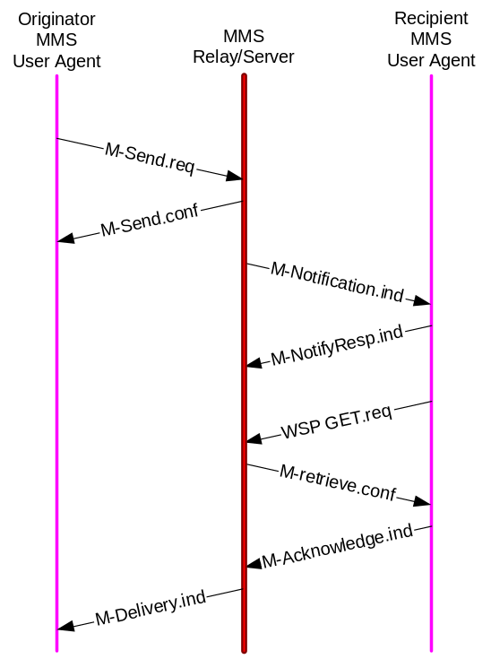

Figure B.3: Example MMS Transactional Flow in WAP
The transactions utilise a variety of transport schemes. For example, the MMS User Agent originates an MM by sending a M-Send.req to the MMS Relay/Server by use of a WSP/HTTP POST method. This operation transmits the required data from the MMS User Agent to the MMS Relay/Server as well as provides a transactional context for the resulting M-Send.conf response.
The MMS Relay/Server uses WAP PUSH technology to send the M-Notification.ind to the MMS User Agent. This is how the MMS User Agent is informed of MMs available for retrieval. Included, as a data component, is the URI of the MM that the MMS User Agent is to use for the retrieval.
The retrieval activity is performed by the MMS User Agent using the WSP/HTTP GET method on the URI provided. The fetch of the URI returns the M-retrieve.conf which contains the actual MM to be presented to the user.
The MMS Relay/Server may request information that would permit to know that the MM was actually received by the MMS User Agent. One approach would be for a distinct M-Acknowledge.ind to be passed from the MMS User Agent to the MMS Relay/Server.
The MMS Relay/Server is responsible for supporting an optional delivery report back to the originator MMS User Agent. Based upon possible delivery outcomes, the MMS Relay/Server would again utilise WAP PUSH technology to inform the MMS User Agent with the M-Delivery.ind message.

B.1.4 Terminal Capability Negotiation
WAP provides a mechanism to inform an origin server, such as the MMS Relay/Server, of the capabilities of the MMS User Agent. This is known as User Agent Profile (UAProf) [25]. It provides information about the characteristics of the display (e.g. size, color support, bit depth), supported content types and network limitations (e.g. max message size).
The UAProf data is encoded in an RDF [26] data description language. It is conveyed, possibly indirectly, when the MMS User Agent performs a WSP/HTTP operation, such as a GET, to an origin server. It is up to the origin server to decode the RDF data, extracting any needed device characteristics, to guide the content generation or filtering operation it performs before returning data to the MMS User Agent.
For MMS, the MMS Relay/Server should be able to utilise the capability information to make adjustments to the delivered MM contents. For example, an MMS Relay/Server may delete a message component if the content type was not supported by the terminal. Alternatively, the MMS Relay/Server may adapt an unsupported content type to adjust the size, color depth or encoding format. WAP makes no requirements to the handling of this data or of any notifications that may be made to the user concerning such adjustments.

B.1.5 MMS Message Contents
The WAP work on MMS is defining a message encapsulation scheme to convey the data between the MMS User Agent and the MMS Relay/Server.

B.1.5.1 Multimedia Messages
The MIME multipart technique is standard Internet technique to combine the email body and the attachments together. The WAP has a binary equivalent to this, referenced in [23] which can be used to combine multimedia objects in the multimedia messages together. This approach shall be used for messages between the MMS Relay/Server and MMS User Agent which also include MM components. This includes the message send and retrieve.
The use of the WAP binary multipart structure allows easy conversion between binary format and the Internet MIME multipart. In addition, the binary format allows efficient handling of the message especially in cases when some multimedia objects must be taken out of the structure.
A special, application specific part should contain the MMS header information. This header information is used to provide the message type information as well as message-specific information. The proposed content type for this part is application/mmsheader and until registration within IANA, the interim content type shall be application/x-mmsheader.

B.1.5.2 Other Messages
Other MMS transactional messages utilise additional PDUs for multimedia message notification, acknowledgements and delivery reports. These messages are conveyed with messages that just utilise a content type proposed to be application/mmsheader. Until registration within IANA, the interim content type shall be application/x-mmsheader.

B.1.6 MMS Presentation
The rendering of an MM for a user is the ultimate objective of the MMS. This rendering operation is known as presentation. Various types of data may be used to drive the presentation. For example, the MM presentation may be based on a WML deck [27] or Synchronised Multimedia Integration Language (SMIL) [28] which includes links to other component elements in the multipart message. Other presentation models may include a simple text body with image attachments. WAP has not specified any specific requirements on MMS presentations. UAProf [25] content negotiation methods should be used for presentation method selection.
NOTE: In the future, it will be desirable to consider mobile-optimised presentation technologies. For example, WAP Forum and W3C have initiated work on a mobile-optimised version of SMIL that would be suitable for use in an MMS environment.

B.1.7 MMS Security Model between MMS User Agent and MMS Relay/Server
No MMS-specific requirements are in place within the WAP Forum to support security mechanisms in the transactions between the MMS Relay/Server and MMS User Agent. Existing schemes such as WTLS [29] and WIM [30] are available and other end-to-end techniques are under development.

B.2 IP Based Implementation of MMS for future releases
This informative annex conceptually demonstrates how IP based MMS would be fulfilled using standard internet transport and email protocols.
It is not expected that fully featured implementations of MMS will be realised using existing IETF protocols until additional capabilities are included to support all aspects of MMS. It is anticipated that in due course, these new capabilities will be standardised by appropriate standards organisations and will be described in a future release of this specification.

B.2.1 Protocol Framework
The following figure B.4 is an example of the protocol framework definition for IP Based Implementation of reference point MM1 in 3GPP MMS.
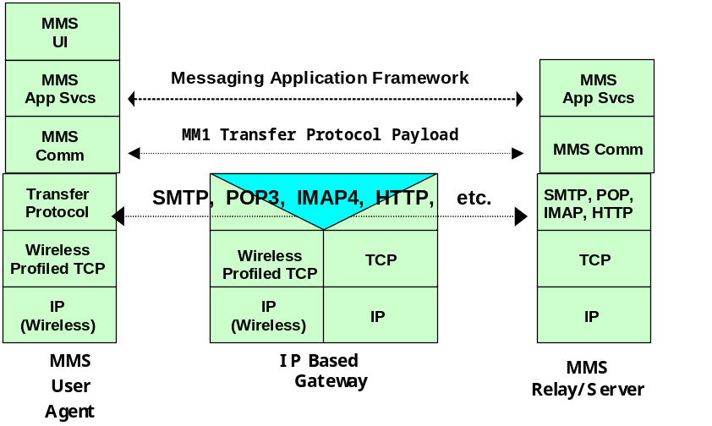
Figure B.4: Example of Protocol Framework Definition for IP Based Implementation in 3GPP MMS

The protocols of IP Based Implementation would be based on the Internet standards that have been standardized by IETF. Wireless profiled TCP, which tunes up the wireless network, would be used for the transmission control protocol. What kind of wireless tuned TCP could be used, would be defined by a profile.
The Transfer Protocol between MMS User Agent and MMS Relay/Server would be SMTP, POP3, IMAP4, HTTP, etc., depending on the services.
The notification services and the other needed services between MMS User Agent and MMS Relay/Server would be supported by using the appropriate protocol.
NOTE: The appropriate protocol would be used as soon as the standardization would have been completed.

B.2.2 Architectural Support for MMS
The following figure B.5 is an example of the architecture definition for IP Based Implementation in 3GPP MMS.
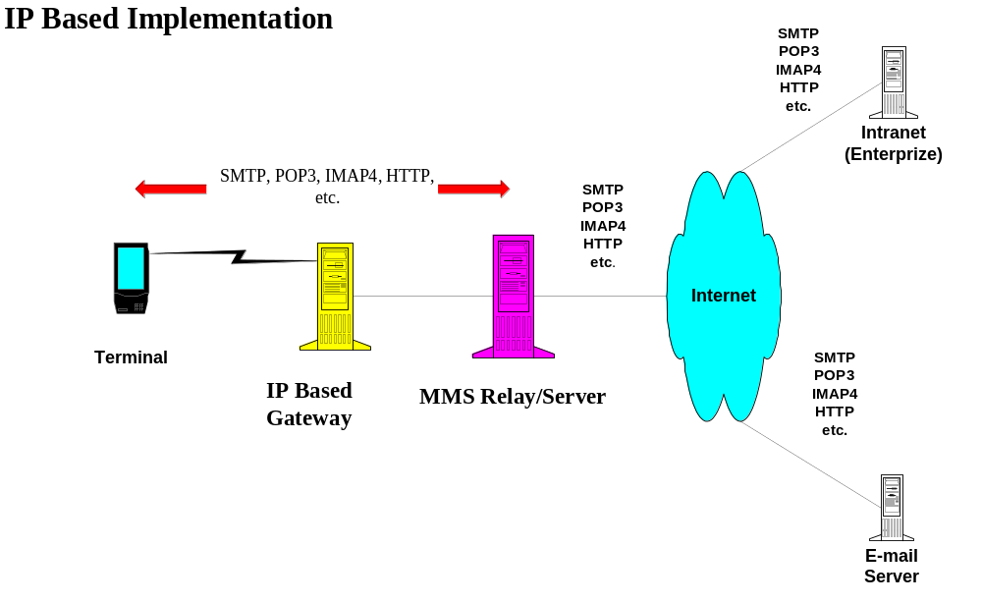

Figure B.5: Architectural example of IP Based Implementation for 3GPP MMS

The communication between a terminal and the IP Based Gateway would use the appropriate IP Based protocol like SMTP, POP3, IMAP4, HTTP, etc. on wireless profiled TCP to provide services.
The communication between the IP Based Gateway and the MMS Relay/Server would use the appropriate IP Based protocol like SMTP, POP3, IMAP4, HTTP, etc. on TCP to provide services. Wireless profiled TCP would be translated to normal TCP in the IP Based Gateway.

B.2.3 Transaction Flows Supporting MMS
The following figure B.6 is an example of transaction flows for IP Based Implementation in 3GPP MMS.

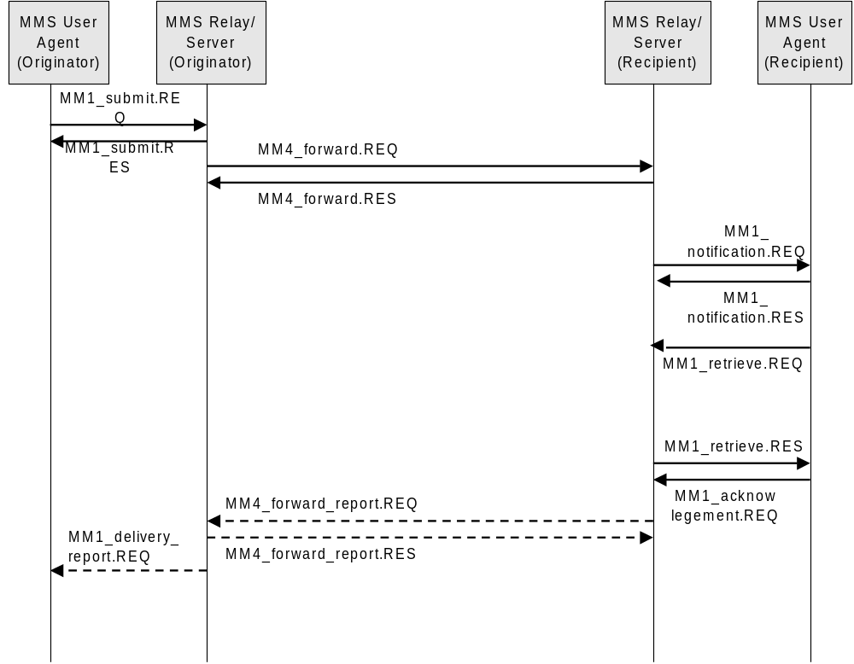

Figure B.6: Example of transaction flows for IP Based Implementation in 3GPP MMS

For example;
- MMS User Agent (Originator) would send a Multimedia Message (MM) by sending MM1_Submit.REQ to MMS Relay/Server by use of a SMTP or HTTP POST method. There could be MM1_Submit.RES response by use of HTTP.
- MMS Relay/Server (Originator) would forward the MM sending MM4_forward.REQ to MMS Relay/Server (Recipient) by use of SMTP. There could be MM4_forward.RES response by use of HTTP.

- MMS Relay/Server (Recipient) would use IP based PUSH technology to send MM1_notification.REQ to MMS User Agent (Recipient) by use of HTTP POST method or the other appropriate way. There could be MM1_notification.RES response by use of HTTP.

- The MMS Relay/Server might request information that would permit to know that the MM was actually received by the MMS User Agent. One approach would be sending MM1_acknowledgement.REQ from the MMS User Agent to the MMS Relay/Server.
- As an option, MMS Relay/Server (Recipient) might forward a message by using MM4_forward_report.REQ to MMS Relay/Server (Originator) by using SMTP or HTTP. There could be MM4_forward_report.RES response by use of SMTP or HTTP.
- The MMS Relay/Server is responsible for supporting an optional delivery report back to the originator MMS User Agent. Based upon possible delivery outcomes, the MMS Relay/Server would again utilize IP based PUSH technology to inform the MMS User Agent with the MM1_delivery_report.REQ message.

B.2.4 Terminal Capability Negotiation
The Terminal Capability Negotiation would be based on the Internet standard (e.g. CC/PP).

B.2.5 MMS Message Contents
The MMS Message Contents would be video mail, audio mail, image mail, text mail and so on.

B.2.5.1 Multimedia Messages
The Multimedia Messages would be based on RFC822 (Standard for the format of ARPA Internet text messages) and MIME (Multipurpose Internet Mail Extensions, RFC 2045 - 2049).

B.2.6 MMS Presentation
The MMS Presentation would be based on MIME (Multipurpose Internet Mail Extensions, RFC 2045 - 2049) and Internet standard.

B.2.7 MMS Security Model between MMS User Agent and MMS Relay/Server
What kind of security mechanism could be used, would be defined by a profile.

Annex C (Informative): Call Data Records.
This annex describes information of MMs/abstract messages which may be required for inclusion into Call Data Records (CDR’s) for MMS for the purpose of Billing and Traceability.
This list of information elements is not complete but includes:
- MMS-specific message-ID
- Recipient address(es)
- Sender address
- Message size (sent / received)
- Identification if a message has been sent to a pre-defined group
- Time stamp ( including timezone ): for submission time, earliest delivery time and time of expiry
- Duration of transmission (e.g. for streaming purposes)
- Duration of storage (in the MMS server)
- Type of message: (e.g. notification, message MM, delivery report, read-reply)
- Bearer type used
- Content information (e.g. audio, picture, video, text,)
- Message class (e.g. advertisement/informational)
- Delivery Report Request
- Read Reply Request
- Charging Indicator ( e.g. Pre paid charging, Reply charging, Reverse charging, Third party financed )
- MM Status (e.g. delivered, abandoned, time expired, delivery pending).
- Indication of forwarding
This information shall be time-stamped.

The following information elements at least will be considered for the future.
- A specific class / type for MMS used for the Instant Messaging functionality
- Conversion of type and media
- Security level used
- Priority/QoS

Annex D (Informative): MM3 principles

D.1 Sending of MMs
On sending an MM to an external server the MMS Relay/Server:
- should map as many fields as possible to corresponding fields of the message format or protocol of the external server while suppressing MMS-only relevant fields (e.g. MMS-version) or sensitive fields (e.g. originator Address when address hiding is requested) and fields that cannot be mapped (e.g. Content-type in case fax gateway).
- In the case the external server uses RFC 822 formatted messages the mapping should be according to the mapping on MM4 under consideration of the above mentioned constraints.
- May add relevant fields that cannot be mapped to fields of the message format or protocol of the external server to the content body of the message if suitable (e.g. Print Content-Type, Priority, etc. on fax).
- should convert the content itself into the appropriate format used by the external server (e.g. WAV(G.723) attachment to AMR attachment for voice mail system)

D.2 Receiving of messages
On receiving a message from an external server the MMS Relay/Server should be able to handle the following on MM3:
- The external server may send a message with RFC 822 formatted header and a body with encapsulated message type of the external server (e.g. e-mail with attachment application/sms). In that case the MMS Relay/Server should map as many fields of the RFC 822 header to the corresponding header fields of an MM. Additionally the MMS Relay/Server may be able to copy MMS relevant information from the MIME encapsulated body and map them to the corresponding header fields and body of an MM. The attachment itself should be forwarded unaltered as attachment of the generated MM to the recipient.
- The MMS Relay/Server should be able to interpret MMS specific fields in the RFC 822 header of a message from an external server (e.g. voice mail can specify expiry date)
- The external server may send a message with regular RFC 822 formatted header and MIME encapsulated attachments which may comprise content and/or profile information (e.g. VPIM multipart/voice-message). The MMS Relay/Server should be able to map as many fields of the RFC 822 header to the corresponding header fields of an MM. Additionally in the case the attachments contain some message profile information the MMS Relay/Server should be able to map those to the corresponding header fields of an MM. The attachments / parts of the attachments with message content may be converted to another media type or format subject to the capabilities of the MMS User Agent. In most cases the attachments might be forwarded unaltered to the recipient.
- The external server may send a message with a format different from RFC 822. In this case the MMS Relay/Server should be able to extract as many information from the external message format and protocol and map them to corresponding fields of the MM header. The content of the message from the external server should be mapped to an appropriate MIME type/subtype and attached to the MM. (e.g. SMS via 3G TR 23.039 -> MM with text/plain)

Annex E (Informative): Use cases for Reply-Charging
The following detailed example use case of reply-charging describes the case when MMS User Agent A and MMS User Agent B belong to the same MMSE. MMS User Agent A is the sender of the reply-charged MM and MMS User Agent B is the recipient of the reply-charged MM.

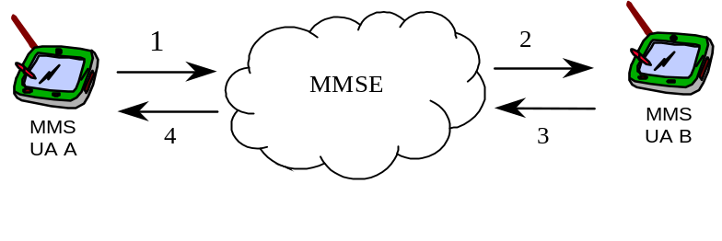
- User A produces an MM and marks it “reply-charged” before it is submitted to the MMSE. The MMSE notes that user A is willing to pay for a reply-MM to this particular MM and notes the message-ID of the original MM and the originator’s limitations.
- The MM is retrieved by user B in accordance to the user profile of user B. This might imply charges for user B when retrieving the MM. User B retrieves the original MM and discovers that the first reply to this message (that is accepted by the Service Provider) will be paid by user A.
- User B creates an answer, the MMS User Agent B marks it as a reply-MM and submits it on to the MMSE. The MMSE identifies this MM as a reply to the original MM and checks the originator’s limitations. If the MMSE accepts the reply the reference set before (as described in transaction 1) is deleted. User A is billed for transaction 3.
- User A retrieves the reply-MM and eventually is billed for transaction 4.
The other use case of reply-charging where MMS User Agent A and MMS User Agent B belong to different MMS Service Providers is for future elaboration.
The use case of reply-charging where the originator MMS User Agent is actually the MMS VAS Application (using MM7 reference point) behaves in the same way as the use case of two MMS User Agents in the same MMSE.

Annex F (Informative): Change history

Change history
Date | TSG # | TSG Doc. | CR | Rev | Subject/Comment | Old | New
15/03/00 | T#7 | TP-000028 |  |  | New | 2.0.0 | 3.0.0
 |  |  |  |  | Editorial change by MCC | 3.0.0 | 3.0.1
22/09/00 | T#9 | TP-000144 | 001 |  | Set of mandatory media formats for MMS | 3.0.1 | 4.0.0
08/12/00 | T#10 | TP-000195 | 002 |  | High-level description of MMS | 4.0.0 | 4.1.0

