Trade Input
Typing text in the Trade Description column is the primary way to drive what is modelled. We aim to support all the terminology typically seen in chats and there are usually many ways to model the same structure. For example the 4 Trade Descriptions in the below all resolve to the same:
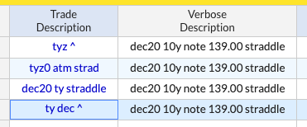
The system will try to interpret as much of the input as possible and flag what it doesn’t understand. In the below the “bought” at the end of the description has not been recognised and shows in red:
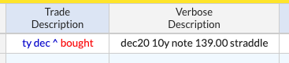
If you want to see how the system has interpreted the Trade Description click anywhere in the row and the status bar at the bottom of the page will show a description of how it sees the trade. In the below tym ^ shows as jun22 10y note 123.00 straddle
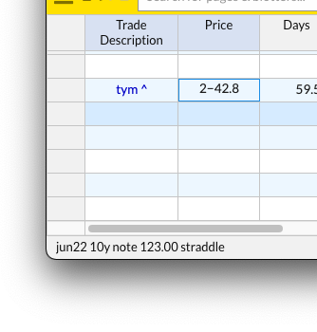
The convention throughout Pricing Monkey is that input from the user is shown in blue, outputs are in black, and if the input is not recognised or invalid it shows in red.
Examples
To give a quick flavour of what’s possible you can write things like the following:
- jun ty 125 123 ps – the 125 123 put spread in CBOT 10y note options for the next June expiry series
- 1st monthly bund ^ – the straddle in next monthly Eurex bund expiry
- gcz 25 delta fence – 25 delta risk reversal in the next december expiry in Comex Gold options
- sfrz6 97.50 put vs 97.40 30d – CME SOFR Dec 2026 97.50 put hedged with 30% futures @ 97.40
- jun spx 105% call – CBOE SPX calls expiring next June struck at 105% of spot
- 6 month cl straddle – a synthetic straddle on Nymex Wti Oil options expiring in 6 months time
Links to blotters with further examples in rates, equites and metals can be found here or via the menu in the top left under Examples -> Trade Syntax.
Trade Description Syntax
Delta Hedges
You can create a delta hedged trade by adding a hedge at the end of the description. You can provide either:
- A price and a hedge amount
- A price only (the amount will default to the delta of the options)
- The string delta hedged (the amount will default to the delta of the options and the price will default to at market)
Here are some examples:
- ... vs 98.51 40d – hedged with futures at 98.51 using 40% hedge ratio
- ... x98.51 40d – hedged with futures at 98.51 using 40% hedge ratio
- ... ref 98.51 – hedged with futures 98.51 using the current delta as the hedge ratio
- ... delta hedged – hedged with futures priced at market and using the current delta as the hedge ratio
Relative Strikes
Several styles are supported. By default the system will snap to the nearest listed strike.
- X out – eg rxz 100 out call will give a call that is 100 cents away from the underlying.
- Xbp out – eg tyz 25bp out call will give a call that is 25bps away from the underlying.
- X delta – eg rxz 20 delta call will give a call that has 20% delta.
- X% – eg sx5e dec25 105% call will give a call that is struck at 1.05 * spot.
- X% of forward – eg sx5e dec25 105% of forward call will give a call that is struck at 1.05 * forward.
- X wide – eg gcz5 100 wide fence will give the 50 out call vs the 50 out put.
Rolling Expiries
Using 1st, 2nd, 3rd … will give all the contracts listed by the exchange in order. If you only want to see a particular type, such as the monthly expiries, you can write 1st monthly, 2nd monthly, etc. This syntax is what drives our straddle runs. For example the next 3 monthly bund expiries would be:
- 1st monthly bund ^
- 2nd monthly bund ^
- 3rd monthly bund ^
For STIRs you can also use syntax like ED1 ^, ER2 ^, etc for the quarterly expiries.
Relative Expiries
You can specify the expiry in terms of days, months or years from today. Structures will be priced by interpolating between the neighbouring listed expiries and strikes. Relative expiry futures can also be modelled with the word “forward”. For example:
- 30 day rx ^ – an atm bund straddle expiring in 30 days time
- 6 month forward er – a euribor future expiring in 6 months time.
Structure Vs Structure
To price the spread between two structures you can either use “vs”, or use a formula style input. For example:
- sfr^ vs erz^ to price Dec SOFR straddles vs Dec Euribor straddles
- 1*sfrh5^ - 1.5*sfrz6^ for 1x Mar25 SOFR straddles – 1.5x Dec26 SOFR straddles
Strategies
We aim to support all the commonly used ways to describe strategies. The following is not an exhaustive list:
- Straddle – straddle, strad, ^
- Call Spread / Put Spread – call spread, cspd, cs, put spread, pspd, ps
- Call Fly / Put Fly – call fly, cfly, put fly, pfly
- 1×2 Call Spread – 1x2 call spread, 1x2 cspd, 1x2 cs (and equivalent for puts)
- 1x2x3 Call Fly – 1x3x2 call fly, 1x3x2 cfly (and equivalent for puts)
- Weighted flies/spreads – 1x1.5 cs, 1x2.5x1 cfly
- Ladders / Trees – call ladder, c lad, cl
- Combos / Risk Reversals – combo, squash, fence, rr
- Strangles – strangle, ^
Other Input Columns
Allow Synthetic Strike Column
When using relative strikes the system will snap to the nearest listed strike by default. If the Allow Synthetic Strike column is checked then the system will model theoretical strikes that correspond to the exact relative distance by interpolating between the nearest listed strikes.
To add this column, right click in the blotter area and go to Insert Column -> Input -> Allow Synthetic Strike.
Trade Amount, Trade Price, And Trade Date Columns
These columns allow you to PV and risk theoretical portfolios. When trade amount is provided the NPV column will populate and the risk columns will show in cash terms. Trade Price will be factored into the NPV column when provided.
When plotting NPV historically the NPV will be zero before the Trade Date. If you create a formula which is the sum of the NPVs or risks of several rows, then if you right click and Plot History of the formula you can construct historical PnL and risk.

