CURRICULUM VITAE

PERSONAL PROFILE
Full name:  Date of Birth:  Sexual:  Marital status:  Mobile:  Email:  Address:  ID No.: | Do Thi Kim Oanh  13/07/1991  Female  Single  01632101641  kimoanhdt91@gmail.com  Thanh Xuan- Ha Dong- Ha Noi  135505393 |  |  |  | 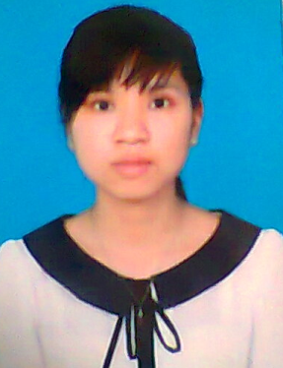
JOB OBJECTIVE
Position: TESTER
Salary: Negotiable |  |  | Date available to Start: Immediately
EDUCATION
2009- 2014 |  | Posts & Telecoms Institute of Technology  Department: Information Technology  Ranking: Fairly Good  Student scholarships for the second semesters 2012 and 2013
English skills |  | Reading for understanding
Testing Skills |  | Complete course Fresher Tester
Software Testing Skill
Testing Methods |  | Black Box Testing
- Have knowledge and experience in software testing
- Proficient in Microsoft Word, Excel, Power Point
- Java, C, C++, PHP
- Have knowledge of databases
- Have experience in Web Application
EXPERIENCE
6/2014 – 9/2014 |  |  |  | FPT software  Position: Tester  Project: Test mobile  Job Description: executing tests for Camera, Setting, FOTA, Playstore, Gallery and doing test report
9/2013 – 5/2014 |  |  |  | FPT software  Position: Tester  Project: Defect management system  Job description: designing and writing testcase, executing tests for Add defect, Update defect
OTHER SKILLS
- Reading for understanding skills for major documents
- Searching and using Internet skills
- Able to work independently and team work as well
- Planning and organizing skills, problem solving
- Communication skills, quickly adapt to new environment
- Honest, enthusiastic, reliable, able to work under pressure
- Open - minded, able to play sports, social activities, etc.
OTHER INFORMATION
- Characteristic: outgoing, caring and resourceful, honest, have a good sense of humour
- Job objective: learning from others, gaining experience and work skills, becoming a test leader
- Hobbies: Travelling, shopping, relax by foreign and instrumental music, reading book

