Career Profile
♦ Personal Information

Name  Born  Sex  E-mail  Phone | : NGUYEN VAN TIEN  : 08/07/1987  : Male  : quangtienhc@gmail.com  0984502539 | 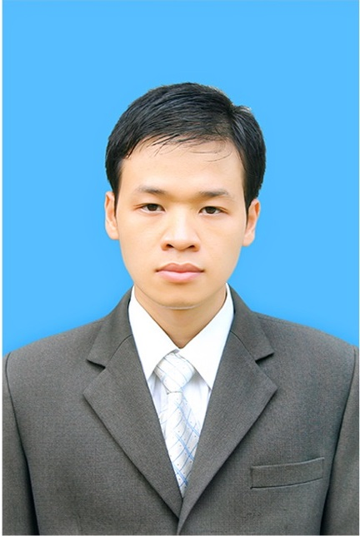

♦ CAREER OBJECTIVE
Researching new technologies, learn from colleagues around, contribution, dedicate enthusiasm for the company and own career promotion.

♦ Education and Qualification
 | Graduated from | - BachKhoa-Aptech Education  - National Academy Public of Administration

♦ Languages

 | Fluent | Good | Fair
Vietnamese | ✓
English |  | ✓
Japanese |  |  | ✓

♦ Skill Summary

- Software Development Experience: 2.5 years work for FPT Software
- Java/ JSP: 2.5 years
- Python: 6 months
- PHP: 1 years

♦ Skill Details

Technical skills | Years of experiences | Last used
Operating Systems  Win7/Win8/Winserver/WinNT/2000/2003/XP/98  CenOS | 8 years  2,5 years | 2015  2015
Programming Languages and Tools  HTML, Javascript, jquery,css2,css3  C  C#  XML  PHP  Java Spring, Strust2, Core  Python  Eclipse  NetBean  Adobe Dreamweaver  Adobe Photoshop  Adobe Illustrator  Corel draw  SVN  Githup, Gitlab  Enterprise architecture  Solr server  MS Source Safe | 4,5 year  4 months  4 months  4 months  2 year  3 year  6 months  2,5 year  3 year  5 year  5 years  5 years  3 years  2,5 years  2 years  2 year  2 year  1 year | 2015  2011  2012  2015  2013  2015  2014  2015  2015  2015  2015  2015  2015  2015  2015  2015  2015  2015
Databases  SQL Server  MySQL  MongoDB  Posgress | 3,5 years  3,5 months  1 year  1year | 2015  2015  2015  2015
Data Communication Networks

Projects

• Talkminer |  |  | From sept 2013  to May 2014
Position in project |  | Developer
Technical Environment
 | - Hardware | PC, 256 Megabytes of Ram or higher
 | - Software | CentOS 6.5  Posgress  Python 2.7 or up  Jdk 1.6.0_23 or up,  Chrome, fire fox, IE browser…  Apache tomcat 6 or up
Project Description
 | - Characteristics | Analyzing text from video, managed video information
 | - Target | * Objective:  This project is analyzing the content of the video of university lectures. Then give it to students through search web server.  * Scope:  - Study function spec  - Create detail design  - Coding  - Create SST document  - Testing
 | - Customer | (A Japanese company)
 | - Size | About 75 MM

• MAM |  |  | From May 2014  to Oct 2014
Position in project |  | Developer
Technical Environment
 | - Hardware | PC, Iphone, Ipad, Android smartphone.
 | - Software | CentOS 6.5  Jdk 1.6.0_23 or up,  Apache Tomcat 7.0,  Mysql, Mongodb  Chrome or Firefox or InternetExplorer or Opera… Browser
Project Description
 | - Characteristics | Lecturers provide video, images via a smartphone or tablet. System storage and management then give the website by embedding.
 | - Target | * Objective:  This project is management and providing video to Websites outside of the system via the embedded.  * Scope:  - Create Basic design / Detail design  - Create SST document  - Create Guideline document  - Coding
 | - Customer | (A Japanese company)
 | - Size | About 45 MM

• TOYA365 |  |  | From May 2014  to Oct 2014
Position in project |  | Developer
Technical Environment
 | - Hardware | PC
 | - Software | CentOS 6.5  Jdk 1.6.0_23 or up,  Apache Tomcat 7.0,  Maven 3.0  AWS service  Chrome or Firefox or InternetExplorer or Opera… Browser
Project Description
 | - Characteristics | Analyzing text from video, managed video information
 | - Target | * Objective:  This project authenticate to Office 365, get videos and providing to Analyzing system on cloud AWS service then store and manage information in the system Solr Server, provide searching information to user by Web Search UI.  * Scope:  - Create Basic design / Detail design  - Create SST document, UT script test  - Coding  - Testing
 | - Customer | (A Japanese company)
 | - Size | About 45 MM

♦ Other skill
- Write and communicate in English.
- Presentation skills

♦ Hobbies
Football, Film, Badminton, Game, Music, Cooking, Travel.

