CURRICULUM VITAE
INFORMATION PERSONALLY

Full name : Nguyen Dang Tuan Vu
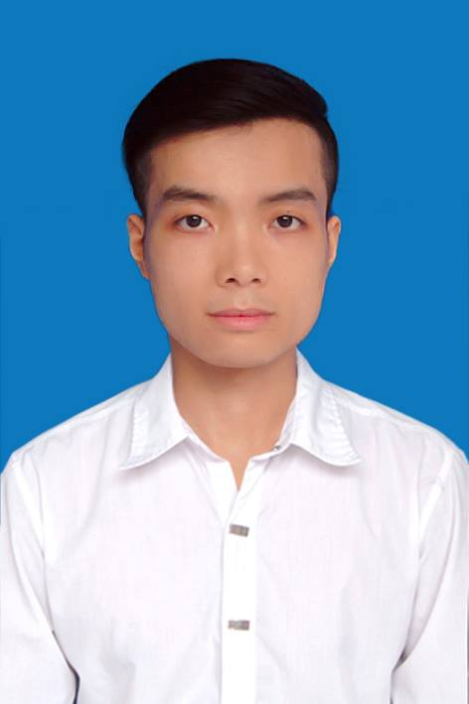
Date of Birth : October, 5th 1992
Gender : Male
Place of birth : Vinh Phuc
Health : Good
Interests : Game, Music, Technology
Character : Friendly, cheerful, agile, careful, approachable, sociable.
Current Address : 271 Nguyen Trai- Hung Vuong - Phuc Yên -Vinh Phuc
Phone : 0978961896
Email : vundtse02805gmail.com
Position : New Developer

EDUCATION AND TRAINING
2011 -2012 | FPT University
2012 - 2015 | FPT-APTECH

OBJECTIVE
1: Working in a creative environment, modern and dynamic.

2 : Stable job, good mode and is capable of advancement.

3: Full labor rights as social security, health, holidays, and other benefits.

PROJECTS IMPLEMENTED

FPT_Aptech
Project Name | Onlinerecuriment Process for HR
Description | This project is aimed at developing a web-based and central Recruitment Process System for the HR Group for ABC company. Some features of this system will be creating vacancies, storing Applicants data, Interview process initiation, Scheduling Interviews, Storing Interview results for the applicant and finally Hiring of the applicant. Reports may be required to be generated for the use of HR group.
Programming Languages | C#, SQL.
Development Tools | Netbean, SQL Server Management Studio.
Responsibility | The work done: design the all web interface, participants database design, team management, wrote code .

FPT-Aptech
Project Name |  | Bug Reporting System
Description |  | With some retail product of companies, Due to some arrears in the delivery of the product, or due to some failures occurred for the product, they want to start up a front end business (like the After-  Sales support system of the firm), where the customers can lodge their complaints, or reports regarding their concerns either by calling to the help desk lines or through the mail ids as provided in the product menu and on the bill receipt of the product. Applications “Bug Reporting System” meet the requirements as: it is a standalone application, it was built to record the complaints/reports lodged and their status, so as track the service provided and as to ensure that there will be the timely service.
Programming Languages |  | Java, SQL.
Responsibility |  | The work done: analyzed for the group, interface design, database design, job-sharing for members, wrote code .

SKILLS

- Technical skills
- Basic knowledge
- Software development process
- Problem solving
- Object Oriented Programming
- MVC model, 3-layer model
- Web/win form application developing
- Database analyzing and designing.
- OS: window
Programming languages: C, C++, ASP.NET, HTML, JAVA …
- Database: MS SQL Server, MySQL …
- Packages: .net framework, MS office
- Methodologies & Tools: Dream weaver 8, Visual Studio2008, MS SQL server 2005/2008...
- Soft skills
- Team working ability.
- Working under high pressure ability
- Capable of working and functioning independently.
- Fast learner, hardworking and committed to do a job well
- Flexible, energetic, patient and able to work within a multi-cultural environment.
- Excellent communication, especially in human relations…

REFERENCES
Developer Mr. Nguyen Viet Khoa
Email:khoannv@fpt.ac.vn

Addr: Ha noi, Vietnam. Phone: +84.912151629

