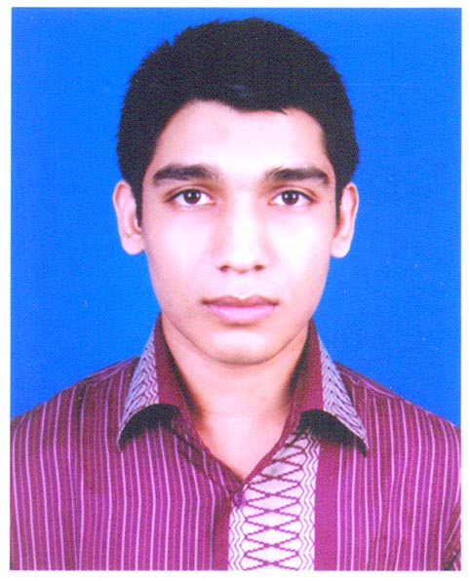
Amimul Hossain
S/O Md. Khalilur Rahman and Habiba Rahman
H-75, W-5, Uzampur, Uttarkhan, Dhaka
Contact No. Cell - 01820996126
Email- amimul.se@gmail.com
Date of Birth – December 31, 1992

Career Objective:

Strong desire to build up a successful career by obtaining a challenging position in a reputed institute where I can apply my skill and knowledge to enhance origination’s success and also to enhance my own personal knowledge.

Education:

Bachelor of Software Engineering, 2010-2013

American International University-Bangladesh (AIUB).
House #55/B, Road # 21, Kemal Ataturk Avenue,Banani, Dhaka – 1213.
GPA: 3.84 (Out of 4.00)

Higher Secondary Certificate Examination (Science Group)-2009

Government Science College.
East Tasturi Bazer, Tejgoan, Dhaka-1215
GPA: 4.90 (Out of 5.00)

Secondary School Certificate Examination (Science Group)-2007

Uttara High School.
Sector No. 7, Road No. 27, Uttara Model Town, Dhaka -1230.
GPA: 5.00 (Out of 5.00)

Certification:

Titanium Certified Developer (TCD).
License No. 2C6E-1932-FACD-4043
Titanium top 200 (ranked 66) experts.
https://developer.appcelerator.com/devlink/profile/1615125/amimul-hossain

Job Experience:

OscilloSOFT PTY LTD.
Jr. Software Engineer (From July 2014 to Still Now)
.NET Developer
Address: Unit 3, 62 Owen Street, Glendenning NSW – 2761, Australia.

Grameen Solutions Ltd.
Software Engineer (From October 2013 to June 2014)
Mobile Application Developer
Address: Grameen Bank Tower, 12th Floor, Mirpur 2, Dhaka 1216, Bangladesh.

Internship:

Teacher Assistant of C++ course at American International University-Bangladesh (AIUB)

Project:

.NET Application:

1. Fountain Head Solution

Fountain Head Solution is a management type of software for The Fountainhead Method in Australia. It can manage their schedule for day to day purpose along with maintains their all of employee information, auto permission for access portal, dynamic Event generation, internal Module preparation, Resource management, Configuration accessibility and tracking the General Holidays event. Fountainhead Method is a one kind of health associated organization and Fountain Head solution is also providing to upload and download facility to maintain the daily task.

2. TAFE BUDGET

This software is developed for all Institute of Australia. TAFE (Technical and Further Education) Institute of Australia automation system. In this software we can calculate the whole of budget for the specific semester. Budget is produced based on courses with full time, part time teaching, administrative support cost and non administrative support cost. It can generate automatically hourly rate for teaching and non teaching staff for the Institute. This software is also internally communicated with SAP application.
3. Coats

This software is developed for Garments Industry. It is ERP software. This software is used for collect, store, manage and interpret data. By using this software we can manage Inventory management, Daily Attendance process, Product planning, cost and development, Marketing and sales, Service delivery and Payment process.

4. Teach Help

This software is developed for University teaching purpose. It is used by the entire faculty and their permitted student of the university. This software can dynamically generate per semester class routine, CGPA calculation, file sharing, notice board controlling, attendance processing, and student query management. By using this software each faculty can maintain their upcoming courses student enrollment.

Technology used: ASP.NET MVC 5, MSSQLSERVER 2014, Entity Framework, jQuery, AJAX, Telerik, AngularJS, WCF, SignalR

Android App:

1. MoneyGram

This application is developed for Money Gram for their customer (Senegal) so that they can transact money using their android devices. I have used Tama system API to retrieve the customer database information.

2. Hilton Hotel Event Management

This application automatically generates an event for the Hilton hotel (USA) and also tracks the all of upcoming, ongoing, past events. You can also take part in a event by using this application.

3. Attendance System

This application will track your position through GPS and will automatically give attendance to office server. It can dynamically show the list of monthly attendance with early and late count.

4. Ekushe Boi Mela

Ekushe Boi Mela application is useful to the user for searching available books in the Boi Mela market with details information of book price, author etc.
https://play.google.com/store/apps/details?id=com.grameensolutions.ekusheyboimela

5. Bishwa Sahitya Kendra

A complete Bengali application featuring Bishwa Sahitya Kendra.This app features
Kendra Library Contents, Programs and Events, History and Information for admission
https://play.google.com/store/apps/details?id=com.gsl.bsk

Technology used: Titanium SDK, Android SDK, Node.js, Backbone.js, GPS, GSM

Scholarships:

Unique Welfare Society’s Scholarship in 2004
Council of District scholarship for SSC in 2007
Merit Scholarship of BIWTC for SSC in 2007
Council of District scholarship for SSC in 2008
Merit Scholarship of BIWTC for HSC in 2009

Language Proficiency:

Bangla: Reading, Writing, Listening and Speaking.
English: Reading, Writing, Listening and Speaking.
Arabic: Reading and Writing.

Extra –curricular Activities:

Champion in Gazipur District Debate Competition in 2002.
Participate in Gazipur District Extempore speech Competition in 2003.
Participate in Dutch Bangla Bank Math Olympiad in 2004.

Hobby:

Gardening, traveling, reading, meeting different types of people and smiling all the time.

Personal Information

Father’s Name : Md. Khalilur Rahman Bhuiyan
Mother’s Name : Habiba Rahman
Permanent Address : Village : Uzampur
P.O : Uzampur
P.S : Uttarkhan
Dist : Dhaka
Present Address : House : 218(Abdul Khalak)
Road : Monshi Para
Ward : 57
Tongi, Gazipur-1710
Nationality : Bangladeshi
Religion : Islam (Sunni)
Blood Group : “A+”
Marital Status : Single
Date of Birth : 31 December 1992

Referees:
Rahman Md. Hafizur
Assistant Professor, Department of CS
American International University-Bangladesh (AIUB).
Cell-01671115223
Email: hafizur@aiub.edu
Sazedul Alam
Lecturer, Department of CS
American International University-Bangladesh (AIUB).
Cell-01676827563
Email: sazedul.alam@aiub.edu

Signature

