Curriculum Vitae
Personal Information
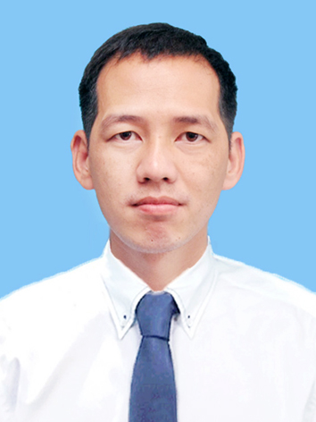
Full name: Đoàn Văn Thảo
Nationality: Vietnamese
Place of birth: Ha Noi ,Viet Nam
Date of Birth: 23-08-1985
Gender: Male
Marital status: Single
Phone: 0989305099
Email: thaodvbk@gmail.com
Languages: Vietnamese (Native), English (Normal)
Experience Summary

- 2+ years of software experience
- Strong experiences in Java technology, Android framework,C++ , Unit test .
- Strong experiences design pattern
- Strong experiences Ui/Ux
- Strong experience memory performance
- Strong experiences google service
- Strong experiences android framework
- Strong experiences back- end.
- Knowledgeable of Struct , php framework
- Knowledgeable of Git and SVN tools.
- Knowledgeable javascript ,html5

Skills

- Soft Skills

- Team work
- Japan : N5
- English: Can communicate to the customer in project context effectively

- Programming Skills

- C/C++
- Java,Android, Java web
- HTML, Javascript, Servlet, php
- MSQL Server 2008 , Good at MSSQL .
- Object Oriented Analysis (OOA), Object Oriented Design (OOD), Object Oriented Programming (OOP), Unified Modeling Language (UML)
- Software

- Platforms: Windows
- Others:Android Studio , Eclipse,Netbean, Visual Studio 2005, Visual Studio 2008, Rational Rose, Rational Test Suite, Rational Test Real Time.

Education

- 2011 – 2015 Ha Noi University Of Technology And Scientist , Ha Noi , Vietnam
- Degree : good
Working history
- I work as a freelancer
- I worked in FSOFT company

Professional Experience
Software Engineer
- Android development
- Java technology
- Database: SQL Server 2008
Hobbies & Interests
- Reading books.
- Playing football

Project References

Automative Project

Project : automation
Position : sub-leader and code
Size : 80 dev
Description : navigation for Car
Responsibilities :

- Code and unit test

Hardware :
O/S : Android
Special software :
Languages : Android
Work Location : Hanoi
Music Social

Project : Music Online
Position : Design and code
Description : Login database music with a account and listerning file music,download file music, post comment.

Responsibilities :

- Code and unit test

Hardware :
O/S : Android
Special software :
Languages : Android
Work Location : Hanoi

Image Description:

1.Login
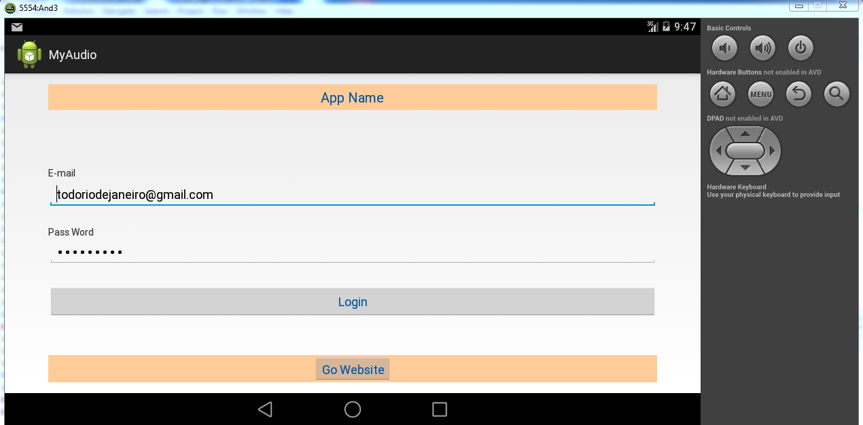

2.Screen category
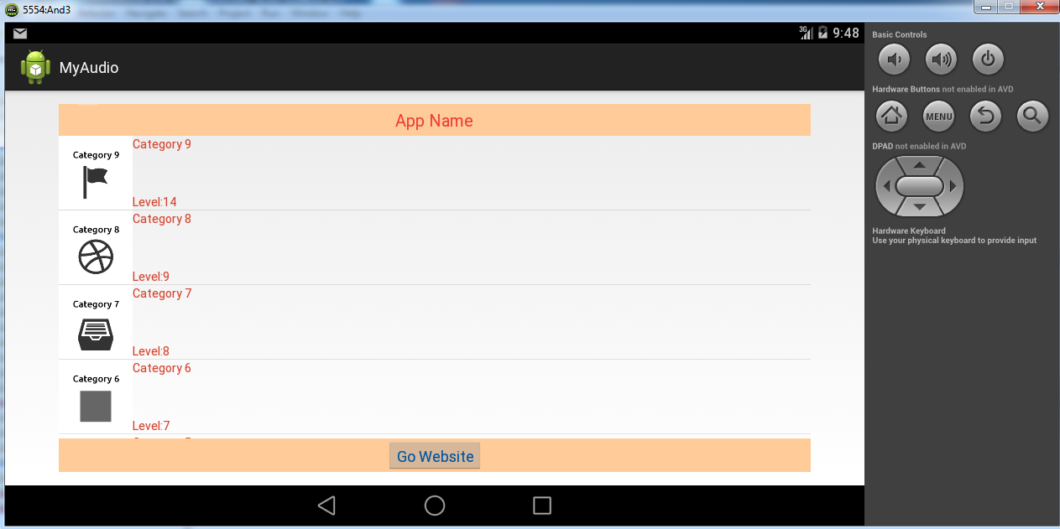

3.List music
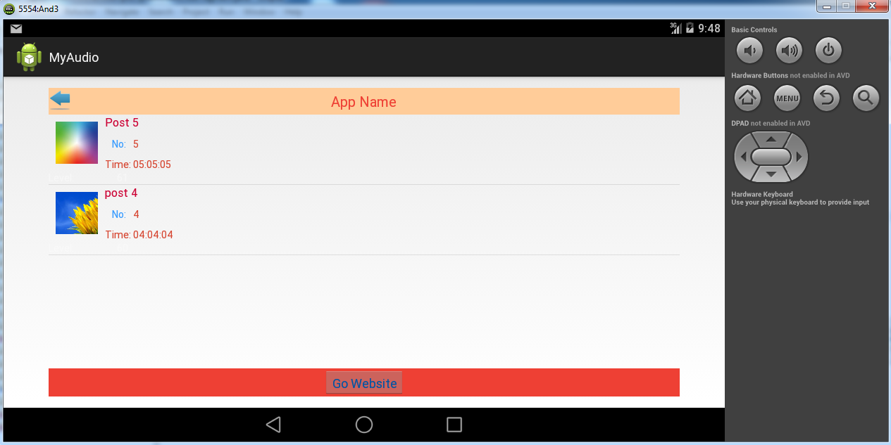

4.Listening and post comment
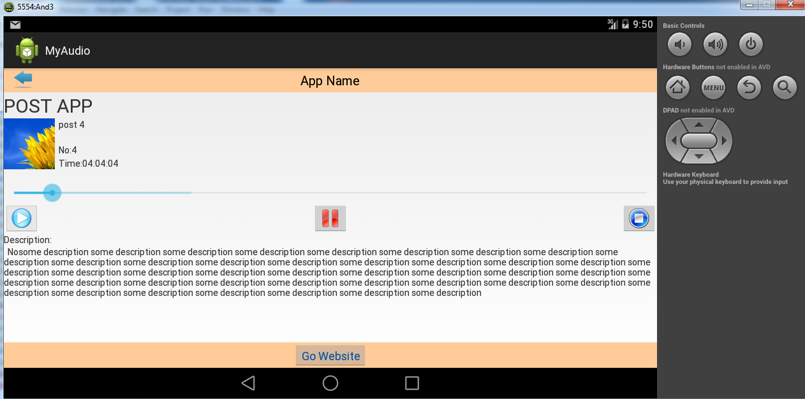

SoXo Online
Project : SoXo
Position : Design and code
Description : View result Soxo , receive result Loto omtime( real time ) using gcm technology and webservice using php .

Responsibilities :

- Code and test

Hardware :
O/S : Android
Special software :
Languages : Android
Work Location : Ha Noi

