Ngoc-Khoa  Vu  Software Engineer | 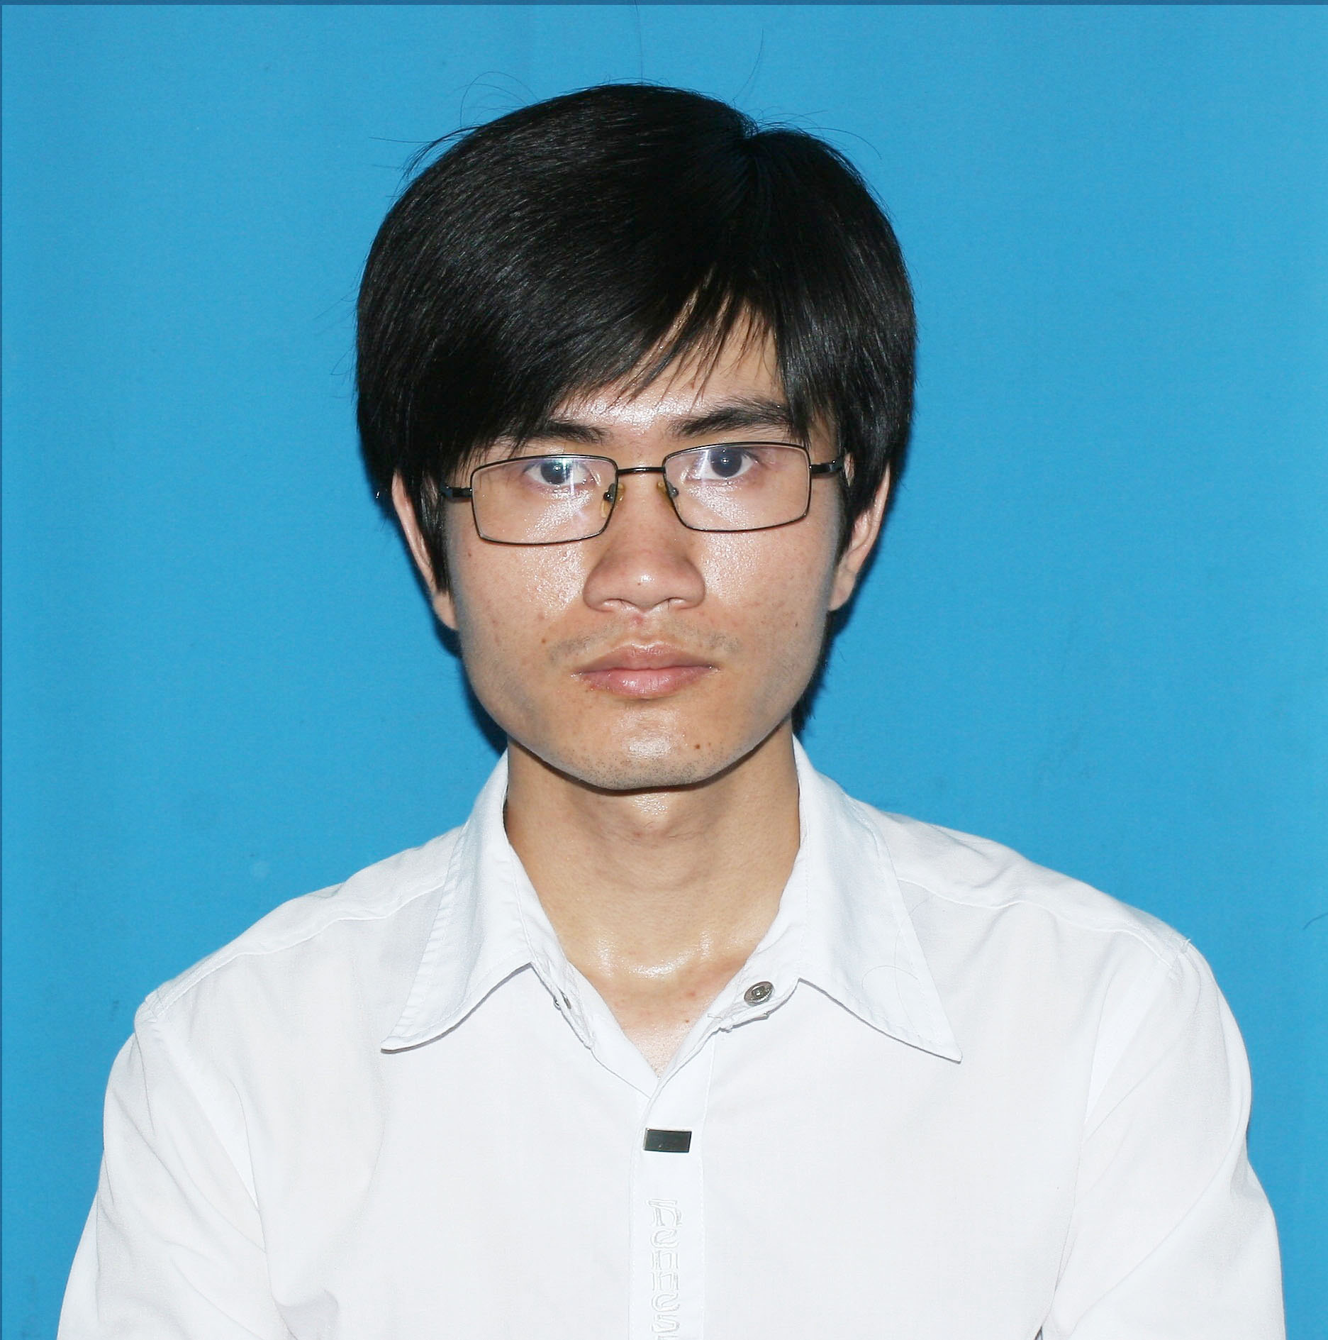

Information
Fullname: | VŨ NGỌC KHOA
Gender: | Male
Birthday: | 06/08/1993
Nationality: | Vietnamese
Contacts
Phone number:  Email:  Address: | (+84) 16 95 744 556  vu.ngoc.khoa.68@gmail.com  Van Xa Town, Kim Bang District, Ha Nam Province, Vietnam
Education
09/2008 – 06/2011:  09/2011 – 05/2015: | C Kim Bang Hight School, Hanam Province  GPA ~ 8.0/10.0  University of Engineering and Techology, Vietnam National University, Hanoi  Information Technology,  GPA ~ 2.74/4.0
Programming Skills
Website:  Apps:  Basic: | - Php/MySQL (experienced)  - Laravel 5.1 (experienced)  - Codeigniter 3.0 (experienced)  - HTML, CSS, JavaScript, Jquery/Ajax, Bootstrap (experienced)  - Web Services (experienced)  Java-Android  C, C++
Computer Skills
Advanced: | Microsoft Windows, Microsoft Office
Basic: | GIT, Adobe Photoshop, Linux
Experience
Courses’ project
Website:  Java-Android Application: | [1] System vote person  - Role: User can sign up, sign in into system. User vote 1 in 3 footballer who you like. User only vote once.  - Language: Php Framework Codeigniter  - Database: MySQL  [2] Training Access  - Role: CRUD (create-read-update-delete) participant follow training session  - Language: Php Framework Codeigniter, Jquery/Ajax  - Database: MySQL  [3] System Chatroom  - Role: : User can sign up, sign in into system. All user in system can contact together.  - Language: Php Core  - Database: MySQL  [4] Simple Blog  - Role: CRUD (create-read-update-delete) posts. Reader can comment at a post.  - Language: Php Freamwork Laravel 5.1  Database: MySQL  [1] PDF Manager  - Tasks: Viewer content file PDF(zoom in/out, next/back, jump page) and extract metadata.  - Language: Android-java
Company
VietSoftware International: | Intership  - Training Php Freamwork Codeigniter  - Module: Traning Access.  - Time: 3 months (part-time).  - Point: 8.5/10.0

