CURRICULUM VITAE

Personal Information
Full name: TRINH THI THOM  Gender: Female  Date of Birth: 01st November, 1991  Place of Birth: Thanh Hoa  Address: 99,group 2 Tan Binh, Xuan Mai town,  Chuong My District, Hanoi City, Vietnam.  Mobile: +84(0)979.534.201  Email: thom011091@gmail.com  Marital status: Single |  |  | 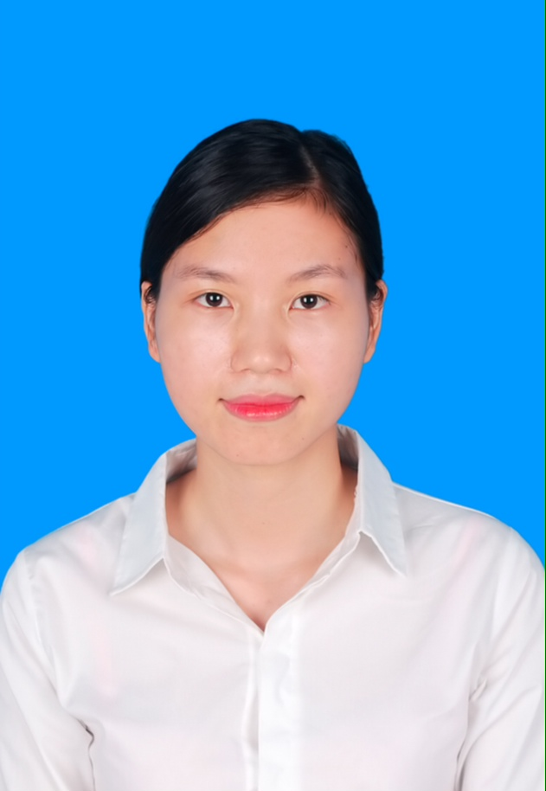
Objective
 |  | - attachment and develop business objectives of the company
Education
- 2009 – 2013: Hanoi University of Business and Technology, Hai Ba Trung District, Hanoi.
Faculty of Banking and Finance
2006 – 2009 : Xuan Mai High School, Xuan Mai, Chuong My, Ha Noi.

Skills
- Communication skills:
The experience at work as well as organizing outside activities has improved my ability to communicate effectively with every body. It also taught me the importance of listening, supporting and respecting the others.
- Computer Skills:
MS Excel  MS Word  PowerPoint  Windows  Internet, Email | Intermediate  Advanced  Advanced  Advanced  Very efficient use of Internet for information searching and generating
- Presentation Skills:
Presented topics and thesis to classmate.

Activities
- Reading psychology books, watching nmovies, listening to music and traveling.

Employment History
- Jan, 2013 Internship Company LILAMA 10, Ha Noi, Viet Nam
- Feb,2014 Production planner at Esquel garment manufacturing Vietnam-Hoa binh Co.,Ltd
.
Voluntary Work Experiments
- Sep, 2010 – Sep, 2012 Volunteer to the Hanoi University of Business and Technology manual examination
- Volunteer of Blood Donation Movement
- 2009 – 2013 Volunteer to Vietnam Veterans Association Friendship Village

Personal Information
- Independent, creative, enthusiastic, open minded, caring and resourceful
- Have ability to work both independently and with team
- Sense of responsibility, carefulness in all the works done are my greatest strengths.

References
Ms. Nguyen Thi Tham
Hanoi University of Business and Technology
Tel: +84(0)975.740.253
Email: thamnguyen@gmail.com
Ms.Nguyen Ly Ly
Hanoi University of Business and Technology
Tel:+84(0)1689295193
I certify that the information provided in this CV is true and correct and I will bear the full responsibilities for them.

