CURRICULUM VITAE OF
HOANG KHANH CHI
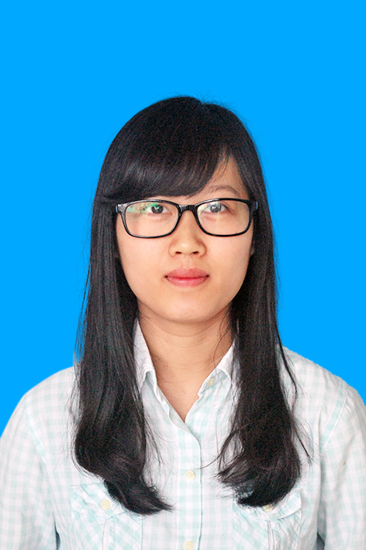
PERSONAL DETAILS
Date of Birth: 20 January 1993
Address: Dong Anh, Ha Noi
Mobile: 01277118618
Email: hoangkhanhchi1993@gmail.com
EDUCATION
2011-2015 National Economics University
• Management Information System (Good Degree- 7.6/10)
2009-2011 Co Loa High School, Dong Anh, Ha Noi
• High School Diploma (Grade: Excellent)
ACHIEVEMENTS
- 2014, 2015: scholarships “THE BEST STUDENTS WITH HIGH SCORES” from the University
- 2013: joining in scientific research competition of university
- Being nominated as a team leader in many subjects: economic management, financial IT, accounting IT, informatics resources management, commercial banking,…
- Used to take responsibility in finance of class
QUALIFICATIONS
- High School diploma (excellent)
- Certificate of financial reporting from National Economics University
- Toeic: 705
- Economic Bachelors - Good
LANGUAGE SKILLS
- English: C-level at University. I can speak English to foreigners at primary level
- Toeic: 705
EMPLOYMENT HISTORY
- From 9/2013 to 5/2014, I took part in Boo Company to be a collaborator for Booshirt- uniform manufacture
- Joining business training of the company
- Doing office tasks: transit invoices, documents and money of contracts between departments
- Arranging contracts into appropriate folders followed guiding of chief office
- Manage schedule of promotion for Booshirt.
- Checking and comparing fabric codes
- Being a sale person in a fair of foreigners
- 3/2015: I have been a sale person in a Daisy fashion shop.
- Welcoming customers
- Introducing products to customers
- Consulting to customers about fashion and style
- Persuading customers to buy products
- 7/2015: Quality Analyst position in Synergix Technologies Pte Ltd company, Vietnam branch.
- Tester and customer support
- 10/2015: professional staff in Veritas Vietnam
- Translate documents from Vietnamese to English
- Teach English
- Manage and modify documents, folders
VOLUNTARY WORK EXPERIENCE
- 360 environment club- National Economics University
- Growing trees
- Earth Hour campaign
- Volunteer of supporting entrant university examination
PERSONAL SKILLS
- Enthusiastic, responsible and voluntary in work
- Managing class funds
- Well using MS word, excel, Powerpoint, Prezi…
- Reading and understanding English well
OTHER INTERESTS
- Art competition: 3th prize Hanoi’s competition, when being 5 grade
- The second prize in English for children in Hanoi and got a scholarship of Language Link

