CURRICULUM VITAE

PERSONAL DETAILS
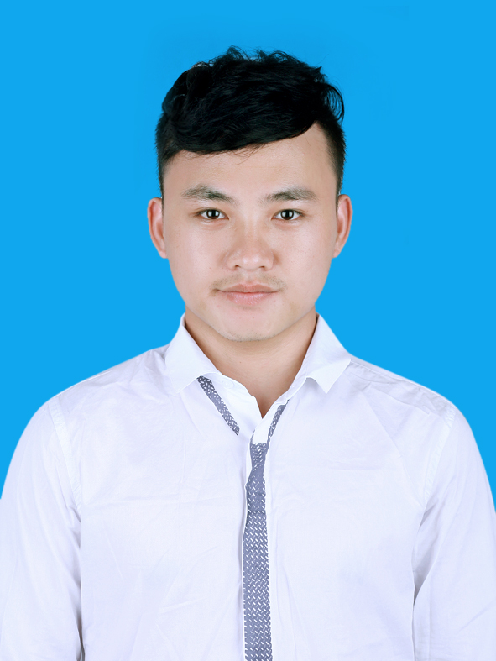
- Name TRUONG VAN THANG
- Nationality Vietnamese
- Date of Birth November, 19th 1991
- Sex Male
- Marital status Single
- Address Ho Tung Mau – Tu Liem – Ha Noi
- Phone No. +(84)973 595 405
- Email thangtv01737@fpt.edu.vn

EDUCATIONAL BACKGROUND
- Software engineering – FPT University – Vietnam

PROFESSIONAL SUMMARY
- 12/2015 Graduated from FPT University with Degree in Software Engineering,
Embedded System Major.
  - Main Course components:
    - Using C, Java, C#.
    - Object Oriented Paradigm Using C++.
    - Basic about Database (SQL Server).
    - Design and manage Software (Software Engineering, Software Requirements, Human Computer Interaction, Testing).
    - Basic about Computer(Operating System, Computer Network).
    - Basic about Embedded System (UART, PCI, I2C…).
    - Mobile Programming (Android, IOS).
    - Communication by English and Japanese.
- Soft Skill :
  - Communication, presentation, working group skills.
  - Ability to work under pressure and meet tight deadlines.
  - Have a high sense of responsibility.
  - Hard working, eager to learn.
  - Like watching and playing football, badminton, billard.
- Language:
  - Vietnamese.
  - English : good at reading, and intermediate at writing, speaking, listing.
  - Japanese: basic speaking, reading.

SOFTWARE
- Programming Languages: C, C++, Java, C#.
- Databases: SQ-Lite, MS SQL Server.
- Programming Tools: Visual Studio, NetBeans, Android Studio, Notepad++, QT.
- App server / Middleware: Apache Tomcat.
PROFESSIONAL EXPERIENCE

6/2015-9/2015 (Capstone Project)

Project: Monitoring and Management System ATM Station.
Project Description: A system mount in ATM station can control get temperature, humidity, gas, smoke, vibration and record to database, send SMS to manager’s device in ATM station when any value over validate.
Live Stream and photograph scene.
Through Window application, user can manage user, device, get report of ATM station.

Domain:

Team size: 4 peoples

Project size: 4 months

Responsibilities:
- Control the Sensors.
- Serial Port Communication Arduino & Raspberry Pi.
- Writing Documentation, Slide.

Software:
- Visual Studio 2012
- Linux environment
- Arduino IDE
- Putty

Hardware:
- Raspberry Pi B+
- Arduino Uno R3
- 4 sensors (DHT11, MQ2, Light, Vibrate)

2014 (Self study Python)
- Basic knowledge about Python.

10/2013- 4/2014 (On Job Training)
Company: F-TICO
Project Description:
Responsibilities:
- Design fix Bug.
- Test fix Bug.
Technologies Used:
- C#

