CIRCUMSTANCE VITAE

Person Information
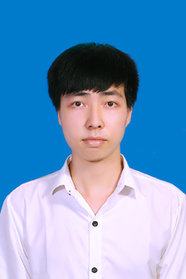 | Full Name: | Nguyen Bui Viet Linh
 | Gender: | Male
 | Date of birth: | 23/5/1994
 | Nationality: | Viet Nam
Contact Info
Address: |  | Tuy Loc – Cam Khe – Phu Tho
Phone: |  | 0962 134 872
Email: |  | nguyenbuivietlinh@gmail.com
Education /Language
9/2012 - 09/2016 |  | Ha Noi University of Industry  Software Technology / Information Technology  - I have basic knowledge of C/C++, Java  - Structured Query Language: MS SQL Server, SQLite  - From 05/2015 to 10/2015: Learned Android programing at DevPro Viet Nam and graduated.  - I’m capable of programing with tools: Android Studio, Eclipse, Visual Studio.
Language: |  | English
Experience
Project Android |  | Hoc phat am tieng anh  DenDen Mushi Ringtone  Ke chuyen cho be  Tu van suc khoe  Tinh cuoc phi Taxi
Skills
Microsoft Office |  | Very good.
Goals
Position: |  | Internship
Short term goals: |  | I want to study more Android via real project. Because I want to learn, gain experience for myself. After that, I’ll have enough knowledge to be able to do the job.
Long term goals: |  | First of all, I want to become company’s official developer.  After that, I will work try hard to become manager.
Other information: |  | Weight: 59 kg  Height: 177 cm  Hobby: Reading book, listening music, travel around Ha Noi by bus…

