NGUYEN DUC THANG
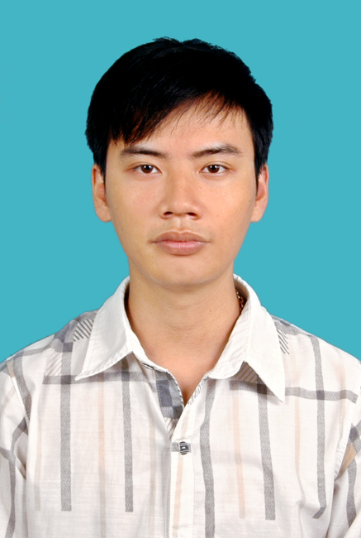

PERSONAL DETAILS

- Name NGUYEN DUC THANG
- Nationality Vietnamese
- Date of Birth March, 26th 1991
- Sex Male
- Marital status Single
- Phone No. (84) 912260391
- Email nguyenducthang91@gmail.com
- Adress Hoang Liet – Hoang Mai – Ha Noi

EDUCATIONAL BACKGROUND

- The degree of engineer of Information Technology - Hanoi Open University – Vietnam
- Studying master at VNU University of Engineering and Technology.

CERTIFICATE AND AWARD

- Salesforce Certified Force.com Developer (SP15)
- Participated in Examinations National Youth Information Technology in individual block ompetition using C/C++ at 4th year and I got consolation prize.

PROFESSIONAL SUMMARY

- I have graduated of Information Technology major at Hanoi with GPA 7.78.
- Participate in Examinations National Youth Information Technology in individual block competition at 4th year and I got consolation prize.
- Participate in The ACM-ICPC International Collegiate Programming Contest on teamwork block competition at 4th year
- Good at working with hight presure.
- Good at Team-building.
- Good at Logical thinking.
- I can reading English document and good at finding out new technologies.
- Practising and working JAVA before and after graduated using Spring

SOFTWARE

- Databases etc: MySQL, SQL Server 2005-2008
- Programming Languages: C#, VB, ASP, Java, HTML, JavaScript/VBScript, C, C++
- Programming Tools: Visual Studio 2005-2008-2010, Eclipse, Netbean, PHPDesign, Nusphere, DevC, CodeBlock
- App server / Middleware: Tomcat, Apache, XAMPP, WAMP
- Framework: Struts , Spring, JSF, Zend, Codeigniter, Liferay
- Configuration Management tools: VSS, CVS, SVN
- Browsers: IE 10, Firefox 26.0, Chrome
- OOAD/OOP: Object Oriented Analysis (OOA), Object Oriented Programming (OOP), Unified Modeling Language (UML)

OPERATING SYSTEMS
- Windows XP, Windows 7, Window 8, window 10
- Ubuntu 12, 14

PROFESSIONAL EXPERIENCE

- I had 4 years study and research algorithm at university with schools’s Olimpic team and participated in Examinations National Youth Information Technology in individual block competition

- Other experience:
Company: FPT Fis
Project: VETC | Responsibilities:  - Programming
Position: Teamlead | Technologies Used:  - Hardware environment: Window, linux  - Software environment: JSF, Hibernate  - Development tools:  - Eclipse, Netbean  - Programming Language:  - HTML, JSF  - Javascript, Jquery  - Java
From date: Oct 2015
To date: Today
Project Description:

Teamsize: 4

Company: FPT Software
Project: DUPONT | Responsibilities:  - Programming
Position: Teamlead | Technologies Used:  - Hardware environment: Window  - Software environment: Salesforce (Cloud Computing)  - Development tools:  - Eclipse  - Programming Language:  - HTML, APEX  - Javascript, Jquery  - Java
From date: June 2015
To date: Otc 2015
Project Description:

Teamsize: 6

Company: FPT Software
Project: SFCAM | Responsibilities:  - Programming
Position: Teamlead | Technologies Used:  - Hardware environment: Window  - Software environment: Salesforce (Cloud Computing)  - Development tools:  - Eclipse  - Programming Language:  - HTML, APEX  - Javascript, Jquery  - Java
From date: Sep 2014
To date: Jun 2015
Project Description:

Teamsize: 5

Company: FPT Software
Project: CRM | Responsibilities:  - Programming
Position: Developer | Technologies Used:  - Hardware environment: Window  - Software environment: Java, struts  - Development tools:  - Eclipse  - Programming Language:  - Java  - Curl
From date: March 2014
To date: Sep 2014
Project Description:

Teamsize: 5

Company: Elearning center Hanoi Open University
Project: Build E-Learning Management System.  Customer: Elearning center Hanoi Open University | Responsibilities:  - Deploy Elearning HOU’s portal using Liferay  - Programming website Profile for student using JSF  - Programming website manager English document using PHP
Position: Employee, Developer | Technologies Used:  - Hardware environment: Window, Centos  - Software environment: JSF, Liferay, Zend framwork  - Development tools:  - Netbean  - Eclipse  - Programming Language:  - Java/JSP  - HTML, CSS, Javascript  - PHP
From date: December 2012
To date: Today
Project Description: Build E-Learning Management System, consist of:
- Portal – using JSP with Liferay framwork
- Learning Management System – using Moodle
- Profile Management System – using JSF
Teamsize: 4 people

Reason for leaving: I want to learn and improve some my other skills

Company: VDC online
Project: Build Service Management System  Customer: VDC | Responsibilities:  Creat HTML & CSS file from images, and so on…  Programming web using Java with Spring Framework
Position: Employee, Developer | Technologies Used:  - Hardware environment: Window  - Software environment: Spring Framework  - Development tools  - JDeverloper  - Oracle  - Programming Language:  - Java/JSP  - HMTML/CSS/Javascript
From date: July 2011
To date: July 2012
Project Description: Build Service Management System will manages VDC’s services.
Teamsize: 15 people

Reason for leaving: I want to learn and improve some my other skills

