CIRRICULUM VITAE | 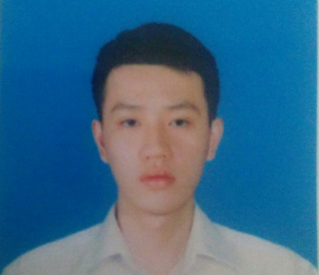
Đầu Xuân Đăng
36/61 Yen Hoa Street,
District Cau Giay, Ha Noi
E-mail : dxdang93@gmail.com
Tel : 01688.579 189
PERSIONAL DETAILS
Date of Birth: October 5th, 1993
Gender: Male
Marital Status: Single
Permanent Address: 36/61 Yen Hoa Street, District Cau Giay, Ha Noi, Vietnam
Mobile phone: 01688 579 189
E-mail: dxdang93@gmail.com
OBJECTIVE
- To be a good staff.
- Try to learning as much as possible and doing my best in order to accompish my task.
- To have good opportunities to get promotion in my job.
- Develop my skills with development of company,I want to prove myself.
EDUCATION
2011 - 2015
Ha Noi Open University, Vietnam
Subjects studied :
§ Operating Systems : Windows 2000, XP and Linux
§ Programming languages : C, C++, ASP.NET, C#, Java, HTML, XML.
§ Databases : MS SQL Server 2008.
§ And subjects : System Analysis and Design, develop mobile app, Object - Oriented Programming(using Java language ), Database Management System, Design and develop website
§ I have 1 years programming experience
§ After once subjects I must make a project for close.
Some projects :
- Staff handbook (Android)
- Store Management (OOP - using C# language)
EXPERIENCE
Take part in University projects
SKILLS
§ .NET programming - expert - 2 month
§ Java programming - expert - 1 years.
§ Android expert - 5 month.
§ Object - Oriented Programming
§ Independent or team work
§ Communication and interpersonal skills
- English skills: read and understand
INTERESTS
- Football, Gym, Music, Reading book.

