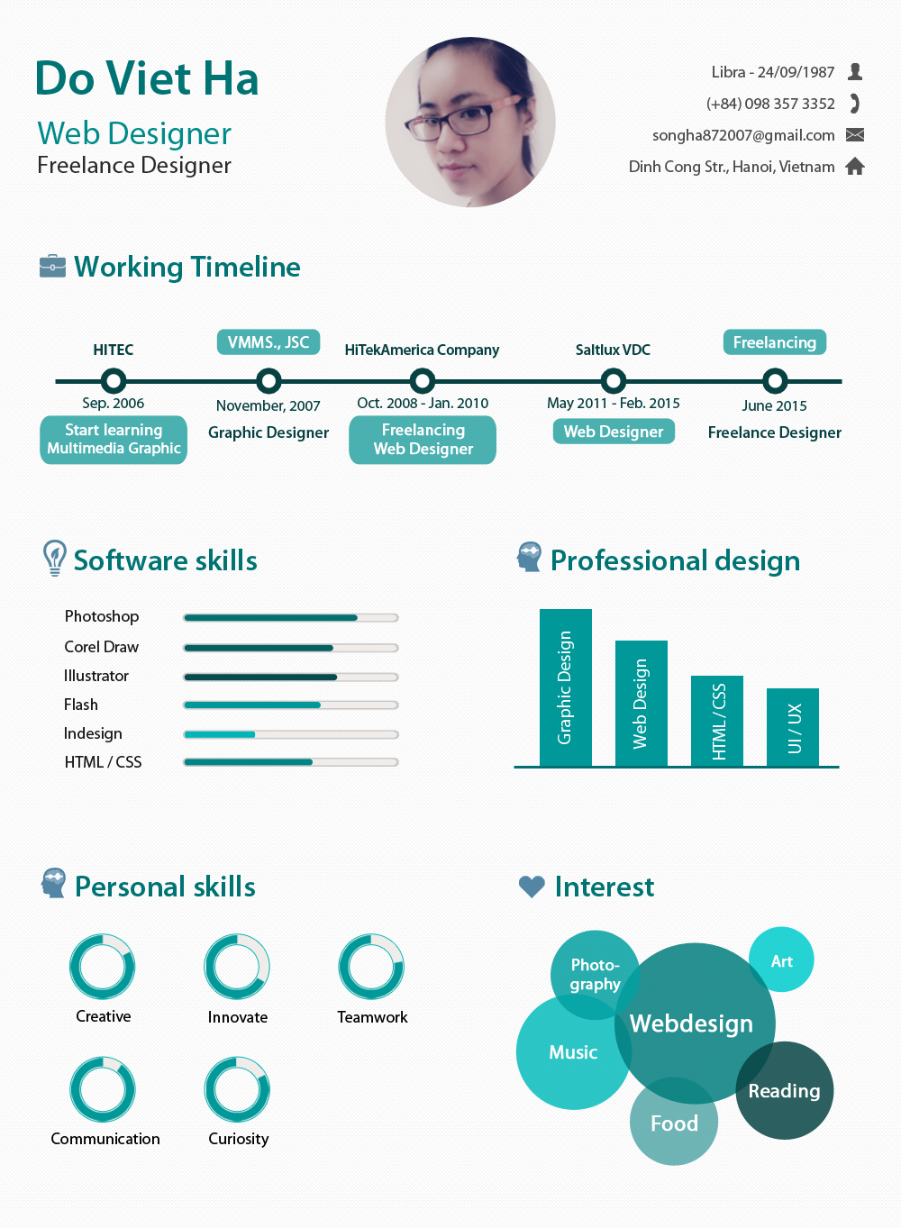
CURRICULUM VIATE

 | Job position: UI/UX Designer | Time to start: Nov.2015
 | Job type: Fulltime/Partime

PERSONAL INFORMATION
Full name: Do Thi Viet Ha | Email: songha872007@gmail.com | Tel: 098 357 3352
Gender: Female  Height: 158cm  Weight: 55kg | Birthday: 24/09/1987  Birthplace: Hà Nội | ID: 012717692  Issuance date: 20/07/2004  Issued by: Hanoi
Residence: Group 3, Ward ThinhLiet, HoangMai Dist., Hanoi
Address: No 45, Alley 61, DinhCong Str., Hanoi

LEARNING PROCESS

Expert skills:
Starting | Completion | Expertise | School | Degree | Grade
2006 | 2008 | Multimedia Graphic | HITEC education center (affiliated by University of Science HoChiMinh City) | Certificate | Good

Other course
Starting | Completion | Expertise | School | Degree | Grade
2014 | 2014 | Basic Tester | NIIT – ICT Hanoi | Certificate | Good

Working experiences
- UI/UX web/app
- Branding Identify (Logo, Bizcard, Letter, Envenlope, Brochure, Cataloge, Trifold, …)
- Customize layout web/icons (HTML/CSS, responsive, bootstrap)
- Design marketing sale kits

Using applications skils
Detail Description | Years experience | Working latest | Proficiency
Adobe Photoshop
Used to design the UI / UX, layout, banner ... | 8 | 2015 | Advance
Adobe Flash
Used to design and build animation banner (*.swf format) (can't coding actionscript) | 4 | 2014 | Intermediate
Illustration
Used to design branding identify, marterial design | 4 | 2015 | Upper Intermediate
Corel Draw
Used to design printing layout | 7 | 2014 | Upper Intermediate
Other tools design
- Used to Brackets (brackets.io) to customize layout to HTML/CSS (better than Adobe Dreamweaver)  - Used to Adobe Indesign to design some priting document: Lookbook, Cataloge, … | 7 | 2015 | Upper Intermediate
HTML, CSS, Javascripts knowledge
Customize layout psd to HTML/CSS *beautify and clear theme, using js library...  Responsive design (bootstrap frame support or not) | 5 | 2015 | Intermediate

Languages: Good at reading comprehension English, restriction on communication
Other skills
- Writing document project (User guide, user manual), Testcase, testing
- Website administration
- Using tools to create Email marketing

WORKING PROCESS

From: 05/2011 - 02/2015 | Company: SALTLUX – VDC (Korea)  www.saltlux.com | Position: Graphic/Web Designer
Starting salary :  5,000,000 VND | Ending Salary  7,300,000 VND | Number of projects: less than 5
Key Tasks:
- Design UI/UX layout for web, app (window and mobile)
- Customize layout (HTML, CSS)
- Printing design (Logo, bizcard, brochure…)
- Testing

From: 04/2010 - 11/2010 | Company: LifeVi Jsc.,  (suspended) | Position: Graphic/Web Designer
Starting salary :  4,500,000 VND | Ending salary  4,500,000 VND | Number of projects: more than 10
Key Task:
- Design layout for Ecommercial Bussiness
- Printing design (Logo, bizcard, brochure…)
- Customize layout (HTML, CSS)

From: 10/2008 - 01/2010 | Company: HiTekAmerica (not in Vietnam) | Position: Freelance Designer
Starting salary:  4,000,000 VND | Ending salary  4,500,000 VND | Number of projects: more than 20
Key Task:
- Design layout for Ecommercial Bussiness
- Printing design (Logo, bizcard, brochure…)
- Customize layout (HTML, CSS)

From: 11/2007 - 9/2008 | Company: VMMS Jsc., | Position: Graphic Designer
Starting salary:  3,500,000 VND | Ending salary  4,000,000 VND | Number of projects: more than 20
Key Task:
- Design layout for Ecommercial Bussiness
- Printing design (Logo, bizcard, brochure…)

ADDITIONAL INFORMATION
Interest | - Manga/Anime  - Game mobile  - DIY handmade
Character: | - Strong Personality  - Friendly  - Funny
Working desire | - Long-term collaboration  - Working Professional  - Promote in career  - Improve the skills of self

FAMILY PROFILE
Relationship | Name | Birthyear | Career
Father | Do Duy La | 1947 | Retired
Mother | Nguyen Thi Tu | 1957 | Retired
Sister | Do Thi Hai Ninh | 1992 | Staff working

REFERENT INFORMATION
No | Name | Work place | Số ĐT liên lạc, email
1 | Pham Quynh Giao | Saltlux – VDC | 0983392011
2 | Nguyen Xuan Quynh | Saltlux - VDC | 01689920730
3 | Lê Thanh Hà | Vatgia Jsc., | 01233776636

I assure that all the information above is true and completely responsible for the provision of information.
I agree to verify the information source.

Hanoi, 21stOct. 2015

Do Thi Viet Ha

