Curriculum Vitae For Android Developer

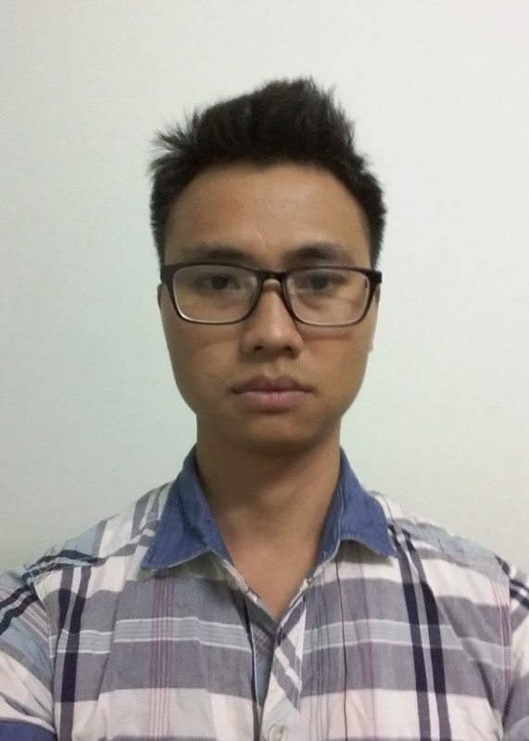 | Full Name: Nguyen Van Truong
 | Date of birth: 01/12/1991
 | Passport: 031752912
 | Email: vantruongtlhp@gmail.com
 | Mobile: 01649721229
 | Gender: Male
 | Marial Status: Single
 | Address: Khu 3, Thi tran Tien Lang, huyen Tien Lang, Hai Phong
 | Github: https://github.com/truongnv91

EDUCATION
University | Ha Noi university of science and technology
Major | Electronics and telecommunication.
Graduation month & year | 06/2014
Grade | Engineer
Prize | The third prize in students research science with project: measure heart rate using smartphone in 2014

PERSONAL SUMMARY
- Highly skilled about IT special android with over 2 years continue work for company and self development including application development, implementation, deployment and maintain.
- Have ability to work individual as well as work in group.
- Have experience with using android api, publish on google play, ASO
- Ability use English for working.

TECHNOLOGIES
Programming languages | Java, C#
Mobility | Android, Libgdx
Databases | SQL, Oracle, SQLite
OOAD/OOP | UML, Object Oriented Programming, MVC
Programming Tools | Netbean, Eclipse, Android studio, IntelliJ IDE
Configuration Management tools | SVN, Git
Social Network SDK | Facebook SDK, Google plus SDK
Design patern | Singleton, Adapter, Observer…
Unit Test | Robotium, Esspresso.

EXPERIENCE PROJECTS
Project’s name | Lunar Calendar
Customer’s name | Self development
Team size | 1
Position | Developer
Project descriptions | This project was written for both desktop and android app. The main function include:  - Get system time of device.  - Using lunar calculation algorithm of Ho Ngoc Duc (http://www.informatik.uni-leipzig.de/~duc/amlich/calrules.html) to convert system time to day, month, year in lunar.  - Calculator day number in month, determine bad day, good day…  - Show detail time info, using viewpager to slide day by day.  - Using slide menu to show functions for user’s option.  - Add widget to show detail in home screen.
Platform | Window, Android
Programming Language | Java, Android.
Tools | Netbean, eclipse
Project’s name | Measure Heart Rate On Smartphone
Customer’s name | Samsung Electronic Viet Nam
Team size | 6
Position | Android developer
Project descriptions | This app is used to measure heart rate in realtime using camera of smartphone.  - Read the science papers to research algorithm measure heart rate using smartphone.  - Collect info about heart rate of someone (Using camera to capture video heart rate at fingertips).  - Using matlab to find algorithm process noise filter video signal.  - Implement on smartphone  - Using back camera and flashlight to get native frame video at fingertips.  - Calculate average value of red color in center frame area  - Using algorithm researched in matlab to apply in java with signal is array average value.  - Using recursive to calculate heart rate in realtime.  - Draw signal on device in realtime  - Compare calculation results with the medical device.
Platform | Android
Programming Language | Java, android
Tools | Android studio, matlab, redmine, Git
Project’s name | Samsung Snote App
Customer’s name | Samsung’s product
Team size | 50
Position | Developer
Project descriptions | This is app run on some Samsung device, such as Samsung Note 3, Note 4, Samsung galaxy S5… User can use to draw, note, edit picture, insert object using pen or finger… My work in project:  - Fix bug  - Maintain app in another Samsung model device  - Research and develop other function.  - Test app
Platform | Android
Programming Language | Java, android
Tools | Android studio, P4, jira
Project’s name | 16 Naviapp
Customer’s name | Pioneer in Japan
Team size | About 70
Position | Android developer
Project descriptions | This is application using in car, with function is navigator, show facility info, map.  - Read Operation spec, function spec, sequence IF  - Make GUI design, coding UI parts  - Implement code business for each state  - Check sequence to apply SDK Adapter  - Implement Unit test  - Report bug on jara  - Fix bug and maintain
Platform | Android
Programming Language | Java, Android
Tools | Android studio, Git, SVN, Jira
Project’s name | Shadow Camera
Customer’s name | Self development
Team size | 1
Position | Android developer
Project descriptions | This is useful app to make shadow photo only using camera of smartphone.  - Create show case view to training for user how to use this app.  - Make UI design  - Create custome camera and take two photo.  - Get bitmap from photo, adjust transparent value and merge two photo  - Save photo in sdcard and show folder.  - Support balance white, turn on flashlight, using both back camera and front camera.  - Set timer auto take photo  - Filter effect for photo  - Add google play service and show ads.  - Fix bug and maintain
Platform | Android
Programming Language | Java, Android
Tools | Android studio, Git, Bitbucket
Project’s name | Other app: Live wallpaper, Multi camera, Change coin, Learning English…
Customer’s name | Self development
Team size | 1
Position | Developer
Project descriptions | - Develop application  - Connect server API  - Add google play service, run ads  - Publish on google play  - Fix bug, maintain
Platform | Android
Programming Language | Java, Android
Tools | Android studio, Git, Bitbucket

MY APP
Shadow Camera | https://play.google.com/store/apps/details?id=com.tlhp.transparent.shadow.camera
Magic Camera | https://play.google.com/store/apps/details?id=com.tlhp.magic.camera.pro
Khung Ảnh Giáng Sinh | https://play.google.com/store/apps/details?id=com.tlhp.christmas.photo.frame
Tin Nhắn Chúc Tết | https://play.google.com/store/apps/details?id=com.tlhp.tinnhan.kitu.tinhyeu
Github ID | https://github.com/truongnv91

WORKING
Starting date | 06/2015
Company | FPT Software
Position | Android Developer
Starting date | 06/2014
Finishing date | 04/2015
Company | Samsung Electronic Viet Nam
Position | Android Developer

