CURRICULUM VITAE

TRAN VAN NHAT
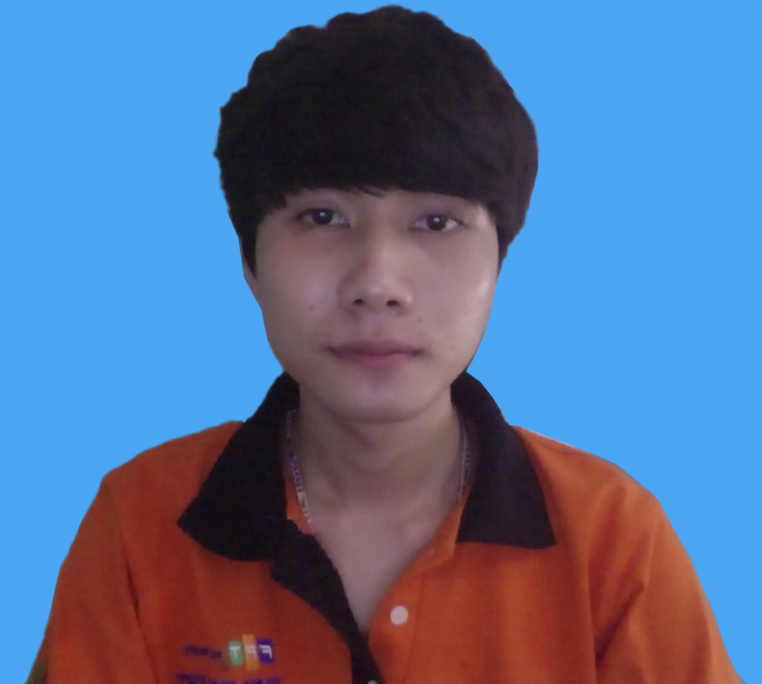

PERSONAL DETAILS

- Name Tran Van Nhat
- Nationality Vietnamese
- Date of Birth August, 1st 1995
- Sex Male
- Marital status Single
- Phone No. (+84) 1644 800 380
- Email nhat.tv18@gmail.com

EDUCATIONAL BACKGROUND

- Software Enginering – FPT Aptech – Vietnam

CERTIFICATE AND AWARD

PROFESSIONAL SUMMARY

- English reading comprehension.
- Hard working, eager to learn.
- Hobbies: Sing, Guitar, Love animals(especially cat).

SOFTWARE

- Programming Languages: Java (Core/J2EE), C#, HTML, CSS, Android.
- Programming Tools: Netbeans 8.0.2, Eclipse, Visual Studio 2013.
- Database: MS SQL Server, Studying Oracle.
- App server / Middleware: Glassfish, Apache Tomcat.
- Framework: JDK 7u51 or more.

OPERATING SYSTEMS

Windows, Mac OS X.

PROFESSIONAL EXPERIENCE

2014:

Project Java Swing: Management library
    - Developer
    - Customer: teacher.
    - Project Description: A software to management library. Insert book, manage book, search book, manage borrowers, etc.
    - Team size: 5
    - Project size: not identified.
    - Responsibilities
      - Insert book.
      - Check validate.
      - Search book and show borrowers, date.
      - Manage borrowers.

    - Technologies Used:
System
- Windows 7.
    - Development tools
- Notepad.
- Netbean.
    - Programming Language:
- Java Swing.

2015/07 – 2015/09

Project Java (J2EE): Website to sale airline tickets online.

    - Developer
    - Customer: teacher.
    - Project Description: A website to buy airline tickets online for an agent.
    - Team size: 4
    - Project size: not identified.
    - Responsibilities
      - Search for flights.
      - Flight bookings.
      - Payment.
      - Admin manage airline tickets.

    - Technologies Used:
System
- Windows 7 and Mac OS X.
    - Development tools
- Netbeans.
    - Programming Language:
- Java (J2EE).
- MS SQL Server.

    - Link source code:

https://drive.google.com/file/d/0B20poxqXEgqlVVN3Z0M4ZjBpcWs/view?usp=sharing

Contact my teacher:
    - Teacher of Java: Bui Duy Linh
Email: Linhbd@fpt.aptech.ac.vn

