Curriculum Vitae

PERSONAL DETAILS
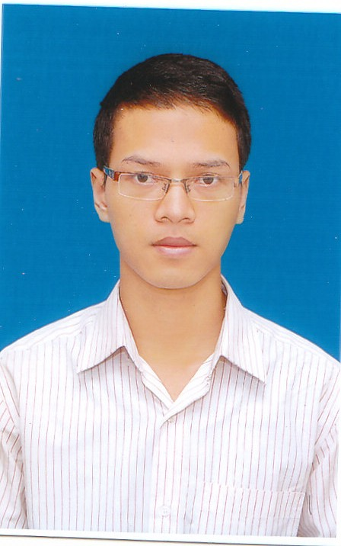
- Name BUI XUAN VU
- Nationality Vietnamese
- Date of Birth October, 12th 1987
- Sex Male
- Marital status Single
- Phone No. (84) 965080111
- Email xuanvu.bui@gmail.com

EDUCATIONAL BACKGROUND

- 2006 – 2011 School of Electronics and Telecommunications - Hanoi University of Science and Technology – Vietnam

PROFESSIONAL SUMMARY

- Good in Java(java core, java framework: spring, struts, hibernate, jboss)
- 4 year experience in Java programing.
- 2 year experience in developing Android apps using Java SDK.
- 1 year experience in developing web application (ajax, jquery, javascript, jsp, tomcat, jboss, html)
- Deep experience in Microsoft windows environments.
- Basic in Linux environments.

SOFTWARE

- Databases etc: Oracle 8 to 10g, PL/SQL, MS SQL Server, My SQL, PostgreSQL, SQLite
- Programming Languages: Java Core, Android SDK, Html, JavaScript, CSS, Jquery
- Programming Tools: Eclipse, Microsoft Visio, Netbeans, MyEclipse, Android Studio
- App server / Middleware: Apache tomcat, jboss.
- Framework: Struts, Hibernate, Spring
- Configuration Management tools: subversion, git
- Browsers: Firefox, Chrome

OPERATING SYSTEMS

Windows,Linux

PROFESSIONAL EXPERIENCE

Nov 2013 – Now

Developer

FPT Software

Project: Mobile SmartAnalysis ScanTool

Project Description:

Developing application for Android devices is read barcodes of products, managing products by barcode during shipping

Team size: 4 people

Position: Leader, Android developer
Technologies Used:
Hardware environment
- Window
Software environment
- Android
Development tools
- Android Studio
Programming Language:
- Java(Android SDK)

Project: eReportMobile

Project Description:

Create application to report the printer's error. The information will be entered in the form providing by server and sent to the server , app will export the chart

Team size: 4 people

Position: Leader, Android developer
Technologies Used:
Hardware environment
- Window
Software environment
- Android
Development tools
- Android Studio
Programming Language:
- Java(Android SDK)

Project: Multimedia Mobile Application

Project Description:

Build website for viewing videos , photos are uploaded from the client . Build your client app to take pictures , record video , and then upload to the server image tag

Team size: 4 people

Position: Web developer, Android developer
Technologies Used:
Hardware environment
- Window
Software environment
- Linux
Development tools
- Netbean, Eclipse
Programming Language:
- Java(Spring, Hibernate, Android SDK)
- Html, Javscript, jquery

June 2013 – Oct 2013

Developer

VTT VIETTEL

Project: Online Purchase application
Project Description:
An online purchase system for agents Viettel. It allows the agent purchasing items. This system has two modules, one for admin (back-end) and one for agent (front-end). The front-end is a wap application that connect to the back-end server and show all available items for agent to make an order. The back-end is a web application for administrator to approve the orders or manage the items…
Team size: 4 people

Position: Web developer
Technologies Used:
Hardware environment
- Window
Software environment
- Linux, Oracle SQL
Development tools
- NetBeans
- SQL Developer
Programming Language:
- Java(Strut, Hibernate, Ajax, Jquery)

Project: Viettel Online Payment
Project Description: An online payment system for customer Viettel. It allows the customer pay telecommunications service online by ATM card, Visa card. This system has two modules, one for admin (back-end) and one for customer (front-end). The front-end is a web application connect to the back-end server allows customer select telecommunications service and payment gateway to pay. The back-end is a web application for administrator to implement paying, config
Team size: 2 people
Position: Web Developer
Technologies Used:
Hardware environment
- Window
Software environment
- Tomcat
Development tools
- NetBeans
- SQLDeveloper
Programming Language:
- Java

Project: Mobile Banking
Project Description: Mobile Banking help customers to easily control their bank accounts anytime, anywhere via mobile phone.
Team size: 4 people
Position: Web developer
Technologies Used:
Hardware environment
- Window
Software environment
- Tomcat
Development tools
- NetBeans
- SQLDeveloper
Programming Language:
- Java, Android SDK

June 2012 - June 2013

Developer

VIVAS

Project Rich media apps
Project Description: An android application help customer listening music, radio online.
Team size: 4 people
Technologies Used:
Hardware environment
- Window
Software environment
- Android
Development tools
- Eclipse
Programming Language:
- Java, Android SDK

Project Provisioning web
Project Description Constructing, developing application Web, integrating application with existing systems for provisioning.
Team size: 3 people
Position: Developer
Technologies Used:
Hardware environment
- Window
Software environment
- Tomcat
Development tools
- MyEclipse
Programming Language:
- Java, SQLDeveloper

