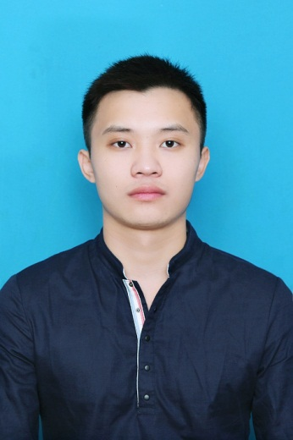

**CURRICULUM VITAE**

**Applied position:** Java Programming

**Date:** 13/09/2015.

**Offered salary:** 600$

**I. PERSONAL DETAILS**

* **Full name**: Ngo Hai Dang
* **Gender:** Male
* **Marital status:** Single
* **Date of birth:** 03/10/1993 **Place of birth**: Me Linh District, Vinh Phuc Province
* **Permanent address:** Quang Minh Town, Me Linh District, Ha Noi City
* **Mobile phone**: 0978 534 865.
* **Gmail**: [dang.nh.aprotrain@gmail.com](mailto:dang.nh.aprotrain@gmail.com)
* **Skype:** dangnh.aprotrain

**II. QUALIFICATION**

* Being a student of 2-year international programmer training system of Aprotrain Aptech ACCP 2011 (i11)
* Record table during studying process:

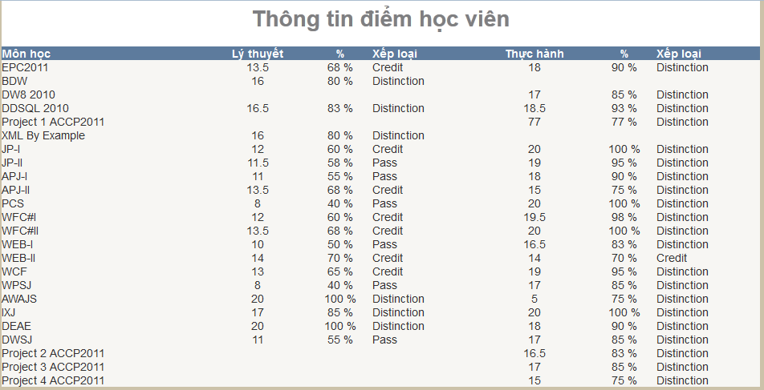

**III.** **SKILLS**

* Have good programming skill.
* Have ability to analyze, solve complicated problems.
* Have high ability to adapt for new environment.
* Always update the cutting edge technology.
* Have ability to learn quickly the technology.
* Can work both individually and teamwork, can work under high pressure.
* Have deep knowledge about how to use the technologies:
  + HTML, CSS, JavaScript, jQuery, Ajax, XML, Json.
  + PHP, Smarty engine template.
  + Core C#, Winform C#, Crystal Reports, Asp.net, Linq To Sql, XML parser in C#, Web Service, WCF.
  + Java core, Java swing, Jsp&Servlet, Struts1, Struts2, JSF, Apache poi, XML parser in Java, Web Service, EJB 2.x, Jasper report, Memcached, Apache Lucene, Apache Maven, R2Framework, 2Way-SQL …
* Have basic knowledge of Hibernate.
* Have experiences in working in web server and in web application server: IIS, Tomcat, GlassFish, JBoss, Websphere 7.0, WebSphere 8.5.
* Have experiences in working with Database: MySql, SQL Server, Oracle.
* Tools : Notepad++, Sublime Text, Netbeans, Visual Studio, Esclipse, IBM Rational, PLSQL Developer, SVN, WinSCP, Git, Oracle JDeveloper, iReport-5.1.0 …
* Operating Systems: Windows XP, Windows 7, Windows Server, Red Hat 5.

**IV.** **PROFESSIONAL WORKING EXPERIENCE**

* **Team leader of project I –“Website watches shop online” at Aprotrain Aptech.**
  + Number of members in group: 4.
  + Time duration: 1 month.
  + Technologies used in the project: HTML, CSS, JavaScript, jQuery, PHP.
  + RDBMS: MySQL.
  + Duty: Analyze, design database, code 70% project, train and manage group members.
  + Programming tool: Notepad++.
* **Result: 77% Distinction.**
* **Team leader of project II – “Hostpital management system” in Aprotrain Aptech.**
  + Number of members in group: 2.
  + Time: 1 month.
  + Technologies used in the project: Java Swing.
  + RDBMS: SQLServer.
  + Duty: analyze, design database, code 80% project, train and manage group members.
  + Programming tool: Netbean 6.9.1.
* **Result: 83% Distinction.**
* **Team leader of project III - “SMS Online site” at Aprotrain Aptech**
  + Number of members in group: 1.
  + Time: 1 month
  + Technologies used in the project: HTML, CSS, JavaScript, jQuery, Asp.net, Linq to Sql.
  + RDBMS: SQLServer 2008.
  + Duty: Analyze, design and code 100% project.
  + Programming tool: Visual Studio 2012.
* **Result : 85% Distinction.**
* **Developer of project IV - “Career system” at Aprotrain Aptech.**
  + Number of members in group: 4.
  + Time: 1 month.
  + Technologies used in the project: HTML, CSS, JavaScript, jQuery, Jsp&Servlet.
  + RDBMS: SQLServer 2008.
  + Duty: Code examples.
  + Programming tools: Netbeans 7.0.1.
* **Result: 75% Distinction.**
* **Do the difficult exercises concerning to the technologies:** Web Service .NET, WCF, Web Service Java, EJB 2.x…
* **Participate in building Law software, restaurant management software for Café - Karaoke.**
* **09/2013 – 02/2015: Work at FIS BANK.**

**Main Tasks:**

* **09/2013 – 04/2013**: Take part in LAO - VIETBANK project. Responsibility for doing maintain core Banking on the deposit subsystem FLEXCUBE.
  + Support members in the project.
* Complete project: I got the experiences in Bank job, in teamwork, in PL/SQL Oracle, in database management; in operating system of Red Hat 5; in working with tools of putty, Xmanager, WinSCP, PLSQL Developer...
* **04/2014 – 02/2015**: Participate in the project of enhance Multilateral Payment System of BIDV bank. The main duties:
  + Repair the pending errors.
  + Inherit and code the new functions under requirements. Create two new modules: Build exclusive right account, and calculation of overdraft charges.
  + Create fake model clustering on virtual machine using WebSphere Application Server 8.5.
  + Join query optimization Oracle, improve efficiency of some functions of exporting slow report according to day, month.
  + Support other members in project.
* Experiences in teamwork, in technologies J2EE: Struts2 Framework, Web Service, EJB, WAS 7.0 and 8.5, Apache POI, XML parser, Jasper Report, PL/SQL Oracle… Experiences in working with Tool IBM RAD, SVN, iReport…
* **03/2015 – 08/2015: Work at FSOFT.**

**Main tasks**:

* **03/2015 – 05/2015**:
  + Study Recruitment Management System (Rikunabi) for Japanese partner base on the old document and old source code.
  + Learn about R2Framework, 2Way-SQL, Coding convention of the project…
  + Do documents of screen transition, business flow…
  + Do the test according to customers’ requirement: SVN, SQL, Coding convention, Basic Design, Detail Design, Function Unit Test, Mock Project before starting the real project, do test about the business system...
* **05/2015 – 06/2015**:
  + Develop Main site Rikunabi 2016 for Japanese partner.
  + Study and analyze the customer’s request based on Requirements definition documents.
  + Design documents: Basic design, detail design for screens: Student profile details, management screen for Student CV, common functions.…
  + Fixed comment of Leader and Japanese VUL after reviewing review.
* **06/2015 – 08/2015:**
  + Perform coding and fixed comment from leader and from Japanese VUL based on the document of Basic design and Detail design.
  + Support other members about coding.
* **09/2015:**
  + FUT phase.
* Experiences got:
  + Individual and team working.
  + Standard process of a project.
  + Experience in doing the designing documents: Basic design, detail design, FUT.
  + Experience in doing with R2Framework, Oracle DB, SVN, GIT, 2Way-SQL…

**V.** **LANGUAGES**

|  |  |  |  |
| --- | --- | --- | --- |
| **Language** | **Reading** | **Writing** | **Communication** |
| English | Good | Normal | bad |

**VI.** **CAREER OBJECTIVE**

* Being participated in big projects, know and have experiences with a lot of technologies.
* Active working environments.
* The result equal to what done.
* Work forever with company.