**PERSONAL DETAILS**

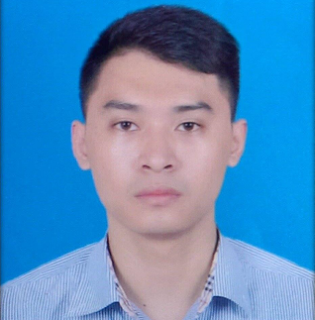

* Name : **Nguyen Van Sang**
* Nationality : Vietnamese
* Date of Birth : 11/08/1992
* Sex : Male
* Marital status : Single
* Phone No. : 01695764641
* Email : sangbk92@gmail.com

**EDUCATIONAL BACKGROUND**

* Student – Hanoi University of science and techlonogy (HUST).
* CPA: 2.79

**CERTIFICATE AND AWARD**

* Android Programming Course at Bachkhoa Information Techlonogy Academy.
* Training courses of Samsung Talent Program.

**PROFESSIONAL SUMMARY**

* Can work independently, have faculty for work in teams and work under pressure well.
* Good English communication.
* Analysis, Design Software Project.
* Soft skills certificate of Hanoi University of science and techlonogy: communication skills, problem-solving skills, time management abilities, teamwork skills.
* Hard working, eager to learn.
* Hobbies: Reading book, traveling, watching movies, listening to music.

**SOFTWARE**

* **Databases**: MS SQL Server, SQLite, MySQL, PostgreSQL.
* **Programming Languages:** Java, C/C++, HTML, C#.
* **Programming Tools:** Eclipse, Netbean, Microsoft Visual Studio, UML, SQLite Studio, Android Studio.
* **Browsers**: IE 8+, Firefox 10+, Chrome 10+.
* **OOAD/OOP**: Object Oriented Programming (OOP), Unified Modeling Language (UML).

**OPERATING SYSTEMS**

* Windows
* Linux.

**PROFESSIONAL EXPERIENCE**

**2013/06 – 2014/04**

**Project: Measure Heart Rate and Blood Pressure on Android device.**

**Developer at Intel lab (HUST)**

**Project Description**:

* This project can help and support users having better health. It must be easy for using, doesn’t take more time to discover. We focus on customer in Vietnam, so designing by Vietnamese can solve this problem. In concluding, it will have fulfill function as other application from foreign, but become 100 percent Vietnam-application.

**Domain**:

**Responsibilities**:

* Project Analysis.
* Testing
* Coding.

**Technologies Used**:

* Eclipse
* DB: SQlite
* Android developer tools

**2014/04 - 2015/08**

**Project: System of Smart tour on Dien Bien province with smart phone android.**

**Developer at R&D lab (HUST)**

**Project Description**:

* Develop a new system for tourism at Dien Bien
* Designed smartphone interfaces
* Coding unit test

**Domain**:

**Responsibilities**:

* Analyze the requirement.
* Solving algorithms.
* Design Interface.
* Coding.
* Build Web services

**Technologies Used**:

* Eclipse 4.2
* PgRouting libraries.
* DB: PostgreSQL/PostGIS (include sql syntax)
* JavaScript & Ajax: JSon