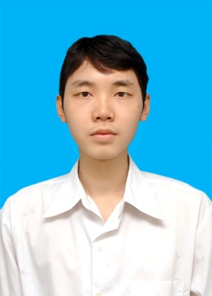

Nguyễn Thanh Đức

Software Engineer

Gender: Male

Birth: December 30th 1989

Address: No. 43 - Alley 77 - 8/3 street, Hai Ba Trung district, Hanoi

Tel: 0983 139 261

Email: thanhducict@gmail.com

|  |  |
| --- | --- |
| Professional Abilities | * Work with programing languages: C, C#, Java * Work with .NET platform (SQL Server, ASP.NET, Windows Phone) * Be able to work with HTML, CSS, JavaScript * Work well with English * Be willing to learn and work under pressure |
| English Skills | **TOEIC 755**  Listening ★★★★★★★★★★  Speaking ★★★★★★★★★★  Reading ★★★★★★★★★★  Writing ★★★★★★★★★★ |
| Experience | R&D - Vietnam korea exchange 2012 – Present  Software Engineer   * Developing Core Network of Telecommunication * Tmax Middleware Implementation * Android Development * ASP.NET MVC Development * “Human Resources Managemt” Software Development   data center - FPT information system 2011  System Engineer   * SharePoint Administration and Development. * Windows server Administration |
| Education | Hanoi open university 2007 - 2011  The degree of Engineer |
| Career Goal | * Work in professional an competitive salary environment * Want to be trained to level up technical and work skill |