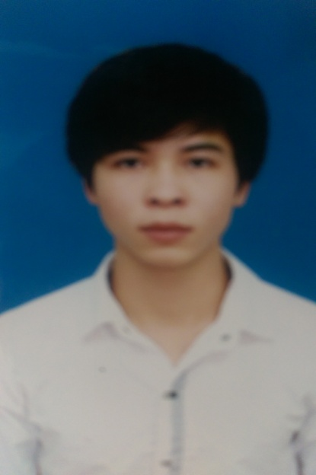 **CURRICULUM VITAE**

VU THANH CAM

|  |  |  |
| --- | --- | --- |
| **PERSONAL DETAILS** | | |
|  | Full name : | Vũ Thanh Cầm |
| Job Titles : | New Developer |
| Date of Birth : | 28/1/1994 |
| Place of Birth : | Thái Bình |
| Sex : | Male |
| Marital Status : | Single |
| Home Address : | Vũ Thư district, Thái Bình province |
| Home Phone : |  |
| Mobile : | 01696274392 |
| Email : | [Thanhcam281994@gmail.com](mailto:Thanhcam281994@gmail.com) |
|  |  |  |

|  |  |
| --- | --- |
| **EDUCATION HISTORY** | |
| From : 2012  To : 2016 | University /School: Hanoi University of Science, VNU  Course : Computer and information of Sciences |

|  |  |  |
| --- | --- | --- |
| **ATTENDED PROJECTS** | | |
| From : 9/2013  To : 2/2014 | Project Name: | Personal management software Viet Tien garment company |
| Position: | Developer, design database |
| Responsibilities: | Development, system analysis, system design |
| Project Description: | Manage members and salaries. Search user code and member name, office |
| Used Programming  Languages: | Java, UML, SQL server |
| Used Technologies: | Model MVC |

|  |  |  |
| --- | --- | --- |
|  | | |
| From : 2/2014  To : 5/2014 | Project Name: | Game Mummy Maze for Android |
| Position: | Developer |
| Responsibilities: | Development, system analysis, system design |
| Project Description: | Instructions the part of the game. To introduce method play game. The goal of player in each maze is to find a way to escape without being arrested mummies and find the stairs leading to the upstairs one safely |
| Used Programming  Languages: | Java, UML, engine |
| Used Technologies: | Mahatan algorithm, API, Android game engine |

|  |  |  |
| --- | --- | --- |
|  | | |
| From : 7/2015  To : 11/2015 | Project Name: | Medicine management software |
| Position: | Developer |
| Responsibilities: | Development, system analysis, system design |
| Project Description: | Software manage remedy, medicinal plant, effect of remedy and disease |
| Used Programming  Languages: | PHP, Javascript, HTML |
| Used Technologies: | Dreamweaver |

|  |  |  |  |  |  |  |  |  |
| --- | --- | --- | --- | --- | --- | --- | --- | --- |
| **INFORMATION TECHNOLOGY SKILLS** | | | | | | | | |
| **Experiences: 0: 0 month 2: 6 – 12 months 4: 2 – 5 years**  **1: 1 – 6 months 3: 1 – 2 years 5: > 5 years**  **Last used: Last year used**  **Expert level: 1: Beginner Level 3: Sometimes have 5: Expert Level**  **to use manuals**  **2: Always have to 4: Can solve problems**  **use manuals** | | | | | | | | |
|  |  | Experiences | Last  used | Expert level | | | | |
|  |  | 1 | 2 | 3 | 4 | 5 |
| **Programming and Scripting Languages** | | | | | | | | |
| 1 | Visual Basic | 1 | 2012 |  |  |  |  |  |
| 2 | JavaScript | 2 | 2015 |  |  |  |  |  |
| 3 | Java | 4 | 2014 |  |  |  |  |  |
| 4 | C# | 1 | 2012 |  |  |  |  |  |
| 5 | Winform | 1 | 2012 |  |  |  |  |  |
| 6 | C, C++ | 1 | 2012 |  |  |  |  |  |
| 7 | PHP | 3 | 2015 |  |  |  |  |  |
|  | | | | | | | | |
| **Operating System** | | | | | | | | |
| 1 | Windows | 4 | 2015 |  |  |  |  |  |
| 2 | Ubuntu | 2 | 2013 |  |  |  |  |  |
|  | | | | | | | | |
| **Databases** | | | | | | | | |
| 1 | My Sql | 3 | 2015 |  |  |  |  |  |
| 2 | Sql Server | 3 | 2014 |  |  |  |  |  |
|  | | | | | | | | |
| Web | | | | | | | | |
| 1 | HTML, CSS | 3 | 2015 |  |  |  |  |  |
|  | | | | | | | | |
| **Analysis and Design Methodology and Tools** | | | | | | | | |
| 1 | UML | 2 | 2013 |  |  |  |  |  |
|  | | | | | | | | |
| **IDEs** | | | | | | | | |
| 1 | Eclipse | 3 | 2014 |  |  |  |  |  |
| 2 | Zend | 3 | 2012 |  |  |  |  |  |
| 3 | Dreamweaver | 3 | 2015 |  |  |  |  |  |
| 4 | Microsoft Visual Studio | 2 | 2013 |  |  |  |  |  |
|  | | | | | | | | |

|  |  |  |  |  |  |  |  |  |
| --- | --- | --- | --- | --- | --- | --- | --- | --- |
| **FOREIGN LANGUAGE** | | | | | | | | |
| **Experiences: 0: 0 month 2: 6 – 12 months 4: 2 – 5 years**  **1: 1 – 6 months 3: 1 – 2 years 5: > 5 years**  **Last used: Last year used**  **Expert level: 1: Beginner 3: Fluent 5: Translator**    **2: Conversational 4: Expert** | | | | | | | | |
|  |  | Experiences | Last  used | Expert level | | | | |
|  |  | 1 | 2 | 3 | 4 | 5 |
| **Languages** | | | | | | | | |
| 1 | English | 5 | 2015 |  |  |  |  |  |
|  |  |  |  |  |  |  |  |  |

|  |
| --- |
| I certify that the information declared above is true to the best of my knowledge and belief.  Hanoi, December, 12 2015  Signature  VU THANH CAM |