 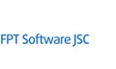 **TRAN QUANG TRUNG**

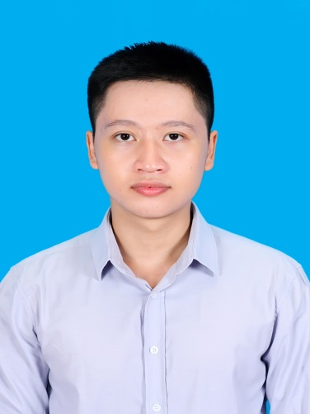

**PERSONAL DETAILS**

* Name **TRAN QUANG TRUNG**
* Nationality Vietnamese.
* Date of Birth June, 26rd 1992.
* Sex Male.
* Marital status Single.
* Phone No. 01699310199.
* Email [tqtrung09@gmail.com](mailto:tqtrung09@gmail.com)
* Language English, Japanese

**EDUCATIONAL BACKGROUND**

* 2010 – 2015 Graduate Posts and Telecommunications Institute of Technology with good degree

**CERTIFICATE AND AWARD**

* 2015 Fsoft fresher training program

**PROFESSIONAL SUMMARY**

* 4 month experience of developing web in Java.
* Working mainly as a developer.
* Working well either in independent or cooperative environment.
* Reading English skill.
* Comfortable learning new technology.
* High responsibility for the work and ready to OT if needed .

**SOFTWARE**

* **Databases**: Oracle, MS SQL Server.
* **Programming Languages:** Java, JavaScript, C#.
* **Knowledge:** jQuery, T-SQL, PL/SQL, HTML, CSS, XML, JSP, Servlet, OpenCV.
* **Programming Tools:** Eclipse, Netbeans, Visual Studio.
* **App server / Middleware**: Apache Tomcat.
* **Framework**: Struts2, R2.
* **Configuration Management tools**: SVN.
* **OOAD/OOP**: Object Oriented Programming (OOP), Unified Modeling Language (UML).

**OPERATING SYSTEMS**

Windows.

Ubuntu.

**PROFESSIONAL EXPERIENCE**

**2013/10 – 2013/11**

**Project: Website NEWS of PTIT**

**Post and telecommunication institute of technology: Home assignments**

**Project Description**:

Project can help users read more news related to the PTIT academy.

**Responsibilities**:

* Analyze the requirement.
* Design database.
* Coding web application.
* Testing.

**Team size**: 1 people.

**Technologies Used**:

Hardware environment

•         Window.

Software environment

•         JRE.

Development tools

•         Eclipse.

* Apache Tomcat.
* SQL Server 2005.

Programming Language:

* Java.
* SQL.
* HTML.

Technology:

* JSP/Servlet
* MVC.

**2014/3 – 2014/5**

**Project: Photo editor software**

**Post and telecommunication institute of technology: Home assignments**

**Project Description**:

This project can help users use simple task manually edit your photos. Example: Rotate image; Transform Color Models; Histogram Equalization…

**Team size**: 1 people.

**Responsibilities**:

* Analyze the requirement.
* Design Interface.
* Coding winform application.
* Testing.

**Technologies Used**:

Hardware environment

•         Windows.

Software environment

•         OpenCV.

Development tools

* Visual Studio.
* SQL Server 2005.

Programming Language:

* C#.
* SQL.

**2015/9 – 2015/10**

**Project: MockProject of Fresher**

**Fsoft fresher training program: Final project program**

**Project Description**:

MockProject is a web project lets companies manage human resources, facilities and services ...

**Team size**: 5 people

**Responsibilities**:

* Analyze the requirement.
* Design database.
* Coding the web application.
* Testing.

**Technologies Used**:

Hardware environment

•         Windows

Software environment.

•        Struts2 MVC.

Development tools

* Eclipse.
* SQL Server 2008.
* Apache Tomcat.

Programming Language:

* Java.
* SQL.

**2015/11 – Now**

**Project: MockProject**

**Fsu17 Bu16 training program: Final project program.**

**Project Description**:

MockProject is a web project lets management information about staff and adding evaluation for each staff.

**Team size**: 7 people.

**Responsibilities**:

* Analyze the requirement.
* BA
* Coding the web application.
* Testing with FUT.

**Technologies Used**:

Hardware environment

•        Windows.

Software environment

•        R2 Framework.

Development tools

* Eclipse.
* Oracle.
* Apache Tomcat.

Programming Language:

* Java.
* 2WaySql