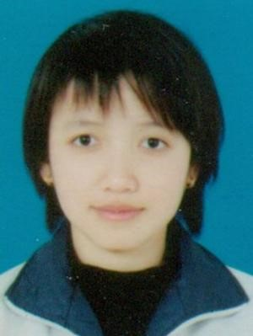VU THI THUY

DOB: 10-05-1993

Phone: 0903 299 680

Email: thuyvt_1005@gmail.com

Address: Khu 4 Thi Tran Tien Lang, Hai Phong

# EDUCATION

|  |  |  |
| --- | --- | --- |
| **FPT University**  *Software Engineer*  **EXPERIENCE** | | Sep 2011 - Dec 2015 |
| **nhanh.vn**  *PHP developer*   * Create design and develop GUI website for project store.nhanh.vn : use HTML, CSS, JavaScript to build website template | | May 2014 - Jun 2014 |
| [**erp.nhanh.vn**](https://erp.nhanh.vn)  *PHP developer*   * Develop ERP system: create system to manage employees in company by using Zend Frame Work, PHP, CSS, JavaScript … | | Aug 2014 - Dec 2014 |
| [**carbase.vn**](http://carbase.vn/)  *PHP developer & Tester*   * Create design and develop GUI website: use HTML5, CSS3, JavaScript… * Develop Back - end, Front - end and API system: built in Laravel 4.2 Frame Work, and PHP, AngularJS ….. * Create test case, and holding of such a tester   **CERTIFICATIONS AND AWARDS** | | Jan 2015 - Dec 2015 |
| * 3rd prize in FU film contests | | July , 2012 |
| * 2nd prize in FU Speech choice contests | | Sep , 2012 |
| * Prospect prize in FU WIG Cup | | Dec , 2012 |
| * Soft skill certificate | | Dec , 2012 |
| * Active members Certificate in Ladies By Night | | Oct , 2013 |
| * Honorable student of semester | | 2015 |
| * The course academic preparatory English Level 5 - Summit 1   **SKILLS AND INTERESTS** | |  |
| Languages | English, Japanese |  |
| Programming | PHP, Java, C, C++, .NET, SQL |  |
| Operating System | Ubuntu, Window |  |

Frame work Zend Frame work, Laravel, AngularJs

# SOFT SKILL

* Self – study ability is good
* Well compatible with working independently and in group.
* Adapt quickly to new environments
* Good skill to debate.

# INTERESTS

* Sing
* Film
* Event
* Game