# Install and Use OpenVPN in Ubuntu

## Install OpenVPN with Ubuntu Software Center Open Ubuntu Software Center and search “network-manager-openvpn-gnome”

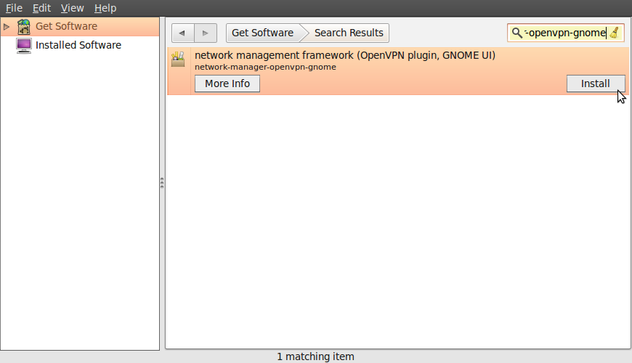

## After install, we can check it install successful or unsuccessfull. We click NetworkManager → VPN Connections → Configure VPN

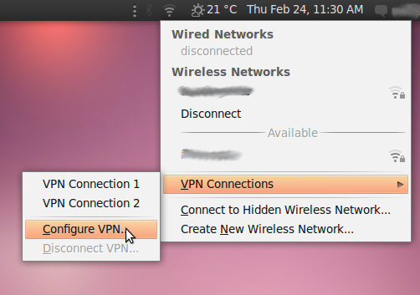

## Click Add in VPN

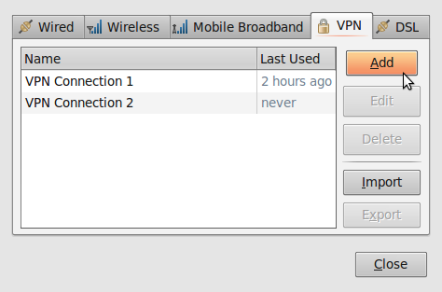

## You can see “OpenVPN” if install successful. And we need to configure account in next step. Click “Create”

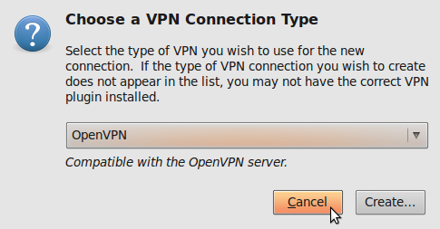

## We can edit “connections name” and Fill gateway is: “1.55.242.188”. Type is “Password with the Certificates (TLS). Username and Password. And find user certicate, CA and your key. OK then click Save.

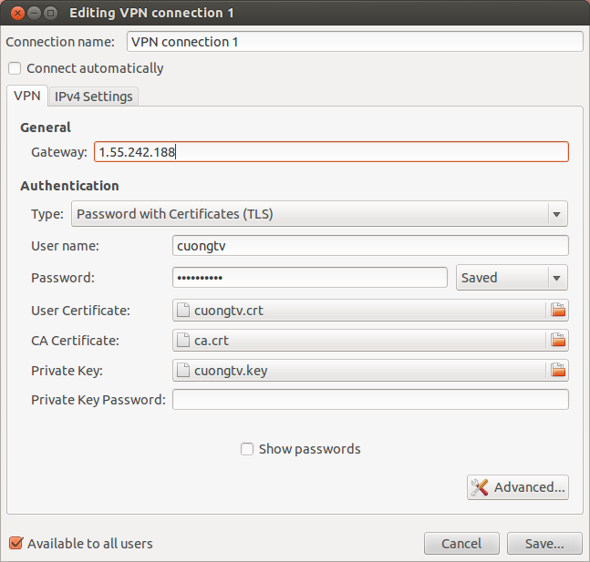

## And last step, we connect to server

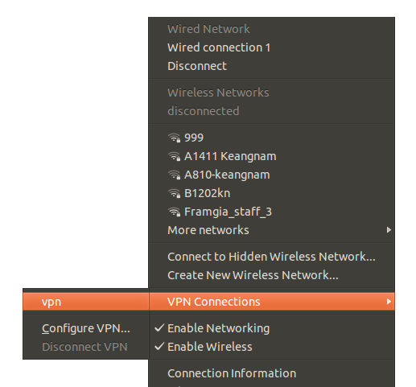

## And we see it connect successful

