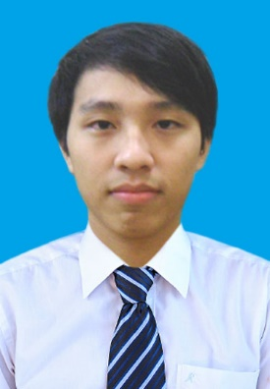

**CURRICULUM VITEA**

|  |  |  |  |  |  |  |  |  |
| --- | --- | --- | --- | --- | --- | --- | --- | --- |
| **PERSONAL INFORMATION** | | | | | | | | |
| Full name* | : | | Đỗ Ngọc Nam | | | | | |
| Day of Birth* | : | | 12/04/1992 | | | | | |
| Gender | : | | Male | | | | | |
| Marital Status | : | | Single | | | | | |
| Address* | : | | Tân Mai - Hoàng Mai – Hà Nội | | | | | |
| E-mail* | : | | [namdn.learn@gmail.com](mailto:namdn.learn@gmail.com) | | | | | |
| Phone number* | : | | 0988951113 | | | | | |
|  | | | | | | | | |
| **EDUCATION** | | | | | | | | |
| University* | | | | | : | Hanoi University of Science and Technology | | |
| Major* | | | | | : | Electronics and Telecommunication | | |
| Thesis topic | | | | | : | Install module fuzzy logic inference and application | | |
|  | | | | | | | | |
| **EXPERIENCE** | | | | | | | | |
|  | | | | | | | | |
| **1. TAKEN PROJECTS** | | | | | | | | |
| |  |  |  |  | | --- | --- | --- | --- | | 🗹 At university | | | 🞏At company | | Project’s name* | DESIGN INTERACTIVE ELECTRONIC BOOK | | | | Customer’s name |  | | | | Starting date* | 2015 | Finishing date: 2015 | | | Team size | 2 | Your role*: Developer + Leader | | | Your responsibility & achievements | Designing, coding. | | | | Technologies Used | Flash | | |  |  |  |  |  | | --- | --- | --- | --- | | 🗹 At university | | | 🞏 At company | | Project’s name* | Install module fuzzy logic inference and application | | | | Customer’s name |  | | | | Starting date* | 2015 | Finishing date: 2016 | | | Team size | 1 | Your role*: Developer, designer,… | | | Project descriptions* |  | | | | Your responsibility & achievements | Designing, coding and unit testing abilities. | | | | Technologies Used | Java | | | | | | | | | | | |
| |  |  | | --- | --- | | **2.SKILLS** | | | Hard skill | * Using ability on several programming languages such as C/C++, PHP, Java, Adnroid, Ajax,… * Good logical mindset | | Soft skill | * Teamwork * Presentation * Planning * Time management | | | | | | | |
| **3. EXTRA – CURRICULUM ACTIVITIES** | | | | | | |
| Activity | |  | | A volunteer team at university | | | |
| Organizer/ Location | |  | | Volunteer team of Information Technology | | | |
| Your role | |  | |  | | | |

|  |
| --- |
|  |