PERSONAL INFORMATION Hung Quang Doan

Khu tap the Song Da, 55 So Dau, Hong Bang, Hai Phong, Vietnam



(+84)1239897615 (+84)1239897615



[Hungguitar9x@gmail.com](mailto:Hungguitar9x@gmail.com) https:/[/www.behance.net/QuangHung](http://www.behance.net/QuangHung)



Skype: hungdq00842



Gender Male | Date of birth 20/03/1990 | Nationality Vietnamese

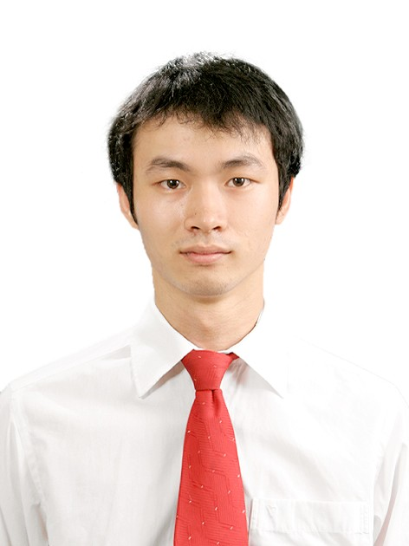

EDUCATION AND TRAINING



2008 - 2013 FPT University – Bachelor of Software Engineering (Full- Scholarship)

▪Website: <http://fpt.edu.vn>

2012 - 2013 Arena Multimedia – Diploma of Multimedia and Design

▪Website: <http://www.arena-multimedia.vn/>

October 2011 – March 2012 Kyushu Institute of Technology, Japan – Bioinformatics Faculty

(Exchanged Program)

▪Website: <http://www.kyutech.ac.jp/english/>

2005 - 2008 Tran Phu Gifted High School - High school graduation

▪Website: <http://www.chuyentranphu.edu.vn/>

WORK EXPERIENCE



March 2015 – Present UX/UI Designer

▪Employer: Next Generation Mobility GmbH

▪Website: <http://www.fleetster.net>

▪Responsibilities: UX/UI Design for website, mobile, and marketing material.

▪Technique: Adobe Photoshop, Illustrator, InDesign, Dreamweaver, HTML, CSS, JavaScript.

June 2014 – January 2015

2014 – April 2014

Web & Graphic Designer

▪Employer: Naue GmbH

▪Website: <http://www.naue.de>

▪Responsibilities: Website Design, Graphic Design.

▪Technique: Adobe Photoshop, Illustrator, InDesign, Dreamweaver, HTML, CSS, JavaScript.

Web & Graphic Designer

▪Employer: Time Universal Communication

▪Website: <http://timeuniversal.vn>

▪Responsibilities: Website Design, Printing Design

▪Technique: Adobe Photoshop, Illustrator, Dreamweaver, HTML, CSS, JavaScript

September 2012 – March 2013 Web Developer

▪Employer: 3S International Software Joint-Stock Company (Japanese co-operated Company)

▪Website: <http://3si.vn/en/>

▪Responsibilities: Develop application mostly for Japanese customers

▪Technique: Mangento, Joomla, PhP, HTML, CSS, jQuery, JavaScript, MySQL

HONOURS AND AWARDS



|  |  |  |
| --- | --- | --- |
| **Time** | **Type/Organization** | **Prize/Awards** |
| March 2013 | Microsoft Office Championship in Hanoi, Vietnam | Participated Candidate |
| October 2011- March  2012 | Exchanged program in Kyushu Institute of  Technology, Japan | Exchanged student |
| March 2011 | English Olympiad Contest for the best students in Hanoi | Third prize |
| February 2011 | “Ring the Golden Bell” – A knowledge  Contest in Vietnam. | Participated Candidate |
| July 2010 | IBM Technology Discovery Contest for the best students in Hanoi | Second prize |
| September 2008 | FPT University | Full scholarship for  Bachelor Degree |
| 2008 | Vietnam National Olympiad in Math using  Casio calculator | Second prize |
| September 2007 | Rencontres du Vietnam Organization | VALLEY scholarship |
| 2007 | Vietnam National Olympiad in Biology | Third prize |

PERSONAL SKILLS



Mother tongue(s) Vietnamese

Other language(s)

English 6.5 Ielts

Japanese

German

JLPT N4

Fundamental

Social Activities ▪Class monitor for 4 years (2008-2012)

▪Volunteer at International Conference on Project Management 2013 in Hanoi. (2013)

▪Vice President of FPT University Guitar Club (2009-2013)

▪Member ship of Aiesec (A global network of young leaders)

▪Enthusiastic tour-guide with foreigner visitors in Hanoi.

Professional skills ▪Familiar with Adobe Product: Illustrator, Photoshop, Dreamweaver, InDesign.

▪Good at Java and PHP programming language.

Other skills ▪Photography

▪Classical Guitar Playing

▪Cooking

▪Backpacking travel to many cities and provinces in Vietnam by motor-bike. Backpacking travel to

many cities in Japan; 6 countries and 13 cities in Europe within first 6 month in Europe, and will keep traveling it as much as possible.

REFERENCES



▪▪**Tran Dinh Tri (Ph.D, Head of Engineering Department)**

Organization: FPT University Software Engineering Department Cell phone: (+84)913091952

Email : [tritd@fpt.edu.vn](mailto:tritd@fpt.edu.vn)

▪▪**Ingo Friedrich Christian Naue (Dr. Ing, Leading Manager)**

Organization: Naue GmbH

International Welding Engineer (IWE/SFI) Cell phone: (+49)6150-9738-0

Email : ingo[.naue@naue.de](mailto:naue@naue.de)

DECLARATION



I hereby declare that the information furnished above is true to the best of my knowledge. **(Doan Quang Hung)**