

**T.C. KARABUK UNIVERSITY ENGINEERING FACULTY DEPARTMENT OF COMPUTER ENGINEERING**

**SOFTWARE ENGINEERING**

**Aircraft Repair-Maintenance Database**

**GAMZE TAŞKIN 2013010213055**

**KÜBRA ÜSTÜN 2013010213054**

# ABSTRACT

**Aircraft Repair-Maintenance Database**

**GAMZE TAŞKIN 2013010213055**

**KÜBRA ÜSTÜN 2013010213054**

**Project Supervisor:**

**Asst.Prof.Dr. OĞUZHAN MENEMENCİOĞLU**

**August 2019,12 Pages**

Maintenance is an important application to ensure that all types of equipment and equipment are operational and to extend the service life of these equipment and equipment. The priority work for the Aircraft-Repair Maintenance database is to decide which repair or maintenance process is required for each aircraft. In the software project we have made, since all the requirements are clearly defined at the beginning of the project, “waterfall model” has been realized by choosing.

Aircraft maintenance planning should be carried out very carefully in accordance with certain maintenance procedures and rules.

The decision model used for the aircraft repair-maintenance database within the scope of the study, which unit operations will be performed and in which workshops will be performed, the work schedules of these workshops, which materials will be used for each operation, stock statuses, all kinds of models and designs for the system, object oriented analysis, use case, class, sequence, state machine and expressions of these processes will be included.

Keywords: Aircraft Maintenance Cost, Aircraft Repair-Maintenance Database,Aircraft Repair - Maintenance Planning, Maintenance Time.

CONTENTS

ABSTRACT ii

CHAPTER 1 1

INTRODUCTION 1

1.1. Project Topic 1

1.2. Process Model 1

CHAPTER 2 2

UML DIAGRAMS 2

2.1. Class Diagram 2

2.2. Use Case Diagram 2

2.3. Sequence Diagram 3

2.4. State Machine Diagrams 4

CHAPTER 3 6

REQUIREMENTS AND ARCHITECTURE 6

3.1.Requirements 6

3.2. Software Architecture 6

CHAPTER 4 8

PLANNING AND SCENARIO 8

4.1. Aircraft Repair and Maintenance Planning 8

4.1.1. Analysis-Design 8

4.1.2. Coding-Test 8

4.2.Scenario 8

4.2.1.Use Case Planning 8

CHAPTER 5 10

COST ESTIMATE 10

5.1.Cost Estimate 10

CHAPTER 6 11

RESULT 11

REFERENCES 12

# CHAPTER 1

# INTRODUCTION

## Project Topic

Aircraft Repair-Maintenance Database

## 1.2. Process Model

During the preparation of our Aircraft Repair and Maintenance database, process steps were performed based on the “waterfall model”.

The waterfall process model is the oldest known model. The reason you choose this process is that all software requirements are clearly defined in the project scenario.After determining our process model, our project will be realized by following the stages. In our design step, the interface of the software, database, class etc. will be designed and documented. Then the coding and test steps followed by the process model will be realized and these will be included in the documentation. In the event of any error during the software process, the process was repeated by returning to the beginning.

# CHAPTER 2

# UML DIAGRAMS

## 2.1. Class Diagram

This stage will include the characteristics of the classes in our project and their relations with each other.

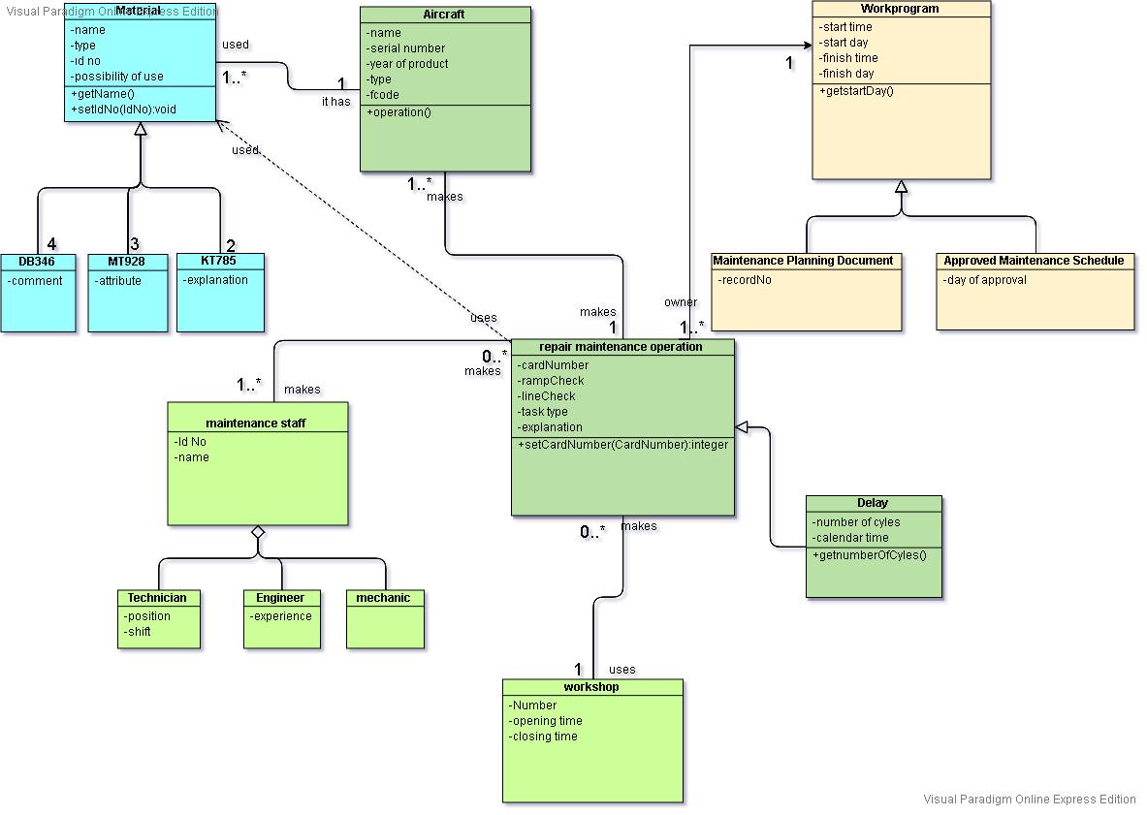

Image 2.2.1

## 2.2. Use Case Diagram

A collection of scenarios that describe the interaction between a user and a system. Use case diagrams are used to describe the functionality of the system. They consist of four main elements. System (determines the scope of the project), Actors, Use Caseler and their relations.

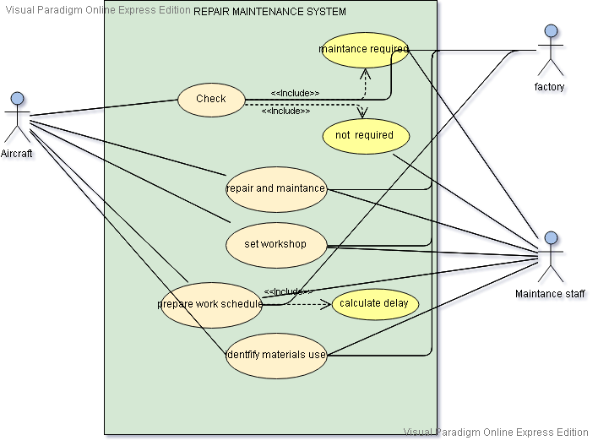

Image 2.2.2

## 2.3. Sequence Diagram

It is usually used to show the communication of objects with each other, respectively. Shows the static structure of the system. It also deals with them in the time dimension. In our system, a certain time limitation has been included in the repair-maintenance of the vehicles. This item knows the symptoms thanks to the time diagram.

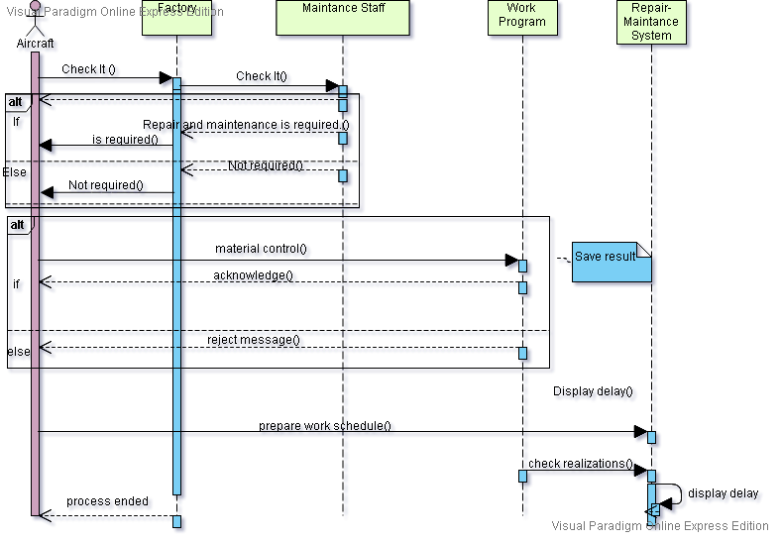

Image 2.3.3

## 2.4. State Machine Diagrams

The State Machine consists of a limited number of states, transitions and actions between these states. It is also used in related fields to define the behavior of systems.We have described the behavior of our aircraft repair and maintenance system in the following machine diagram.

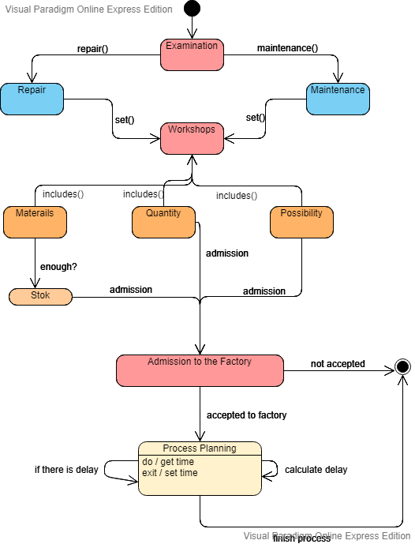

Image 2.4.4

# CHAPTER 3

# REQUIREMENTS AND ARCHITECTURE

## 3.1.Requirements

- Airplanes that have been deemed necessary for repair-maintenance must be composed of a series of unit operations.

-Each unit operation should be performed in a specific workshop.

-For repair-maintenance process, a certain proportion of each material should be used.

-How many materials will be used for each unit-process and the stock status of these materials should be determined.

- In accordance with the above requirements, it should be determined whether the aircraft is accepted to the factory or not.

- Work schedules should be prepared for each aircraft accepted to the factory.

-In the prepared work program, each workshop should include information on which workshop took place, on which day and time it will start and end.

- If any delay occurs, arrangements should be made and the delay should be indicated.

## 3.2. Software Architecture

It is the process of preparing a structural solution in order to meet the technical and operational needs determined for computer systems and to meet the general quality features such as performance, security and management. Our main point in software architecture is the separation of software into components.

The software architecture development process consists of a cycle. After the architectural requirements were determined, documentation was created for our project in line with the requirements. After the analysis process is evaluated, it is developed.

-In order to realize the aircraft repair and maintenance database system, it is provided to answer which components the whole system will consist of, whether all components are determined and integrated together in a harmonious way.

-Multi-layer architecture is preferred when the system is being implemented. It is also easier to understand than others.

-Any web browser is sufficient for application use.

-Any changes to the application may affect the entire software.

-No unnecessaryauthority.

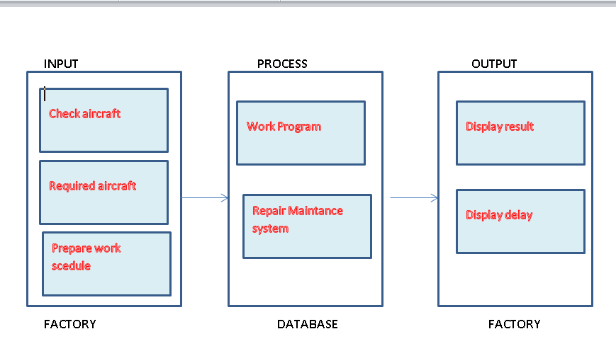

Image 3.2.1

# CHAPTER 4

# PLANNING AND SCENARIO

## 4.1. Aircraft Repair and Maintenance Planning

In order for the repair and maintenance to be carried out efficiently, the factory must establish a program. Otherwise, existing transactions may go back. Time advantage is achieved with planning. The maintenance management program will allow you to know which maintenance will be performed by which technician. Costs and many other materials will be included, such as equipment or equipment to be used. The process model we use starts with the name analysis.

### 4.1.1. Analysis-Design

First, all software requirements for aircraft repair - maintenance database are clearly defined and analysis document is obtained.

Then, the design step should be carried out and software, interface, database, class etc. designs should be realized.

It is checked by the aircraft maintenance personnel who arrive at the factory and if there is sufficient material stock after deciding which repair maintenance process to be carried out, it is determined whether the aircraft will be accepted to the factory or not according to the decision model.

After the maintenance of the aircraft is determined, work schedules will be prepared and necessary arrangements will be included in all programs in case of a delay.

### 4.1.2. Coding-Test

Test scenarios are written for all functional and non-functional requirements. If no error is found at the end of the test step, the integration step is taken and made available to the customer.

## 4.2.Scenario

### 4.2.1.Use Case Planning

**Use Case** : Check  
Actors :Aircraft, Maintance Staff  
Description : Necessary examinations on airplanes coming to an aircraft repair-maintenance factory; each which repair or maintenance is necessary for the aircraft.   
Stimulus : Communication between the aircraft and the factory is carried out by a maintance staff.  
Response : They report each which repair or maintenance is necessary.  
Comments : Workload is reduced by predetermining the required process. Improper operation is prevented.

**Use Case** : Acceptance Decision  
Actors : Maintance Staff, Factory  
Description : It is decided whether the aircraft can be accepted to the factory.  
Stimulus : Maintance staff decided whether the aircraft can be accepted according to a decision model.  
Response : It is assumed that the repair and maintenance required for each aircraft is one.  
Comments : If repair and maintenance cannot be carried out in this factory, the aircraft from idle to ground is not accepted to the factory.

**Use Case** : Set Workshop  
Actors :Aircraft, Factory  
Description : Which work program unit-process, which workshop, which day / hour to start and end to what day / hour information requested.  
Stimulus : Communication between the aircraft and the factory is carried out by a maintance staff.  
Response : Monitoring of unit-operations performed on each aircraft; realizations with work programs  
comparison and when there is a delay in the realization of a make necessary corrections in programs.  
Comments : Determining when the work will end is important both in terms of speed and efficiency. This avoids possible delays and minimizes downtime.

**Use Case** : Identify Materials Use  
Actors : Aircraft, Maintance Staff  
Description : Certain materials during unit-processing,  
used in certain quantities, with certain possibilities. You need to identify them.  
Stimulus : The requirements between the aircraft and the factory are determined by maintenance personnel.  
Response  : For each unit-process, which materials are likely to be used, the number of escapes to be used and examines the stock status of materials.  
Comments : Identifying requirements prevents disruptions and provides jobability

# CHAPTER 5

# COST ESTIMATE

## 5.1.Cost Estimate

Our project team should have an experienced programmer and analyst.There are 24000 source codes in our project. (24  KLOC)

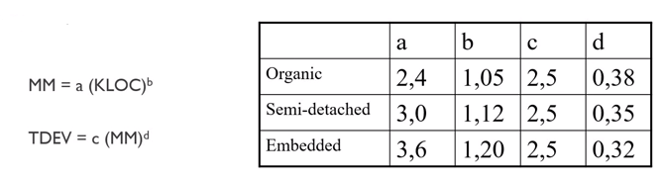

Image 5.1.1

The kind of "organic project" that we should use because internal team, programmers and analysts developing similar programs, pre-defined requirements.  
MM =  a (KLOC) ^ b   
MM = 2.4 (24) ^ 1.05 = 67 man-months  
TDEV = c (MM) ^ d   
TDEV = 2.8 (67) ^ 0.28 = 10 months  
Productivity  = 24000 DSI / 67 MM = 358 DSI/MM  
Average Staff = 67MM/ 10 months = 6.7 FSP

# CHAPTER 6

# RESULT

UML diagrams have been drawn within the framework of the framework activities by providing the solution of the project subject and the process model representing the project. Visual-paradigm program was used to draw UML diagrams. The requirements for each problem were identified when creating a database. Documentation has been created by including the model and design envisaged for the system. In addition, cost estimation and planning required for the creation of the project were included.

# REFERENCES

1. *Havacılık Sektöründe Yabani Hayatı Yönetim Üzerine .* **Ramazan ÇOBAN, İsmail BAHAR.** 23.12.2018, Journal of Aviation , s. https://dergipark.org.tr/download/article-file/599394.

2. **COMMERCE, AIRCRAFT.** JUNE/JULY 2006, AIRCRAFT COMMERCE, pp. http://www.aircraft-commerce.com.

3. Visual-paradigm. *Visual-paradigm.* [Online] https://www.visual-paradigm.com/tutorials/.

4. **DÖNMEZ, Kadir and USLU , Suat.** *INVESTIGATION OF ACCIDENTS RELATED TO AIR TRAFFIC CONTROL.* Mart 2017, pp. https://dergipark.org.tr/download/article-file/289699.

5. **ÇOBAN, Ramazan; BAHAR , İsmail.** Havacılık Sektöründe Yabani Hayatı Yönetim Üzerine. *Journal of Aviation .* 12 23, 2018, pp. https://dergipark.org.tr/download/article-file/599394.