Task 1 – Prepare, Design, and Plan
Scenario
The purpose of the website is to match pet owner with pet sitters. The website provides users with a list of pet sitters with information on how much they charge, their location and a brief description of them. User can message and book pet sitters through their profile pages.

Aim of the content
Client requirements:
The website should have clear and demonstratable interactive features as well as a shopping cart, clear imagery and at least one animation.
Marketplace
Accessible
Informative
Easy to use

User expectations:
User can browse through a full list of pet sitters or they can filter by the city. They can view each profile and message the pet sitters if they wish so. They can book as many pet sitters as they want for the selected dates and they can view their bookings separately.
Pet sitters can share their calendars on their profiles to show which days they aren’t available, They can highlight a summary card for a quick display of anything they want to highlight, their daily rates and a brief description of themselves.
Web Site Overview
Home page:
This is the first page user sees when they go to the website.
They can navigate to the full list of pet sitter profiles, their previous bookings and Frequently Asked Questions.
They can select a city to view the pet sitters only in that city.

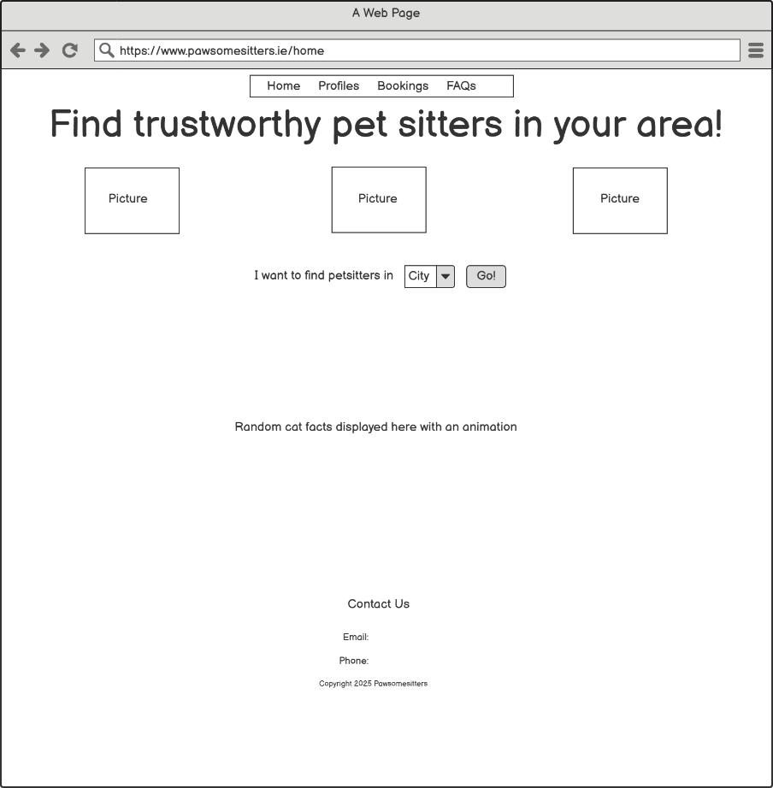

Profiles page:
This page displays the full list of pet sitters in Ireland or pet sitters filtered by city.

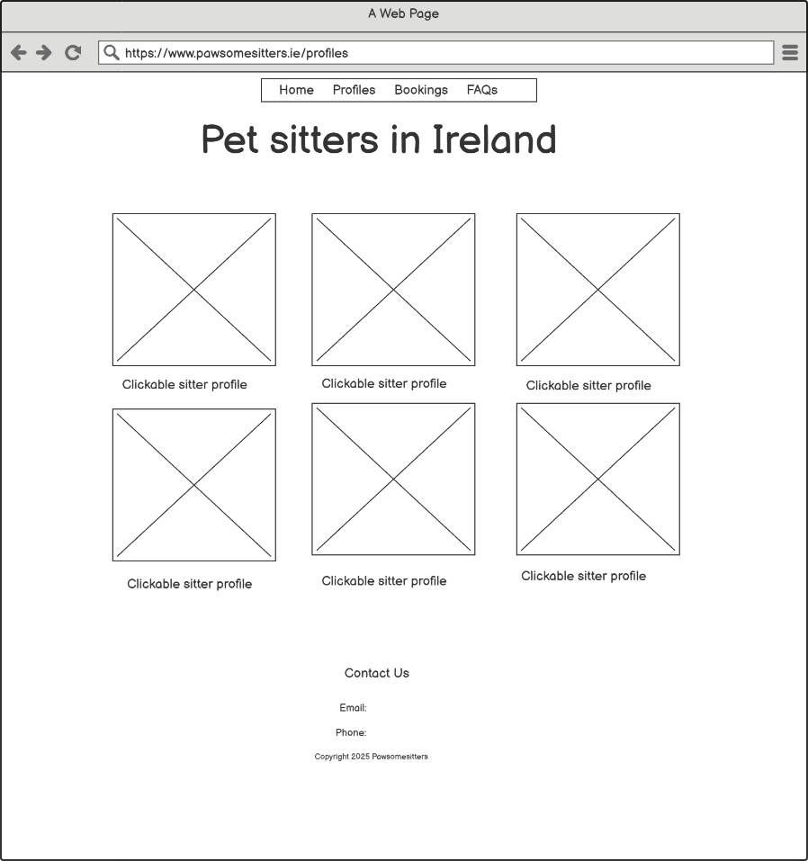

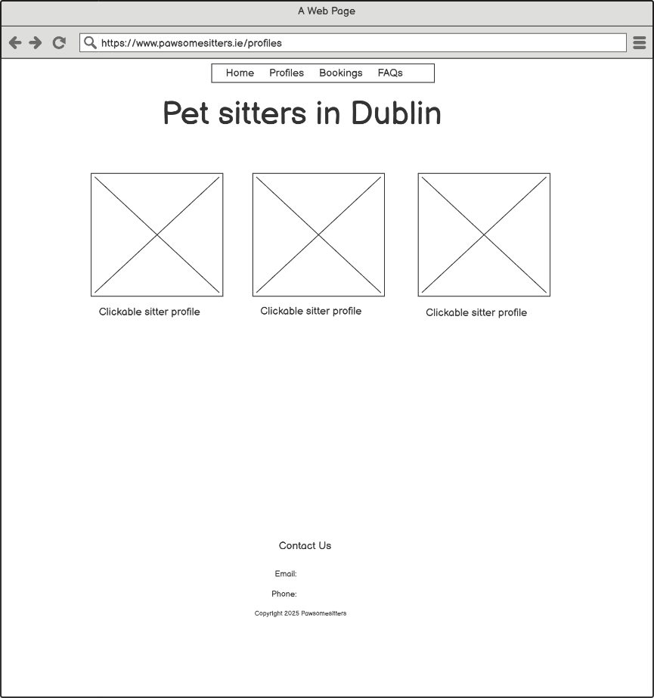

Profile page:
Profile page is where the user finds all the information about a pet sitter.
They can start a chat with them, view their calendar for availability and pick the dates to book them.

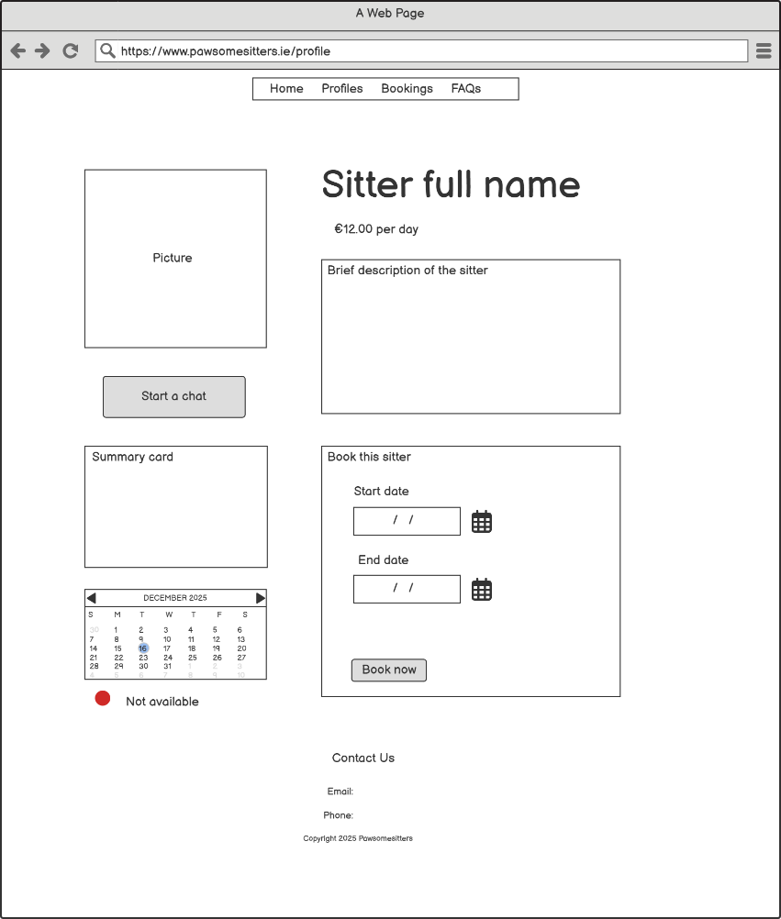

Message page:
User can message the pet sitter in this page.
They can go back to the profile whenever they want.

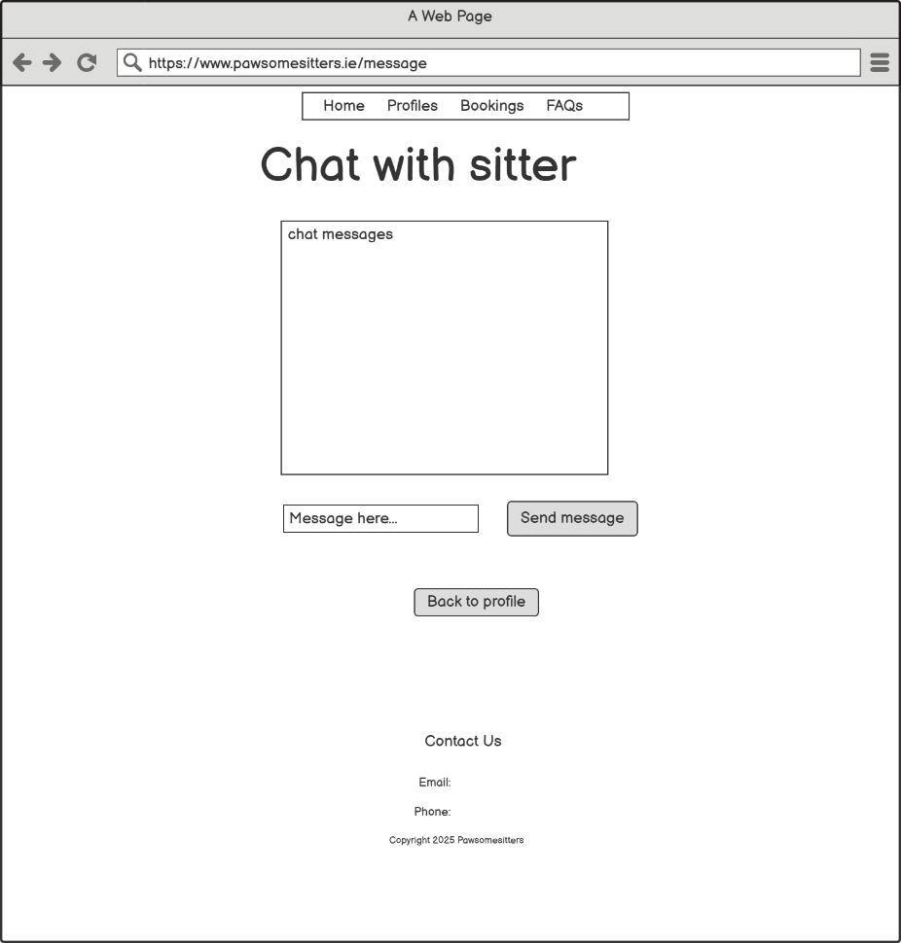

Checkout page:
This page shows the booking information. User can confirm and make the payment.
They can also go back to the profile without completing the booking.

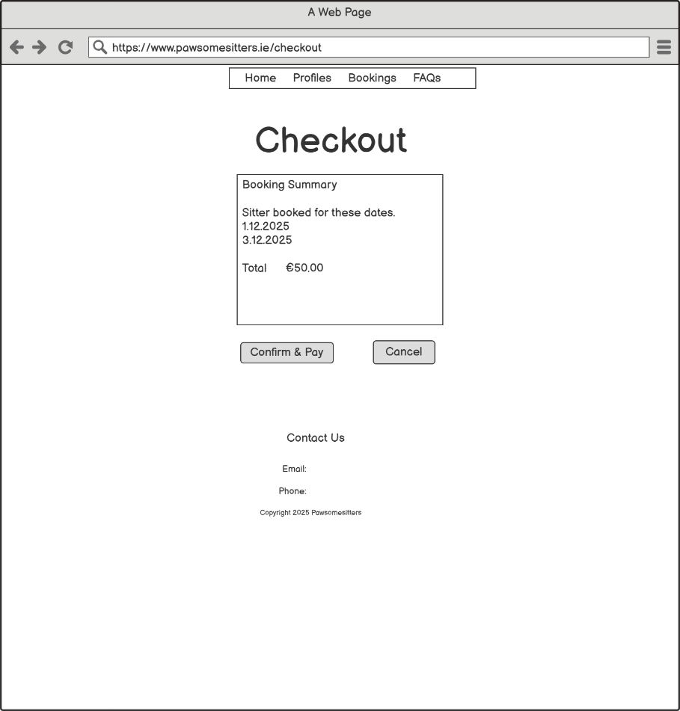

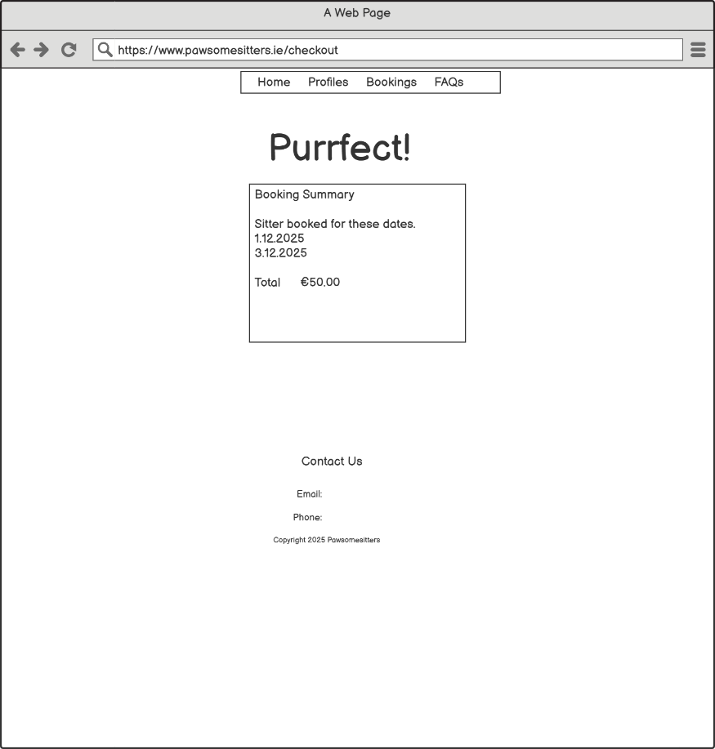

Bookings page:
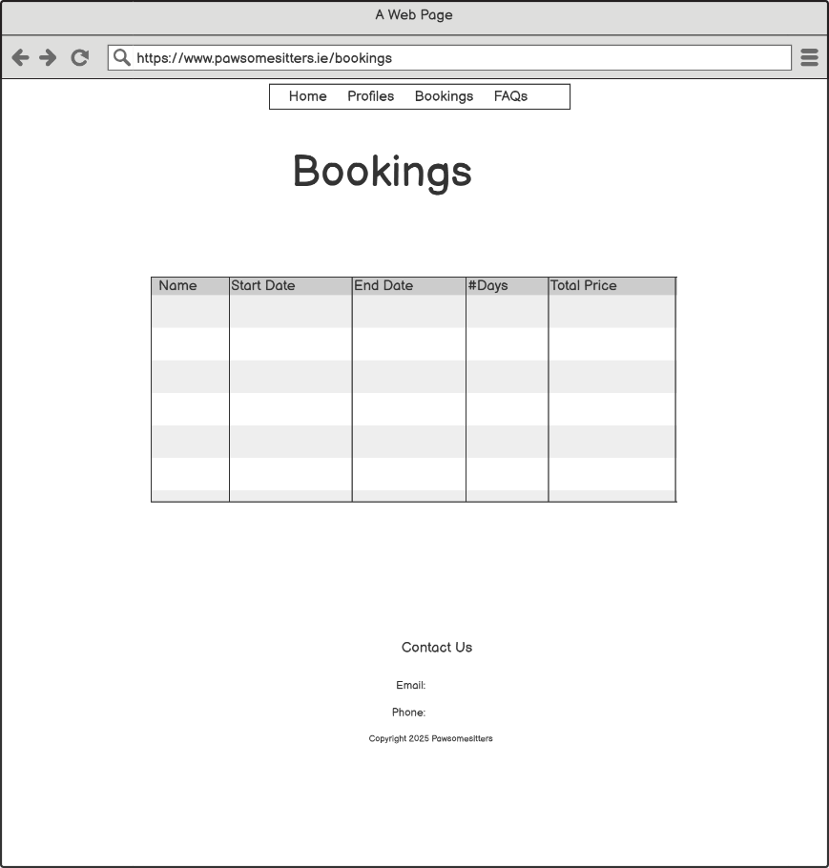

FAQs page:
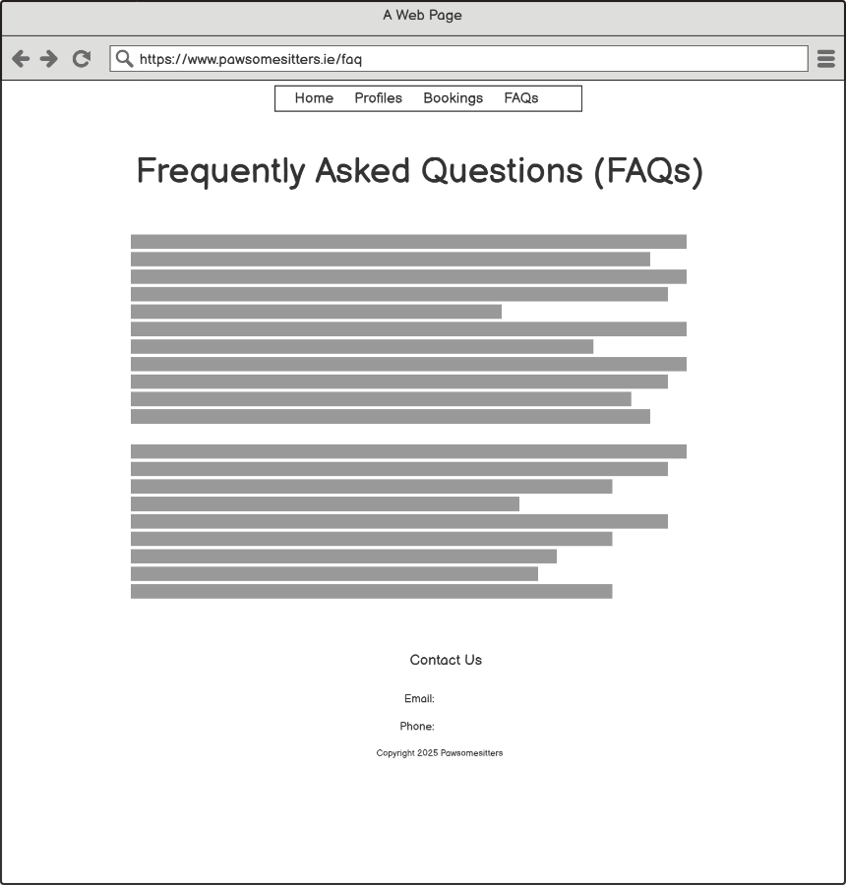

Navigation

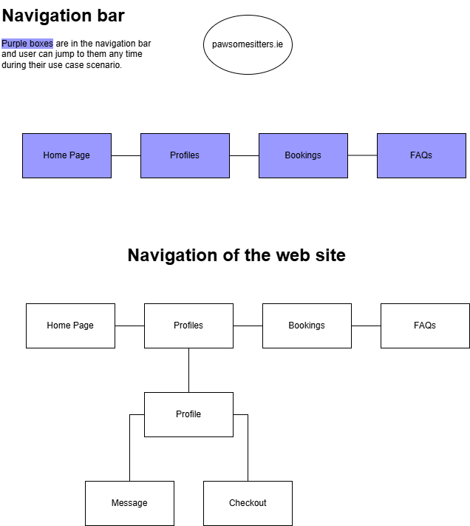
User Interactions
Ability to select items, make donation, shopping cart, easy navigation, accessibility, Feedback, Email query
HOME PAGE:
- User can select a city from a dropdown menu and click Go. This takes the user to the list of pet sitters in that city.
- User can see the full list of pet sitters in Ireland by clicking Profiles in the navigation bar.

PROFILES PAGE:
- User can view a pet sitter profile by simply clicking on the profile card.

PROFILE PAGE:
- User can click the Start a Chat button to message the pet sitter.
- User can select dates and book the sitter between those days by clicking Book Now.

CHECKOUT PAGE:
- User can click the Confirm & Pay button to checkout. This is where the use case for booking a pet sitter ends.
- User can click Cancel to go back to the profile without completing the booking.

MESSAGE PAGE:
- User can type in a message and click Send Message button. The message appears in a chat box.
- User can go back to the profile by clicking the Back to Profile button.

FAQs PAGE:
- User can view the Frequently Asked Questions to find quick answers to possible questions.
- User can report an animal abuse by clicking the link on the page.

Interactive features

Possibilities include - Highlighting active menu, Dropdown list to avoid spelling mistakes, Number inputs for quantities and prices etc.

In the home page, there is a drop-down menu for the user to select cities from. This prevents misspelling a city or typing in a place name that is not included in the web site.
Navigation is very easy; it’s at the top of every page and easily accessible. User can jump any of the main pages at any point of a use case if needed.
In the checkout page, user has an option to choose to go back to the profile without completing the booking.Hovering over the profile cards. Animation.

Animation
The web site uses an API to pull interesting cat facts from an external source and displays them in the home page using an animation. Animation happens when the function pulling data from API uses two classes (fade-in and fade-out) and alternate between these two classes when displaying the data from the API. Every time fade-out class is removed, and fade-in class is displayed with the cat fact, the element in HTML looks like it’s changing. This is done continuously by setInterval function where every 10s, a new fact is pulled from the API and the two classes (fade-in, fade-out) alternate. The background of fade-in class is in purple, so the change (i.e. the animation) is even more visible to the user.

HTML5 Features
Header and Footer
Nav
locaStorage

Search Engine Optimization (SEO) approaches
h1 h2 h3 tag: These tags ensure structure and hierarchy in the pages and help search engine bots understand content importance and structure.

Title tag and Meta Description and Keywords Optimization: Relevant titles and meta descriptions for each page ensures that they accurately reflect the content of the page and entice users to click. Keywords go in meta tags.

User Experience (UX) and Responsiveness: User-friendly website with a clear navigation structure with <nav> tags. Page loading speed optimized, and site is mobile-friendly. This helps with keeping bounce rates low.

Social Media Presence: Engaging with the audience on social media platforms. Facebook and Instagram links are added in the footer on each page. Content is shared on social media to increase its visibility and reach.

Quality Content: High quality and relevant content for the audience. Regular updates keep the content fresh and relevant. Variety of content types, such as text, images, videos, and infographics.

Conclusion
Design created in user friendly way….

