Edgar Andersons’s Iris Data

gamzekecibasvit

2025-09-23

Table of Contents

# Description

This famous (Fisher’s or Anderson’s) iris data set gives the measurements in centimeters of the variables sepal length and width and petal length and width, respectively, for 50 flowers from each of 3 species of iris. The species are *Iris setosa*, *versicolor*, and *virginica*.

# Usage

iris

# Format

iris is a data frame with 150 cases (rows) and 5 variables (columns) named:

* **Sepal.Length**
* **Sepal.Width**
* **Petal.Length**
* **Petal.Width**
* **Species**

# Source

Anderson, Edgar (1935). “The irises of the Gaspe Peninsula.” *Bulletin of the American Iris Society*, **59**: 2–5.

Fisher, Ronald A. (1936). “The use of multiple measurements in taxonomic problems.” *Annals of Eugenics*, **7** (Part II): 179–188.

# Examples

We investigate the Sepal and Petal leaves for the three species in the Iris data:

summary(iris)

## Sepal.Length Sepal.Width Petal.Length Petal.Width   
## Min. :4.300 Min. :2.000 Min. :1.000 Min. :0.100   
## 1st Qu.:5.100 1st Qu.:2.800 1st Qu.:1.600 1st Qu.:0.300   
## Median :5.800 Median :3.000 Median :4.350 Median :1.300   
## Mean :5.843 Mean :3.057 Mean :3.758 Mean :1.199   
## 3rd Qu.:6.400 3rd Qu.:3.300 3rd Qu.:5.100 3rd Qu.:1.800   
## Max. :7.900 Max. :4.400 Max. :6.900 Max. :2.500   
## Species   
## setosa :50   
## versicolor:50   
## virginica :50   
##   
##   
##

To examine the Sepal leaves, we select the length and the width:

llen <- iris$Sepal.Length   
lwid <- iris$Sepal.Width

Then we plot the data:

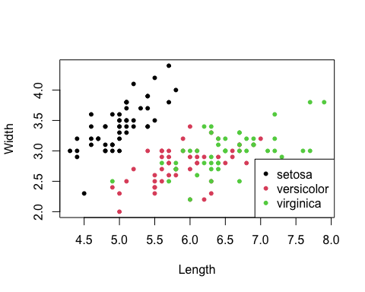

We can also select the Petal leaves:

llen <- iris$Petal.Length   
lwid <- iris$Petal.Width

This gives us the following plot

