<Project Name>

Object Design

<Version>

<Date>

<Your Name>

Prepared for

SE301 Software Engineering



Table of Contents

1. Introduction 1

1.1. Object Design Trade-offs 1

1.2. Interface Documentation Guidelines 1

1.3. Definitions, Acronyms, and Abbreviations 1

1.4. References 1

2. Packages 1

3. Class Interfaces 1

OBJECT DESIGN DOCUMENT

# Introduction

## Object Design Trade-offs

The project name is: Hotel Reservation System. This website is about: Booking. The purpose of this document is decribe to design and architecture of the "HotelReservation" site. All code in this system is our own original work, including data and user interfaces. We use the database to keep information. The objective of the system is to be simple, but also to cover every detail and function needed by HotelReservationSystem. Therefore database increase security in system. System some keep some information like address, password,username securitely.

## Interface Documentation Guidelines

In this system, object-design principle had applied. There are two groups of graphical design in this project. First graphical design was made for User side and the other was made for Admin side. User panel has also two groups; User and Hotel User. These two designs are similar to each other.

On the user side,there are some of criterias . For instance; user may understand the site easily and do his/her actions easily on the site,also can done their reservations easily.The side should be understandable. In addition, Hotel User can see the reservations that are done by a user and The Hotel User can check the user’s information who had done a reservation. Hotel User also can add a hotel to the system by an admin approval.

The Admin panel, is more complex according to user-side. However, it is also easy to use for an admin. Menus are clearly identified on the panel. An admin can check all users’ information, can approve/reject hotel addition requests and user comments for reservations. In addition, an admin can send messages to hotel users before accepting/rejecting a hotel addition request.

## Definitions, Acronyms, and Abbreviations

## References

# Packages

# Class Interfaces

**3.1.1 user.java**

this class explain and contents about user functions

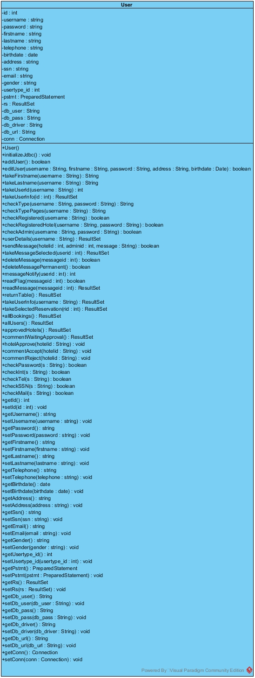

**3.1.2 hotel.java**

this class explain and contents about hotel functions

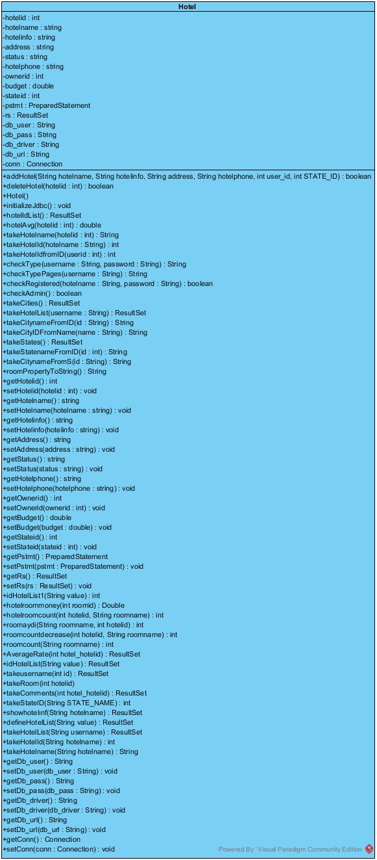

**3.1.3 reservation.java**

this class explain and contents about reservation functions

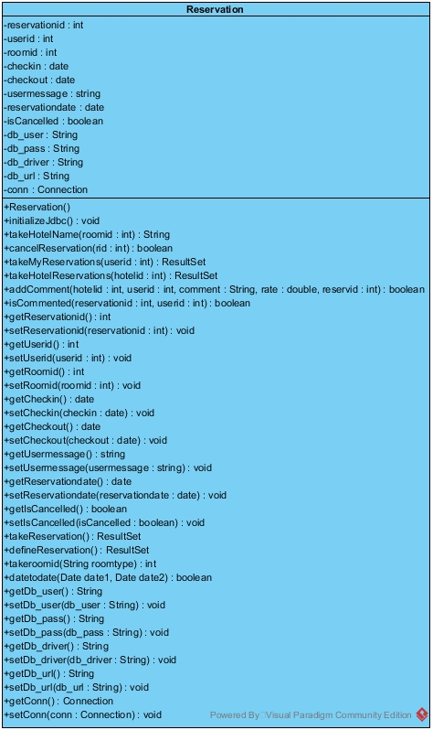

**3.1.4 hotelroom.java**

this class explain and contents about hotelroom functions

