**Job Application Platform (Indeed) Plan**

***Scenario:***

*A platform where users can apply for job postings and follow the application process.*

***Requirements:***

*Browsing Job Postings: Users can filter job postings by category and access their details.*

***Application Management:***

*Users can view the job postings they have applied for and track their application status.*

**Test Scenarios to be prepared:**

1. **See Job Posting Test Scenarios:**

* **Displaying a list of job postings for a specific category or location.**
* **Performing a keyword search of job postings and filtering the results correctly.**
* **Checking how results are rendered when a non-valid category is selected or a blank search is performed.**

1. **Application Management Test Scenarios:**

* **Applying for a job vacancy and saving the application in the system.**
* **The user can view the details and application dates of the job advertisement applied for.**
* **Checking how the system provides guidance when the candidate's contact information or resume needs to be updated during the application process.**

**See Job Postings**

**Name of Test Scenario: See Job Postings**

**Description:** Displaying a list of job vacancies for a specific category or location, performing a keyword search of job vacancies and correctly filtering the results, checking how the results are processed when a non-valid category is selected or a blank search is performed, will be tested.

**Prerequisites:**

* The user must have a test account to log in.

**Test Case1:** Successful listing of job adverts

**Description:** Displaying a list of job vacancies for a specific category or location.

**Steps:**

1. Type "Software Test Engineer" in the search box.
2. Select a region from the location.
3. Click on the search symbol.

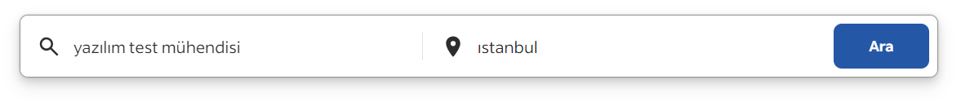

**Expected Result:**  Job adverts will be listed according to the profession and location we have selected.

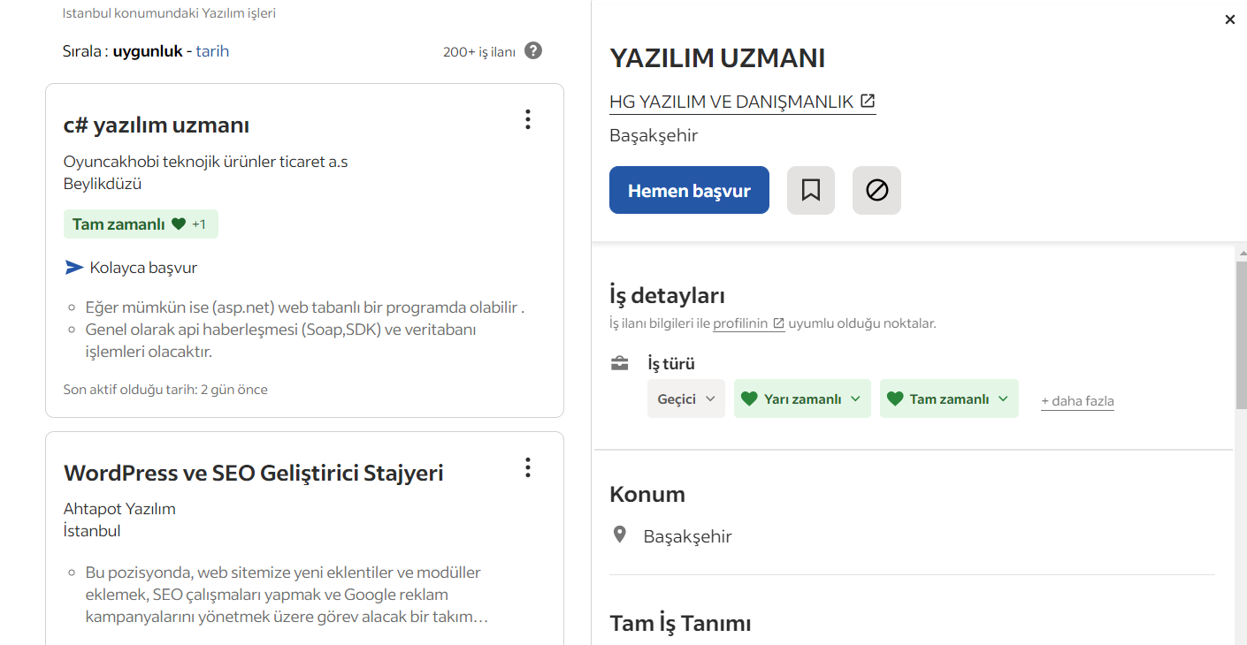

**Test Case2:** The user should search for job adverts according to certain criteria.

**Description:** Keyword searches of job adverts and correct filtering of the results will be tested.

**Steps:**

1. Enter specific keywords (e.g. "software engineer") in the search bar.
2. Click on the search button.

**Expected Result:** Job adverts matching the search criteria are listed.

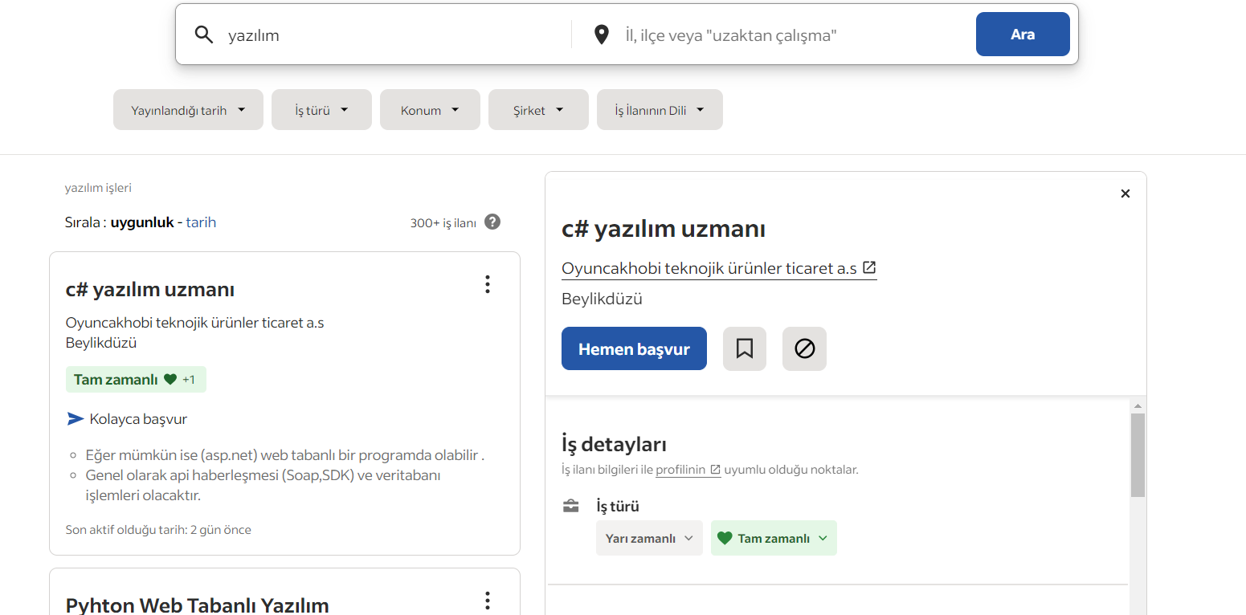

**Test Case3:** Search job adverts with no action.

**Description:** It will be checked how the results are processed when a non-valid category is selected or an empty search is performed.

**Steps:**

1. Click on the search bar.

**Expected Result:**  The warning message "Enter a position or location to search" will appear.

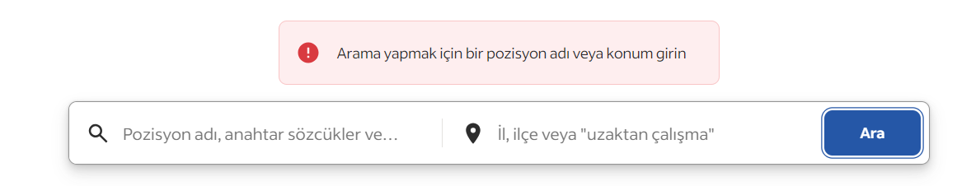

**Test Case4:** Invalid Filter

**Description:** It should be tested whether a warning message appears when an invalid filter combination is entered.

**Steps:**

1. Type "Software" in the search bar.
2. Enter "Van" in the location field.

**Expected Result:**  A warning message will appear.

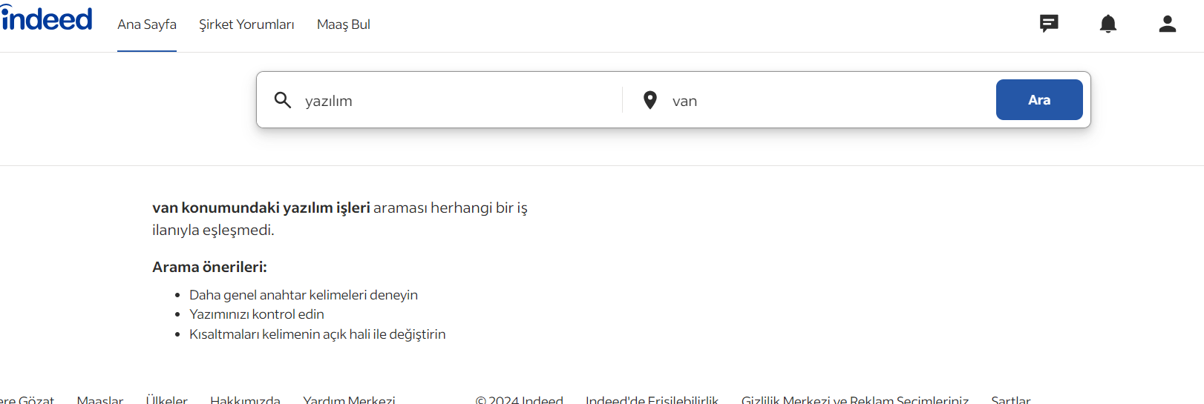

**Application Management Test Scenarios**

**Name of Test Scenario: Application method testing**

**Description:** Testing the successful application to a job advert, updating and displaying information about the job advert applied for.

**Prerequisites:**

* The user must have a test account to log in.

**Test Case1:** Applying for the Job.

**Description:** The user should apply for the job posting.

**Precondition:** The user must be on the job details page.

**Steps:**

1. Click the “ Apply” button.
2. Fill out the application form (upload resume, cover letter, etc., if applicable).
3. Click the “Submit” button.

**Expected Result:**  A The application is successfully submitted and a success message is shown to the user.



**Test Case2:** Recording the Application in the System

**Description:** The application should be correctly recorded in the system.

**Precondition:** The user must have successfully applied for the job.

**Steps:**

1. Go to the “My work” section in the user profile.
2. Check if the new application is listed.

**Expected Result:**  The new application is listed with correct details.

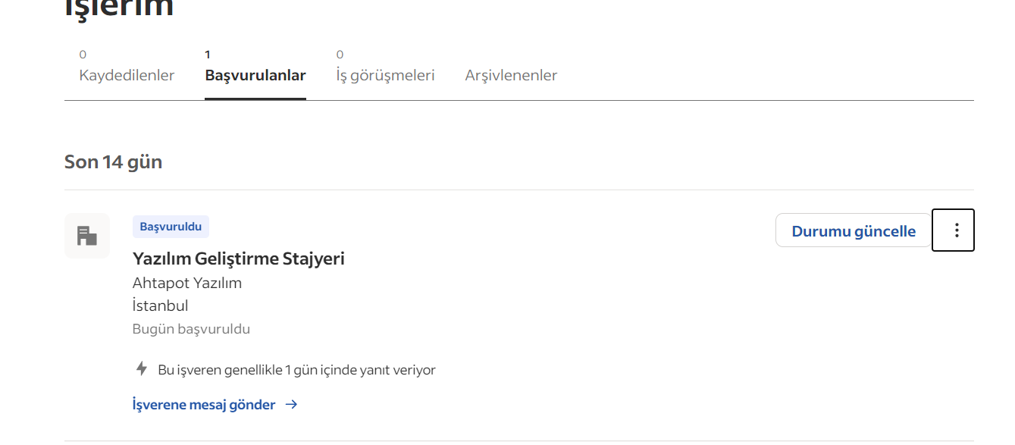

**Test Case3:** Applying for the Job and Information Update Prompt

**Description:** The system sshould promt the user to update personal informaiton if needed during the job aplication process.

**Precondition:** The user must be on the job details page.

**Steps:**

1. Click the “Apply” button.
2. Fill out the application form.
3. The system should detect any missing or outdated information(e.g., address, educational background).
4. Display a message to the user indicating the need to update missing or outdated information.
5. The user must update the information standing above the warning message.

**Expected Result:**

* The system detects missing or outdated information.
* The user is shown a message indicating the need to update information.

